Sveučilište u Zagrebu
Filozofski fakultet
Ivana Lučića 3
10 000 Zagreb

Siniša Bosanac, Dora Lukin, Petra Mikolić
A Cognitive Approach to the Study of Diminutives: The Semantic Background of Croatian Diminutives

Zagreb, 2009.

Ovaj rad izrađen je na Filozofskom fakultetu u Zagrebu pod vodstvom prof. dr. Milene Žic-Fuchs i predan je na natječaj za dodjelu Rektorove nagrade u akademskoj godini 2008./2009.

Abbreviations

M | male
F | female
prim. ed. | primary education
sec. ed. | secondary education
high. ed. | higher education
affect. | affection
pej. | pejorative
lex. | lexicalized
contex. | contextualized

Contents

1. Introduction 1
2. Hypothesis 4
3. Methods 5
3.1 Description of fieldwork 5
3.2 Research methods verification study 11
3.2.1 Description 11
3.2.2 Results of the research methods verification study 13
3.3 Processing the data 17
4. The results 18
4.1 Features of meanings 18
4.1.1 Small 19
4.1.2. Large 20
4.1.3 Affection 21
4.1.4 Contextualized, associative and stylistic 21
4.1.5 Lexicalized 22
4.1.6 Pejorative 23
5. Discussion 24
5.1 Small 27
5.2 Large 28
5.3 Affection 30
5.4 Lexicalized 31
5.5 Contextualized meaning 31
5.6 Pejorative 33
6. Conclusion 34
7. Acknowledgements 35
8. Literature 36
9. Appendices 37
9.1 Appendix 1 – Questionnaire 38
9.2 Appendix 2 – Research methods verification study questionnaire 42
9.3 Appendix 3 – Corpus screenshot 1: Digitalized questionnaires 43
9.4 Appendix 4 – Corpus screenshot 2: Definitions marked as meanings 44
9.5 Appendix 5 – Corpus screenshot 3: Results represented as statistical data 45

1. Introduction

Croatian is one of the most productive Indo-European languages when it comes to diminutives due to the numerous morphological forms used for their formation. Yet, not much attention has been paid to diminutives, and the few researches that have dealt with them focused primarily on the morphology used in creating diminutives. In other words, Croatian linguists were mostly preoccupied with the morphology of diminutives and in principle disregarded their semantic and pragmatic properties. Pintarić (1996:36), for instance, gives a widely accepted division of diminutives according to semantic determinants according to which she defines them as “diminutives that signify small size“ and “hypochoristics that modify emotions towards entities from our surroundings“.
Croatian grammars do not as a rule provide a complete analysis of diminutives. Even though the word formation of diminutives is carefully dealt with, their meaning is described superficially or not at all. For instance, Babić (1991) does not define diminutives at all, but rather elaborates on the process of word formation. However, he stresses the need for semantic analysis. Barić et al. (1997:396) define diminutives as “nouns expressing something that is in some aspect smaller than the designate of the original word: boca – bočica (‘bottle’ – ‘small bottle’), grad – gradić (‘town’ – ‘small town’). The principal word is always a noun. If the diminutive is motivated by a noun signifying a person, along with the meaning small, the meaning can also be young: grof – grofić (‘count’ – ‘young count’), pastir – pastirić (‘shepherd’ – ‘young shepherd’). By diminutives we also express the meaning of kindness and affection – hypocoristics: sinčić (‘dear son’), cvijetak (‘dear flower’), as well as the feeling of contempt, degrading – pejoratives: činovničić (‘bad clerk’), direktorčić (‘bad manager’)”. Later on they discuss the formation of diminutives; however, a more thorough semantic analysis is omitted.
Anić (2003:326) in his dictionary of Croatian language defines diminutives as “a noun or other nominal word which expresses minuteness or affection and familiarity”. Definitions such as the above are somewhat inadequate. In principle they define diminutives as nouns and nominal words and give only a hint on their semantics.
One of the reasons why these definitions do not represent the actual state of language usage of diminutives lies in the fact that no field research has been conducted on how native speakers actually use them. Diminutives are in fact far richer in their semantics, and the semantics extends beyond the meaning of small, affection and contempt. It should also be stated that diminutive meanings can be formed from other parts of speech such as verbs, adjectives, etc. However this does not lie in the scope of this research.
One of the few linguists who has taken a step further into the semantics of Croatian diminutives is Neda Pintarić (1996) in her comparative study of Polish and Croatian diminutives. This can be considered to be a step towards a semantic analysis of diminutives.
Morphology is naturally a very important part of Croatian diminutives, for Croatian is a Slavic language. However, for the purposes of this paper we will not deal with the morphological aspects covered in the above mentioned researches, nor will we embark on analyzing the connection between suffixes and semantic features, but we will be focusing on the different meanings and their relationships found in contemporary Croatian.
We believe that the empirical data on which this research is based can show how diminutives are used semantically in a much wider sense than has been alluded to in earlier works.
Data collected among native speakers show varied usage that surpasses the typical meanings pertaining to size and affection, and it is precisely these “additional meanings” that we will be focusing on in this paper. This implies that we will be focusing on the semantic network of diminutive meaning or in cognitive linguistics terms, the meaning category of diminutives.
We find it important to emphasize that this paper represents only a surface research, and that the collected corpus of data is a fertile ground for further research, not only in the field of linguistics, but also in other fields such as ethnology, anthropology and psychology.
The idea of this research was proposed and articulated by prof. dr. Milena Žic-Fuchs as part of the course Cognitive Linguistics at graduate level in linguistics in the department of English during the winter semester of the academic year 2008/2009.

2. Hypothesis

The main idea behind this research was to acquire data on the usage of diminutives by the native speakers of Croatian, and to investigate the semantic background of diminutives. Since no prior research of diminutives was focused on semantics, the data obtained through fieldwork did not coincide with the basic semantic network proposed in earlier works. Thus, the main hypothesis behind this research is that diminutives do not always reflect size or affection, as is usually presupposed, but that they cover semantically other meanings as well. Diminutives primarily mean small but can acquire new meanings through metonymical and metaphorical extensions. Our intent was to determine which meanings we find in the semantic network of Croatian diminutives, and to analyze their frequency according to criteria such as age, education, sex and dialect of the examinees. In other words, this research sets out to provide new insights based on empirical data on the bases of which the semantics of Croatian diminutives can be analyzed.

3. Methods
The research was carried out on 354 examinees out of which 149 were men and 205 women. It comprised of 60 diminutives taken according to approximate frequency of suffixes from the Croatian National Corpus. Each diminutive had to be defined and explained by native speakers of Croatian. The speakers were selected on the basis of parameters such as age, education, sex and dialect. As Žic Fuchs (1989) states in her research on forms of address in the city of Zagreb: “The usage will depend on the whole range of factors, such as education, profession etc. of speaker [...]”. This implies that the use of a word and its meaning can have a whole range of variants. Some meanings are used in specific social groups and according to particular pragmatic considerations.
The research was divided into two main phases. The first phase covers the actual fieldwork – collecting data on the basis of interviews, and the second phase covers the interpretation of data from a semantic point of view and the comparison of our results with claims found in previous approaches to diminutives in Croatian.

3.1 Description of fieldwork

We began our research guided by the idea that empirical data collected during fieldwork activities as well as the contact with native speakers is one of the more reliable sources for a cognitive linguistics approach.
The framework for the fieldwork was initiated by our supervisor, while the questionnaires were prepared by Marija Kraljević, assistant lecturer on the Department of English at Faculty of Humanities and Social Sciences, University of Zagreb. The questionnaire was comprised of two parts, that is, of two assignments for native speakers. The first assignment in the questionnaire required the examinees to semantically define the diminutives. The examiners instructed the examinees to provide as many definitions as they could. The second part of the questionnaire required the examinees to form as many diminutives as possible based on the noun provided. They also had to define them semantically. In this paper we have not dealt with the second assignment but focused exclusively on the first part.
The set of diminutives in the first assignment comprised of 60 diminutives selected according to relative frequency in the Croatian National Corpus.
Thirty-two students participated in the fieldwork as the examiners; 26 were female and 6 male. They gathered data on the sample of 354 examinees; out of which 205 were female and 149 male (see Figure 1). The examinees were also selected according to age, level of education, dialect and place of origin. They were divided into five age groups: the first – from 7 to 15, the second from 16 to 25, the third – from 26 to 45, the fourth – 46 to 65 and the fifth – from 66 years of age and above (see Figure 2). There were three groups according to education level: the first – primary education which includes those still in primary school as well as those adults who never continued their education; the second group – secondary education which includes those who finished secondary school but did not enroll university, and the third group – higher education which comprised of those who finished secondary school and enrolled university but did not necessarily complete their studies (see Figure 3). There were also three groups reflecting the dialectal variants of the Croatian language – štokavian, kajkavian and čakavian (see Figure 5). It is important to mention that the above dialectal division is rather simplified in order to enhance data processing.
The above data on examinees are shown graphically in the following diagrams:

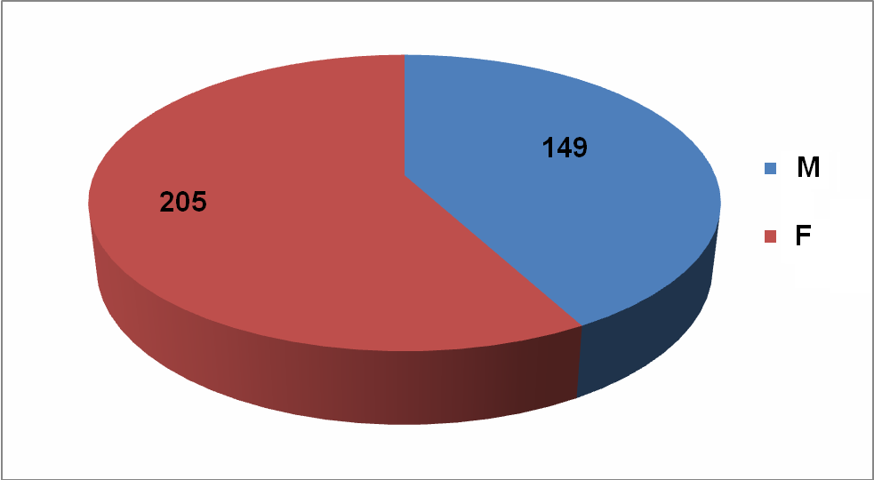
Figure 1. Examinees according to sex

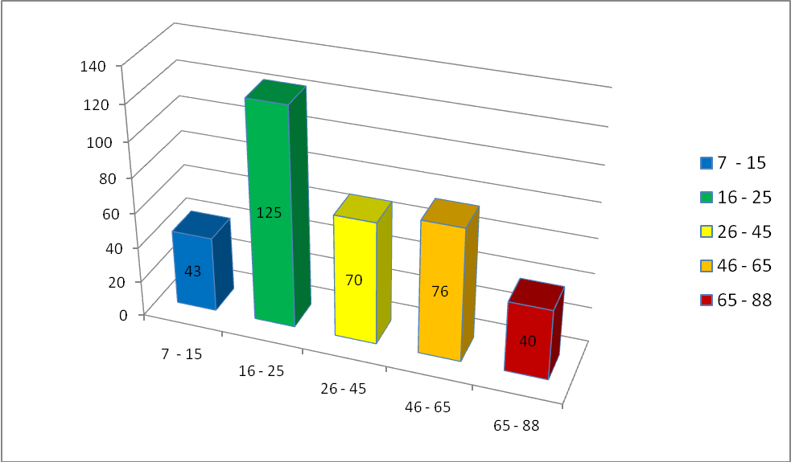
Figure 2. Examinees according to age
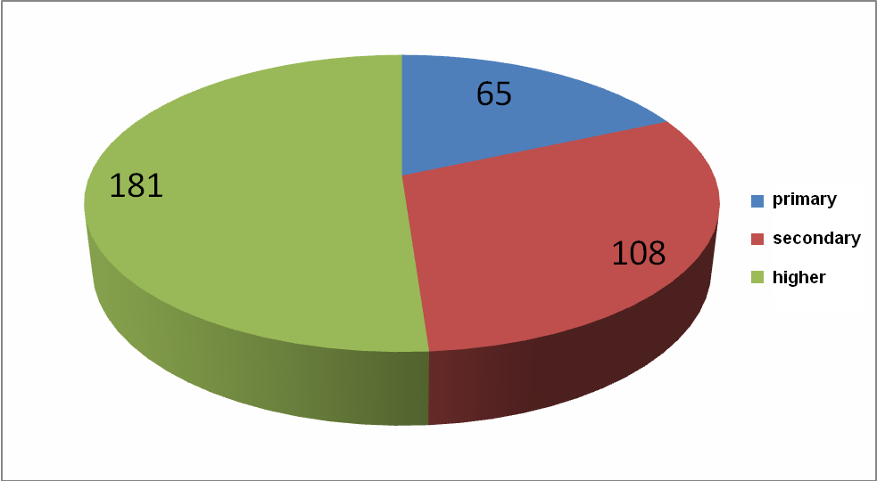
Figure 3. Examinees according to education level

The examiners themselves belong to the second youngest age group (19-25 years of age) and to the third group according to level of education. This is important to note because of the factual established closeness between the examinees and the examiners during the interviews, closeness which influenced the quality as well as the process of selection due to the ease of access based on previous relations. A marked correlation is noticeable between the age and education level of examiners and examinees: 25% of the examinees fall into the group between 19 and 25 years of age with a higher level of education (see Figure 4). The similarity in place of origin and dialect is self-understood because of the physical distance which enabled access and, in some cases, the ability to understand some examinees who speak in less known dialectal varieties of the Croatian language.
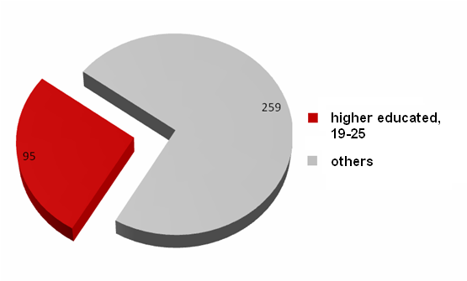
Figure 4. Examinees that belong to the same age group as their examiners – 25%

The fieldwork was conducted during a period of three weeks, from 15th December 2008 to 5th January 2009, mostly during the winter break not only so that it does not interfere with regular classes, but also to enable students who do not live in Zagreb to go home and to interview people from their native home towns, thus making possible collection of data that reflects the above mentioned diversity of examinees.
Students from all parts of Croatia attend the Faculty of Humanities and Social Sciences in Zagreb, and this means that their diverse background has contributed to the diversity of examinees according to geographical and dialectal criteria.
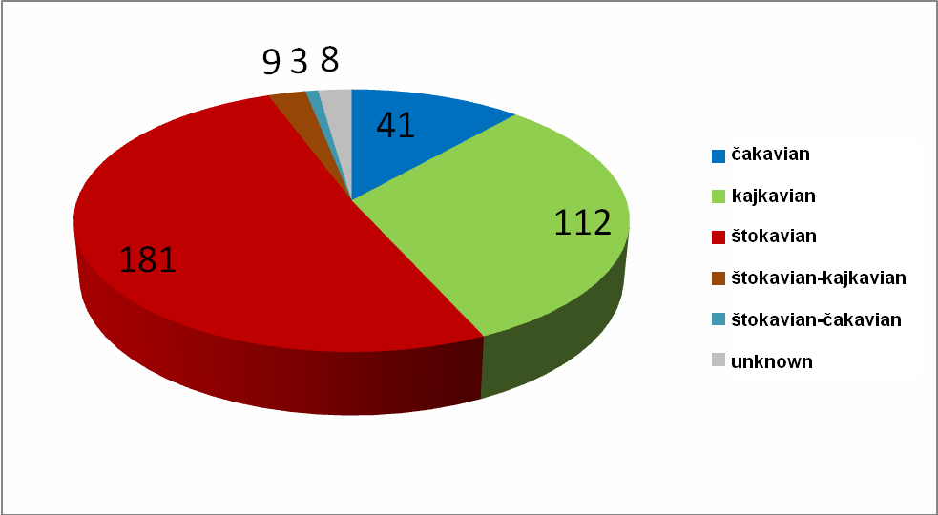
Figure 5. Examinees according to dialectal criteria

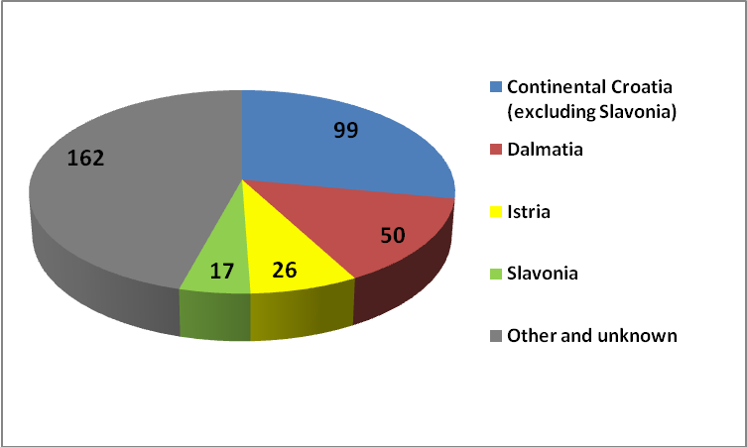
Figure 6. Examinees according to geographical criteria

Data collection was done in principle by answering the questionnaire with the help and supervision of the examiner. When necessary (e.g. poor eyesight or illiteracy of the examinee) the examiner conducted this part in the form of an interview and filled in the questionnaire.

3.2 Research methods verification study

3.2.1 Description

In order to verify the efficiency of fieldwork another, separate, study that examines the methods of our main research was conducted. After the fieldwork was completed, a study that focused on the technical aspects and individual experiences was performed among the examiners. An obvious drawback of this study was the temporal delay that occurred between the actual time when the fieldwork was performed and the time when the examinees (former examiners) were asked to provide approximations for questions such as the time required to answer the questionnaire. The temporal delay was caused by the fact that the instigator of the study (Siniša Bosanac) also participated in the fieldwork. Out of 32 students originally acting as examiners 11 completed the new questionnaire and in total provided data on 72 separate interviews. Purely technical areas of interest in the study include pointers such as the duration and the location of the interview.
Certain other aspects were studied pertaining the measurement of effort on part of the examinees and the extent to which they followed instructions in the fieldwork on Croatian diminutives. These values were determined on the basis of the examiners subjective evaluation on the scale from 1 to 5 where 5 signifies maximum effort and following of instructions.
The duration of a single interview was determined on the basis of the estimation of the examiners, and should be viewed as an approximation. The average time required to complete a questionnaire according to the results from the study was 82 minutes, the minimum being 30 minutes while the longest was around 300 minutes (see Figure 7). The members of the oldest age group took the longest to complete the questionnaire, taking an average of 112 minutes, while the members of the second and the fourth group took around 70 minutes on average.
From this data we can conclude that this phase required roughly 480 working hours in total or 15 working hours per examiner.

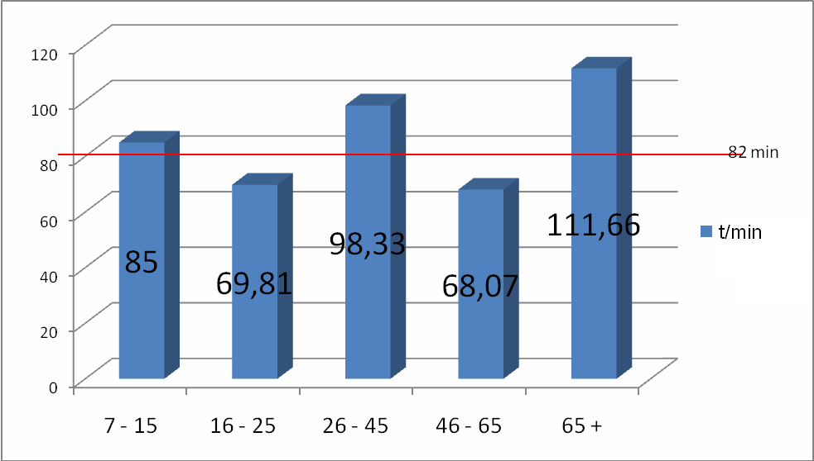
Figure 7. Duration according to age groups

One of the more interesting factors investigated in the study was the relation between the examiner and the examinee. Examinees were divided into four groups – family, relatives, friends and acquaintances (see Figure 8). The aim of establishing this criterion was to determine whether the closeness of the two actors in the interview influenced the quality of the results. The influence of relation on the selection of research subjects is evident by itself and does not require further discussion.

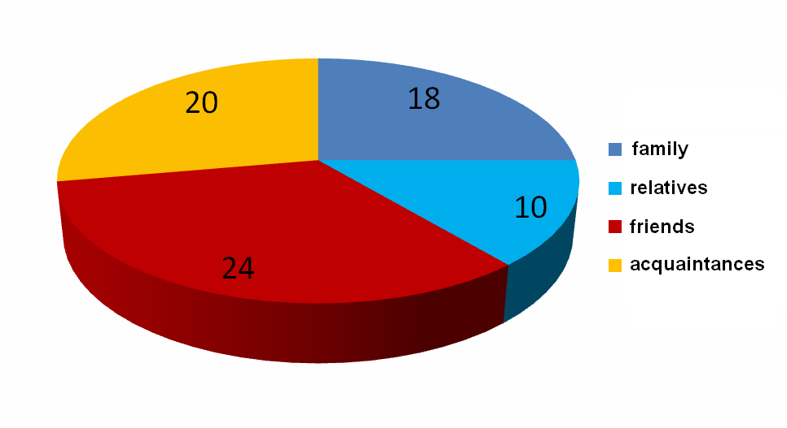
Figure 8. Relationship of the examinees and examiners

The study done after the original fieldwork also contained a section in which the examiners described the most pronounced factors that motivated or demotivated the examinees. Some factors that motivated the examinees were as follows: solidarity with the examiner who had to complete the research as a course assignment (23), solidarity based on family relations (9), material compensation (8), compensation by favors (7), the examinee gladly participates in researches (5), fun and socializing with the examiner (4). Two main demotivating factors were: the significant amount of time required for completing the questionnaire and the fact that examinees found it hard (55) as well as the fear of the examinees that they will be ridiculed because of the incorrect answers (5).

3.2.2 Results of the research methods verification study

According to the results of the study that examines the methods of our main research we can conclude the following:
examiners prefer or have easier access to examinees of similar age level or level of education (see Figure 4). The weak point of this claim lies in the fact that all the examiners are of a similar age and have the same level of education. In order to achieve a higher level of representativeness, it would be necessary to include examiners of different ages and levels of education in the fieldwork.
The examinees that belong to the examiners family (core family group plus grandparents) and acquaintances on average attained significantly lower grades for their efforts as well as following instructions, while relatives (excluding core family and grandparents) were graded best according to these criteria (see Figure 9).

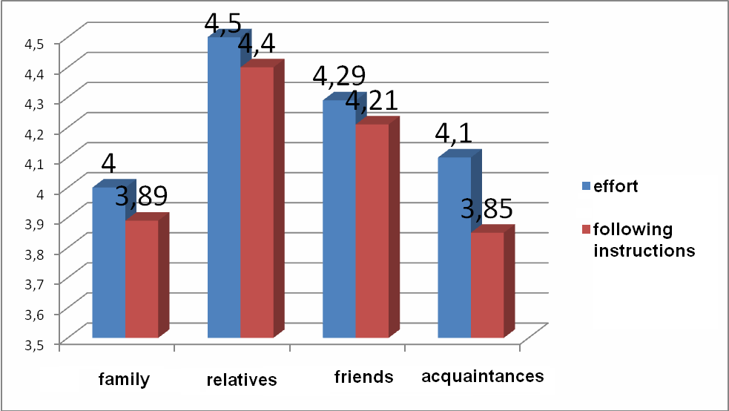
Figure 9. Measures of effort and following instructions according to relation

The location where the interview was conducted also had a significant influence on the above two criteria (see Figure 10). The examinees invested more effort and were more cooperative when they were outside their homes than when they were at home.

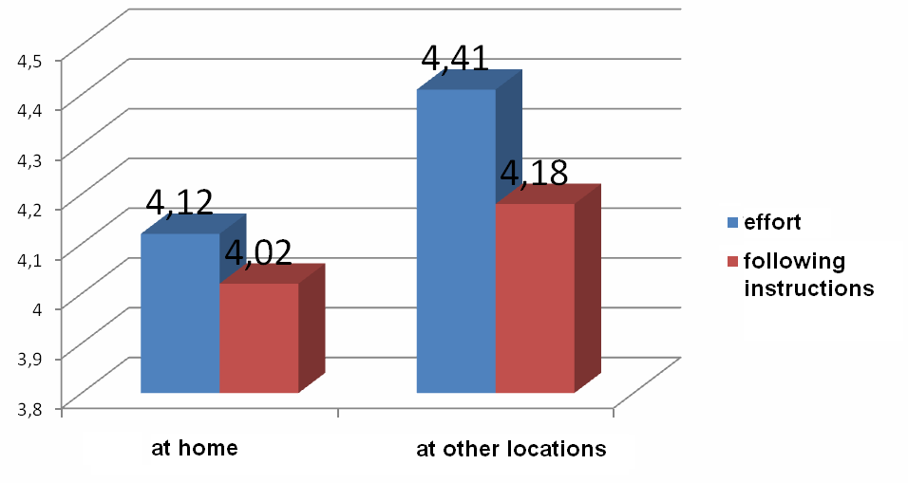
Figure 10. Measures of effort and following instructions according to place of the interview

Sex, age and level of education of the examinees also had significant influence on the efficiency and quality of the interviews (as seen in Figure 11). Female examinees scored higher than the male ones on both criteria. The score on effort is lowest in the youngest age group and peaks in the second oldest age group while the score on following instructions reaches its peak in the intermediate age group (26-45 years of age) and after that decreases with age reaching its lowest value in the oldest age group. According to level of education, the score on effort is significantly lower in the group with just the primary education when compared with those with secondary and higher education while, interestingly, the score on following instructions is highest in the group of examinees with the secondary education and lowest in those with higher education.

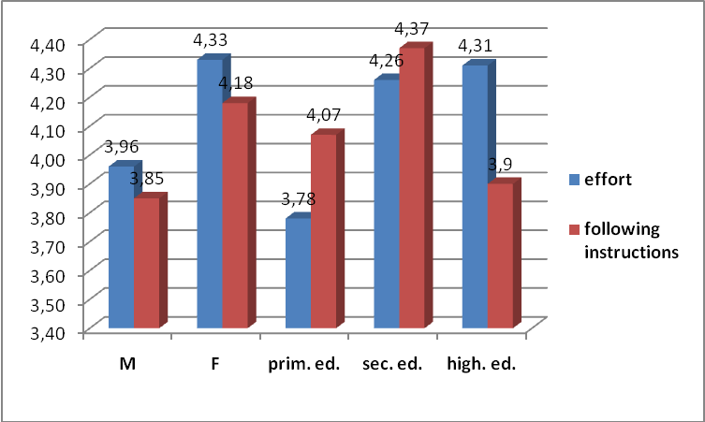
Figure 11. Relation between effort and following instructions according to sex and education

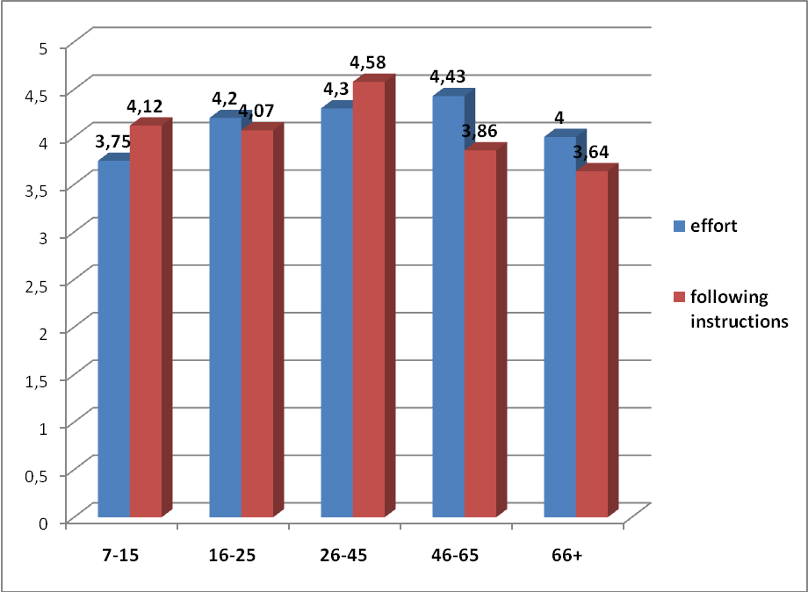

Figure 12. Relation between effort and following instructions according to age
We will not go any deeper in examining the factors that lead to these results pertaining to the fieldwork. The above should be viewed primarily as a description and not as an analysis. In our view the above pointers should be taken in consideration in future research in order to make it more efficient and easier to conduct.

3.3 Processing the data

The first step in processing the data was the digitalization of the questionnaires which required around 30 minutes on average for each examinee, and around 15 hours for building the actual corpus. Every definition of each diminutive was entered into the spreadsheet which enabled easier filtering and sorting of examinees according to the criteria of age, sex, dialect and place of origin. In total around 190 work hours were spent for digitalization alone. The next step following the digitalization was determining the meanings and replacing every definition with a designation within the semantic category. After this the matter of extracting statistical data was rather simple.
Now we will go on to the second phase which is the actual research itself, meaning the actual analysis of the given results and their interpretation.

4. The results

The term diminutive is traditionally used as a word meaning something small or sometimes expressing affection. This is what we most often find in the analyses of Croatian diminutives with the exeption of research done by Pintarić (1996). We have already mentioned that linguists such as Babić (1991), Barić et al. (2003) were primarily preoccupied with the morphology of the diminutives that is word formation. Semantics remained outside of their sphere of interest and only a few basic meanings were mentioned.
Jurafsky (1996) did extensive research on the semantics of diminutive in over sixty languages. His research opened up new vistas for possible meanings of diminutives and some of these “new meanings” can be, according to our data, found in Croatian. The basis of his analysis is grounded on radial categories, a concept originating from Lakoff (1987). Lakoff (1987:84) states that a radial category consists of “a central case and its conventionalized variations which cannot be predicted by general rule” and therefore each must be learned individually. Jurafsky (1996:536) sees Lakoff’s radial categories as an explanation of “the varied and contradictory senses of the diminutive, such as its simultaneous use as an approximating and intensifying device.” In other words, the category of diminutive meanings is polysemous and grounded on metaphoric and metonymic extensions.
We find this polysemous structure very important for the nature of the diminutive and its use in Croatian. However, we will first discuss semantic/pragmatic features necessary in the analysis of the variety of meanings characteristic for diminutives in Croatian.

4.1 Features of meanings

In order to see how diminutives are actually used by native speakers of Croatian, we will employ a linguistic approach of analyzing meaning on the basis of semantic/pragmatic features. in the ensuing analysis we will be referring to features used by other linguists, but we will also be adding some not mentioned so far in the literature, or used in some different sense.
On the basis of the analyzed data, we came up with the following, in our opinion necessary, six semantic/pragmatic features: small, large, affectionate, contextualized, lexicalized and pejorative.
Since lots of examinees ‘defined’ diminutives providing the word a diminutive originates from or did not know how to define particular diminutives, we have decided not to take them into account in our statistics. Those definitions were categorized as neutral.

4.1.1 Small

The well-known general assumption is that the prototypical meaning of the diminutive is small. Our data has confirmed this assumption and this semantic feature is probably basic in the majority of languages. Thus this meaning is always listed the first, as being the most important and sometimes the only meaning of the diminutive. On the basis of our corpus, it is quite obvious that the native speakers of Croatian feel it very much to be the prototype and use it in this way in the majority of cases (48%). We will, however, try to show that small is, besides physical smallness, as well as very closely related to short temporal duration, as well as to processes of low intensity or poor quality, and the young of an animal, as well as the small part of something (partitive sense).We believe that all these semantic features are very much related in the mind of a speaker and we will attempt to illustrate this.
Short temporal duration is a very common meaning of diminutives according to Taylor (2003:173) because the abstract notion of time can very easily be broken into smaller pieces, at least in the western tradition. We divide time into smaller units every day (years into months into weeks, days, minutes...), so it is not unusual that we also use diminutives to describe something that takes up less time than something else. Some examples are: godinica (‘short year’), kavica (‘short coffee’), pićence (‘short drink’), sanak (‘short sleep’).
The meaning of low intensity or poor quality refers to both abstract and non-abstract entities. This semantic feature includes diminutives such as smiješak (‘light smile’) and sanak (‘light sleep’), which refer to something not fully actualized. For instance, sunašce (‘light sun’) and plamičak (‘light flame’) refer to the Sun or flame which does not emit enough light or warmth. This semantic feature was proposed by Taylor (2003) based on the case of Italian diminutives. However, it should be stressed that he employed this feature of low intensity and poor quality for adjectives and verbs. In our case, we are dealing with diminutives of nouns having meanings that can be explained as ‘having low intensity or poor quality’ in Croatian.
According to our data, people often define words such as konjić (‘small horse’), ježek (‘small hedgehog), prasence (‘piglet’) as young and not strictly small. For example, people defined konjić as both poni (‘pony’), which is an adult animal but physically small, and as ždrijebe (‘colt’), which is a young of a horse. As shown, there is an obvious connection between the young and the small since young animals are usually small.
Partitive meaning has a direct link to physical smallness since a part of something is smaller than the whole. Jurafsky (1996:555) illustrates this semantic feature on an example from Yiddish in which a diminutive of the word sand means a grain of sand. According to our results, we found that the partitive meaning exists in Croatian also. Examinees defined diminutives as grančica (‘small branch’ – ‘small part of a branch’), jezičac (‘small tongue’ – ‘part of a shoe’), krvca (‘small blood’ – ‘drop of blood’), komadić (‘small part’ – ‘small piece of something’), komadičak (‘small part’ – ‘small piece of something’) as partitive. For instance, krvca was often defined as krvna zrnca (‘blood cells’) or kap krvi (‘drop of blood’), grančica as dio grane (‘part of a branch’), jezičac as dio vage (‘part of a scale’) and so on.

4.1.2. Large

The next feature we found is the one that denotes big size, that is large. The use of diminutives in this sense has an intensifying effect, which has been noted by some linguists, but can also refer to physical size, which is something we became aware of for the first time. We see the intensifying use as meaning something increased in strength, degree or intensity, and not as an intensifier of diminutivization as found in examples such as komadičak – vrlo mali komad (‘very small piece’) but rather as in sanak which examinees defined as velik san or dubok san (‘deep sleep’).
According to the data, some examinees can see particular diminutives as augmentatives, that is, as physically large. For instance, the diminutive mravac was defined as veliki mrav (‘large ant’) or grmečak as veliki grm (‘large bush’), jezičac as veliki jezik (‘big tongue’) etc.

4.1.3 Affection

The next semantic/pragmatic feature that is also very frequent is the so-called affectionate use by which we express closeness, tenderness and intimacy towards someone. Analysis of the data indicates that affection is sometimes directly connected to the semantic feature of small (the speaker mentions small along with affection – mala slatka ruka (‘cute small hand’), malo drago dijete (‘dear small child’), so here we can see the direct link from which the affectionate use probably came to exist in the first place. We perceive small things as cute, non-threatening, kind. As Taylor (2003:174) explains, “[h]uman beings have a natural suspicion of large creatures, while small animals and small children can be cuddled and caressed without embarrassment or fear”. However, sometimes affection did not seem to be connected to size at all: prasence (‘piglet’) – izraz od milja za debelu osobu (‘affectionate expression for a corpulent person’), milijunčić (‘small million’) – izraz od milja za milijun (‘affectionate expression for a million’). In these cases we see that the semantic feature of affection has derived from the meaning of small (emotions = size) but has through time lost this connection and nowadays we conceptualize it against the domain of affection with no correlation to size. According to Taylor (2003:174), this semantic feature detached itself from the prototypical category of diminutives through the processes of metonymic transfer.

4.1.4 Contextualized, associative and stylistic

Following frequency, the next semantic feature, or in this case determinant, is what we call contextualized meaning. This feature refers to explanations of diminutives which cannot be defined as having a specific feature.
This feature does not have the semantic connotations as the previous ones, but we think it is important to mention it since it reflects an important linguistic mechanism. We have noticed that quite often speakers do not know how to define a diminutive outside of syntagmatic context. What happens in actual fact is that they supply context rather than providing a specific definition. For example, tračak (‘small ray’) was often “defined” as tračak nade (‘ray of hope’). The collocation tračak nade is so frequent that the examinees were unable to deal with tračak outside sentential context, i.e. as a diminutive of the word trag (‘trail’) which is actually is. Other examples are the “definition” of puteljak (‘small path’) which in one case was defined as okretaljka- mjesto za okupljanje lokalne mladeži (‘a place of gathering for adolescents’), or jezerce (‘small lake’) “defined” as malo zaleđeno jezero na koje u proljeće dolaze patke (‘small frozen lake where the ducks come in the spring’), or hrpica (‘small pile’) “defined” as hrpica sranja (‘pile of shit’), šećer rasipan slučajno u ormariću (‘sugar spilt accidentally in the cupboard’), etc.
A subgroup of this phenomenon contains “definitions” provided through indirect context or associations. We believe that this feature gives an important insight into the way people conceptualize the world around them. They recognize entities that are linked to something from their personal experience, that is, through association they place a word in a context through which they can conceptualize it, for example ogledalce (‘small mirror’) is often connected to the story of Snow White. This implies that they understand some words through their connection to specific semantic properties, as for instance, in the case of djevica (‘virgin’) in which the meaning nevinost (‘innocence’), čistoća (’purity’) is dominant, while the once basic menaing mlada djeva (‘young girl’) is practically non existant.
The diminutives can sometimes be seen as a stylistic device. In this sense they represent a subdivision of contextualized meaning. Our examinees often felt that some words, such as danak (‘small day’), jezerce (‘small lake’), krvca (‘small blood’) etc, were rare and stated that they were stylistically marked, and most often found in literary texts.

4.1.5 Lexicalized

The other common linguistic mechanism which we find in Croatian as well as other languages can be referred to as lexicalized meaning. This is the case when diminutives through the development into specialized meaning no longer denote their once basic meaning referring to the meaning of the word they originated from, but rather become an independent lexical item.
For example, words such as djevica (‘virgin’), rukavac (‘small sleeve’), danak (‘small day’), igrica (‘small game’), kvačica (‘small hook’) no longer mean something small, but djevojka bez seksualnog iskustva (‘girl with no sexual experience’), ogranak rijeke (‘effluent’), porez (‘tax’), igra za kompjuter (‘computer game’) and štipaljka za rublje (‘clip’), oznaka za točan odgovor (‘tick mark’) or dijakritički znak (‘diacritic’) respectively.

4.1.6 Pejorative

The next semantic/pragmatic feature is pejorative meaning. Pejoratives are used when we want to express either a low opinion of someone or something, or a feeling of pity or dismissal of something as being unimportant or irrelevant. Some diminutives are obviously pejorative, while others are not. For instance, novinarčić (‘small reporter’) is recognized as pejorative by most examinees, i.e. as derogatory for a reporter, as in examples such as loš novinar (‘bad reporter’), pogrdno za novinara (‘derogatory for a reporter’), or as insignificant beznačajan novinar (‘insignificant reporter’), nepoznati novinar (‘unknown reporter’) and, as Grzegorczykova (1984) names it, taunting, posprdno za novinara (‘taunting for a reporter’). We also found other diminutives mostly defined as being pejorative in državica (‘small state’) and feljtončić (‘small feuilleton’). It is very difficult to claim whether this phenomenon is either semantic or pragmatic and we can only agree with Langacker (1987:147) when he states that “...the distinction between semantics and pragmatics is basically a matter of degree and descriptive convenience.”
Following Langacker’s thoughts, other diminutives are not as transparently pejorative, such as godinica (‘small year’) which is defined as nevažna, nebitna godina (‘insignificant year’), and grmečak (‘small bush’), defined as kržljav, mali grm (‘small scraggy bush’). These diminutives can be interpreted contextually in some instances as pejorative, while is others they simply mean small.

5. Discussion

The results presented so far indicate that the variety of meanings occur in everyday use of diminutives. Interestingly enough, examinees sometimes provided more than one meaning for a diminutive and occasionally some of them even subcategorized these meanings. This indicated to us that we were dealing with a complex semantic network or a category as defined in cognitive linguistics as in for instance, as Langacker (1999:4) puts it, a lexical item with more than one meaning is a “complex category [...]. These senses comprise a network, being linked by categorizing relationships [...]”. Furthermore, he states that “a lexical item is not thought of as incorporating a fixed, limited, and uniquely linguistic semantic representation, but rather as providing access to indefinitely many conceptions and conceptual systems, which it evokes in a flexible, open-ended, context-dependent manner.” Taylor (2002:197) also states: “For most concepts, we need to make reference to more than one domain for their full characterization”.
The previous analysis of Croatian diminutives shows that diminutive morphology can be analyzed on the basic of semantic/pragmatic features. After gaining insight into the meaning structures of the diminutive, we also studied patterns of occurrence and noticed some correlations between specific parameters, for instance age, education etc.
We can see from the analyzed data that diminutives are polysemous in nature, as is a large part of vocabulary. Polysemy is a lexical-semantic phenomenon which can be defined as “variation in the construal of a word on different occasions of use” (Croft, Cruse: 2004). This is why context is required for a native speaker to categorize and transport meaning from one domain to another. As Taylor (2003:87) puts it, “[…] context dependence had to do with the syntagmatic and paradigmatic relations between items within the linguistic system, i.e. the context for the definition of a meaning was internal the language itself”.
It should be noted that the preceding analysis of diminutives in Croatian confirms basic cognitive claims about the relationship of meaning and linguistic structures, such as the well known postulate put forward by Langacker (1987:12) “Meaning is what language is all about...”, as well as his claim (1987:99) that “Semantic structure is conceptualization tailored to the specifications of linguistic conventions.”
Apart from basic claims of cognitive grammar, the previous analysis indicates the existence of a semantic network of related senses or, as is called, a category. The basic tendency on which this category is grounded is semantic and pragmatic features, or at times, a combination of both. Our aim was to indicate and pinpoint the basic features necessary for describing the category of Croatian diminutives and not so much to give a detailed structural account of the category itself.
It should also be noted that our examinees, in order to define one meaning of a diminutive, placed or imagined diminutives in a specific context or occasion of use, and according to that context explained what a diminutive means. Since context can vary, of which our examinees were aware, they provided us with more than one meaning for each instance. This would in a sense confirm Jurafsky’s idea that diminutives have a radial structure. He believes that diminutives have a central case meaning (a prototype) and non-central cases originating from the central case and motivated by it in unpredictable ways. What is unpredictable is that the peripheral cases are always motivated by the central meaning, but cannot be predicted from the prototype unilaterally.
On the basis of the data, we can also see that some meanings of the diminutive are learned later than others. Lexicalized and pejorative meanings of some diminutives are good examples of this. Since their meanings can be apparently contradictory, the only explanation that ensues is that meanings are learned through convention and culture. Examples for this are words such as kavica (‘small coffee’), which can have a literal meaning, small meaning, or it can transform into lexicalized meaning through association and be defined as druženje s prijateljima uz kavu ili bilo koje drugo piće (‘meeting friends for a coffee or any other drink’). The word igrica (‘small game’), which can have its meaning of small as in kratkotrajna igra (short game), is lexicalized into video igrica or kompjuterska igra (‘video game’ or ‘computer game’). It can also have a pejorative meaning of spletkarenje (‘scheming’). Diminutives comprise of a central sense or prototype, that is, small, and can develop conceptual extensions of sense, as illustrated by the above examples.
Some meanings most often occur in particular age groups. For instance, the meaning large primarily occurred in the youngest age group, while lexicalized and pejorative do not appear. The occurrence of pejorative and lexicalized meaning increases with age and level of education (see Figure 13). We could say that particular meanings are learned and adopted later in life.
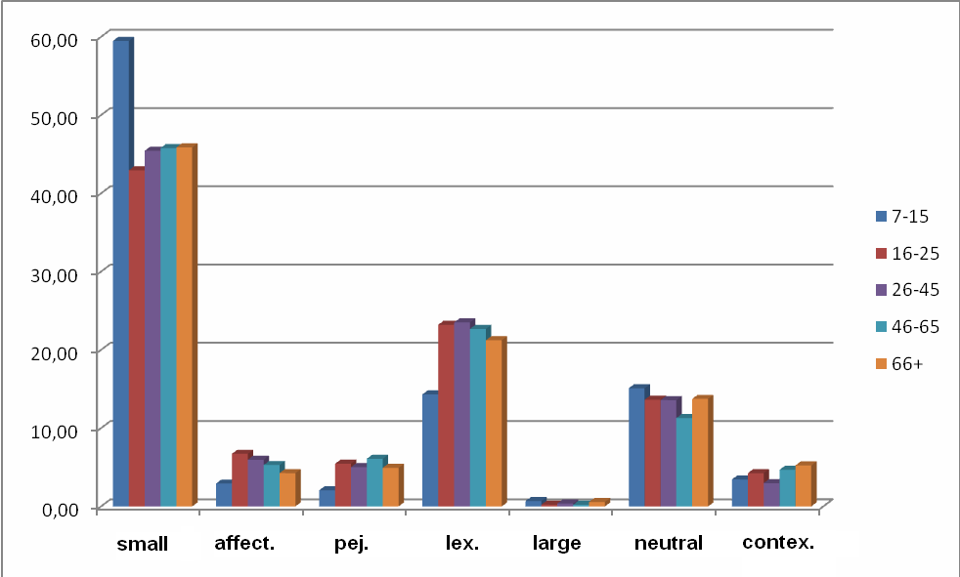
Figure 13. Meaning according to age groups.

Diminutives are a grammatical, morphological category, whose basic meaning small is based on the basic domain of physical size. It is interesting to see how various meaning expand to more abstract domains and create a polysemous structure. Furthermore, it is interesting to see how various meanings are acquired and used. In order to illustrate this, we have decided to divide all previously mentioned features into simple and complex.
By a simple feature, we refer to those meanings that rely on a basic domain. These can be the domains of physical size, duration or emotion. Since these domains are basic, apparently, they are learned first, as evidenced by the research results. This can be seen from the research results.
The results obtained according to features of meaning will be viewed from the various parameters used in the fieldwork, such as age, level of education, sex, etc.

5.1 Small

The youngest age group used mostly the domain of physical size (whether small or large). For instance, the meaning small is most frequent in this group, that is, it occurs in 60% of cases compared to the 48% of the whole corpus. In other age groups, the percentage is similar to the percentage of the whole corpus, i.e. approximately 45%.
Simple meaning diminutives as brežuljak (‘small hill’), brdašce (‘small hill’), rukica (‘small hand’) etc. were most often defined as small with very few variations (see Figure 14). This meaning occurs in all the age groups and is so frequent that it occurs even in diminutives where it was not expected. For example, the diminutive rukavac was recognized as a small sleeve in as much as 12% of cases in the whole corpus, even though its meaning is ogranak rijeke (‘effluent’). In the first age group this number rises up to 38%. Such results may be explained by factor of age and education. The number of cases in which this word was defined as small fell drastically with higher level of education.
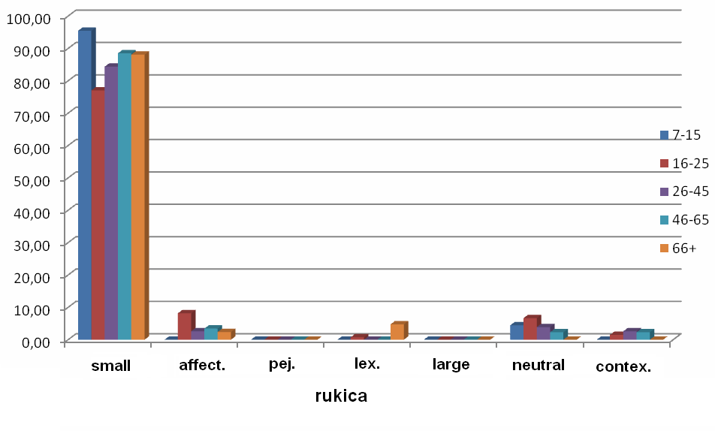
Figure 14. Rukica

5.2 Large

When a diminutive was defined as meaning something large, it was usually defined by a member of the youngest age group. Diminutives defined as such are mravac (‘small ant’), milijunčić (‘small million’), praščić (‘piglet’), puteljak (‘small path’), selašce (‘small village’), kavica (‘small coffee’), smiješak (‘small smile’), darak (‘small day’), igrica (‘small game’), komadić (‘small piece’), trbuščić (‘small belly’), vrtić (‘small garden’), grmečak (‘small bush’) and jezičac (‘small tongue’). The occurrence of this meaning in the whole corpus is 0.4% while in this group it is 0.7%. This category was the one that surprised us most since it was not expected to occur and other Croatian linguists have never mentioned this dimension when dealing with the semantic background of diminutives. This is probably because no fieldwork was done among the native speakers of Croatian. We believe the reason for such a view lies in the phonetic characteristics of the words themselves, but this has yet to be explored. As Babić states in his Tvorba riječi u hrvatskom književnom jeziku (1991): “The suffix –(a)c is practically non-productive as a diminutive suffix” and this may be the reason why it was not recognized as marking a diminutive, but it was sometimes perceived as meaning large. Most striking were the results for the word mravac (‘small ant’) which was often defined as large, male or strong (see Figure 15a and 15b).
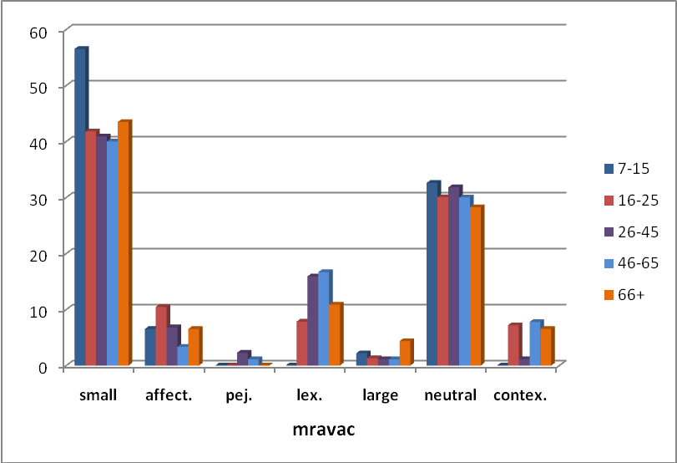
Figure 15a. Mravac
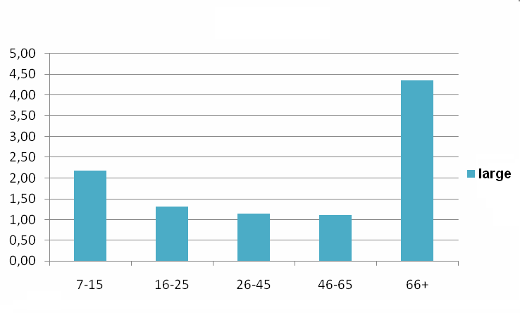
Figure 15b. Mravac – meaning large according to age groups

5.3 Affection

The meaning of affection often occurred in correlation to small. For instance, the diminutive djetešce (‘small child’) was very often recognized as connected to emotions, and not only size. Our examinees identified it milo malo dijete (‘small dear child’). The diminutive sunašce (‘small sun’) is however one of the diminutives most recognized as bearing this emotional dimension, but through the process of metonymic transfer, and is mainly used in addressing children. It was recognized in the first age group, yet not as much as the domain of physical size (see Figure 16). This does not mean that the members of the youngest age group do not express emotions through language, but rather that they are not aware of this emotional dimension of diminutives. According to the corpus, affectionate meaning occurs in 3% of cases in the first age group, while in the whole corpus it occurs in 5% of cases.

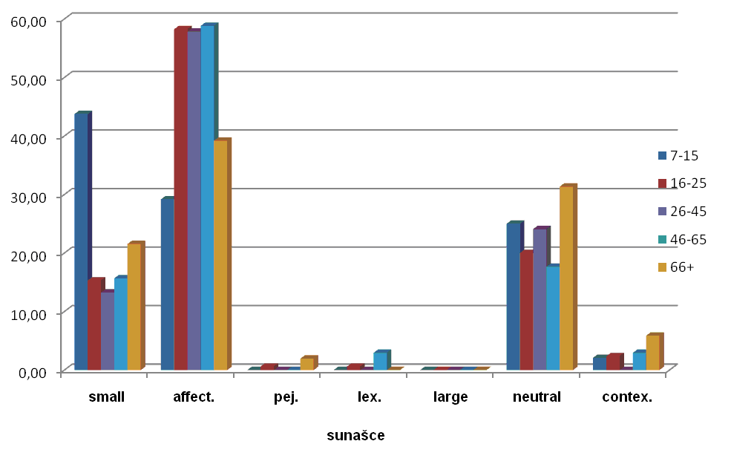
Figure 16. Sunašce

5.4 Lexicalized

The feature of lexicalized meaning was not usually recognized by the first age group, which is not surprising considering that lexicalized meaning must be learned, that is, each lexical item must be learned separately. According to the theory of radial categories, this meaning is also motivated by the central case meaning, but in a highly complex way.
It is interesting to note that within the first age group the diminutive most often recognized as bearing lexicalized meaning is igrica (‘small game’), meaning video igrica (‘video game’), igra za kompjuter (‘computer game’), compared to other diminutives which have lexicalized meaning, yet were not recognized as such. Also, younger age groups recognized this word as lexicalized in approximately 31% of cases, while the older age groups (fourth and fifth age group) recognized it as such in 23.5% and 16% of cases. This is probably due to the fact that older people are not as familiar with computer technology as the younger are.
This example could be seen as being in the process of lexicalization. Its connection to the original meaning is still seen, but with the development of technology it could lose this original meaning and specialize for the computer sphere. A similar process can be observed in the diminutive kavica (‘small coffee’), which still bears the meaning of physically small or temporally short, but was also very often defined as standing for a particular social ritual of spending time with friends in a café.
Lexicalized meaning occurs in the first age group in 4.7% of cases, compared to 5.7% in the whole corpus.

5.5 Contextualized meaning

Examinees used context when they found it difficult to define certain diminutives. In the first age group it occurs in 2% of cases compared to other groups where the percentage is approximately 4%. This proves that more complex meanings are learned through time which also presupposes experience and education. The members of the youngest age group probably do not use as many words as other groups and therefore could not place certain diminutives into a context as did the other examinees.
Words as listić (‘small leaf’), daščica (‘small plank’), grupica (‘small group’) etc. were often defined through a context, for example, they were defined as listić za klađenje (‘betting ticket’), daska za rezanje (‘cutting board’), grupica studenata (‘small group of students’) respectively. The word listić (‘small leaf’) was especially interesting because not only was it most often defined through a context, but the context varied with respect to sex. For example, our male examinees defined the diminutive as related to specific male activities such as betting, while female examinees defined it through domestic activities (listić za klađenje (‘betting ticket’) vs. listić želatine (‘leaf of gello’) (see Figure 17).
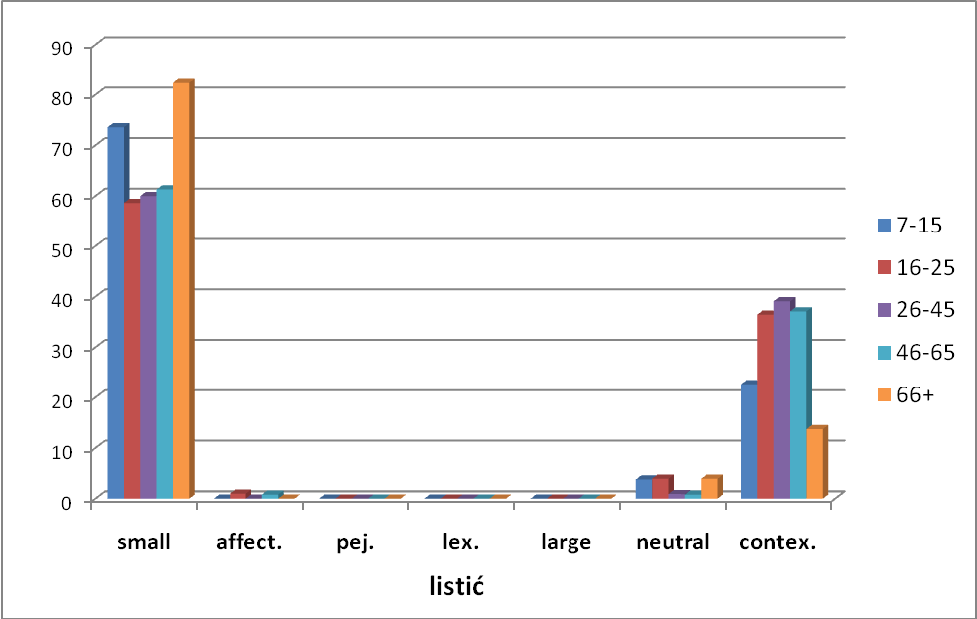
Figure 17. Listić

This category is the one that shows how strongly semantics and pragmatics are linked. Some linguists, as Leech (1983:6), claim that pragmatic meaning is “defined relative to speaker or user of the language, whereas meaning in semantics is defined purely as a property of expressions in a given language, in abstraction from particular situations, speakers, or hearers.” But, as we have already mentioned, Langacker sees the difference between them as a matter of degree. Our data confirms Langacker’s claim. The meaning of the word can be defined only considering language both internally and externally, as used by its speakers. Speakers, by using intrinsic properties of language and combining it with their world knowledge, are those that give words their meaning.

5.6 Pejorative

This category is also one of the more complex ones. It reflects the convention of the usage of diminutives in the sense of indicating lesser level of importance or relevance. This category is also acquired later in life, since all conventional meanings are acquired in successive stages of language acquisition. This explains why the youngest age group used this meaning less frequently or did not recognize it at all. The best example for this category is diminutive novinarčić (‘bad reporter’) which occurs as pejorative in 70% of cases in the whole corpus, while in only 36% among the youngest (see Figure 18). Pejorative meaning occurs to a lesser degree in the lower level of education groups also, showing once again how education and age are one of the most important factors when it comes to the more complex categories of meaning.

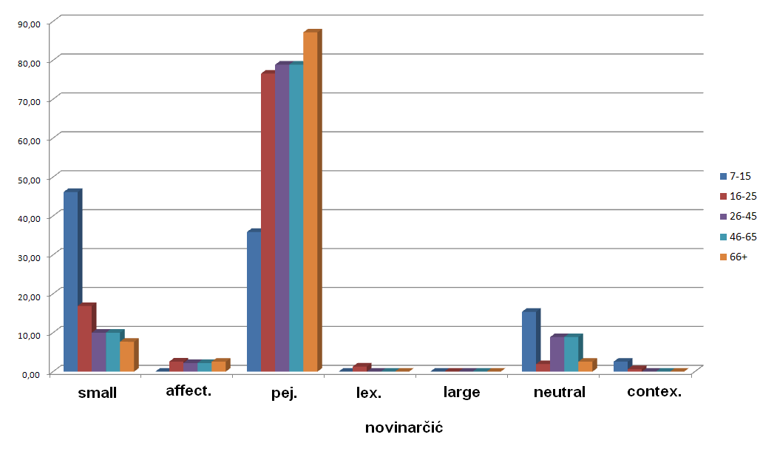
Figure 18. Novinarčić

6. Conclusion

In this paper, we have tried to show the complexity of meanings structures found in diminutives in Croatian, some of which have not previously been acknowledged.
The intermeshings of semantic/pragmatic features mirrored in the various meanings of the diminutive category indicate the high level complexity of the semantics of Croatian diminutives. The various parameters of this research provide insights into how meanings extend from the prototypical central meaning, and show a possible approach for a better understanding of complex semantics networks. Diminutives as such are just an example of how the world is shaped by our experiences and ability to categorize, and this ability is reflected in language structures.
We have identified six basic semantic/pragmatic features on the basis of sixty diminutives, as used by 354 native speakers of Croatian. Some of these have been proven to be more complex than the others, and the data shows that they are learned later in life.
Our contention is not that these six features exhaust all possible meaning variants of Croatian diminutives. On the contrary, we believe that more research should be done on the subject, and hope that Croatian diminutives will one day receive a thorough interpretation and explication.

7. Acknowledgements

Many thanks to our dear professor and mentor dr.sc.Milena Žic Fuchs who provided the idea for the research and inspired us to conduct further study on the subject, and to her assistant Marija Kraljević who contributed to the development of the questionnaire.
Many thanks to our colleagues who took part in the fieldwork.
Special thanks to all the good people who were interviewed for the purposes of this research and willingly allowed us to take a peek into their minds. The data they gave us are of big significance and make up a corpus that could be used in further research on Croatian diminutives.

8. Literature

1. Anić, Vladimir (1998) Rječnik hrvatskoga jezika. Novi Liber, Zagreb
2. Babić, Stjepan (1991) Tvorba riječi u hrvatskom književnom jeziku. Globus, Nakladni zavod, Zagreb
3. Barić, Lončarić, Malić, Pavešić, Peti, Zečević, Znika. (2003) Hrvatska gramatika. Školska knjiga, Zagreb
4. Croft, William and Cruse, D. Alan (2000) Cognitive Linguistics. Cambridge University Press.
5. Jurafsky, Daniel. (1996) Universal Tendencies in the Semantics of the Diminutive. Language, vol. 72, No. 3
6. Langacker, Ronald W. (1999) Grammar and Conceptualization. Mouton de Gruyter, Berlin.
7. Langacker, Ronald W. (1987) Foundations of Cognitive Grammar, Stanford University Press.
8. Lakoff, George (1987) Women, Fire and Dangerous Things, University Chicago Press.
9. Leech, Geoffrey N. (1983) Principles of Pragmatics, Longman Group Limited, New York.
10. Palmović, Marijan (2007) “The Acquisition of Diminutives in Croatian”, in Savickienė, I. and Dressler, W. U. (eds) The Acquisition of Diminutives, A cross-linguistic perspective, John Benjamins Publishing Company, pp 73-78
11. Pintarić, Neda (1996) “Odnos umanjenica i umilnica u hrvatskome i poljskom jeziku”. Strani jezici No. 1-2: 36-46
12. Taylor, John R. (2002) Cognitive Grammar, Oxford University Press.
13. Taylor, John R. (2003) Linguistic Categorization, Oxford University Press.
14. Žic-Fuchs, Milena (1989) “Osnovna obilježja oslovljavanja u Zagrebu”, SOL 7, 1:27-38
15. Žic Fuchs, Milena (1991) Znanje o jeziku i znanje o svijetu, Filozofski fakultet, Biblioteka SOL, Zagreb
9. Appendices
9.1 Appendix 1 – Questionnaire
9.2 Appendix 2 – Research methods verification study questionnaire
9.3 Appendix 3 – Corpus screenshot 1: Digitalized questionnaires
9.4 Appendix 4 – Corpus screenshot 2: Definitions marked as meanings
9.5 Appendix 5 – Corpus screenshot 3: Results represented as statistical data

Spol:

9.1 Appendix 1 – Questionnaire
Dob:
Stupanj obrazovanja:
Dijalektalna pripadnost:

1. Koje je značenje navedenih riječi? Nabrojite sva moguća značenja pojedine riječi
- brdašce
- brežuljak
- cjevčica
- čovječuljak
- danak
- darak
- daščica
- djetešce
- djevica
- državica
- feljtončić
- godinica
- gradić
- grančica
- grmečak
- grupica
- hrpica
- igrica
- jajašce
- jezerce
- jezičac
- ježek
- kamiončić
- kavica
- knjižica
- kolačić
- komadić
- komadićak
- konjić
- krvca
- kvačica
- listić
- ljestvica
- milijunčić
- mravac
- novinarčić
- nožić
- ogledalce
- otočić
- paketić
- pićence
- pjesmuljak
- plamičak
- prasence
- praščić
- ptičica
- puteljak
- putić
- ručica
- rukavac
- rukica
- sanak
- selašce
- smiješak
- strančica
- sunašce
- tjelešce
- tračak
- trbuščić
- vrtić
- zamotuljak
2. Ovaj se zadatak sastoji od tri koraka:
a) Od svake od navedenih riječi napravite što više različitih umanjenica.
b) Različite umanjenice nastale od iste riječi označite brojevima ovisno o stupnju njihove uobičajenosti i učestalosti (umanjenicu koja vam je uobičajenija i češće ju upotrebljavate označite brojem 1).
c) Navedite značenja svake umanjenice (kao u prvom zadatku).

- anđeo
- crv
- cura
- cvijet
- dječak
- djevojka
- krevet
- kuća
- noga
- oblak
- pjesma
- sin
- soba
- stvar
- šuma
- zvijer
Podaci o ispitaniku
- Spol: M / Ž (obilježiti)

9.2 Appendix 2 – Research methods verification study questionnaire
- Dob : ____
- Obrazovanje: OŠ / SSS / VSS (obilježiti)
- Prebivalište ____________, Županija__________________________________
- Povezanost s ispitivačem (npr. prijatelj, rodbina, poznanik) – kratak opis:
________________________________________________________________

- Ispitivanje
- Lokacija ispitivanja (npr. u ispitanikovu domu, u vašem, u kafiću...) ___________
- Ispitanik je sam ispunjavao: DA / NE (obilježiti)
- Trajanje ispitivanja (procjena + opis prema potrebi):________________________

- Motivacija
- Da li se još netko nalazio u prostoriji prilikom ispitivanja ____________________
- Vaša procjena truda ispitanika (1-5)* ____
- Vaša procjena pridržavanja uputa (1-5)**_____
- Kojih se uputa najmanje pridržavao (kratak opis)
__________________________________________________________________
- Kako ste motivirali ispitanika na sudjelovanje (kratak opis)
__________________________________________________________________
- Što je ispitanika najviše zanimalo o ispitivanju (kratak opis)
___________________________________________________________________
- Što je po vašem mišljenju ispitanika najviše motiviralo/demotiviralo kod ispunjavanja ankete
____________________________________________________________________
D) Osobni dojam i pristup – ispunjava se jednom
- Vaš dojam - što je najučinkovitije motiviralo ispitanike za sudjelovanje u anketi (npr. to rade da vam pomognu, naknada, unaprjeđenje znanosti...)
_________________________________________________________________________
- Kako ste pristupali ispitanicima – kako ste objasnili zašto radite ovo ispitivanje (kratak opis)
_________________________________________________________________________

* prema procjeni ispitivača koliko se ispitanik trudio u usporedbi s drugima (1 – ispunjavao samo da što prije obavi, 3 – uložio je prosječan trud, 5 – ispitanik je bio izrazito zainteresiran i trudio se prisjetiti što više definicija/umanjenica
** prema procjeni ispitivača - 1 – ispitanik nije ispunjavao sva polja, nije odvajao različite definicije, u zadnjem zadatku nije ispunio sva 3 dijela, pisao „šaljive“ odgovore, 3 – u usporedbi s drugima prosječan broj izostavljanja / krivog upisivanja, 5 – sve ispunjeno prema uputama
NAPOMENA: Upitnik se odnosi na jednog ispitanika. Molim da ispunite najmanje pet upitnika. Odaberite ispitanike koje opisujete tako da pokrijete što više skupina prema dobi i obrazovanju.
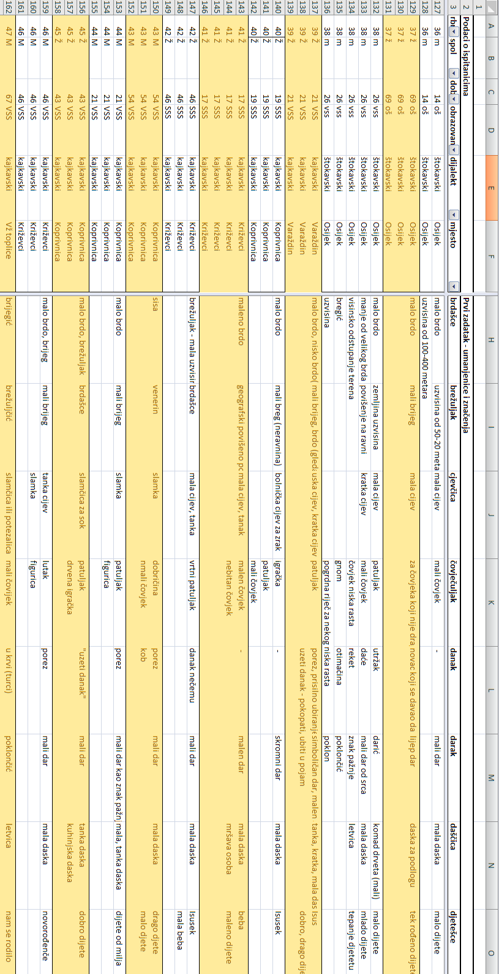

9.3 Appendix 3 – Corpus screenshot 1: Digitalized questionnaires

9.4 Appendix 4 – Corpus screenshot 2: Definitions marked as meanings
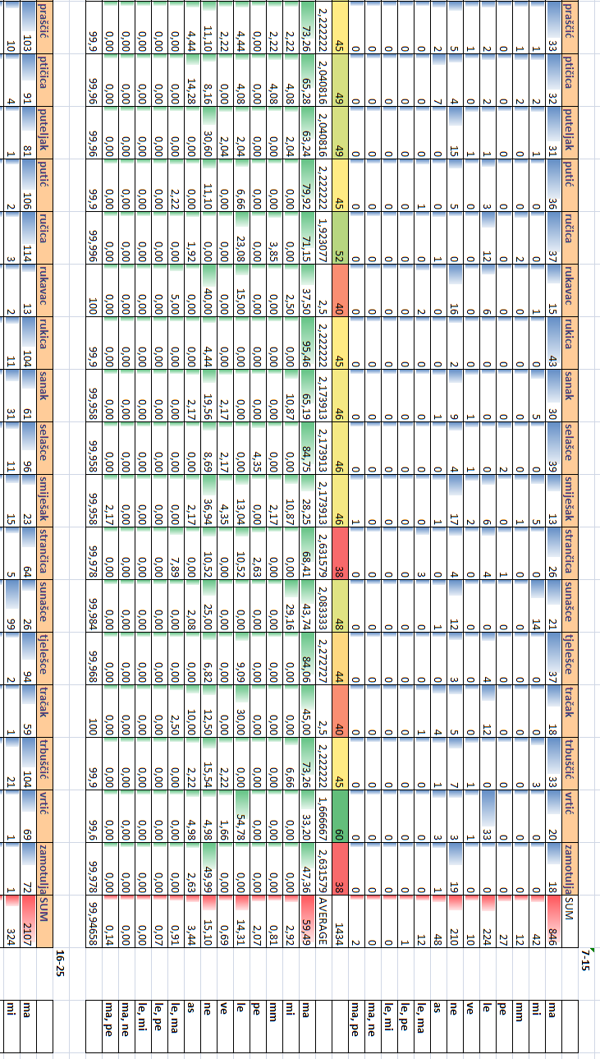

9.5 Appendix 5 – Corpus screenshot 3: Results represented as statistical data

Autori: Siniša Bosanac, Dora Lukin, Petra Mikolić
Naslov: Kognitivni pristup značenjima umanjenica: Značenjska analiza hrvatskih umanjenica
Ključne riječi: umanjenice, hrvatski jezik, kognitivna lingvistika, semantika, pragmatika

Sažetak

Značenjska pozadina umanjenica jedna je od najzanimljivijih, a slabo istraženih područja tvorbe hrvatskog jezika. Cilj našeg istraživanja bio je proučiti kako izvorni govornici hrvatskog jezika doživljavaju i upotrebljavaju umanjenice i na temelju toga opisati njihovu značenjsku strukturu. Empirijski podaci koji su korišteni u istraživanju dobiveni su analizom korpusa umanjenica i njihovih definicija izrađenog na temelju intervjuâ s N=354 ispitanika, obraćajući posebnu pozornost na zastupljenost ispitanika obaju spolova, svih dobnih skupina, dijalektalnih i regionalnih pripadnosti te razina obrazovanja. Dobivene definicije značenja umanjenica podijelili smo na šest glavnih značenjsko pragmatičkih obilježja – one koje označuju malo, veliko, milo, one s leksikaliziranim i one s pejorativnim značenjem te one čija je definicija dana kroz kontekst. Navedene smo kategorije dodatno podijelili prema njihovoj kompleksnosti na jednostavne i složene. Rezultati našeg istraživanja, tj. veća učestalost nekih kategorija u pojedinim dobnim skupinama, pokazali su da na razumjevanje značenja koja smo svrstali u kompleksna utječu čimbenici dobi i obrazovanja. Pokazali smo da je kontekst bitan faktor za razumijevanje umanjenica te da pragmatika kao i semantika igraju ključnu ulogu u njihovom tumačenju. Dobiveni korpus, koji je prvi te vrste, može se koristiti za daljnja istraživanja u području istraživanja značenja umanjenica, kao i u drugim znanostima poput psihologije, antropologije i etnologije.

Authors: Siniša Bosanac, Dora Lukin, Petra Mikolić
Title: A Cognitive Approach to the Study of Diminutives: The Semantic Background of Croatian Diminutives
Key words: diminutives, Croatian language, cognitive linguistics, semantics, pragmatics

Summary
The semantic background of diminutives is one of the more interesting areas of research of Croatian morphology, yet not much attention has been paid to it. The goal of our research was to examine how native speakers of Croatian perceive and use diminutives, and to describe their semantic background. This paper resulted from the analysis of empirical data collected during extensive fieldwork. The corpus consists of diminutives and their definitions, and was built from data collected in interviews with N=354 examinees. The examinees were selected on the basis of an equal distribution according to sex, age, education level, dialectal and regional criteria. The results provided various meanings which we have analyzed on the basis of semantic/pragmatic features. The results give insight into various meanings which we have grouped into various semantic domains. The six main features are – those which denote small, large, affection, lexicalized, contextualized and pejorative meaning. The meanings were further divided according to their complexity into simple and complex. The results of the analysis, i.e. higher frequency of particular meanings in specific age groups has shown that factors such as age and education can influence the understanding of meanings. We have also shown that context is an important factor in defining diminutive meaning, and that pragmatics and semantics play a crucial role in explaining them. The corpus, which is first of its kind, could be further implemented in research in the fields of psychology, anthropology and ethnology.

Pintarić Odnos umanjenica i umilnica u hrvatskome i poljskom jeziku (1996:36): “Uspoređujući umanejenice (deminutive) i umilnice (hipokoristike), može se reći da prve imaju referencijski odnos korisnika prema značenju dimenzija (umanjenih) nekog entiteta, a druge, kako je riječ o odnosu jezik-emocija, iskazuju naš osjećaj kojim “modificiramo” (Grzegorczykowa, 1984:366) neki predmet, biće ili pojavu.”
Barić et al: Hrvatska gramatika 1997:326: ”Umanjenice one su imenice kojima se izriče da je što po čemu manje od onoga što znači osnovna riječ: boca – bočica, grad – gradić. Osnovna je riječ uvijek imenica. Ako je umanjenica motivirana imenicom koja znači osobu, uz značenje ’malo’ dodaje se i značenje ’mlado’: grof – grofić, pastir – pastirić. Umanjenicama se također izriče osjećaj nježnosti i dragosti – h i p o k o r i s t i č n o s t: sinčić, cvijetak, kao i osjećaj prezira, omalovažavanja – p o g r d n o s t ( p e j o r a t i v n o s t ) činovničić, direktorčić.”
Žic Fuchs, Milena (1989): “Nedvojbeno je da postoje velike razlike u frekvenciji i načinu upotrebe standardne štokavštine, odnosno zagrebačke štokavštine i zagrebačkog kajkavskog koinè. Njihova upotreba ovisit će o cijelom nizu faktora, kao što su stupanj obrazovanja govornika, njegova profesija, itd., ali nadasve će ovisiti o mjestu i svrsi govorne interakcije, te društveno uvjetovanim odnosima među samim sudionicima.”
In order to clarify who is who in the actual fieldwork and the study mentioned above it should be stated that the examiners in the fieldwork on diminutives become examinees in the study on fieldwork method efficiency.
For an overview of the basic claims of cognitive linguistics, see Žic Fuchs (1991)
See Palmović (2007) for an account of the acquisition of diminutives in Croatian based on one case study.
Babić.Stjepan (1991): “Sufiks –(a)c praktički je neplodan kao deminutivni sufiks”

