UNIVERSITY OF ZAGREB
FACULTY OF ELECTRICAL ENGINEERING AND COMPUTING

Matija Srbić
REDUCING ACCIDENTAL HOME INJURIES INVOLVING CHILDREN WITH BLUETOOTH SMART SENSORS

Zagreb, 2016
This work was made within Department of Telecommunication under the leadership of Assist. Prof. Vedran Podobnik and it was submitted for Rector’s Award in academic year 2015/2016.
Abbreviations

BLE Bluetooth Low Energy
iOS iPhone Operating System
IoT Internet of Things
JSON JavaScript Object Notation
RSSI Received Signal Strength Indication
Smafe Smart and safe
SQL Structured Query Language
Table of Contents

Introduction 1
1. Background and motivation 3
1.1. Accidental home injuries involving children 3
1.2. Other groups in need of assistance 4
1.2.1. Elders 4
1.2.2. People with Alzheimer’s disease and dementia 5
1.2.3. Blind and visually impaired people 5
1.2.4. Sleepwalkers 6
2. Materials and methods 7
2.1. Market analysis 7
2.2. Parents’ experiences 8
2.3. Contacting experts 8
2.4. Creating and analysing surveys 9
3. Results 12
3.1. Juvo – Home Friend solution architecture 13
3.2. Juvo – Home Friend core technologies 14
3.2.1. Device development 14
3.2.2. Cloud development 15
3.2.3. Mobile application development 17
3.3. Scenario: Using Juvo – Home Friend mobile application 18
3.4. Business potential of Juvo – Home Friend product 21
3.4.1. Pricing and special offers 22
3.4.2. Sales channels 22
3.4.3. Advertising 23
4. Discussion 25
Conclusion 26
Bibliography 27
Summary 29
Sažetak 30

Introduction
Internet of Things (IoT) is next big evolution of Internet [1] and the way people interact with their environment. With appearance and development of microcontrollers and credit-card size computers [2], more and more students work on innovative and creative IoT projects that include those kind of devices.
Many IoT projects are based on distance measurement or presence sensing. Both of these activities can be achieved with new Bluetooth standard (version 4) and new Bluetooth technology (Bluetooth Low Energy, BLE).
This work will research and experiment how reliable and accurate is distance measurement between pair of BLE transmitter and receiver for indoor systems. Also, it will give detailed insight in development of smart and safe (“smafe”) home project based on distance measurement with Bluetooth technology. Project will include:
- distance measurement with Bluetooth sensor attached to Raspberry Pi,
- communication between Raspberry Pi and cloud (Azure),
- communication between cloud and mobile application (Xamarin.Android).
This smafe home project will help to raise awareness and offer a solution for a major problem that in United States silently takes more child’s lives than next three causes combined: unintentional injury [3]. Leaving a child without supervision for just a second can end up tragically.
Even though millions of children are injured in and around their home every year, and thousands of these children die [4], there is no practical, modern and comprehensive solution. For some of these accidents (e.g. drowning) there is even no suitable solution yet.
Every modern parent has a several problems:
- how to raise a (first) child without stress, worry, anxiety, nervousness and panic regarding child’s safety inside their home,
- how to monitor child’s movement and keep it safe all the time,
- how to know when something is wrong with a child and react in time.
The solution that is developed through this project is named Juvo – Home Friend and it helps modern parents to raise their children stress-free, ensuring them calmness and relaxation regarding children’s safety. Also, Juvo – Home Friend monitors their children’s movement in those short moments of inattention. It covers all potential dangerous places for a child and notifies parent when child may be in danger.
Juvo – Home Friend collects data about children’s movement and development that is currently unavailable and unknown. This data has major value for future analysis and research in field of child care, safety and development.
Great potential of this project is also recognized by Microsoft Corporation. This project won on this year “Microsoft IoT Hackathon” in Slovenia, qualified as finalist of “Software Startup Academy”, won “Microsoft Imagine Cup 2016: Hrvatska” competition and qualified as a World Semifinalist of “Imagine Cup 2016”.

Background and motivation
The main reason for such a fast and successful growth of Internet of Things field is price of hardware and Internet communication that is constantly dropping. With constant increase of performances of services and volume of collected data [5], Internet of Things projects are getting more and more creative and diverse.
Even though technology is advancing and new, helpful solutions are developed every day, there is still too many major problems that people are facing too often. One of these problems is childhood death rate caused by accidental injury. What is being even more devastating is that many of these accidents happened in what most people think as a safest place – their own home.

Accidental home injuries involving children
At early age, children are not aware of all dangers surrounding them within the home. Sadly, leaving a child without supervision for just a second can end up tragically.
Every year, millions of children are injured in and around home. Thousands of these children die and the leading cause of childhood death is accidental injury.
Almost all of these accidents had two things in common:
- They happened in just a few seconds of parents’ inattention,
- They were preventable.
Every home consists of many potentially dangerous places for children: power sockets, drawers and cabinets with dangerous (sharp, flammable, poisonous) objects, stairs, kitchen and kitchen appliances, bathroom and balcony, etc.
Most of the homes are not properly secured and lot of the parents are not aware that their child can get injured on so many ways. For securing some of the places in their homes, parents are using many different products.
Juvo – Home Friend is universal product that can cover all dangerous places and increase home safety. Using Juvo – Home Friend smart sensors parents can mark places in their home with sensors that react when child approaches.
Hypothesis is that by using Juvo – Home Friend smart sensors parents will drastically reduce chances of accidental home injury involving their children. Accordingly, childhood death rate caused by accidental injury will be also reduced and that is the main purpose of this project.

Other groups in need of assistance
Juvo – Home Friend is product originally developed to help parents to raise their children stress-free and to keep their home as safe as possible, but it proved to be even more.
Juvo – Home Friend has great potential to expand its services to different groups that need help or assistance. That may be elders, blind and visually impaired people, people with Alzheimer’s disease and dementia, sleepwalkers or similar groups that require continuous or periodic monitoring or they are adjusting to the new situation.

Elders
In 2015, 617 million people were aged 65 or older, and by 2050, there will be 1.6 billion older people worldwide [6]. Sometimes, elders live in separated homes or in nursing homes, away from their families.
If they live in separated home, they are exposed at risk of getting hurt or sick with nobody there to help them. Wearing smart bracelet, that risk is drastically reduced. Smart bracelet can notify their families and emergency services when somethings wrong. Through Juvo – Home Friend project our plan is to develop smart bracelet with those kind of functionalities.
Also, their family needs to be notified if they unplanned leave their home (e.g. late at night). Using Juvo – Home Friend smart sensor, families could monitor movement of their elders.
Nursing homes often have many members of different age group, with different degree of mobility and with various illness. To monitor movement of all of them or only movement of some special members, nursing homes can use Juvo – Home Friend. Using Juvo – Home Friend they wouldn’t need to supervise their members while they are taking a walk or hang out in nursing home area. With Juvo – Home Friend smart sensors on exit gates, they would be notified if member leaves nursing home area.

People with Alzheimer’s disease and dementia
As population getting older, there is more and more people with Alzheimer’s disease and dementia. In 2015, over 46 million people were living with dementia worldwide and by 2050 that number will almost triple [7]. Families of people with Alzheimer’s disease or some other type of dementia often spend a lot of money to give their loved ones a proper care in specialized nursing homes.
With Juvo – Home Friend smart sensors, people with Alzheimer’s disease and dementia would not need to be separated from their families, at least in early stages of disease. Juvo – Home Friend smart sensor can help person with Alzheimer’s disease or any other type of dementia to regularly take medications and to help them with orientation in their home. Also, they could notify family member when person with Alzheimer’s disease or some other type of dementia leave a home.

Blind and visually impaired people
By the last statistics, there is 285 million blind and visually impaired people worldwide [8]. One of the biggest problems for them is how to orient in new, unfamiliar places. Shopping, paying bills, orienting in any new or modified space is big challenge for a blind and visually impaired people and they can’t do it without assistance. Even walking down by very familiar streets could be challenging and dangerous for them if there are roadworks.
Juvo – Home Friend smart sensors can be used to help them. Major institutions that get frequently visited like stores, banks, post offices, hospitals, schools and colleges can mark their interior with Juvo – Home Friend smart sensors to help blind and visually impaired people with orientation. When blind or visually impaired person comes closer to smart sensor, it can give that person directions to desired destination.
Also, whole cities can get “smarter” by using Juvo – Home Friend smart sensors. Juvo – Home Friend smart sensors can give blind and visually impaired people instructions where they currently are and what major institutions, organizations or public services are around. Living in such smart cities, blind and visually impaired people could travel alone and do their daily activities without any assistance.

Sleepwalkers
Sleepwalking is one of disorders that is often underestimated and not taken as serious problem. Many children and some of adults suffer from this behavior disorder. Sleepwalkers can seriously hurt themselves (e.g. falling) or someone else (e.g. assault).
With Juvo – Home Friend smart sensors, parents will be notified if their child is moving close to windows or front door in the middle of the night.

Materials and methods
For purpose of this project, several research methods were used:
- market analysis,
- parents’ experiences,
- contacting experts,
- creating and analysing surveys,
- consulting specialized literature.
To get a detailed picture of accidental home injuries that involve children problem, it was necessary to use as many research methods as possible. These researches led to four big conclusions:
- parents are unaware that accidental injury is one of the leading causes of childhood death,
- most of the parents experienced accidental home injury involving their child,
- parents are afraid that their child could get hurt if it is not supervised,
- parents are willing to use modern technologies to reduce chances of accidental home injury involving their child.

Market analysis
Target market for Juvo – Home Friend product are parents with children under six years old.
Nowadays, more and more highly educated parents are often very busy. Growing trend is that more and more couples have decided to have two or most likely only one baby. It is well-known that parents are more careful and extremely stressful while raising their first child. These “modern” parents are target market for Juvo – Home Friend product.
Product is equally interesting for mothers as well as for fathers. Mothers are usually those who take a lot of care about child’s safety and want to prevent that their child comes to any potentially dangerous situation. On the other hand, fathers do not only take care of child's safety but also love using latest technologies.
Parents that are caring and prone to modern technologies are perfect match for Juvo – Home Friend product.
Due to predictions, global baby care market will be worth $66.8 billion by 2017 [9]. At very beginning, target market for Juvo – Home Friend product would be United States and European Union. According to statistics from 2015, there are 15.036 million households in the USA with children under six years old [10], while due to statistics from 2014, there are 26.194 million of these type of households in European Union [11]. It means that potential market counts 41.23 million households in total.

Parents’ experiences
For research like this, real life stories mean a lot. Several family members were interviewed to tell about their experiences when it comes to accidental home injuries involving children. Also, parents on specialized forums for parenting were also encourage to tell what they think about accidental home injuries involving children, did they experienced it and are they afraid for child’s safety. Several parents told that they constantly monitor their child because they are afraid that it could hurt itself if left without supervision for just a second.

Contacting experts
Roda organization is Croatian organization formed from parents in order to help other parents with their experience, information and advices. This organization was contacted several times but there was no detailed response yet. Only a brief answer about two groups in organization with opposite opinion: half of members think Juvo – Home Friend is good product and the other half is little bit skeptical. They are currently in process of evaluation of Juvo – Home Friend product.

Creating and analysing surveys
Created survey had six yes/no questions and one question with multiple answers. Yes/no questions were:
- Were you aware that accidental injury is one of the leading causes of childhood death?
- Has your child ever suffered from minor injury inside your home?
- Has your child ever suffered from major injury inside your home?
- Do you think your child could get hurt if it is left without supervision?
- Would you use smart sensors to get notified when child is too close to potentially dangerous place?
- Would you use smart bracelet for a child to monitor its temperature, heartbeat and to get notified when something is wrong?
Only 13.6% of surveyed parents were aware that accidental injury is one of the leading causes of childhood death (Figure 1).
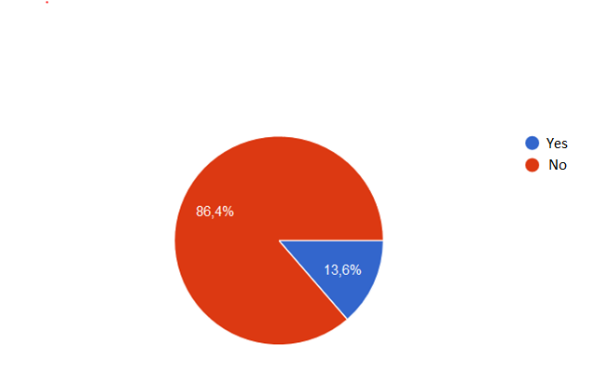
Figure 1 Were you aware that accidental injury is one of the leading causes of childhood death?
As for experiences with child’s home injuries and behavior, many parents’ child experienced minor injury (Figure 2) and smaller percentage of them experienced major injury (Figure 3).
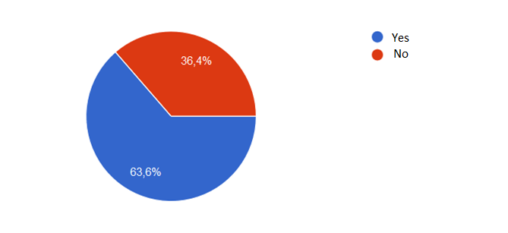
Figure 2 Has your child ever suffered from minor injury inside your home?
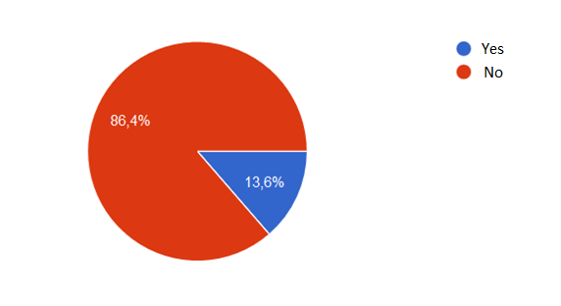
Figure 3 Has your child ever suffered from major injury inside your home?
Even parents whose child didn’t experience minor or major injury think that it could get hurt if it is left without supervision (Figure 4).
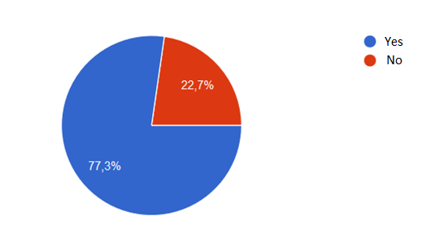
Figure 4 Do you think your child could get hurt if it is left without supervision?
In general, parents are willing to use modern technologies to reduce chances of accidental home injury involving their child (Figure 5) (Figure 6).
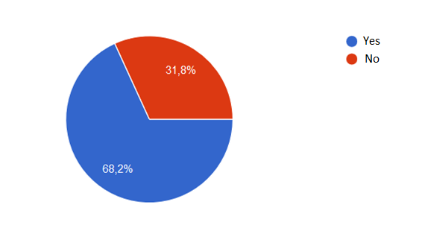
Figure 5 Would you use smart sensors to get notified when child is too close to potentially dangerous place?
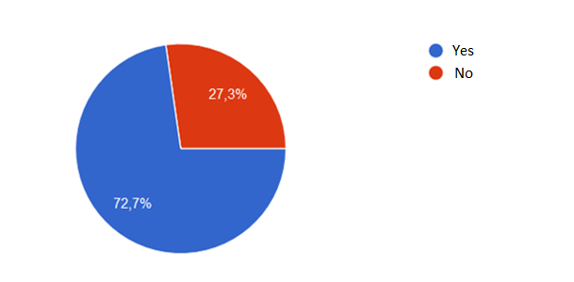
Figure 6 Would you use smart bracelet for a child to monitor its temperature, heartbeat and to get notified when something is wrong?

Results
Result of this project is IoT service Juvo – Home Friend. Juvo – Home Friend is an innovative product that takes care of child's safety and ensures parents calmness and relaxation. Providing them with constant insight into child's movement within their own home, parents can safely perform their daily activities knowing that their child is safe. Name Juvo comes from Latin word iuvō which means help, aid, assist, support and serve.
Using Juvo – Home Friend smart sensors parents can mark the places in their home with sensors that react when child approaches.
The child should wear an object (most practical bracelet), which supports Bluetooth technology, in presence of which the sensors would react. Potential bracelet can be multifunctional and measure the child's temperature, monitor heart rate and so on.
Similar bracelets already exist and are used to monitor the health of patients [12], but in the near future a plan is to develop our own bracelet (or similar object) that would allow parents to monitor their child's health in real time through mobile application.
Juvo smart sensors consist of mini-speaker and technologies for communication with parent's mobile application. Because sometimes it is not possible to react quickly enough, the speaker is required to distract, confuse, alert and prevent the child in its intention, playing an unfamiliar sound or even recorded voice of parents.
Additionally, every parent will be immediately notified through mobile application if their child is in danger.
Key uniqueness of product Juvo – Home Friend is that it is the first product that preventively cares for the safety of children in their most sensitive and vulnerable age, inside their home. Also, it is very important to note that Juvo – Home Friend does not use cameras or video surveillance as a way of babysitting and monitoring the movement of a child. Many people still worry that cameras will invade their privacy.
It is also unique because it collects data that currently no one collects, the data that will be used for various analyzes to get new information about children development and in order to improve the safety of children.
Juvo – Home Friend is special because it has a big humanitarian purposes caring for those who are still unable to care for themselves. In addition, Juvo has great potential to expand its services to different groups that need help. That may be elders, ill, blind and visually impaired people or similar groups that require continuous or periodic monitoring or they are adjusting to the new situation.

Juvo – Home Friend solution architecture
As many other IoT solutions, Juvo – Home Friend consist of sensors (Bluetooth), minicomputer (Raspberry Pi) that collects data from sensors and sends them to the cloud (Azure). Cloud then sends notifications to users through mobile application (Android) (Figure 7).
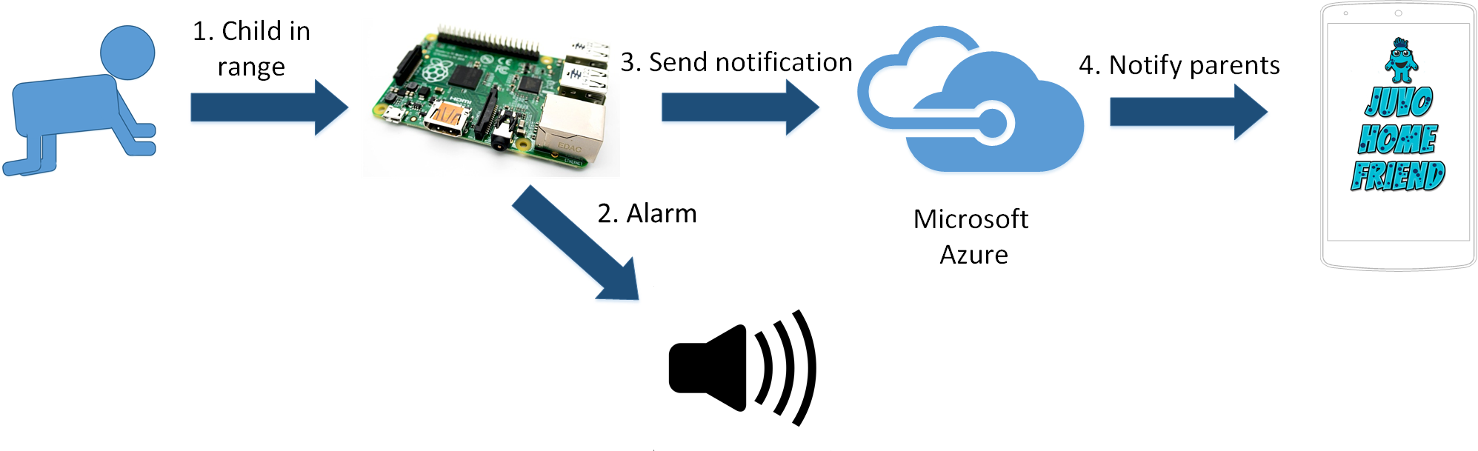
Figure 7 Juvo – Home Friend solution architecture
Sensors are constantly searching for a Bluetooth connection with selected Bluetooth device (e.g. bracelet). If Bluetooth connection is available, Raspberry Pi estimates distance. If selected Bluetooth device is to close, Raspberry Pi activates an alarm, organizes data and sends it to the cloud. Data sent to cloud is in JavaScript Object Notation (JSON) format and consist of device ID, user’s email address and date and time when dangerous event occurred.
{
"deviceId":1,
"userEmail":"john_doe@email.com",
"happenedAt":"04.03.2016 10:20:44"
}

User’s email address is used for sending notifications to only specific user(s) (parents). Device ID is replaced with name that user chose for his sensor (e.g. Kitchen sensor) so user could know which sensor is sending notifications. Date and time of dangerous event will be used for future analysis.
In the cloud data is queried, stored to database and transformed into notification that is then sent to user. Database contains information about all users, their devices (sensors) and about dangerous events that happened in their home.
User needs to be authenticated to start receiving notifications. After first login, user’s email address is registered for receiving notifications. User receives notifications in intervals of few seconds as long as child is too close to dangerous place.

Juvo – Home Friend core technologies
Development of IoT solution Juvo – Home Friend was divided into three parts: device development, cloud development and mobile application development.

Device development
Raspberry Pi 2 Model B with operating system Raspbian and Bluetooth version 4.0 adapter is used for detecting Bluetooth connection (Figure 8).
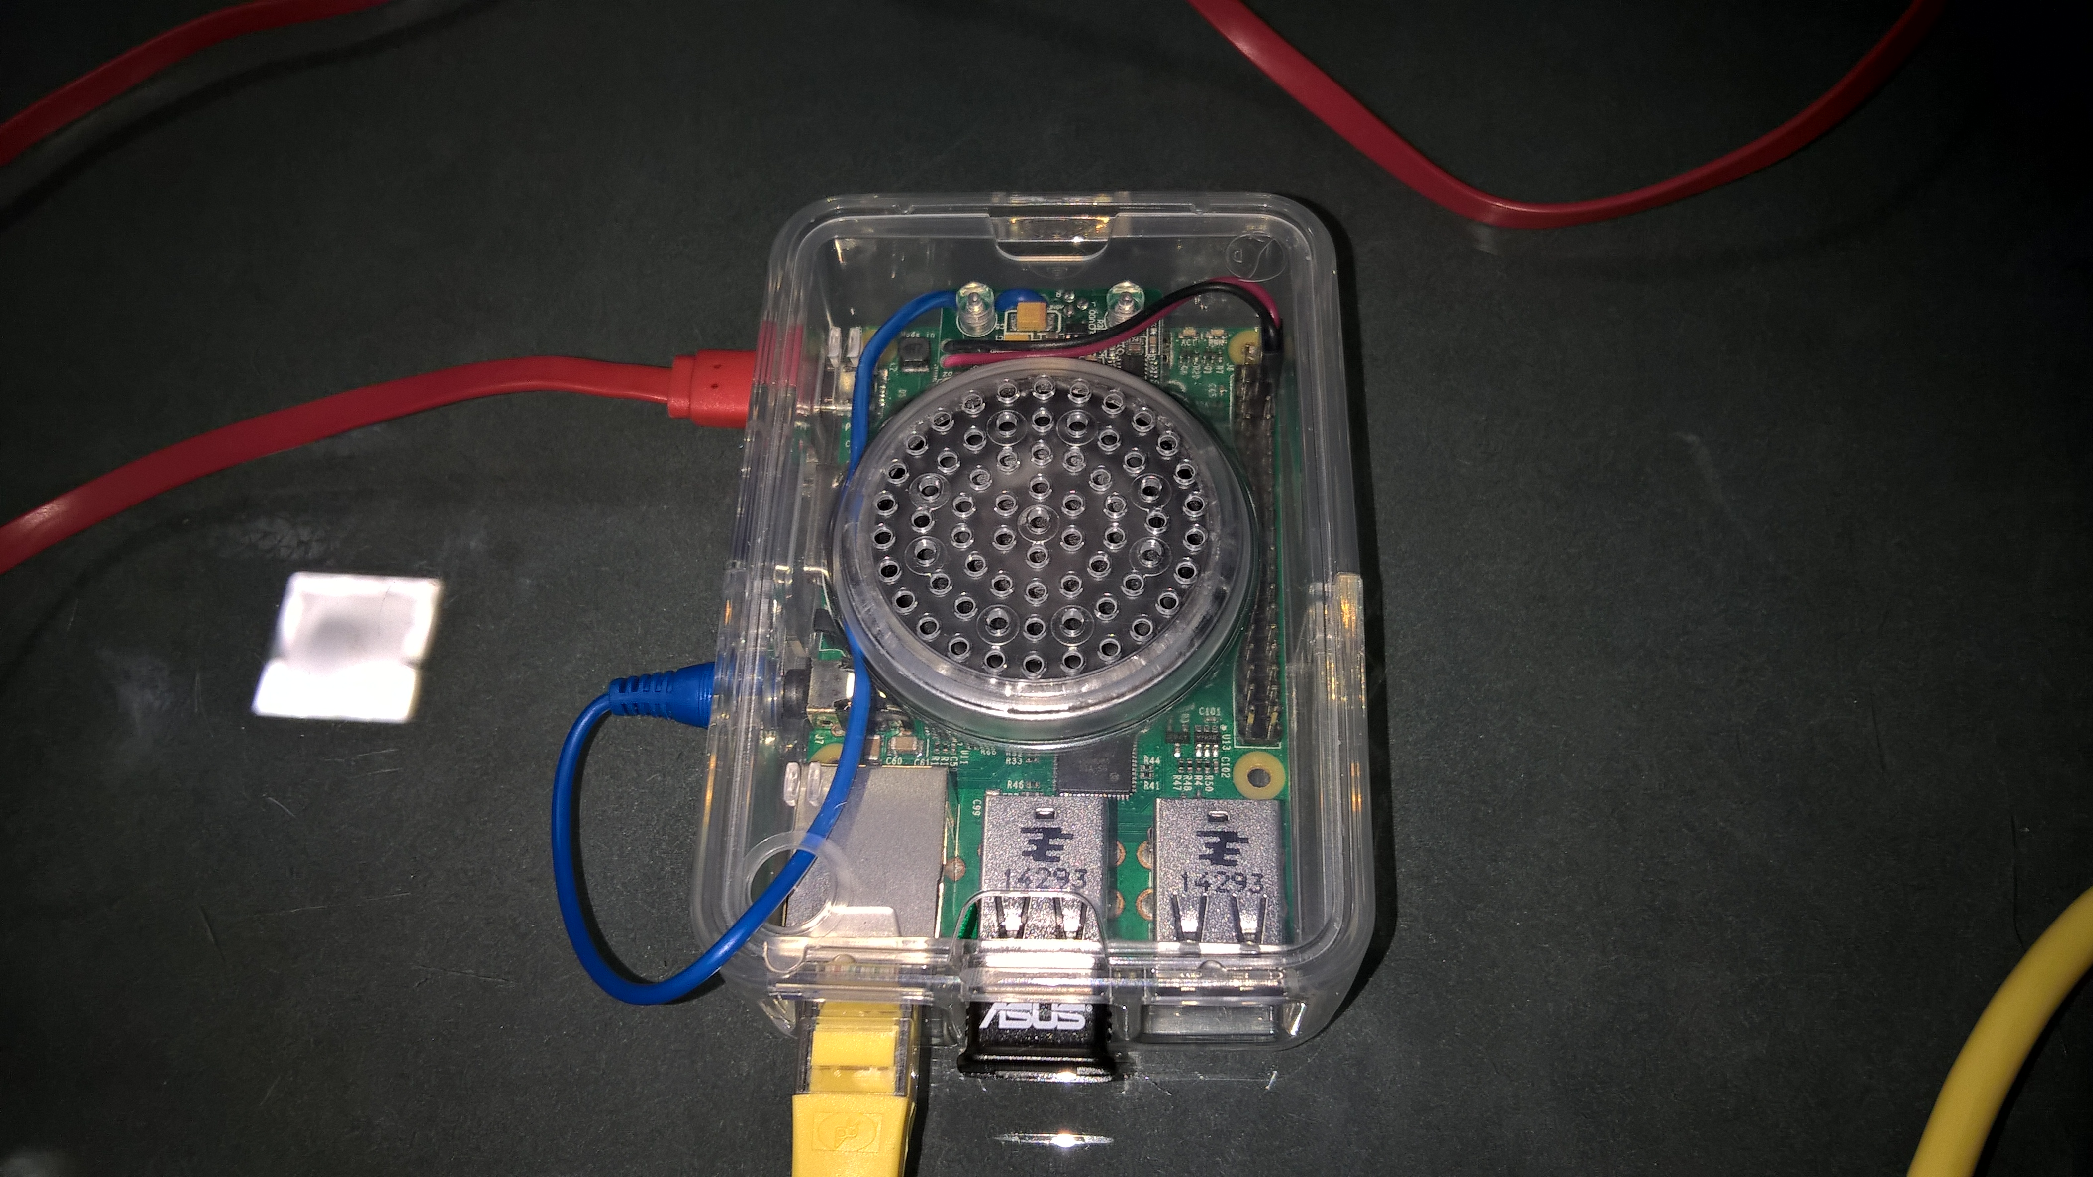
Figure 8 Raspberry Pi 2 Model B with mini-speaker and Bluetooth version 4.0 adapter
After Bluetooth connection is established, Raspberry Pi parses all data received through script written in programming language Python. In Python, received signal strength indication (RSSI) is isolated for estimating distance between Raspberry Pi and targeted Bluetooth device.
Reliability and accuracy of distance measurement between pair of BLE transmitter and receiver for indoor systems still oscillates too much for any precise measurements. But to determine if someone or something is “close” or “far” this method is perfect solution. To achieve more precise measurements, several other methods (like triangulation) could be used [13], but that was not necessary in this project as determination of close/far was good enough.
Using programming language Java, Raspberry Pi communicates with the cloud and calls Python script for fetching RSSI value. If estimated distance between Raspberry Pi and targeted Bluetooth device is too short, Raspberry Pi plays an alarm through mini-speaker and sends notification to the cloud.
Currently Arduino with same functionalities that will replace Raspberry Pi in terms of detecting Bluetooth connection, parsing received data and playing an alarm is being developed. Then Raspberry Pi will be used only for collecting data from several Arduino sensors in one home and sending them to the cloud over Internet. Reason for that is price of these devices – using an Arduino (or even better, only a microcontroller) is lot cheaper than Raspberry Pi. Also, microcontrollers consume way less power and on a simple battery they can last for a very long time [14].

Cloud development
Complete cloud services were developed through Microsoft Azure cloud service. IoT Hub and Event Hub services were used to collect data, Stream Analytics service was used for routing data to database and Notification Hub service. For notification delivery, Notification Hub service was used (Figure 9).
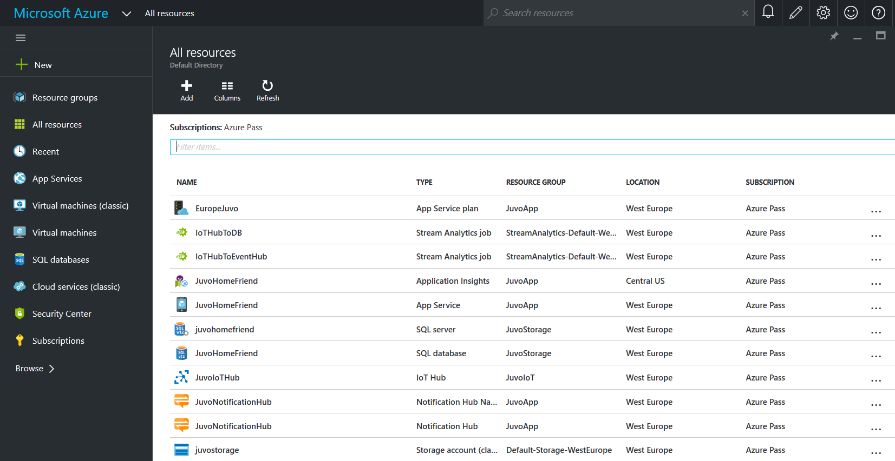
Figure 9 Microsoft Azure cloud services used in project Juvo – Home Friend
Data sent from Raspberry Pi to the Microsoft Azure cloud service is collected through IoT Hub. IoT Hub is perfect solution because it can communicate with millions of IoT devices at the same time [15].
IoT Hub is than used as an input data stream for two Stream Analytics services. Stream Analytics query data in cloud before storing it in database and passing it for new notification.
For the first Stream Analytics service a SQL (Structured Query Language) database is selected as an output. SQL database contains tables users, devices and dangerous_events. All information about users like name, email, password, time zone, number of devices, etc. are stored in users table. Information about devices like device’s name and owner’s ID are stored in devices table. In dangerous_events table are stored information like date and time of past dangerous events and device’s ID on which an event was registered.
Second Stream Analytics service has an Event Hub as an output and queries data from IoT Hub, selecting only data necessary for creating new notification.
Transforming queried data to new notification requires some kind of backend service. In this case, simple .NET console application is used. .NET console application is continuously running as a WebJob on Microsoft Azure cloud service and receives every message that comes on Event Hub. When it receives a message, .NET console application uses Notification Hub for sending notifications to certain users (Figure 10).
To deliver notifications successfully to Android users, Microsoft Azure cloud service is relaying on Google Cloud Messaging service.
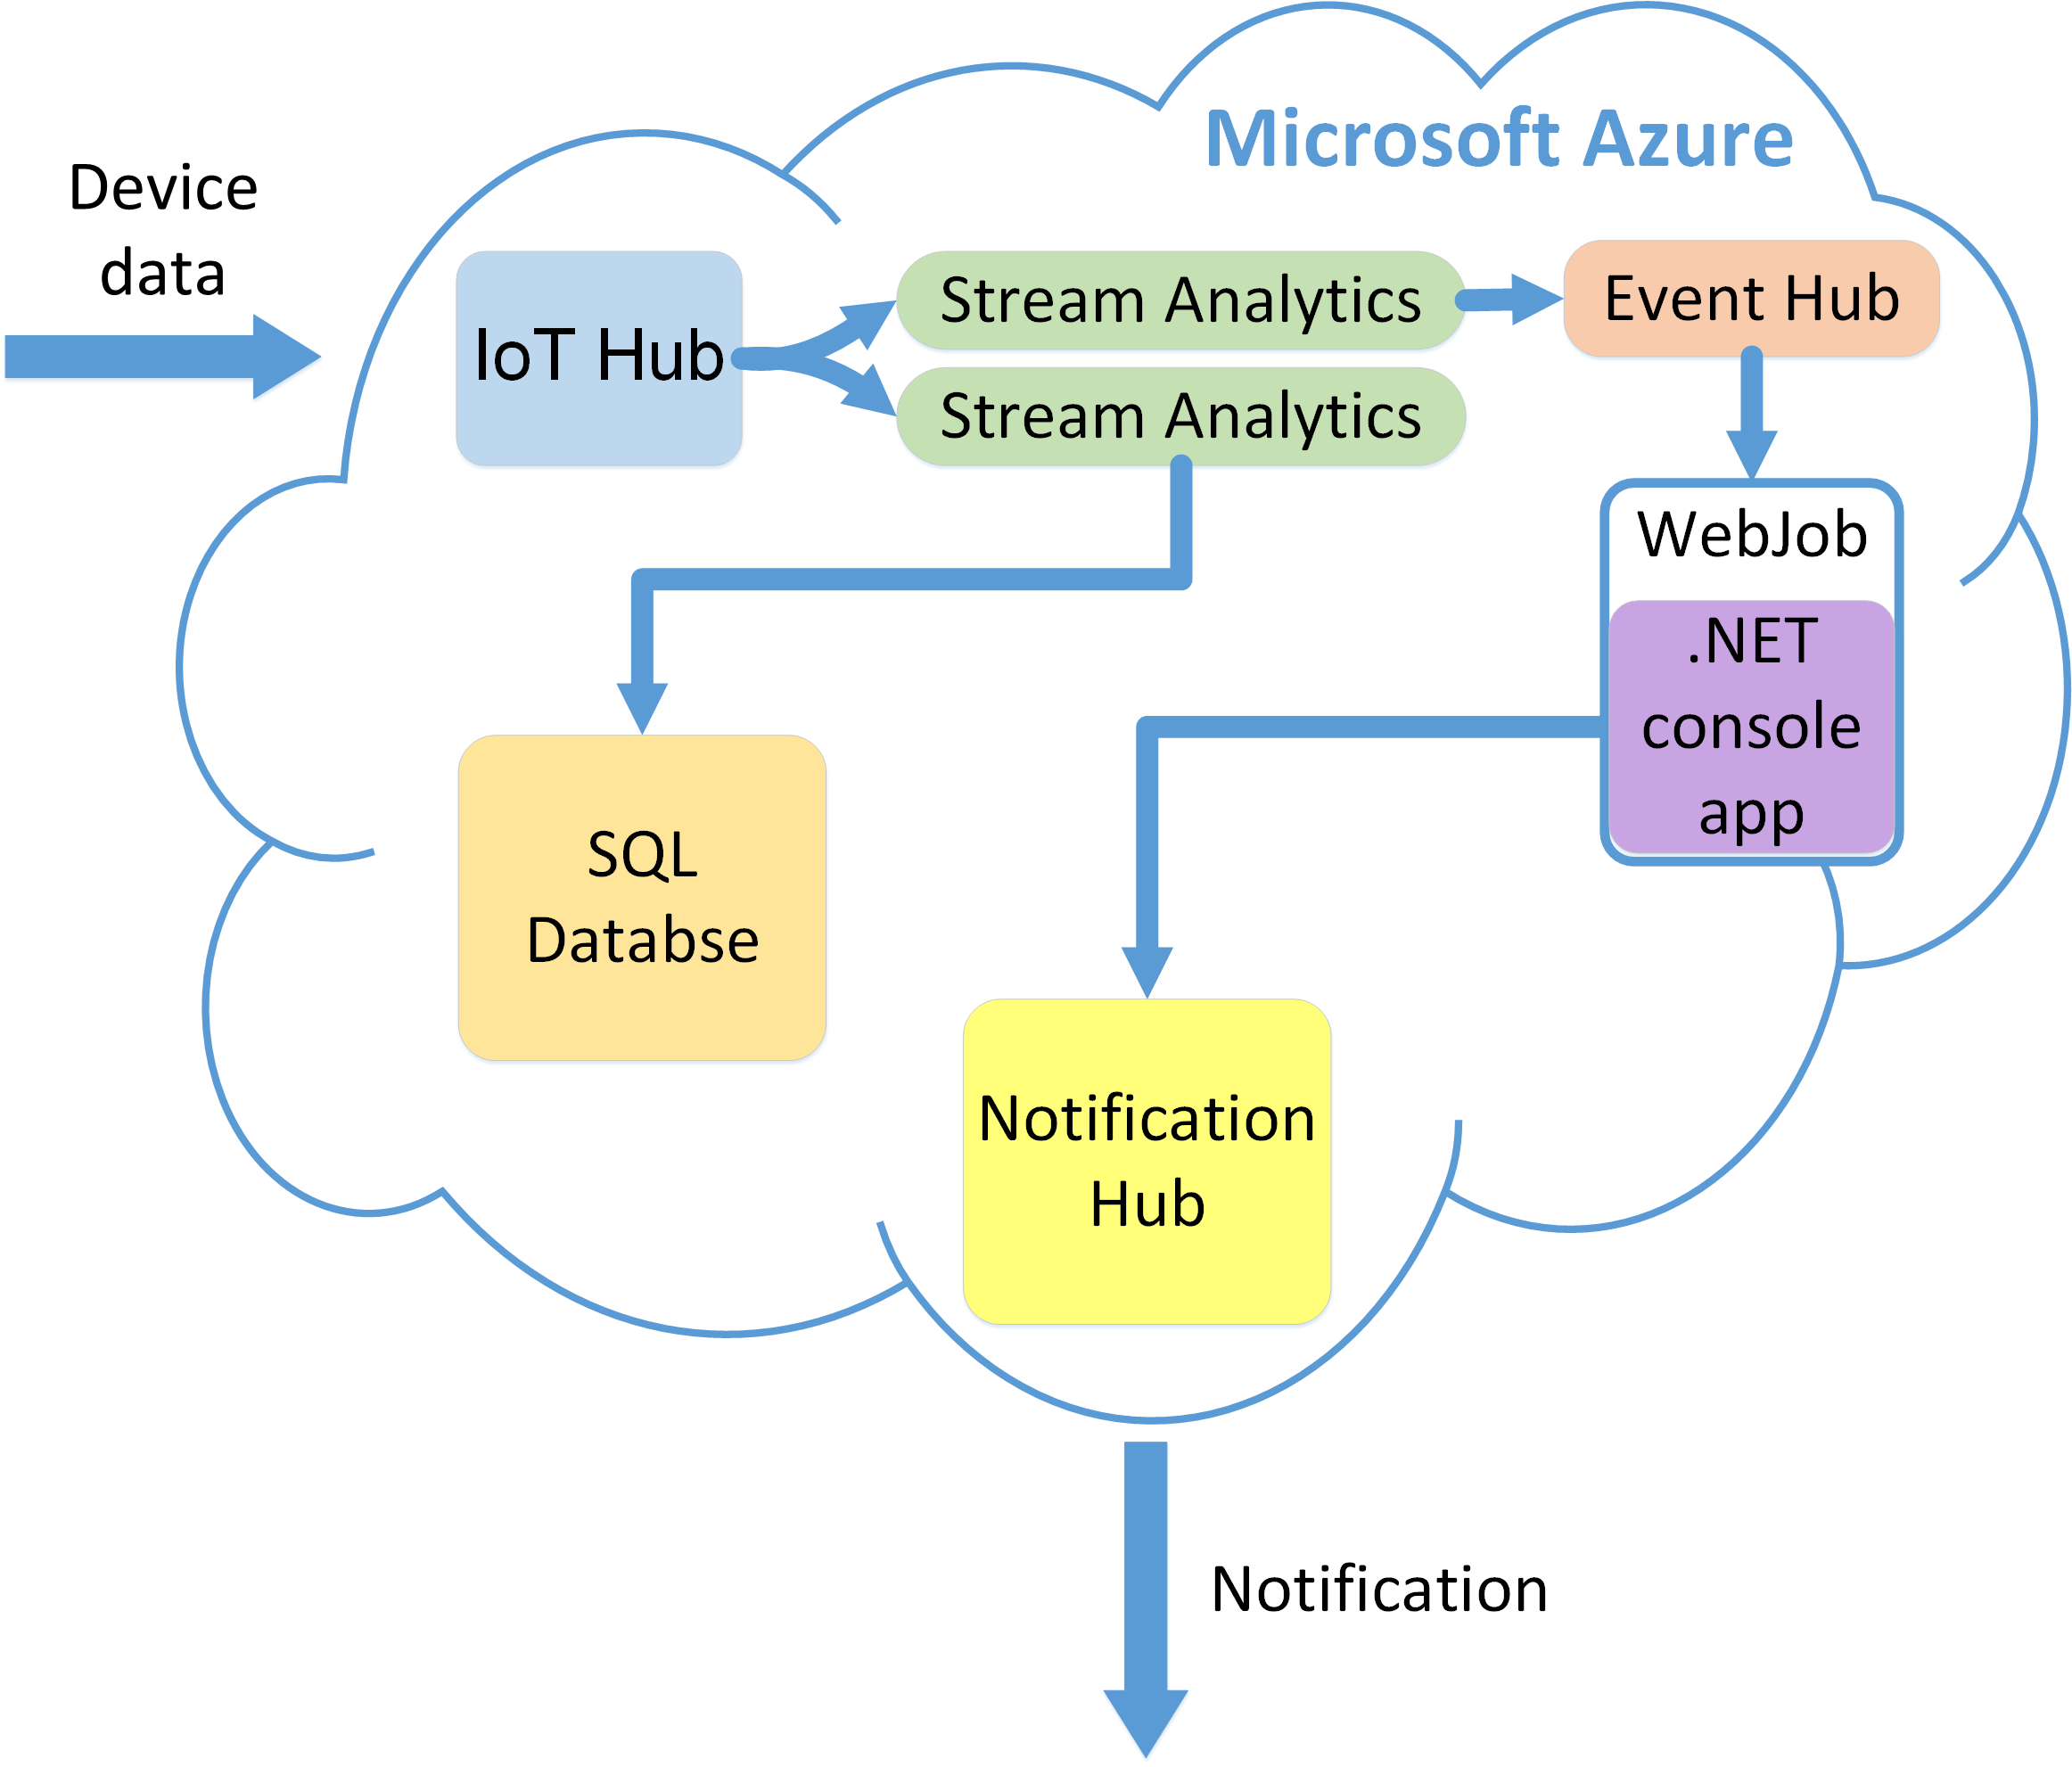
Figure 10 Microsoft Azure workflow for Juvo – Home Friend solution

Mobile application development
All notifications sent from Microsoft Azure cloud service user gets through Android application developed in Xamarin. Xamarin is used because it is a cross-platform development software and it makes easier to develop native Android, iOS and Windows applications.
Developed Android application also uses Google Cloud Messaging service for receiving notifications sent from Microsoft Azure cloud service.

Scenario: Using Juvo – Home Friend mobile application
User starts using Juvo – Home Friend mobile application by clicking on “Juvo – Home Friend” icon on his smartphone. After that, login screen is shown (Figure 11).
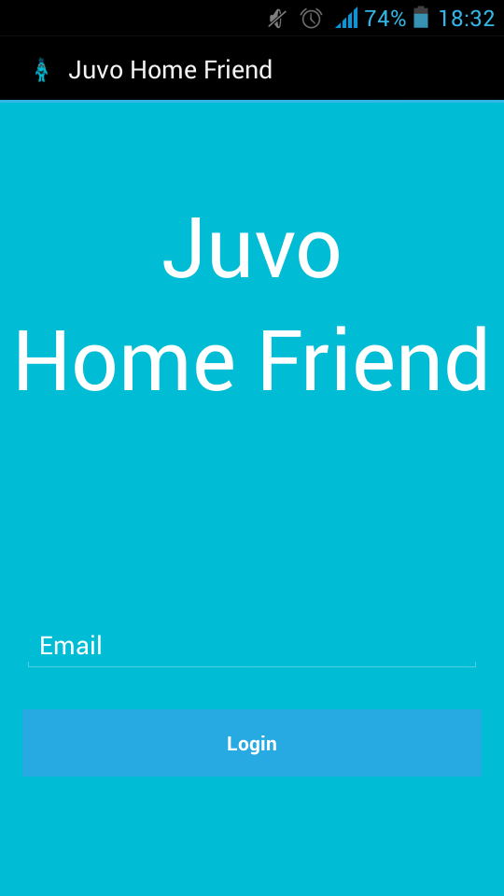
Figure 11 Juvo – Home Friend login screen
User needs to type in his email address and press “Login” button (Figure 12).
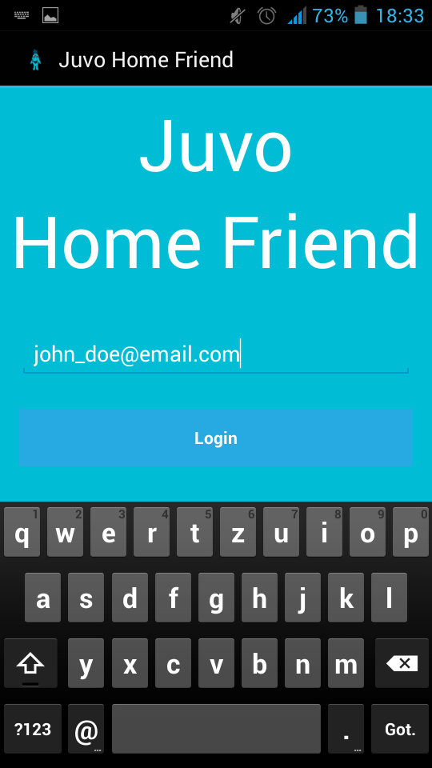
Figure 12 Juvo – Home Friend login
On successful login, user will see history of all dangerous events in his home (Figure 13).
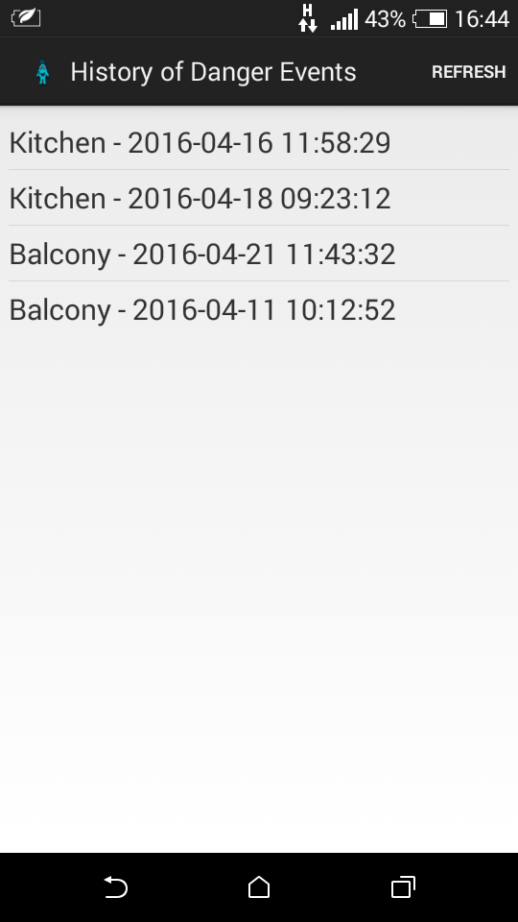
Figure 13 History of dangerous events
After dangerous event occurs, user will be immediately notified with information where and when that event happened (Figure 14).
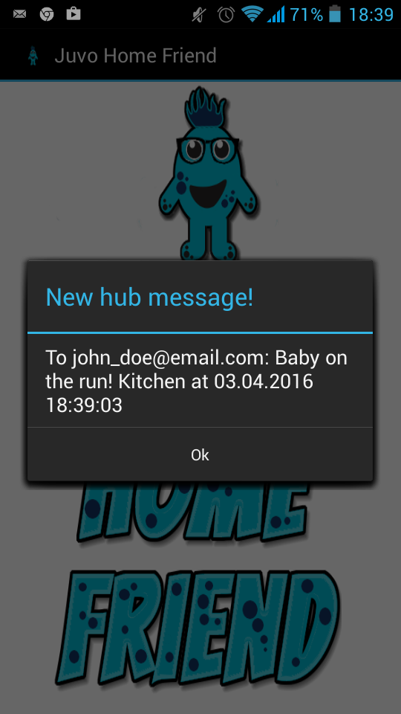
Figure 14 Juvo – Home Friend notification

Business potential of Juvo – Home Friend product
Target market is huge and demand on baby care market is inelastic. Parents are not price sensitive when it comes to the safety of their child and for them higher price often symbolizes quality, more reliable and safer product. They want best product on the market, no matter the price. Juvo – Home Friend is a unique product on the market and therefore the price of a product can be higher at the start. When competition emerges, price of product will be gradually reduced and adjusted with respect to the cost invested in product development and value of the security that the product offers to the user.

Pricing and special offers
The plan is to grant discounts when selling to end customers at higher volumes or packages of products Juvo – Home Friend. Packages are determined based on the square footage of household with an estimate of how many dangerous places there is in the household of a certain square footage (Table 1).
Table 1 Packages pricing based on square footage of household
 | Little  Helpers | Medium Helpers | Big  Helpers
House size (m²) | <50 | 51-100 | 101-150
Number of sensors in package | 4 | 6 | 10
Covered areas | Kitchen, bathroom, cabinets, drawers | Kitchen, bathroom, stairs, cabinets, drawers, windows | Kitchen, bathroom, workroom, balcony, stairs, cabinets, drawers, windows
Package price | $199 | $269 | $399
Special sales will be used during the holidays to help parents carefree and stress free spent their free time with their loved ones. Juvo – Home Friend can then serve as a perfect family gift. In addition, the holiday packages come with additional bracelets that parents can give to the children of their guests while they are staying in their home. Additional bracelets have no additional functionality and are used to inform parents when a child is close to potentially dangerous places in their home.

Sales channels
Juvo – Home Friend will be sold through three sales channels:
- Our own web shop – directly selling products through our own web store,
- Intermediate stores – indirectly selling through intermediate stores (e.g. Amazon)
- Retail stores – selling through physical stores specialized for the sale of baby care products.
Sales through own web store is an excellent sales channel for beginning. Potential users will be able to sign up on a waiting list before the product is placed on market. Also, users will be able to find out everything they want to know about the product and become familiar with the product before purchase.
When the product becomes well-known, sales through intermediate store becomes an ideal way to increase sales and reach more customers. Also, sales through well-known brand like Amazon gives the product additional value and fulfills customers with trust and confidence.
Sales through the physical store is a sales channel that will be approached last. When the product becomes a brand, it is important that everyone can buy it in their nearest store specialized for baby care products.

Advertising
In order to reach as many potential users as possible, the plan is to focus on Internet marketing.
Marketing campaign will begin several months before placing product on the market to create anticipation and increase the desire for the product at potential customers. For beginning it is important to build a community of users who are interested in product Juvo – Home Friend and users who are very supportive.
Community building will begin on the Facebook using Facebook's advertising service. The initial strategy will be to reach out users of the following characteristics: employed and has a child under 6 years old. Using Facebook's advertising services, it is easy to target a specific group of users and advertise them product. After forming initial community, plan is to launch a new campaign to bring more women/mothers who often publicly communicate on Facebook. This will encourage interaction within the community and posts on the Facebook will be visible to more potential users.
In order to protect the product from the competition and potential copying, the plan is to build a brand which customers can trust and with which they already have built a certain connection.
When the product becomes well-known, Google's advertising services (Google AdWords) will be used to recommend Juvo – Home Friend product to parents who are searching for baby care products.

Discussion
With new technologies in everyday life, lot of people are concerned about their privacy. Almost all of home safety and s surveillance systems use some kind of cameras. People are afraid that those cameras could be easily hacked and used to violate their privacy.
Juvo – Home Friend does not use cameras or video surveillance as a way of babysitting and monitoring the movement of a child. Thus parents can be sure that their privacy and privacy of their child will stay untouched.
Some people misunderstood purpose of this product. Some of them think that Juvo – Home Friend is product which tries to “replace” child’s human supervisor (older brother, babysitter, parent, grandparent, etc.). Even with Juvo – Home Friend, parents will still need to keep an eye on their child just like they did before. But, next time when they leave a child for just a second to check if meal is done, answer a phone or open a door, take something from other room or feed a pet, they will not worry is something going to happen to their child. Also, when they accidentally leave a child without supervision for just a moment, nothing bad will happen.
Others think that Juvo – Home Friend will unsuccessfully try to prevent older kids in their intention. Purpose of Juvo – Home Friend for older kids is not to prevent them from opening cabinets and drawers or leaving a home, by playing a sound alarm. Juvo – Home Friend will let them know, by playing a sound alarm, that their parents now know what are they doing.

Conclusion
Predictions are that in near future, IoT project will become common part of every home. Reason for such a fast and successful growth of IoT field is price of hardware and Internet communication that is constantly dropping. With constant increase of volume of collected data, various Internet of Things projects are getting more and more helpful, creative and innovative. Devices will become smarter and will be able to communicate, assist, help and serve to people in their everyday activities.
Even in this modern times, some major problems still stayed unsolved. Many vulnerable groups like children, elders, blind and visually impaired people don’t have appropriate help and assistance.
To help those vulnerable groups, Juvo – Home Friend product and service was developed. Juvo – Home Friend smart sensors can help to improve child’s safety, reduce chance of accidental injury, help people with orientation and notify supervisors that something is going on.
Juvo – Home Friend will improve general quality of living, let children grow up safely and change the way blind and visually impaired people interact with their environment.

Bibliography

Summary
At early age, children are not aware of all dangers surrounding them within the home. Sadly, leaving a child without supervision for just a second can end up tragically.
Juvo – Home Friend is an innovative product that takes care of child's safety and ensures parents calmness and relaxation. Providing them with constant insight into child's movement within their own home, parents can safely perform their daily activities knowing that their child is safe. Name Juvo comes from Latin word iuvō which means help, aid, assist, support and serve.
Using Juvo – Home Friend smart sensors parents can mark the places in their home with sensors that react when child approaches. Potentially dangerous places and objects for children such as power sockets, drawers and cabinets with dangerous (sharp, flammable, poisonous) objects, stairs, kitchen and kitchen appliances, bathroom and balcony can be marked with smart sensors that react if a child is in danger.
Juvo – Home Friend is also unique because it collects data about child’s movement and development that is currently unavailable and unknown. This data has major value for future analysis and research in field of child care, safety and development.
In addition, Juvo – Home Friend has great potential to expand its services to different groups that need help or assistance. That may be elders, blind and visually impaired people, people with Alzheimer’s disease and dementia, sleepwalkers or similar groups that require continuous or periodic monitoring or they are adjusting to the new situation.

Sažetak
U svojoj ranoj dobi, djeca nisu svjesna svih opasnosti koje ih okružuju unutar vlastitog doma. Nažalost, samo trenutak roditeljske nepažnje je dovoljan da se dogodi nesreća koja može tragično završiti.
Juvo – Home Friend je inovativni proizvod koji se brine za sigurnost djece te roditeljima osigurava smirenost i opuštenost po pitanju brige o djetetovom zdravlju i sigurnosti. Pružajući im konstantan uvid u kakvoj se okolini dijete nalazi, roditelji mogu bezbrižno obavljati svoje svakodnevne aktivnosti znajući da je njihovo dijete sigurno. Naziv Juvo dolazi od latinske riječi iuvō koja znači pomagati, liječiti, asistirati, podupirati i služiti.
Koristeći Juvo – Home Friend pametne senzore roditelji mogu označiti mjesta u kućanstvu senzorima koji reagiraju kada im se dijete približi. Potencijalno opasna mjesta i stvari za djecu poput električnih utičnica, ladica i ormarića s opasnim (oštrim, zapaljivim, otrovnim) objektima, stepenica, kuhinje i kuhinjskih uređaja, kupaonice i balkona mogu se označiti pametnim senzorima koji reagiraju ako je dijete u opasnosti.
Juvo – Home Friend je također poseban jer prikuplja podatke o djetetovoj kretnji i razvoju koji su trenutno nedostupni i nepoznati. Ti podaci imaju veliku vrijednost za buduću analizu i istraživanja u području brige o djetetu te djetetove sigurnosti i razvoja.
Dodatno, Juvo – Home Friend ima veliki potencijal u proširenju svojih usluga za različite skupine koje trebaju pomoć i potporu. To mogu biti starije osobe, slijepe i slabovidne osobe, osobe oboljele od Alzheimerove bolesti i demencije, osobe koje mjesečare ili slične skupine koje zahtijevaju konstantan ili povremen nadzor ili se prilagođavaju novonastaloj situaciji.

