Sveučilište u Zagrebu
Medicinski Fakultet
Medical Studies in English

Antun Pavelić

Hemodinamski odgovor na zračno-provodljiv zvučni podražaj je posredovan vestibulosimpatičkim refleksom
Hemodynamic response to air-conducted sound stimulus is mediated via vestibulosympathetic reflex

Zagreb, 2016

Ovaj rad izrađen je u Katedra za Neurologiju Medicinski Fakultet, Sveučilište u Zagrebu pod vodstvom doc. dr. sc. Mario Habek, dr.med. i predan je na natječaj za dodjelu Rektorove nagrade u akademskoj godini 2015/2016.

Abbreviations
ACSS, air-conducted sound stimulus; BP, blood pressure; EP, electrical potentials; GVS, galvanic vestibular stimulation; HDR, head-down rotation; HR, heart rate; IOM, inferior oblique muscles’; MSNA, muscle sympathetic activity; RSA, respiratory sinus arrhythmia; SCM, sternocleidomastoid; VSR, vestibulosympathetic reflex; VEMP, vestibular evoked myogenic potentials; VN, vestibular neuritis; VR, Valsalva ratio.

Sadržaj rada
Uvod…………………………………………………………………………………….….…………..….. 5
Hipoteza…………………………………………………………………………………….………….….. 6
Metode…………………………………………………………………………………..……….…….….. 7
Rezultati ...…………………………………………………..……………………….…..………………... 9
Rasprava …………………………………………………………………………..………………….….. 10
Zaključci ………………………………….………………………..…………………………..………….12
Zahvale …………………………………………………………………………………….…..………….12
Popis literature ...………………………………………………….…………………...………………….13
Sažetak na hrvatskom jeziku ..………………………………………………………………………...….24
Sažetak na engleskome jeziku .……...……………..………………………………………..…...……….25

Table of Contents
Introduction………………………………………………………………….….…………………...….….5
Hypothesis ………………………………………………………………………..………………………..6
Methods ……………………………..………………………………………………..……………………7
Results ………………………………………………………………………………………..……...…… 9
Discussion ………………………...…………………………………………………………………...… 10
Conclusion ………………………………………………………………………………………...…… ..12
Special thanks……………………………………………………………………………………..………12
References …………………………………………………………………………………………..….....13
Summary in Croatian……………………………………………………………………………...............24
Summary in English…………………………………………………………………………….. ..............25

Introduction
Cardiovascular reflexes are responsible for the maintenance of stable blood pressure during various postural challenges. Although the most recognized reflex responsible for regulation of blood pressure during orthostasis is the baroreflex, several studies have also identified the existence of a vestibulosympathetic reflex (VSR); in earlier literature referred to as the vestibulo-autonomic reflex. (Carter & Ray 2008.; Cohen et al. 2013; Kasumacic et al. 2012; Gotoh et al. 2004; Balaban & Porter 1998; Balaban & Yates 2004; Radtke et al. 2003; Furman et al. 1998). This reflex, in conjunction with the baroreflexes, interacts to increase sympathetic nerve activity and regulates arterial blood pressure during orthostasis (Sauder et al. 2012). When the change of posture occurs, namely from a horizontal to an upright position, 300-800mL of blood is redistributed towards lower extremities under gravitational influence. It has been proposed that the VSR acts even before compensatory mechanisms, including the baroreceptor-reﬂex, to counteract the drop in blood pressure due to the posturally induced hypotension. (Biaggioni et al. 1998; Yates et al. 1999)
Thus far, studies have observed vestibulosympathetic responses in animals and in humans, however methodology used to test the VSR significantly varied between studies: head-down rotation (HDR), caloric stimulation, yaw head rotation, sinusoidal linear acceleration, off-vertical axis rotation and galvanic vestibular stimulation (GVS) (Table 1) (Carter & Ray 2008; Cohen et al. 2013; Kasumacic et al. 2012; Gotoh et al. 2004; Sauder et al. 2008; Ray et al. 1998; Carter & Ray 2008; Hammam et al. 2014; Kaufmann et al. 2002; Rosengren & Kingma 2013; Papathanasiou 2015). Due to various methods used, there is a discrepancy of the results, but the most consistent finding is an increase of muscle sympathetic activity (MSNA) in response to HDR (Table 2) (Ray, 1998; Wilson, 2004; Cui, 1999a; Cui, 1997; Costa, 1995; Short, 1997; Wilson, 2004a; Wilson, 2004b; Dyckman, 2007; Sauder, 2008; Cui, 1999b; Yates, 1999; Jaregui-Renaud, 2006; Cui, 2001; Grewal, 2012; Hammam, 2013; Hammam, 2014; Bolton, 2004; Voustianiouk, 2006; Bent, 2006; Hammam, 2011; Hammam, 2012; Kaufmann, 2002). This increase in MSNA is accompanied by peripheral vasoconstriction (Dyckman et al. 2007). Several studies led to the conclusion that the VSR produces greater effect in states of imminent hypotension (Sauder et al. 2012), thus it seems that VSR responds to this threat with peripheral vasoconstriction. Several studies also reported an increase in heart rate and blood pressure in response to vestibular stimulation. (Table 2).
Vestibular evoked myogenic potentials (VEMP) are another method of testing the vestibular system. The administration of air-conducted sound stimulus (ACSS) (clicks or pure tones) in the range of 130-145dB (Rosengren & Kingma 2013; Cal & Babmad 2009) activates the saccule and utricle, which leads to changes in the sternocleidomastoid (SCM) and inferior oblique muscles’ (IOM) electrical potentials (EP) respectively. Changes of EP recorded over the SCM via surface electrodes have been shown to directly correlate with the activity of the afferent vestibular nerve branch of the saccule (inferior branch of the vestibular nerve); this is referred to as cervical VEMP (cVEMP) (Radtke et al. 2003). Ocular VEMPs (oVEMPs) recorded over the IOM, originate at the utricle and are conducted via the superior branch of the vestibular nerve (Papathanasiou 2015). Thus, VEMPs are used as a valuable tool in investigating the function of the vestibular system in various pathologies. Although ACSS activates primarily the saccule and utricle, which are most likely involved in the VSR, this method was never used to investigate the VSR. More interestingly, there have been studies of the VSR using animal models with vestibular lesions (Abe et al. 2011; Jian et al. 1999), but no studies actively investigating the VSR in human patients with vestibular lesions were conducted.

Hypothesis
Therefore, the objective of this study was to investigate the existence of the VSR in humans by comparing the hemodynamic responses to ACSS of the vestibular system between healthy subjects and patients with vestibular neuritis (VN).

Methods
Participants
Twenty-one healthy controls and seven patients with vestibular neuritis were included in the study. Diagnosis of vestibular neuritis was based on the following clinical parameters: (1) constant rotatory vertigo lasting no longer than 48 hours, (2) unidirectional horizontal-rotatory nystagmus toward the unaffected ear, (3) positive head impulse test toward the affected ear, (4) absence of skew deviation assessed by Maddox rod. The diagnosis was then confirmed with caloric testing, video head impulse test and VEMPs. Vestibular paresis on caloric testing was defined as an asymmetry of more than 25% using the Jongkees’ formula. Ethical committee of the University Hospital Center Zagreb approved the study. All participants signed informed consent.

Vestibulosympathetic Reflex Testing
All tests were performed in a quiet and dimly lit room. Participants were instructed not to drink coffee or smoke before the testing. Blood pressure (BP) and heart rate (HR) values were recorded using Task Force Monitor (TFM) (CNSystems Medizintechnik AG, Austria). After the patient was supine on the testing table, headphones used to emit the sound stimuli (clicks, in further text ACSS), BP cuffs (constant measurement via phalangeal cuff and measurement at regular intervals via brachial cuff) and ECG electrodes were adjusted at appropriate sites. Once the subjects were readied, a period of rest was recorded in the supine position to establish baseline levels of cardiac function (resting HR and BP) for 10 minutes. Once completed, ACSS (described in VEMP testing) was administered to healthy subjects’ right ear at 130 dB for 50 seconds at a frequency of 1 Hz, and VN patients had clicks administered to the affected side at identical intensity and frequency.
Testing of the autonomic nervous system was performed as described previously (Novak 2011):
- HR response to Valsalva maneuver (3 intervals without ACSS, 2 intervals with ACSS). The Valsalva maneuver was performed in the supine position by blowing through a mouthpiece connected to a mercury manometer for 15s. The mercury column of the manometer was maintained at 40mm. There was a small air leak in the system to prevent closing of the glottis. The test was repeated until a reproducible response was obtained. Valsalva ratio (VR) was defined as the maximum HR during the Valsalva maneuver divided by the lowest HR recorded within 15 seconds of the peak HR.
- HR response to deep breathing (90 seconds without, and 50 seconds with ACSS). Respiratory sinus arrhythmia (RSA) was calculated from the deep breathing exercise. It is calculated as the difference between the end of expiration and end of inspiration in heart rate values (in bpm). An average from at least 5 RSA values is obtained and presented in the results.
- BP response to 70° passive tilt. Participants were tilted for a duration of 5 minutes followed by 50 seconds of ACSS. The point where the patient was brought back to a supine position is noted.
- Lastly, the BP response to active standing of 5 minutes followed by 50 seconds of ACSS.
Each test was conducted first without and then with ACSS of the vestibular system. After each individual bout of testing, subjects were given at least 3 minutes for their cardiac readings to return to baseline (determined during the initial 10 minutes)

Vestibular stimulation
The stimuli (ACSS) were delivered by a pair of headphones in series of 50 trials to the right ear of the healthy subject and affected ear of the VN patient. The presented stimuli were acoustic clicks, 1ms in duration at an intensity level of 130 dB SPL. The stimulation rate was 1 Hz.

Outcomes
Outcomes of the study were to determine differences between parasympathetic measures (VR and RSA) without and during stimulation of vestibular nerve with acoustic clicks in healthy participants. Furthermore, we wanted to determine differences between HR, sBP and dBP in three positions (supine, tilted and active standing) without and during stimulation of vestibular nerve with acoustic clicks in healthy participants. Finally, we wanted to determine whether these differences (if present) are diminished in patients with vestibular neuritis.

Statistics
Statistical analysis was performed using the IBM SPSS software, version 20. The Kolmogorov-Smirnov test was applied to test whether the data have a normal distribution. Differences between variables were determined with the use of paired t-test. Bonferroni adjusted p values were used in the analysis.

Results
Healthy participants
Twenty-one healthy volunteers participated in the study, 7 females, with a mean age of 23.53 ± 3.6 years.
There was a statistically significant difference between RSA values without and with vestibular stimulation (26.63 ± 6.16 vs. 24.67 ± 7.34 respectively, p=0.02), indicating that RSA values during the vestibular stimulation were significantly lower compared to the period without the stimulation. There was no statistically significant difference between VR values without and with vestibular stimulation (2.11 ± 0.31 vs. 2.00 ± 0.39 respectively, p=0.19).
Further analysis was performed to compare the average of equal numbers of beat-to-beat values for HR, dBP, and sBP before the ACSS of the vestibule and during the stimulation, for supine position, during the tilt table test and during active standing.
We found that during the passive tilt the average HR value throughout ACSS of the vestibule was statistically significantly lower than the average HR values immediately preceding the ACSS (88.63 ± 14.68 vs. 90.96 ± 14.93, p=0.001). For supine position and active standing there was no statistically significant difference. The results are shown in Table 3 and graphically presented in Figure 1.
We found no statistically significant differences in sBP or dBP between conditions with and without ACSS of the vestibule in supine position, during tilt table test or active standing. See Tables 4-5, and Figures 2-3.
Vestibular neuritis patients
Seven patients with vestibular neuritis were included in the study (4 females) with a mean age of 31.14 ± 15.3 years.
In the VN group we found no statistically significant difference between RSA values without and with vestibular stimulation (25.55 ± 11.8 vs. 24.26 ± 12.48, p=0.356). There was also no statistically significant difference between VR values without and with vestibular stimulation (2.07 ± 0.51 vs. 2.14 ± 0.56 respectively, p=0.221).
Furthermore, there was no statistically significant difference for HR, sBP or dBP values between conditions with and without vestibular stimulation for supine position, tilt table test and active standing. Results are shown in Tables 6-8.
Tables

Table 1. Methods of vestibular stimulation used in previous studies and vestibular organs they activate.
 | Lateral SC | Anterior SC | Posterior SC | Saccule | Utricle
Yaw head rotation (YHR) | + (Yates et al. 1999)
Caloric stimulation (Ray et al. 1998) | Predominantly | Slightly
Head-down rotation (HDR) | After completion of the rotation influence of semicircular canals is eliminated  (Ray et al. 1998) |  |  | + | +
Sinusoidal linear acceleration (SLA) |  |  |  | Predominant activation when supine; Slight activation when seated (Carter & Ray 2008) | Predominant activation when seated; Slight activation when supine (Carter & Ray 2008)
OVAR (Hammam et al. 2014) | Influence of SCs is eliminated after 10-12 sec |  |  | + | +
Galvanic stimulation (Ray et al. 1998) | + | + | + | + | +
VEMP | New evidence raises the possibility of SC activation (Hammam et al. 2014) |  |  | + (Kaufmann et al. 2002) | + (Rosengren & Kingma 2013)
+ marks vestibular organs which are stimulated by the particular method. SC- semicircular canal.
Table 2. Sympathetic neural and cardiovascular responses to various methods of vestibular system stimulation.
Study | Stimulation method | MSNA | SSNA | HR | BP
Ray, 1998 | YHR | ⇔ | ⇔ | ⇔ | ⇔
Wilson, 2004 | YHR | NS | ⇔ | NS | NS
Cui, 1999a | Caloric stimulation | NS | ⇑ during the first 40 sec; ⇓ with the onset of nystagmus | NS | NS
Cui, 1997 | Caloric stimulation | ⇑ | NS | NS | NS
Costa, 1995 | Caloric stimulation | ⇔ | NS | ⇔ | ⇔
Short, 1997 | HDR | ⇑ | NS | ⇑ | ⇑
Wilson, 2004a | HDR | ⇑ | NS | ⇔ | ⇔
Wilson, 2004b | HDR | NS | ⇔ | NS | NS
Dyckman, 2007 | HDR | ⇑ | NS | ⇔ | ⇔
Sauder, 2008 | HDR | ⇑ | NS | ⇔ | ⇔
Cui, 1999b | SLA | ⇓ | NS | ⇔ | ⇔
Yates, 1999 | SLA | NS | NS | ⇑ | ⇑
Jaregui-Renaud, 2006 | SLA | NS | NS | ⇑ | NS
Cui, 2001 | SLA | ⇓ | NS | ⇑with acceleration peak value of ±20G; ⇔ with lower accelerations | ⇔
Grewal, 2012 | SLA | NS | ⇑ | ⇔ | ⇔
Hammam, 2013 | SLA | ⇑ | NS | NS | NS
Hammam, 2014 | SLA | ⇑* | NS | NS | NS
Bolton, 2004 | Galvanic stimulation | ⇔ | ⇑ | NS | NS
Voustianiouk, 2006 | Galvanic stimulation | ⇑ | NS | ⇔ | ⇔
Bent, 2006 | Galvanic stimulation | ⇑ | NS | NS | NS
Hammam, 2011 | Galvanic stimulation | ⇑ | NS | NS | NS
Hammam, 2012 | Galvanic stimulation | NS | ⇑ | NS | NS
Kaufmann, 2002 | OVAR | ⇑ when nose-up, ⇓ when nose-down | NS | ⇔ | NS
The increase of MSNA during head-down rotation is a consistent ﬁnding and has been replicated in more than 10 studies not enlisted here. * In this study patients underwent SLA in supine and seated position, thus activating both saccule and utricle, respectively. Other studies here listed employed SLA with patient seated, thus activating predominantly the utricle. YHR – yaw head rotation, HDR – head down rotation, SLA – sinusoidal linear acceleration, OVAR – off-vertical axis rotation, HR heart rate, BP – blood pressure (i.e. systolic, diastolic or mean arterial pressure), NS - not studied, ⇑ - increase, ⇓ - decrease, ⇔ - no change.

Table 3. Comparison of HR values of healthy subjects between condition with and without vestibular stimulation during supine position, tilt table test and active standing
Position | Vestibular stimulation | Mean HR (bpm) | Std. Deviation | Median HR  (bpm) | Sig. (2-tailed)
Supine | - | 70.99 | 12.20 | 70.82 | NS
 | + | 70.07 | 12.16 | 68.55
Tilt | - | 90.96 | 14.93 | 94.73 | 0.001
 | + | 88.63 | 14.68 | 90.55
Active standing | - | 90.79 | 15.78 | 88.73 | NS
 | + | 90.02 | 17.17 | 90.19

Table 4. Comparison of sBP values of healthy subjects between condition with and without vestibular stimulation during supine position, tilt table test and active standing
Position | Vestibular stimulation | Mean sBP (mmHg) | Std. Deviation | Median sBP  (mmHg) | Sig. (2-tailed)
Supine | - | 121.76 | 11.70 | 121.32 | NS
 | + | 122.93 | 12.67 | 124.93
Tilt | - | 111.17 | 14.15 | 108.09 | NS
 | + | 113.16 | 14.16 | 111.84
Active standing | - | 118.92 | 18.41 | 112.68 | NS
 | + | 119.63 | 17.03 | 116.33

Table 5. Comparison of dBP values of healthy subjects between condition with and without vestibular stimulation during supine position, tilt table test and active standing
Position | Vestibular stimulation | Mean dBP (mmHg) | Std. Deviation | Median dBP  (mmHg) | Sig. (2-tailed)
Supine | - | 71.64 | 7.67 | 71.08 | NS
 | + | 70.43 | 8.47 | 69.60
Tilt | - | 70.70 | 9.17 | 69.09 | NS
 | + | 71.55 | 9.24 | 69.08
Active standing | - | 74.59 | 12.94 | 73.53 | NS
 | + | 74.31 | 12.75 | 73.67

Table 6. Comparison of HR values of VN patients between condition with and without vestibular stimulation during supine position, tilt table test and active standing
Position | Vestibular stimulation | Mean HR (bpm) | Std. Deviation | Median HR  (bpm) | Sig. (2-tailed)
Supine | - | 78.16 | 9.9 | 79.18 | NS
 | + | 74.85 | 7.85 | 76.06
Tilt | - | 91.57 | 15.91 | 84.52 | NS
 | + | 93.19 | 15.33 | 88.68
Active standing | - | 99.13 | 16.62 | 93.24 | NS
 | + | 97.81 | 15.87 | 94.88

Table 7. Comparison of sBP values of VN patients between condition with and without vestibular stimulation during supine position, tilt table test and active standing
Position | Vestibular stimulation | Mean sBP (mmHg) | Std. Deviation | Median sBP  (mmHg) | Sig. (2-tailed)
Supine | - | 116.18 | 8.29 | 115.30 | NS
 | + | 118.66 | 8.32 | 119.66
Tilt | - | 106.41 | 12.30 | 104.48 | NS
 | + | 109.50 | 10.17 | 104.94
Active standing | - | 120.65 | 15.46 | 119.62 | NS
 | + | 120.40 | 14.41 | 120.80

Table 8. Comparison of dBP of VN patients values between condition with and without vestibular stimulation during supine position, tilt table test and active standing
Position | Vestibular stimulation | Mean dBP (mmHg) | Std. Deviation | Median dBP  (mmHg) | Sig. (2-tailed)
Supine | - | 73.92 | 4.94 | 74.56 | NS
 | + | 73.98 | 4.38 | 75.86
Tilt | - | 73.13 | 11.00 | 72.43 | NS
 | + | 74.10 | 8.24 | 72.12
Active standing | - | 76.64 | 13.14 | 76.19 | NS
 | + | 76.57 | 13.05 | 77.50

Figures
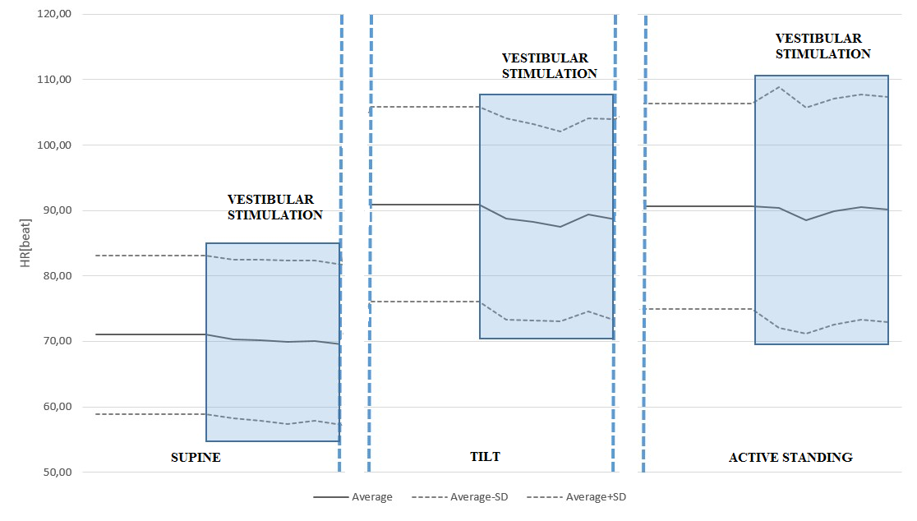
Figure 1. HR response to ACSS of the vestibule during the supine, passive tilt and active standing positions. Note the significant drop of HR during vestibular stimulation in tilted position. It should also be noted that the passive tilt produces the greatest orthostatic stress.

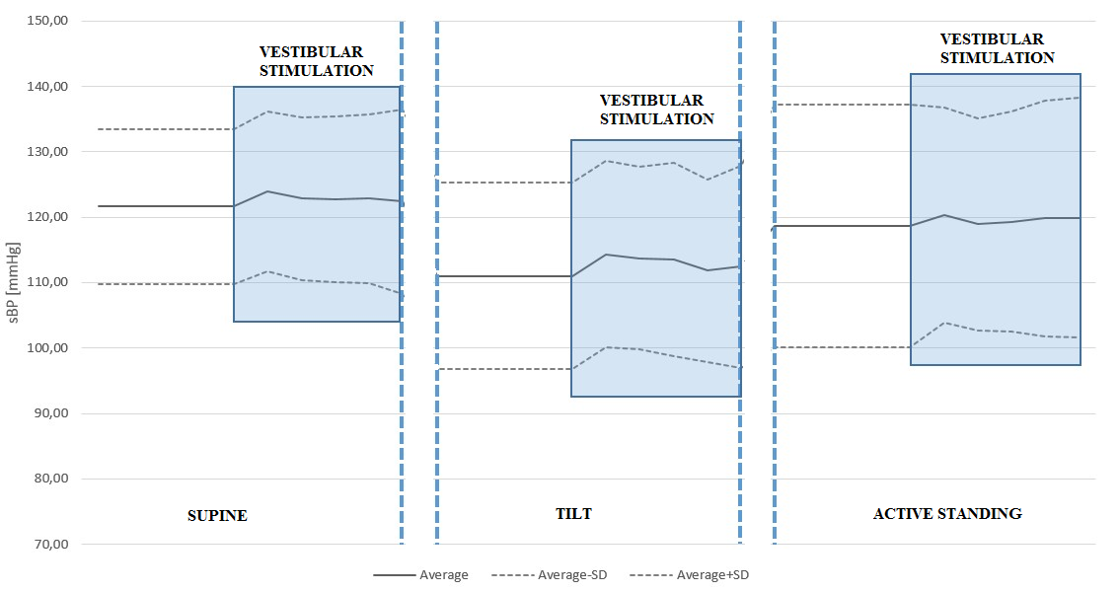
Figure 2. Systolic blood pressure (sBP) response to ACSS of the vestibule during the supine, passive tilt and active standing position. Note that the greatest increase in sBP was elicited by vestibular stimulation during the passive tilt position, although this did not reach significance.

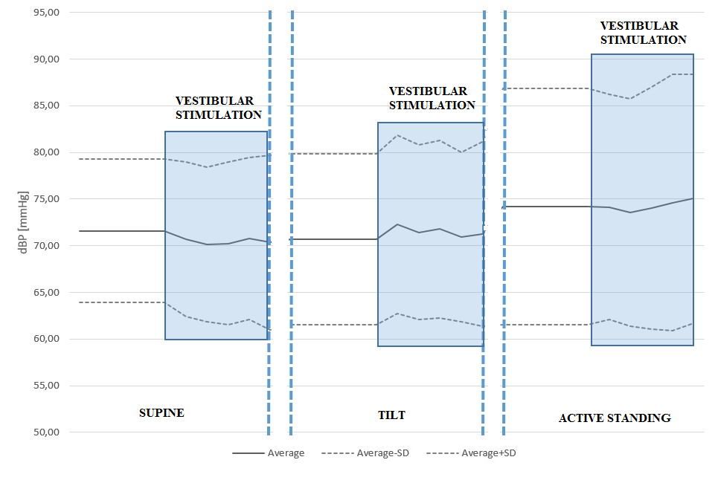
Figure 3. Diastolic blood pressure (dBP) response to ACSS of the vestibule during the supine, passive tilt and active standing position. Again, the greatest increase in dBP was elicited by vestibular stimulation during the passive tilt position.

Discussion
The results of this study further expand the evidence that the VSR exist in humans. We have shown that air-conducted sound stimulation (ACSS) of the otolith organs elicits a hemodynamic response, consistent with the theory of the vestibulosympathetic reflex. Although VSR is thought to elicit an increase in sympathetic activity, this response was recorded as a decrease in heart rate in healthy subjects during passive head-up tilt. Actually, these findings supplement previously published results, despite that at first glance they seem to contradict the idea and supposed purpose of the VSR, which will be supported further on.
The VSR was studied with a number of protocols (see Tables 1 and 2), hence the equivocality of the results. The most consistent finding was found by using the head down rotation resulting in an increase of MSNA (Table 2). The activity of sympathetic nerves innervating muscles leads to vasoconstriction (Hart & Charkoudian 2014), and it has repeatedly been shown that both MSNA and peripheral vascular resistance increase progressively with the severity of orthostatic stress. (Ichinose & Nishiyasu 2012) One study has shown significantly greater MSNA response to head down rotation in head-up tilted humans compared to prone position showing that the sensitivity of the VSR is greater in the upright posture. (Sauder et al. 2008) Another study on rats supports this conclusion. (Abe et al. 2011) Interestingly, in our study, vestibular stimulation elicited a statistically significant decrease in HR only during passive head-up tilt and no significant differences between hemodynamic parameters were found during active standing. This may be because of the higher level of orthostatic stress exerted by passive tilt; since by passively tilting, the effect of the so-called skeletal muscle pump on blood pressure regulation is exempted. In line with this, it is argued that the VSR is designed to be activated the most in conditions with greater risk of hypotension. (Sauder et al. 2012)
Still, it seems unusual that activation of the VSR would lead to HR decrease, since its supposed role is to aid the baroreflex in combating the gravitational blood redistribution which occurs with posture change. Since our subjects first stood in passive head-up tilt position for 10 minutes and received vestibular stimulation afterwards, their cardiovascular system had more than enough time to adjust to this position. This is accomplished mainly through baroreflex unloading and consequential decrease in parasympathetic (cardio-acceleration) and increase in sympathetic tone (peripheral arteriolar vasoconstriction). Although we did not perform MSNA in our study, and whether sympathetic activity increased or not cannot be stated with certainty, both the HDR method and ACSS activate the otholits. It has repeatedly been shown that HDR causes increase in MSNA and peripheral vasoconstriction. (Dyckman et al. 2007) Since ACSS produced hemodynamic response during the head-up tilt, we hypothesize that ACSS also led to peripheral vasoconstriction. Note that both systolic and diastolic blood pressure elevated slightly upon vestibular stimulation (see Table 4 and 5), although this did not reach statistical significance. One study showed that the baroreflex and the VSR have the additive effect on blood pressure modulation, indicating that these two reflexes work independently of each other. (Ray 2000) Supporting this finding, behavioral and cellular physiological studies suggest that the baroreceptor and vestibular reﬂex pathways remain separate until they synapse on the presympathetic neurons in the rostral ventrolateral medulla. (Holstein et al. 2014) Therefore, it is more likely that the decrease in HR during vestibular stimulation of tilted healthy subjects in our study was a result of baroreflex loading caused by vasoconstriction and blood pressure rise elicited by vestibular stimulation.
We also found that the heart rate variability to paced deep breathing is significantly lower during the vestibular stimulation of healthy subjects. The response to the deep breathing test is a commonly used measure of cardiovagal function, and, as in this study, it is usually performed in supine position where vagal tone is greatest. (Freeman 2008) Interestingly, vestibular stimulation did not elicit any response in HR or blood pressure during the resting period in supine position, although the deep breathing test was also performed in supine position. This finding might represent a central integration of baroreflex and vestibular input to the rostral ventrolateral medulla. (Holstein et al. 2014)
One might argue that using sound does not activate only vestibular structures but also the cochlea, and the effect of sound/music on autonomic nervous system heart activity regulation has been documented (da Silva et al. 2014; Sim et al. 2015). Since we found no statistically significant changes in the studied parameters before and during vestibular stimulation in VN patients group, these results indicate that a preserved function of vestibular nerve was needed to elicit a hemodynamic response. This finding is in line with findings by Abe et al. who found that rats who had vestibular lesion responded with greater drop in blood pressure upon voluntary rear-up. (Abe et al. 2011) To our knowledge, this is the first study to investigate hemodynamic responses to otholithic stimulation in patients with vestibular neuritis, although one study reported significantly higher proportion of orthostatic hypotension in patients with absent VEMP responses, i.e. with a dysfunction of the vestibular system (Aoki et al. 2012).

Conclusion
To summarize, this study has shown significant effect of vestibular stimulation with ACSS in healthy participants on heart rate during the passive tilt, while no such difference was observed in VN patients. These data indicate that ACSS could be a valuable method for future studies of the VSR.

Special Thanks
I would like to thank doc. Habek for all of the energy he invested in me and the patience he showed knowing my Croatian was and still is far from perfect. I would also especially like to thank dr. Crnošija who mentored me through the hospital setting and was there for any questions I may have had. Lastly, I would like to thank dr. Ivan Adamec, Anamari Junaković, Magdalena Krbot Skorić all of whom helped me feel part of the team and gave me valuable advice on all aspects of this paper.
References
Abe, C., Kawada, T., Sugimachi, M., Morita, H. 2011. Interaction between vestibulo-cardiovascular reﬂex and arterial baroreﬂex during postural change in rats. J Appl Physiol 111, 1614–1621.
Aoki, M., Sakaida, Y., Tanaka, K., Mizuta, K., Ito, Y. 2012. Evidence for vestibular dysfunction in orthostatic hypotension. Exp Brain Res 217, 251–259.
Balaban, C.D., Porter, J.D. 1998. Neuroanatomic substrates for vestibulo-autonomic interactions. J Vestib Res Jan-Feb;8(1) 7-16. PMID: 9416584.
Balaban, C.D., Yates, B.J. 2004. Vestibuloautonomic Interactions: A Teleologic Perspective. In: Highstein S, Fay R, Popper A, (Eds). 19th The Vestibular System. Springer Handbook of Auditory Research, pp. 286-342. Springer, New York.
Bent, L.R., Bolton, P.S., Maceﬁeld, V.G. 2006. Modulation of muscle sympathetic bursts by sinusoidal galvanic vestibular stimulation in human subjects. Exp Brain Res 174, 701–711.
Biaggioni, I., Costa, F., Kaufmann, H. 1998. Vestibular influences on autonomic cardiovascular control in humans. J Vestib Res 8:35-41.
Bolton, P.S., Wardman, D.L., Macefield, V.G. 2004. Absence of short-term vestibular modulation of muscle sympathetic outflow, assessed by brief galvanic vestibular stimulation in awake human subjects. Exp Brain Res 154, 39-43.
Cal, R., Babmad, Jr. F. 2009. Vestibular evoked myogenic potentials: an overview. Braz J Otorhinolaryngol, 75(3): 456-462.
Carter, J.R., Ray, C.A. 2008. Sympathetic responses to vestibular activation in humans. Am J Physiol Regul Integr Comp Physiol 294, R681-8. doi: 10.1152/ajpregu.00896.2007.
Cohen, B., Martinelli, G.P., Raphan, T., Schaffner, A., Xiang, Y., Holstein, G.R., Yakushin, S.B. 2013. The vasovagal response of the rat: its relation to the vestibulosympathetic reflex and to Mayer waves. FASEB J 27, 2564–2572.
Cui, J., Iwase, S., Mano, T., Katayama, N., Mori, S. 2001. Muscle sympathetic outflow during horizontal linear acceleration in humans. Am J Physiol Regul Integr Comp Physiol 281, R625-34.
a Cui, J., Iwase, S., Mano, T., Kitazawa, H. 1999. Responses of sympathetic outflow to skin during caloric stimulation in humans. Am J Physiol 276, R738-44.
b Cui, J., Iwase, S., Mano, T., Katayama, N., Mori, S. 1999. Muscle sympathetic nerve response to vestibular stimulation by sinusoidal linear acceleration in humans. Neurosci Lett 267, 181-4.
Cui, J., Mukai, C., Iwase, S., Sawasaki, N., Kitazawa, H., Mano, T., Sugiyama, Y., Wada Y., 1997. Response to vestibular stimulation of sympathetic outﬂow to muscle in humans. J Auton Nerv Syst 66: 154–162.
Costa, F., Lavin, P., Robertson, D., Biaggioni, I. 1995. Effect of neurovestibular stimulation on autonomic regulation. Clin Auton Res 5, 289-93.
da Silva, S.A., Guida, H.L., Dos Santos Antonio, A.M., de Abreu, L.C., Monteiro, C.B., Ferreira, C., Ribeiro, V.F., Barnabe, V., Silva, S.B., Fonseca, F.L., Adami, F., Petenusso, M., Raimundo, R.D., Valenti, V.E. 2014. Acute Auditory Stimulation with Different Styles of Music Influences Cardiac Autonomic Regulation in Men. Int Cardiovasc Res J 8, 105-110.
Dyckman, D.J., Monahan, K.D., Ray, C.A. 2007. Effect of baroreﬂex loading on the responsiveness of the vestibulosympathetic reﬂex in humans. J Appl Physiol 103, 1001–1006.
Freeman, R.L. 2008. Noninvasive evaluation of heart rate: Time and frequency domains. In: P.A. Low, E.E. Benarroch (Eds) 3rd Clinical Autonomic Disorders, pp. 185. Lippincott Williams & Wilkins, Philadelphia.
Furman, J.M., Jacob, R.G., Redfern, M.S. 1998. Clinical evidence that the vestibular system participates in autonomic control. J Vestib Res Jan-Feb;8(1) 27-34. PMID: 9416586.
Gotoh, T.M., Nobuhiro, F., Tomoko, M., Shuang, G., and Hironobu, M. 2004. Roles of baroreflex and vestibulosympathetic reflex in controlling arterial blood pressure during gravitational stress in conscious rats. Am J Physiol Regul Integr Comp Physiol 286, R25–R30.

Grewal, T., Dawood, T., Hammam, E., Kwok, K., Macefield, V.G. 2012. Low-frequency physiological activation of the vestibular utricle causes biphasic modulation of skin sympathetic nerve activity in humans. Exp Brain Res 220, 101-8. doi: 10.1007/s00221-012-3118-4
Hammam, E., Bolton, P.S., Kwok, K., Macefield, V.G. 2014. Vestibular modulation of muscle sympathetic nerve activity during sinusoidal linear acceleration in supine humans. Front Neurosci 8, 316. doi: 10.3389/fnins.2014.00316.
Hammam, E., Kwok, K., Macefield, V.G. 2013. Modulation of muscle sympathetic nerve activity by low-frequency physiological activation of the vestibular utricle in awake humans. Exp Brain Res 230, 137-42. doi: 10.1007/s00221-013-3637-7.
Hammam, E., James, C., Dawood, T., Macefield, V.G. 2011. Low-frequency sinusoidal galvanic stimulation of the left and right vestibular nerves reveals two peaks of modulation in muscle sympathetic nerve activity. Exp Brain Res 213, 507-14. doi: 10.1007/s00221-011-2800-2.
Hammam, E., Dawood, T., Macefield, V.G. 2012Low-frequency galvanic vestibular stimulation evokes two peaks of modulation in skin sympathetic nerve activity. Exp Brain Res 219, 441-6. doi: 10.1007/s00221-012-3090-z.
Hart, E.C.J. & Charkoudian, N. 2014. Sympathetic Neural Regulation of Blood Pressure: Inﬂuences of Sex and Aging. PHYSIOLOGY, 29 8–1.
Holstein, G.R., Friedrich, V.L. Jr., Martinelli, G.P. 2014. Projection neurons of the vestibulo-sympathetic reflex pathway. J Comp Neurol 52, 2053-74.
Ichinose, M. & Nishiyasu, T. 2012. Arterial baroreflex control of muscle sympathetic nerve activity under orthostatic stress in humans. Front Physiol 3, 314.
Jaregui-Renaud, K., Reynolds, R., Bronstein, A.M., Gresty, M.A. 2006. Cardio-respiratory responses evoked by transient linear acceleration. Aviat Space Environ Med 77, 114–20.
Jian, B.J., Cotter, L.A., Emanuel, B.A., Cass, S.P., Yates, B.J. 1999. Effects of bilateral vestibular lesions on orthostatic tolerance in awake cats. J Appl Physiol 86, 1552–1560.
Kasumacic, N., Glover, J.C., Perreault, M. 2012. Vestibular-mediated synaptic inputs and pathways to sympathetic preganglionic neurons in the neonatal mouse. J Physiology 590.22, 5809-5826.
Kaufmann, H., Biaggioni, I., Voustianiouk, A., Diedrich, A., Costa, F., Clarke, R., Gizzi, M., Raphan, T., Cohen, B. 2002. Vestibular control of sympathetic activity. An otolith-sympathetic reﬂex in humans. Exp Brain Res 143, 463–469.
Novak P. 2011. Quantitative autonomic testing. J Vis Exp. 2011 53.
Papathanasiou, E.S. 2015. The evidence is finally here: Ocular vestibular evoked myogenic potentials are mainly dependent on utricular pathway function. Clin Neurophysiol, pii: S1388-2457(15)00027-9. doi: 10.1016/j.clinph.2015.01.007.
Papathanasiou, E.S., Murofushi, T., Akin, F.W., Colebatch, J.G. 2014. International guidelines for the clinical application of cervical vestibular evoked myogenic potentials: An expert consensus report. Clin Neurophysiol 125, 658-66.
Radtke, A., Popov, K., Bronstein, A.M., Gresty, M.A. 2003. Vestibulo-autonomic control in man: Short- and long-latency vestibular effects on cardiovascular function. J Vestib Res 13(1), 25-37. PMID: 14646022.
Ray, C.A. 2000. Interaction of the vestibular system and baroreﬂexes on sympathetic nerve activity in humans. Am J Physiol Heart Circ Physiol 279, H2399–H2404.
Ray, C.A., Hume, K.M., Steele, S.L. 1998 Sympathetic nerve activity during natural stimulation of horizontal semicircular canals in humans. Am J Physiol 275, R1274-8.
Rosengren, S.M., Kingma, H. 2013. New perspectives on vestibular evoked myogenic potentials. Curr Opin Neurol 26, 74-80. doi: 10.1097/WCO.0b013e32835c5ef3.
Sauder, C.L., Ray, C. A. 2012. Postural effects of vestibular-mediated sympathetic activation. J Appl Physiol 112:1087.
Sauder, C.L., Leonard, T.O., Ray, C.A. 2008. Greater sensitivity of the vestibulosympathetic reflex in the upright posture in humans. J Appl Physiol (1985) 105, 65-9. doi: 10.1152/japplphysiol.90347.2008.
Short, T.L., Ray, C.A. 1997. Sympathetic and vascular responses to head-down neck flexion in humans. Am J Physiol 272, H1780-4.
Sim, C.S., Sung, J.H., Cheon S.H., Lee J.M., Lee J.W., Lee J 2015. The Effects of Different Noise Types on Heart Rate Variability in Men. Yonsei Med J 56, 235-243.
Voustianiouk, A., Kaufmann, H., Diedrich, A., Raphan, T., Biaggioni, I., Macdougall, H., Ogorodnikov, D., Cohen, B. 2006. Electrical activation of the human vestibulo-sympathetic reﬂex. Exp Brain Res 171, 251–261.
a Wilson, T.E., Ray, C.A. 2004. Effect of thermal stress on the vestibulosympathetic reﬂexes in humans. J Appl Physiol 97, 1367–1370.
b Wilson, T.E., Kuipers, N.T., McHugh, E.A., Ray, C.A. 2004. Vestibular activation does not inﬂuence skin sympathetic nerve responses during whole body heating. J Appl Physiol 97, 540–544.
Yates, B.J., Aoki, M., Burchill, P., Bronstein, A.M., Gresty, M.A. 1999. Cardiovascular responses elicited by linear acceleration in humans. Exp Brain Res 125, 476–484. doi:10.1007/s002210050705.

Summary in Croatian

Antun Pavelić

Hemodinamski odgovor na zračno-provodljiv podražaj je posredovan vestibulosimpatičkim refleksom

Cilj ovog istraživanja bio je naći postoji li vestibulosimpatički refleks u čovjeka uspoređujući hemodinamički odgovor na zračno-provodljiv zvučni podražaj vestibularnog sustava kod zdravih ispitanika i bolesnika s vestibularnim neuritisom. U ispitivanje je uključeno 21 zdravi ispitanik i sedam bolesnika s vestibularnim neuritisom. Testiranje autonomnog živčanog sustava je prvo učinjeno s, a zatim bez zračno-provodljivog zvučnog podražaja. Testiranje autonomnog živčanog sustava se sastojalo od: odgovor srčane frekvencije na Valsalva manevar i duboko disanje te odogovor srčane frekvencije i krvnog tlaka u ležećem položaju, tijekom pasivnog tilta i aktivnog stajanja. Kod zdravih je ispitanika nađena statistički značajna razlika između respiratorne sinusne aritmije bez i s vestibularne stimulacije (26.63 ± 6.16 nasuprot 24.67 ± 7.34, p=0.02). Nadalje, tijekom pasivnog tilta prosječna vrijednost srčane frekvencije za vrijeme vestibularne stimulacije je bila značajno niža od prosječne vrijednosti srčane frekvencije prije početka vestibularne stimulacije (88.63 ± 14.68 vs. 90.96 ± 14.93, p=0.001). U ležećem položaju i tijekom aktivnog stajanja nije bilo statistički značajne razlike u ispitivanim parametrima. Kod bolesnika s vestibularnim neuritisom nije bilo statistički značajne razlike niti u jednom ispitivanom paramtru ovisno o vestibularnoj stimulaciji. Ovo istraživanje je pokazalo značajan utjecaj vestibularne stimulacije zračno-provodljivim zvučnim podražajem kod zdravih ispitanika na srčanu frekvenciju tijekom pasivnog tilta, dok slična razlika nije bila vidljiva kod bolesnika s vestibularnim neuritisom. Ovakvi rezultai pokazuju da bi se zračno-provodljivo zvučno podraživanje moglo koristit za buduća istraživanja vestibulosimpatetičkog refleksa.

Ključne Riječi: zračno-provodljiv zvučni podražaj, autonomni živčani sustav, respiratorna sinusna aritmija, vestibularni neuritis, vestibulosimpatički refleks

Summary in English

Antun Pavelić

Hemodynamic response to air-conducted sound stimulus is mediated via vestibulosympathetic reflex

The aim of this study was to investigate the existence of the vestibulosympathetic reflex in humans by comparing the hemodynamic responses to air-conducted sound stimulus of the vestibular system between healthy subjects and patients with vestibular neuritis. Twenty-one healthy controls and seven patients with vestibular neuritis were included in the study. Each autonomic test was conducted first without and then with air-conducted sound stimulus of the vestibular system. The following autonomic tests were performed: heart rate response to Valsalva maneuver, heart rate response to deep breathing, heart rate and blood pressure response to supine position, passive tilt and active standing. In healthy participants, there was a statistically significant difference between respiratory sinus arrhythmia values without and with vestibular stimulation (26.63 ± 6.16 vs. 24.67 ± 7.34 respectively, p=0.02). Furthermore, during the passive tilt the average heart rate value throughout air-conducted sound stimulus of the vestibular system was lower than the average heart rate values immediately preceding the air-conducted sound stimulus (88.63 ± 14.68 vs. 90.96 ± 14.93, p=0.001). For the supine position and active standing there was no statistically significant difference. In patients with vestibular neuritis no such differences were observed. This study has shown significant effect of vestibular stimulation with air-conducted sound stimulus in healthy participants on heart rate during the passive tilt, while no such difference was observed in vestibular neuritis patients. These data indicate that air-conducted sound stimulus of the vestibular system could be a valuable method for future studies of the vestibulosympathetic reflex.

Key words: air-conducted sound stimulus, autonomic nervous system, respiratory sinus arrhythmia, vestibular neuritis, vestibulosympathetic reflex

