UNIVERSITY OF ZAGREB

FACULTY OF VETERINARY MEDICINE

Ingo Ralph Albin Lobpreis

**MORPHOMETRIC CHARACTERISTICS OF ERYTHROCYTES IN LIČKA PRAMENKA SHEEP**

ZAGREB, 2019

This paper was written at Department for physiology and radiology and Clinic for obstetrics and reproduction, Faculty of Veterinary Medicine University of Zagreb, under the mentorship of assistant professor Ivona Žura Žaja, PhD, DVM, and assistant professor Branimira Špoljarić PhD, DVM, and has been submitted for Rector’s award in academic year 2018/2019.

Index

|  |  |
| --- | --- |
| 1. INTRODUCTION………………………………...………..…………………………. | *1* |
| *1.1. Breed description………………………………………..……………………..……...……..* | *1* |
| *1.2. Herd health control…………………………………………………………..…………...….* | *3* |
| *1.3. Blood……………………...…………………………………..……………..…………...……* | *4* |
| *1.4. Erythrocytes………………………………………………………..…………..……...……...* | *4* |
| *1.5. Hematological analysis and parameters…………………………………....……………..* | *7* |
| *1.6. Packed cell volume (PCV) or hematocrit (HCT)…………………….………......……….* | *7* |
| *1.7. Hemoglobin (Hgb)……………………………………………………………………………* | *7* |
| *1.8. Erythrocyte indices…………………………………………………………………..….…...* | *9* |
| *1.9. Morphometry of erythrocytes…………………………………………..……………….…..* | *10* |
| *1.10. Erythrocyte subpopulations………………………………………………………………..* | *11* |
| 2. HYPOTHESIS (GENERAL AND SPECIFIC GOALS)…………….………..……..... | *13* |
| 3. MATERIAL AND METHODS…………………………………………………..…… | *14* |
| *3.1. Ethics and welfare approval statement………………………………….………...……….* | *14* |
| *3.2. Animals……………………………………………………………………….………..……...* | *14* |
| *3.3. Study design and blood collection of sheep………………………………………………..* | *15* |
| *3.4. Hematological analyses………………………………………………..…………….……...* | *15* |
| *3.5. Morphometric analysis of erythrocytes…………………………..……………….……….* | *16* |
| *3.6. Statistical analysis………………………………………………...……………….…………* | *17* |
| 4. RESULTS………………………………………………………………...…………… | *19* |
| *4.1. Morphometric size and shape parameters of ovine erythrocytes……………..…………* | *19* |
| *4.2. Morphometric parameters of ovine erythrocytes in categorized groups by age and values of hematological parameters…………………………………………………………….* | *19* |
| *4.3. Principal component and cluster analysis based on morphometric size and shape parameters of ovine erythrocytes……………………………………………….………………..* | *22* |
| *4.4. The distribution of subpopulations of ovine erythrocytes in categorized groups by age and values of hematological parameters………………………………………..…………* | *25* |
| 5. DISCUSSION………………………………………………………………...……….. | *33* |
| 6. CONCLUSIONS………………………………………………………………..…….. | *37* |
| 7. ACKNOWLEDGEMENTS…………………...……………………………………… | *38* |
| 8. REFERENCES…………………………………………………………..……………. | *39* |
| 9. SAŽETAK NA HRVATSKOM……………………………………….……………… | *43* |
| 10. SUMMARY………………………………………………………..………………... | *45* |
| 11. CV…………………………………………………………………...……………….. | *47* |

**1. INTRODUCTION**

*1.1. Breed description*

Pramenka sheep breed Lika strain, or Lička pramenka breed, is an autochthonous Croatian sheep breed, raised mainly in the geographical area of Lika, where it derives its name from. Its estimated population is about 30, 000 animals, with about 12,020 animals under control, which makes it the most numerous population in Croatia (29.47 % of the whole sheep population), along with Dalmatinska pramenka (estimated population of 280,000, out of which 11,423 sheep are under control, or 28 % of the whole sheep population), (SINKOVIĆ and ČAČIĆ, 2018). There are 51 registered breeders, with the average herd size of 236 animals. It is one of few Croatian autochthonous breeds that is not endangered (BARAĆ et al., 2011).

Lička pramenka is a sheep adapt to the traditional way of breeding. It is extremely resistant and adaptable. Majority of herds are predominantly kept in small household in Ličko-senjska and Zadarska County, and used for combined production of meat, milk and wool (UREMOVIĆ et al., 2002). Its main product is “Lička janjetina”, a meat obtained from the slaughter of male and female lambs. Lička pramenka is a medium-sized breed of sheep, of solid and strong constitution. Average body weight of ewes is 45-55 kg, while rams can weight 65-75 kg on average. Body length measures more than height. Ewes measure 62-65 cm in height and the rams are higher, 67-72 cm. Rams have horns, while ewes are usually hornless. Their typical wool color is white, with differently big areas of black. Completely black animals are not unusual as well (UREMOVIĆ et al., 2002). Special feature of this and other similar breeds, is an open fleece with visible curly locks (Fig. 1.)

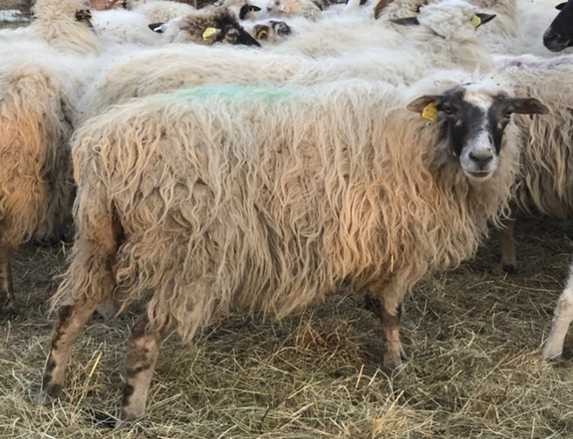

Fig. 1. Lička pramenka- noticeable open fleece with curly locks (Photography by Maja Popović, PhD, Full professor)

Lička pramenka becomes sexually mature relatively late, at the age of 8 to 12 months, and first breeding occurs at the age of 1.5 year on average (VINCE et al., 2017). It is seasonally polyestrous short days breed, with melatonin being the main signal for sexual season. Sheep enter the season by the end of July and remain is season until December. Majority of sheep, however, enter the season by the end of August and during September. Estrous cycle last approximately 17 days. Estrus lasts 36 hours on average (18-72 hours) and is usually hard to notice in the absence of marked rams. Sometimes standing reflex can be observed as an indicator of heat. Ovulation is spontaneous and occurs 27 hours after estrus’ onset (20-40h) (VINCE et al., 2017). Pregnancy lasts for 150 days. Ewes usually give birth to two lambs (Fig. 2.). Average milk yield is 120-150 L during lactation (GRGAS, 2014). At the age of 3-4 months and average body weight of 25-30 kg, male and female lambs are usually slaughtered. This meat is of optimal quality, and it is known worldwide as “Lička janjetina” (GRGAS, 2014). Meat quality comes from special management and feeding habits.

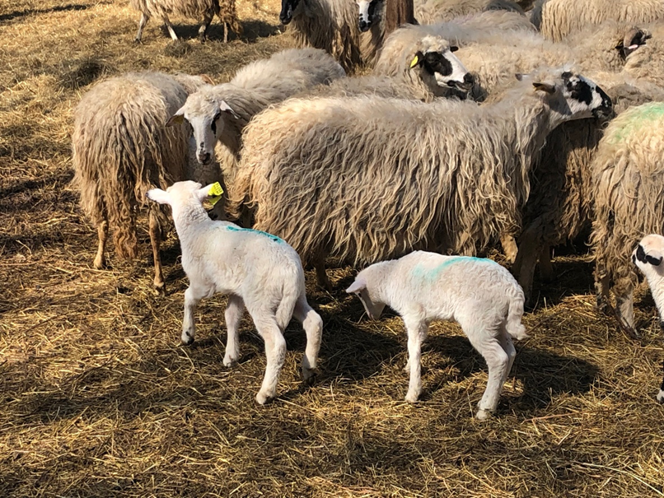

Fig. 2. Sheep with two lambs (Photography by Maja Popović, PhD, Full professor)

Lička pramenka is even nowadays kept in traditional manner in small households and is very important for sustainable production and rural economy of Croatia. During history, this breed has justified its beneficial effect on inhabitants of very hard areas with harsh mountain climate and a relatively short vegetation period and is an irreplaceable source for many traditional clothing items (BARAĆ et al., 2011). Breeding and use of lička pramenka is a part of traditional products of Lika and Gorski kotar, which are efficiently integrated in folklore and touristic offer of that area (BARAĆ et al., 2011). It is raised on open pastures in mountainous areas of Lika region, where pasture is abundant during summer, and nutrition is meagre during winter. Sheep stay on the same area for the whole year, and are therefore very physically active, very strong, disease-resistant and modest in terms of their accommodation and nutritional requirements (UREMOVIĆ et al., 2002). Being raised and pastured on karst plains, with special botanical composition of the meadows and pastures, along with physical activity, is what gives the meat special aromatic profile and color.

In recent years, there has been a trend of some intensification of management, regarding veterinary management and herd health control.

*1.2. Herd health control*

Even though there is no common conclusion about integrating animal health and production programs (CONSTABLE et al., 2017), monitoring of herd health on regulatory basis must be seen as an opportunity to improve profitability and sustainability of the agricultural enterprise while addressing animal welfare at the same time. Some recent studies have failed to identify beneficial effect of such programs on overall farm efficiency, but in dairy sector (DERKS et al., 2014a; DERKS et al., 2014b).

As described in CONSTABLE et al. (2017), herd examination is necessary in the cases of outbreaks of disease, or problems of population productivity caused by subclinical disease. The integrated animal health and production management program emphasizes the importance of its management system, with the assumption that an optimized production system leads to a healthy herd. There is no single protocol for herd examination, for it depends on the type of disease or problem, which are usually multifactorial in origin. Once it is established that clinical illness is a result of disease, clinical examination is essential. Laboratory examination can follow and aid clinical examination in the making of diagnosis, or in the defining of the risk factors. In addition, it can help to evaluate the efficiency of treatment and control strategies. Usually, laboratory examination of samples taken during clinical examination helps establish the presence and severity of organ dysfunction. Hematological and biochemical tests are an important tool for evaluation of nutritional and health status of farm animals and almost indispensable in organic farming, where allowed veterinary interventions are strictly regulated and limited in scope (ŠIMPRAGA et al., 2013). The hematological data refer to cellular elements and their alterations, and also include quantitative and qualitative assessments of red and white blood cell series and morphological data relating to changes to cells. This data can assist clinicians in diagnosing various diseases and pathological conditions (GALLO et al., 2017).

*1.3. Blood*

Blood makes up about 8 to 10 % of the body weight and its two main components are the blood plasma, the fluid part, and the blood cells, consisting out of erythrocytes, leucocytes and thrombocytes. The fluid part is known as blood plasma that makes 55 % of total blood volume and the rest comprises the cellular components or the formed elements. When a blood sample is centrifuged, it is separated into different layers, based on their density. Three complete layers are visible after centrifugation. The bottom layer is red in color due to presence of red blood cells (RBCs). A white band is formed in the middle layer, which is also known as buffy coat and it is made up of white blood cells (WBCs) and platelets. The third or the top layer is a straw colored liquid containing blood plasma, which consist of 92% water, 7% of plasma proteins and 1% other substances. It is mostly composed of dissolved proteins, mineral ions, glucose, clotting factors, oxygen and carbon dioxide. It circulates dissolved nutrients (amino acids, fatty acids and glucose) and removes waste products (carbon dioxide, lactic acid and urea) from the body. Other components of blood plasma are serum albumin, lipoprotein particles, immunoglobulins, electrolytes, etc. (KLEIN, 2013).

The blood in the body has two main functions. The major function of blood is transportation. Blood transports O2 and CO2, ions, energy sources and building blocks such as glucose, amino acids, and lipids, as well as waste products, such as urea. Hormones, which regulate various cellular processes, are primarily transported to their sites of action by the blood (SJAASTAD et al., 2010; THRALL, 2012; REECE, 2015). The second important task of the blood is to maintain homeostasis in the body. Therefore, blood regulates body temperature by distributing the heat produced by the chemical activity of the cells evenly, throughout the body. It is also responsible for the regulation of the blood pressure and the pH in the circulatory system. The third function of blood is to be one of the first defense mechanisms against the invasion of microorganisms and their toxins due to phagocyte action of neutrophils and monocytes and presence of antibodies and antitoxins (SJAASTAD et al., 2010; REECE, 2015).

*1.4. Erythrocytes*

Erythrocytes or RBCs are cells responsible for oxygen transport to tissues. They are the most numerous cells, whose physiological range depends on species, and is measured in 1012/L. Erythrocytes from all mammals are anucleated, and most are in the shape of biconcave discs called discocytes. The biconcavity causes stained RBCs to appear to have a central, pale area. Species with smaller erythrocytes, such as the cat, horse, cow, sheep, and goat, have less concavity and thus, little to no central pallor (HARVEY, 2009). There are significant differences between individuals of the same species, and even within the same breed, because various factors such as sex, age, physical activity, nutritional status, pregnancy, lactation state, altitude, and emotional state all affect erythrocyte number (ADILI et al., 2017). In addition, their morphology differs in different species, especially regarding size, shape, amount of central pallor, tendency to form rouleaux, presence of basophilic stippling in regenerative response to anemia, and the presence of reticulocytes in response to anemia (ADILI et al., 2017). Variation in erythrocyte size is termed anisocytosis and is measured by RBC distribution width (RDW) (BARGER, 2010). This variation may be the result of the presence of large cells (*i.e.* macrocytes), small cells (*i.e.* microcytes), or both. Mild to moderate anisocytosis is normal in ruminants (HARVEY, 2009). Therefore, typical blood smear of sheep includes physiological different size of erythrocytes (Fig. 3.).

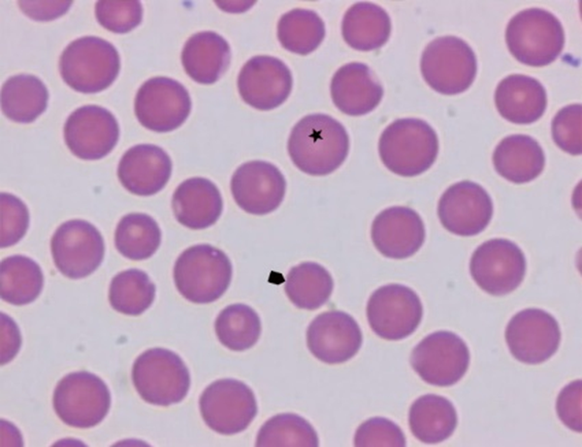

Fig. 3. Physiologic anisocytosis of erythrocytes in sheep (star: the largest erythrocyte; arrow: one of the smallest erythrocytes)

The production of erythrocytes is known as erythropoiesis. Before birth, erythrocyte formation occurs in the liver, spleen, and bone marrow. During the postnatal, growth, and adult periods, erythropoiesis is restricted almost exclusively to the bone marrow (REECE, 2015). As an erythrocyte matures in the red bone marrow, especially in mammals, it extrudes its nucleus and most of its other organelles. During the first day or two that it is in the circulation, an immature erythrocyte, known as a reticulocyte, will still typically contain remnants of organelles. Reticulocytes should comprise approximately 1-2% of the erythrocyte count and provide a rough estimate of the rate of RBC production, with abnormally low or high rates indicating deviations in the production of these cells. These organelle remnants, primarily of networks of ribosomes, are quickly shed, however, whereas mature, circulating erythrocytes have few internal cellular structural components. Lacking mitochondria, for example, they rely on anaerobic respiration. This means that they do not utilize any of the oxygen they transport, so they can deliver it all to the tissues. They also lack endoplasmic reticula and do not synthesize proteins (OLVER et al., 2010). Erythrocytes do contain some structural proteins that help the blood cells maintain their unique structure and enable them to change their shape to squeeze through capillaries. This includes the protein spectrin and actin, cytoskeletal proteins (THRALL, 2012). Erythrocytes are composed of 61% water, 32% protein (mostly hemoglobin), 7% carbohydrates, and 0.4% lipids. Isolated RBC membranes in most animals are composed of approximately 20% water, 40% protein, 35% lipid and 6% carbohydrate (OLVER et al., 2010; ADILI et al., 2016)

Erythrocytes are biconcave disks, plump at their periphery and very thin in the center. Since they lack most organelles, there is more interior space for the presence of the hemoglobin molecules that transport gases. The biconcave shape also provides a greater surface area across which gas exchange can occur, relative to its volume; a sphere of a similar diameter would have a lower surface area-to-volume ratio. In the capillaries, the oxygen carried by the erythrocytes can diffuse into the plasma and then through the capillary walls to reach the cells. On the other hand, at the same time carbon dioxide produced by the cells as a waste product diffuses into the capillaries to be picked up by the erythrocytes. Capillary beds are extremely narrow, slowing the passage of the erythrocytes and providing an extended opportunity for the gas exchange to occur. However, the space within capillaries can be so tiny that, despite their own small size, erythrocytes may have to fold in on themselves if they are to make their way through. Their structural proteins like spectrin are flexible, allowing them to bend over themselves to a surprising degree, then spring back again when they enter a wider vessel. In wider vessels, erythrocytes may stack up much like a roll of coins, forming a rouleaux, from the French word for “roll.”

The life span of erythrocytes varies between species. For adult ruminants, it varies between 125 to 160 days (ovine 70 to 150 days), and is the longest life span between domestic animals (horse 140 to 150 days, pigs 75 to 95 days, dogs 100 to 120 days, and 70 to 80 days in cats) (REESE, 2015; ADILI et al., 2016). As RBCs age, they encounter several metabolic changes regarding their membrane and shape: membrane becomes more fragile and rigid, and they change their shape form discoidal to poorly deformable spherocyte. Approximately 10% of erythrocytes undergo intravascular hemolysis, and the majority is selectively removed from the blood by macrophages in spleen, liver and bone marrow (D'ALESSANDRO et al., 2013; REECE, 2015).

*1.5. Hematological analysis and parameters*

The hematological parameters that should be measured are those recommended by the International Committee for Clinical Pathology Harmonization and include RBC count, hemoglobin (Hgb) and packed cell volume (PCV) or hematocrit (HCT), RBC indices: mean corpuscular volume (MCV), mean corpuscular hemoglobin (MCH), mean corpuscular hemoglobin concentration (MCHC), RBC morphology, white blood cell count (WBC), absolute differential WBC count: neutrophils (mature and band cells), lymphocytes, monocytes, eosinophils, basophils and thrombocytes (platelets, PLT). In addition, RBC distribution width (RDW) and mean platelet volume, platelet distribution width may sometimes be useful to assess changes in RBC populations and PLTs, respectively. According to the results obtained, the clinician gets an insight on the general state of the animal, potential hemopoietic disturbances, bacterial or viral infections, nutritional state of the individual animal and possible exposure to toxic substances (TVEDTEN, 2010).

*1.6. Packed cell volume (PCV) or hematocrit (HCT)*

Hematocrit is a relative proportion of blood cells to plasma and is measured by centrifugation. It can be measured in a column of blood after centrifugation in a microhematocrite tube and measured on reading device as a microhematocrit card reader, and then it is called microhematocrit (THRALL, 2012). The erythrocyte mass occupies lower portion of thus centrifuged blood, and is known as PCV (REECE, 2015). Furthermore, it can be calculated by automated hematology analyzer, in order to avoid the need for microhematocrit centrifugation. Formula for calculation of hematocrit is:

(MCV x 10-15 L) x (RBC x 1012 L) = HCT

where MCV is mean corpuscular volume (THRALL, 2012).

*1.7. Hemoglobin (Hgb)*

Hemoglobin is an iron-porphyrin-protein complex (OLVER et al., 2010). The hemoglobin molecule occupies a central role in physiology: the heme-part is responsible for the oxygen transportation and the globin-part binds carbon dioxide and transports this molecule through the blood system towards the lungs. Hemoglobin consists of four folded chains of a protein called globin, designated alpha 1 and 2, and beta 1 and 2. Each of these globin molecules is bound to a red pigment molecule called heme, which contains an ion of iron (Fe2+) (Fig. 4.). Therefore, one molecule of hemoglobin contains four iron atoms and can carry four molecules of oxygen. The iron atom of heme has a valence of +2 (Fe2+, ferrous) regardless of whether molecular oxygen is combined with it. Because of the presence of hemoglobin, blood can transport about 60 times more oxygen than it would be possible by its simple solution (REECE, 2015). Hemoglobin molecule is approximately 64 kDa in molecular weight, and the entire molecule is, therefore a globular tetramer. This globular structure permits a cooperative interaction of oxygen binding that gives the sigmoid oxygen-Hgb saturation curve (OLVER et al., 2010).

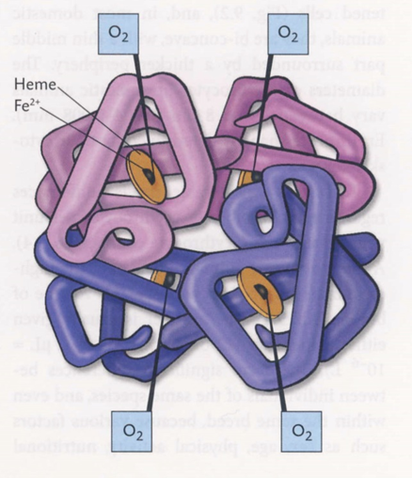

Fig. 4. Structure of hemoglobin molecule (source: SJAASTAD et al., 2010)

In the lungs, hemoglobin picks up oxygen, which binds to the iron ions, forming oxyhemoglobin. The bright red, oxygenated hemoglobin travels to the body tissues, where it releases some of the oxygen molecules, becoming darker red deoxyhemoglobin, sometimes referred to as reduced hemoglobin. Oxygen release depends on the need for oxygen in the surrounding tissues, so hemoglobin rarely hardly ever leaves all of its oxygen behind. In the capillaries, carbon dioxide enters the bloodstream. About 76% dissolves in the plasma, some of it remaining as dissolved CO2, and the remainder forming bicarbonate ion. About 23–24% of it binds to the amino acids in hemoglobin, forming a molecule known as carbaminohemoglobin. From the capillaries, the hemoglobin carries carbon dioxide back to the lungs, where it releases it for exchange of oxygen (KLEIN, 2013; REECE, 2015).

In domestic animals, except pigs, it is normal for two or more types of Hgb molecule to occur. Sheep normally have HgbA, but in severe anemia, they can synthetize HgbC, like goats also (BYERS and KRAMER, 2010). The normal RBCs hemoglobin concentration in sheep is 15 g/dL (ADILI et al., 2017).

*1.8. Erythrocyte indices*

Because hemoglobin is localized inside RBCs, it is possible to derive several clinically useful relationships among the blood Hgb content, RBC count, Hgb content of each RBC, and HCT (KLEIN, 2013). Erythrocyte indices are calculated after the RBCs have been enumerated and HCT and Hgb concentration determined. There are three indices, and each relates to a value for a single RBC, and they are shown as follows:

1. *MCV = mean corpuscular volume*, or mean cell volume (fL): as the erythrocytes are counted, their size distribution is simultaneously constructed, and from this size distribution, the MCV is easily calculated. It is a measure of RBC size and represents the volume of a single erythrocyte (HARVEY, 2009). It can be calculated from RBC and hematocrit formula:

MCV= HCT/ RBC (1012/L)

The RDW is a mathematic index describing the relative width of the size distribution curve. It is the standard deviation of most the erythrocytes divided by the MCV (THRALL, 2012). These values are used for evaluation of anemia, when there is accumulation of micro and macrocytic erythrocytes. Those changes reflect on RDW and shift MCV from physiologic range, which is 25-35 fL for sheep (THRALL, 2012).

2. *MCH = mean corpuscular hemoglobin* (pg) indicates the weight of hemoglobin in an average RBC. It is calculated by formula:

MCH= Hgb (g/L)/RBC (1012/L),

but is seldom used (THRALL, 2012), and usually changes in proportion with MCV (HARVEY, 2009).

3. *MCHC = mean corpuscular hemoglobin concentration*: provides an index for the quantity of hemoglobin relative to the volume of packed erythrocytes, expressed as g/dL or g percent. It is calculated as:

MCHC = (Hgb/HCT) x 100.

A universal relationship among mammalian species is that the hemoglobin value normally is approximately one-third of the hematocrit value. Thus, from the relationship described, the MCHC for all mammalian species ranges from approximately 33 to 38 g/dL. However, the MCHC is not particularly useful for clinical interpretations, it is useful to laboratorians for monitoring instrument performance (THRALL, 2012).

*1.9. Morphometry of erythrocytes*

Morphometry is the measurement of various cell parameters microscopically. Until recently, morphometric studies of red blood cells were essentially based on linear measures of erythrocytes size. Using an ocular micrometer and a lens micrometer (micrometric slide), it is the only valid and recognised method to measure the size of erythrocytes (ADILI et al., 2017). Its detection is routinely performed by subjective microscopic evaluation, which is difficult and strongly dependent on the operator’s expertise. The morphometric studies of erythrocytes performed by sophisticated and advanced software are more appropriate and more precise than conventional measurements with the ocular micrometer. In addition, it is the automated methodology to analyze erythrocyte cell shape support, improve the operator’s capability and expedite measurements (ALBERTINI et al., 2003). It provides a numerical objectification of the most subtle modifications unable to be estimated visually, and as such has clinical and research applications that are becoming more numerous, especially in cytology and histopathology (RUSSACK, 1994; POLJIČAK-MILAS et al., 2009; PARMAR et al., 2015; ADILI et al. 2017). A typical image analysis system consists of a microscope, a high-quality video camera and colour monitor, and a microcomputer. The light microscopic image is converted to an analogue electronic signal by the video camera. This signal is then digitized by an imaging board in the microcomputer, resulting in a matrix of picture elements called pixels (BARTELS and THOMPSON, 1994). Whereas the human eye can distinguish 30 to 40 shades of gray, 256 shades can be distinguished by each pixel (KISNER, 1988). Morphometry is the simplest form of image cytometry and refers to the evaluation of cells or tissue by the measurement of various cellular features, in a two-dimensional view (POLJIČAK-MILAS et al., 2009). Furthermore, changes in morphometrical erythrocyte indicators have been detected in certain human (MANJUNATHA and SINGH, 2000; ZAETS et al., 2003; PARMAR et al., 2015) and dog ailments (BEREZINA et al., 2001). Furthermore, morphometric studies of red blood cells showed several morphological changes; the most important is due to age and breed (DAL'BÓ et al., 2015; ADILI et al., 2016). In addition, the age, sex and altitude have a profound effect on the morphometry of red ovine’s and caprine’s blood cells (ADILI and MELIZI, 2013). BUSLOVSKAYA et al. (2013) defined the set of changes of several morphometric and functional parameters of red blood cells and white blood cells, a characteristic of different adaptive reactions of the chickens’ organism. The changes in erythrocyte morphometric indicators determine their functional properties and reflect the state of both erythrocyte and cell membranes. Moreover, changes in erythrocyte morphometry may serve as an indicator of conduct therapy efficiency. Erythrocyte indices are an additional characteristic of the morphological and functional properties of erythrocytes. The oxygen-binding and oxygen-transporting properties of haemoglobin depend on the morphofunctional state of erythrocyte membranes (NIKINMAA, 1997; REVIN et al., 2017).

*1.10. Erythrocyte subpopulations*

RBC senescence has so far been investigated through the isolation of RBC populations of different mean cell ages. Most of the researches have been conducted on erythrocytes separated on the basis of differences in cell density or volume/size (BOSCH et al., 1992; CONNOR et al., 1994). Of the various techniques used, only a handful have found extensive application in basic science studies: plain centrifugation, angle-head centrifugation, and the use of several discontinuous gradients, which result in variably efficient separation. The use of a Percoll gradient has proven to be an easy and efficient way of separating RBC (BOSCH et al., 1992; CONNOR et al., 1994; D'ALESSANDRO et al., 2013). Nevertheless, it has been suggested that density is not a good criterion to determine RBC age and it has been proposed that separation exploiting differences in RBC volumes through counterflow centrifugation might yield better results. However, a direct comparative study concluded that each of the separation approaches holds specific advantages over the other and both are characterised by one major drawback, that is, the poor yield (low RBC numbers) in every fraction. Studies have been conducted over the years addressing the peculiar characteristics of RBC subpopulations, from younger to older fractions. RBC aging has been reported to correlate with decreased cell volume, size and mean corpuscular volume (VAN OSS, 1982; BOSCH et al., 1992), increased mean corpuscular hemoglobin concentration (BOSCH et al., 1992) and cell deformability (D'ALESSANDRO et al., 2013).

Data from RBCs morphometric size and shape parameters in Pramenka sheep breed in general have not been investigated and only some RBCs morphometric size parameters such as diameter, circumference, and the surface of erythrocytes in sheep have been determined. In addition, to the best of our knowledge, there is no data in the recent literature on the analyses of red ovine’s blood cells subpopulations regarding the morphometric size and shape parameters, both approaches using computer-assisted image analysis of RBC morphology and multivariate statistical methods, including discriminant and cluster analyses.

**2. HYPOTHESIS (GENERAL AND SPECIFIC GOALS)**

The hypothesis of this research was based on the assumption that there might be a connection between RBCs morphometric parameters and hematologic parameters (Hgb, HTC, MCV, MCH, MCHC and RDW).

General goals of this research were to investigate the connection between RBCs morphometric parameters and haematologic parameters as well as to investigate the distributions of RBCs subpopulations in categorized RBCs groups by age and values of haematological parameters in Pramenka sheep breed. By thus established definition of ovine RBCs morphology as well as the connection between RBCs morphometric parameters and haematologic parameters, RBCs morphometry may have important applications and become part of standard procedures in diagnostic interpretations and treatments of haematologic disorders in small ruminants.

Specific goals:

1. To determine the values of haematologic parameters in Pramenka sheep breed.
2. To determine the values of RBCs morphometric size and shape parameters in Pramenka sheep breed.
3. To form the RBCs groups by categorizing continuous variables such as sheep age and some analysed values of haemathological parameters (Hgb, HCT, MCV, MCH, MCHC and RDW).
4. To compare the mean and standard error values of the RBCs morphometric parameters between RBCs groups formed by categorization of age and values of haematological parameters in Pramenka sheep breed.
5. To determine the RBCs subpopulations/clusters by multi-variate statistical methods, including discriminant and cluster analyses.
6. To determine the distribution/proportion of subpopulations of ovine erythrocytes in categorized RBCs groups by age and values of haematological parameters.

**3. MATERIALS AND METHODS**

*3.1. Ethics and welfare approval statement*

All procedures used in this research were in compliance with the European guidelines for the care and use of animals in research (Directive 2010/63/EC) and approved by the Committee for Ethics in Veterinary Science, Faculty of Veterinary Medicine, University of Zagreb, Croatia (records No.: 640-01/16-17/54; file No.: 251-61-01/139-16-2) and Veterinary and Food Safety Directorate, Ministry of Agriculture, Republic of Croatia (records No.: UP/I-322-01/17-01/31; file No.: 525-10/0529-17-2).

*3.2. Animals*

The research is part of the project “Innovative functional lamb meat products” financed by Croatian Science Foundation (IP-2016-06-3685). It was conducted on a sheep farm of Lička pramenka breed, in the ownership of GEA-COM Ltd., situated in Crkvina, Krnjak area, Croatia. Farm is composed of 200 sheep and 20 rams, of different age (Fig. 4).

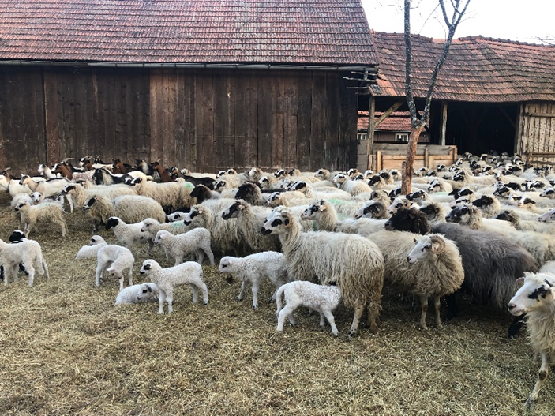

Fig. 4. Pramenka sheep breed on farm in Crkvina (Photography by Maja Popović, PhD, Full professor)

Animals are kept extensively, grazing in the field in the warmer periods of the year, and in a barn during winter, when they are fed with the hay from surrounding pastures. Independently of the season, sheep are also fed with pelleted complete feed (KUŠIĆ PROMET Ltd, product code 914106). Grass and hay from pastures in GEA-COM Ltd. property in Crkvina area were sampled during the second half of May 2018, according to the Animal feed sampling procedures from Department of Animal Nutrition, Faculty of Agriculture, University of Zagreb (HRN ISO 6498:2001), and their physical-chemical properties and energetic value were analysed (Table 1).

Table 1. Physical-chemical properties and energetic value of grass and hay from pastures in Crkvina area

|  |  |  |  |  |
| --- | --- | --- | --- | --- |
| Analysed parameters of feed samples | grass | | hay | |
| dry matter (g/kg) | 1000 | 266 | 1000 | 900 |
| ash (g/kg) | 71 | 19 | 121 | 109 |
| raw protein (g/kg) | 178.2 | 47.4 | 175 | 158.0 |
| fat (g/kg) | 44 | 12 | 63 | 57 |
| raw fibers (g/kg) | 269 | 72 | 200 | 180 |
| neutral detergent fibers (g/kg) | 554 | 147 | 418 | 377 |
| acid detergent fibers (g/kg) | 295 | 79 | 249 | 225 |
| Ca (g/kg) | 5.9 | 1.6 | 9.3 | 8.4 |
| P (g/kg) | 3.1 | 0.8 | 4.9 | 4.4 |
| K (g/kg) | 24.8 | 6.6 | 36.8 | 33.2 |
| net energy for lactation (NEL), MJ/kg | 5.81 | | 7.06 | |
| net energy for growth (NEG), MJ/kg | 5.40 | | 5.40 | |

*3.3. Study design and blood collection of sheep*

Research comprised 36 randomly chosen sheep, 2 to 5 years old, with average body weight of 35 kg. Sheep were clinically examined, and their blood was drawn for further haematological analyses. Blood for haematological analyses was collected by venepuncture of jugular vein with the vacuum-tubes with EDTA. Before the venepuncture, hair on the site of puncture was clipped off and the skin was disinfected according to the usual veterinary aseptic procedure. After the venepuncture and blood collection in vacuum-tubes, 500 µL of blood was separated in micro test tubes (BD Microtainer® Tube, K2EDTA). The samples were then stored at +4 °C and processed in the laboratory on the same day.

*3.4. Hematological analyses*

Before the analyses, blood samples were mixed in automatic mixers for 30 minutes at room temperature (20°C). Haematological analyses were performed at Department of physiology and radiobiology, Faculty of Veterinary medicine, University of Zagreb, on completely automized counter made for *in vitro* use, Abacus Junior Vet haematology analyser (Diatron, Hungary). All analyses were repeated two times, with maximal error of < 4%. Automatic sampling was performed with official reagents (Daitro Lyse_DIFF, Diatro Cleanerand Diatro-Rinse) in four phases. Haematological parameters included total white blood cells (WBC, number), lymphocyte (number and percentage), granulocyte (number and percent), erythrocyte (number), haemoglobin, haematocrit, mean corpuscular volume (MCV), mean corpuscular haemoglobin (MCH), mean corpuscular haemoglobin concentration (MCHC), red blood cell distribution width (RDW) thrombocytes (number and percent), mean platelet volume (MPV) and platelet distribution width (PDW). A smear was made from each sample for differential blood count, and was stained with panoptical method by Pappenheim with May- Grünwald and Giemsa stain. The samples are stored at the Department of physiology and radiobiology, Faculty of Veterinary medicine, University of Zagreb.

*3.5. Morphometric analysis of erythrocytes*

Erythrocyte morphometry was conducted by use of a computer-assisted program package for image analysis, SFORM (VAMSTEC, Zagreb, Croatia). The system consists of a Pulinix high-resolution colour camera (Donpisha 3CCD), which digitalizes and transfers images from an Olympus BX 41 (Olympus, Tokyo, Japan) light microscope, following observation under 100× magnification, onto a personal computer. Morphometric analysis was conducted on the blood smears stained according to Pappenheim method. A total of 36 stained blood smears were analysed, with approximately 100 erythrocytes per smear. Only erythrocytes that did not overlap with other erythrocytes or debris were measured and analysed (n=3600). The borders of the erythrocyte were marked automatically using marking option in SFORM program with manual correction using a computer mouse (Fig. 5). The following erythrocyte size morphometric variables were determined: area (μm2), outline (μm), convex, minimal and maximal radius (µm), length and breadth (μm). Some of the erythrocytes morphometric size measures were used to calculate erythrocyte shape parameters by the next formulas: ellipticity = length/breadth; elongation = [(length − breadth)/(length + breadth)]; solidity = area/convex; roundness = (4 x area)/[ π x (major axis)2 ]; form factor = [4π x area/outline2]; contour index = outline/√area.

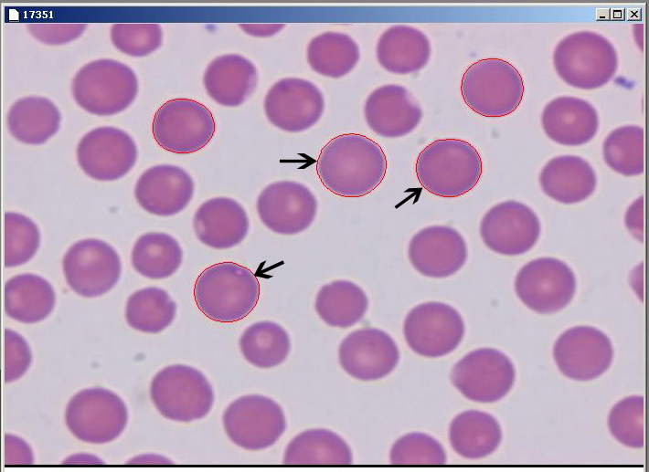

Fig. 5. Erythrocyte of Pramenka sheep breed in blood smear stained by Pappenheim method, automatically marked (arrow: automatically marked erythrocyte)

*3.6. Statistical analysis*

Statistical analyses of data were performed using the SAS 9.4 software package (Statistical Analysis Software 2002–2012 by the SAS Institute Inc., Cary, USA). Descriptive statistics were made using PROC MEANS and PROC FREQ modules. Normal distribution of data was assessed with PROC TRANSREG module. In the case of non-normality and heteroscedasticity of variances, the transformation of variables was performed by log or exponential transformation prior to analysis using the Box-Cox transformation.

Some of the erythrocytes morphometric size measures were used to calculate erythrocyte shapes by the next formulas: ellipticity = length/breadth; elongation = [(length − breadth)/(length + breadth)]; solidity = area/convex; roundness = (4 x area)/[ π x (major axis)2 ]; form factor = [4π x area/outline2]; contour index = outline/ $\sqrt{area}$.

Dependent variables were analysed by multivariate variance analysis (MANOVA) based on the Wilks lambda criterion using the GLM procedure. A multiple comparison test of the least-square means with Tukey’s correction, was performed to compare each group. Groups were formed by categorizing continuous variables such as sheep age and some analysed values of hemathological parameters (hemoglobin - HGB, hematocrit - HCT, mean corpuscular volume - MCV; mean corpuscular hemoglobin – MCH; mean corpuscular hemoglobin concentration – MCHC and red cell distribution width – RDW).

To analyse the erythrocytes subpopulations, the principal component and cluster analyses were done in several steps. The principal component analysis was performed using PROC FACTOR module, to obtain eigenvalues of the morphometric variables using Kaiser's criterion (λ≥1), and to establish the number of the main components for the next analysis. The number of clusters in K-means cluster analysis was determined using HPCLUS procedure, which selects the best k value (number of clusters or subpopulations) using the aligned box criterion value (Fig 7.). To obtain well-separated clusters with non-random initialization the FASTCLUS procedure was used. To specify the mean absolute deviation criterion and to prevent outliers from distorting the results, the FASTCLUS procedure was conducted using the LEAST and STRICT option. The last cluster analysis was done with the same procedure (PROC FASTCLUS) to assign outliers and tails to clusters using zero iterations. Although the cluster analysis has determined that the best number of clusters is four, one cluster was incorporated to the nearest cluster due to the small number of erythrocytes that formed it. To assess the differences between the groups in the distribution of erythrocytes subpopulations, the FREQ procedure was done using the Hi-squared test. The level of statistical significance was set at P < 0.05.

**4. RESULTS**

*4.1. Morphometric size and shape parameters of ovine erythrocytes*

The data of descriptive statistical analysis obtained for morphometric size and shape parameters values of erythrocytes in Pramenka sheep breed are shown in (Table 2.).

Table 2. Morphometric size and shape parameters of erythrocytes in Pramenka sheep breed – Lika strain.



ellipticity = length/bredth; elongation = [(length − bredth)/(length + bredth)]; solidity = area/convex;

roundness = (4 x area)/[ π x (major axis)2 ]; form factor = [4π x area/outline2]; contour index = outline/ $\sqrt{area}$

*4.2.* *Morphometric parameters of ovine erythrocytes in categorized groups by age and values of hematological parameters*

The mean and standard error values of the erythrocytes morphometric size and shape parameters of groups formed by categorization of age and values of haematological parameters in Pramenka sheep breed are presented in Table 3. Significantly higher values of RBCs area, outline, convex, minimal radius, maximal radius, length, breadth, were establish in Hgb 2, HCT 2, MCV 2, MCH 2 and MCHC 2 groups (groups of RBCs higher values of Hgb, HCT, MCV, MCH, MCHC, respectively) than in Hgb 1, HCT 1, MCV 1, MCH 1 and MCHC 1 groups, respectively. At the same time, the RBCs value of contour index was significantly higher in Hgb 1, MCV 1, MCH 1, MCHC 1 groups *v.s.* Hgb 2, MCV 2, MCH 2, MCHC 2 groups, respectively. In addition, significantly higher values of RBCs solidity, roundness and form factor were recorded in Hgb 2, MCV 2, MCH 2 groups than in Hgb 1, MCV 1 and MCH 1 groups, respectively. Only, the values of RBCs solidity were significantly higher in HCT 1 group than in the HCT 2 group. There were no significant differences in the values of RBCs ellipticity and elongation between the Hgb 2, HCT 2, MCV 2, MCH 2, MCHC 2, RDW 2 groups compared to Hgb 1, HCT 1, MCV 1, MCH 1, MCHC 1, RDW 1 groups. It was found that the average values of RBCs area, outline, convex, minimal radius, maximal radius, length, breadth, solidity and roundness were significantly higher in RDW 2 group (group of RBCs higher values of RDW) in comparison with RDW 1 group. There were no significant differences for the values of RBCs area, outline, convex, minimal radius, maximal radius, length, breadth, ellipticity and elongation between the AGE 1 and AGE 2 groups. At the same time, the RBCs value of solidity, roundness and form factor were recorded significantly higher in AGE 1 group (group of RBCs of younger animals) than in AGE 2 group. In addition, the RBCs value of contour index was significantly higher in AGE 2 *v.s.* AGE 1 group.

Table 3. Comparison of the mean and standard error values of the erythrocytes morphometric parameters between groups formed by categorization of age and values of hematological parameters in Pramenka sheep breed – Lika strain.



RBC – red blood cells; HGB – hemoglobin; HCT – hematocrit; MCV – mean corpuscular volume; MCH – mean corpuscular hemoglobin; MCHC – mean corpuscular hemoglobin concentration; RDW – red cell distribution width

ellipticity = length/bredth; elongation = [(length − bredth)/(length + bredth)]; solidity = area/convex; roundness = (4 x area)/[ π x (major axis)2 ]; form factor = [4π x area/outline2]; contour index = outline/ $\sqrt{area}$.

* p<0.01; ** p<0.001; *** p<0.0001

Reference values: JACKSON and COCKCROFT, 2002.

*4.3. Principal component and cluster analysis based on morphometric size and shape parameters of ovine erythrocytes*

Using the principal component analysis prior to the clustering of RBCs morphometric parameters, three characteristic components (factors) were obtained with eigenvalues greater than 1 (λ≥1), which account for the 93.8% cumulative variance of the morphometric variables (Table 4.). The first factor was represented by RBCs size (outline, convex, area, length and breadth), and the most important value for that factor was RBCs outline. The second and third factors were focused on RBCs shape (roundness, form factor, ellipticity, contour index, elongation, ellipticity and solidity), and the most important RBCs value for the second factor was RBCs roundness, whereas the most important value for the third factor was RBCs elongation. Using only one of the most important values from each factor (RBCs outline, RBCs roundness, and RBCs elongation), the aligned box criterion indicates that the best number of clusters is four. Although the cluster analysis has determined that the best number of clusters is four, one cluster was incorporated to the nearest cluster due to the small number of erythrocytes that formed it (Fig. 6.).

Table 4. Eigenvalues of each erythrocytes morphometric variable for the three principal components (factors) in Pramenka breed sheep – Lika strain.



ellipticity = length/bredth; elongation = [(length − bredth)/(length + bredth)]; solidity = area/convex;

roundness = (4 x area)/[ π x (major axis)2 ]; form factor = [4π x area/outline2]; contour index = outline/ $\sqrt{area}$

* The most important erythrocyte value for each factor (only values higher than 0.60 are shown in table).

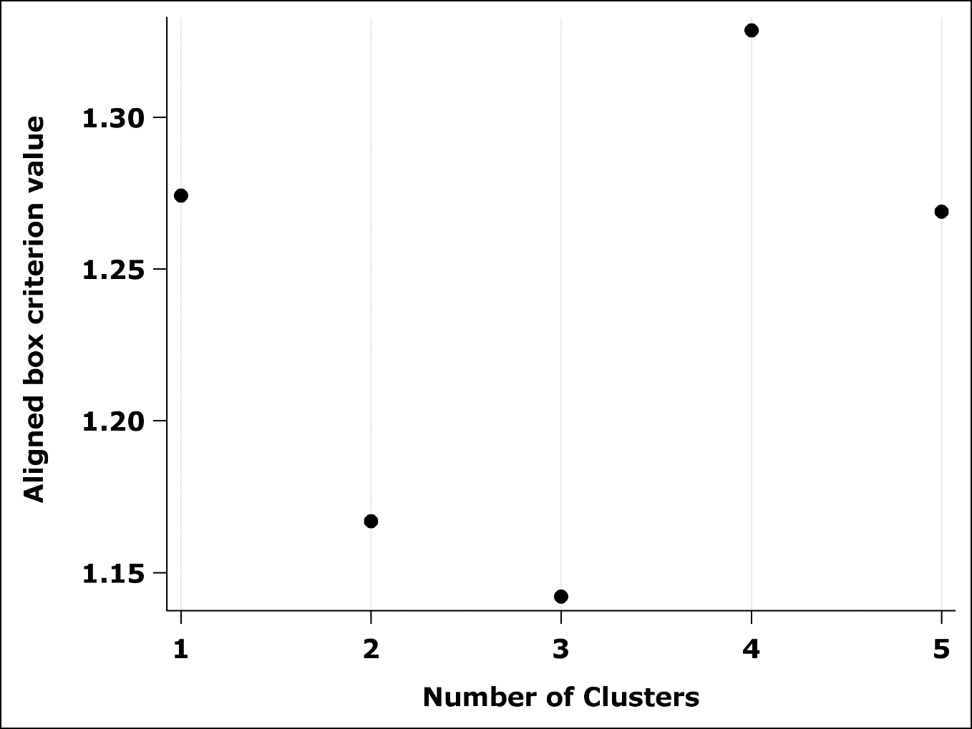

Fig. 6. Selection of the number of clusters or erythrocytes subpopulations with the aligned box criterion value.

By cluster analysis, three precisely defined RBCs clusters or subpopulations, were obtained, based on the RBCs morphometric size and shape parameters (Table 5., Fig. 7. and Fig. 8.). The first RBCs subpopulation (ES 1) comprised of the smallest and most elongated RBCs (19.5%), the second subpopulation (ES 2) comprised the biggest and most rounded erythrocytes (22.9%), and the third subpopulation (ES 3) comprised average size and shape RBCs, but with the highest proportion (57.6%).

Table 5. Erythrocytes subpopulations based on the most important erythrocyte value for each factor (mean and standard error) in Pramenka breed sheep – Lika strain.



ES 1 - The smallest and most elongated erythrocytes; ES 2 - The biggest and most rounded erythrocytes;

ES 3 - Average size and shape erythrocytes

roundness = (4 x area)/[ π x (major axis)2 ]; elongation = [(length − bredth)/(length + bredth)]

Bold values - The highest or lowest value.

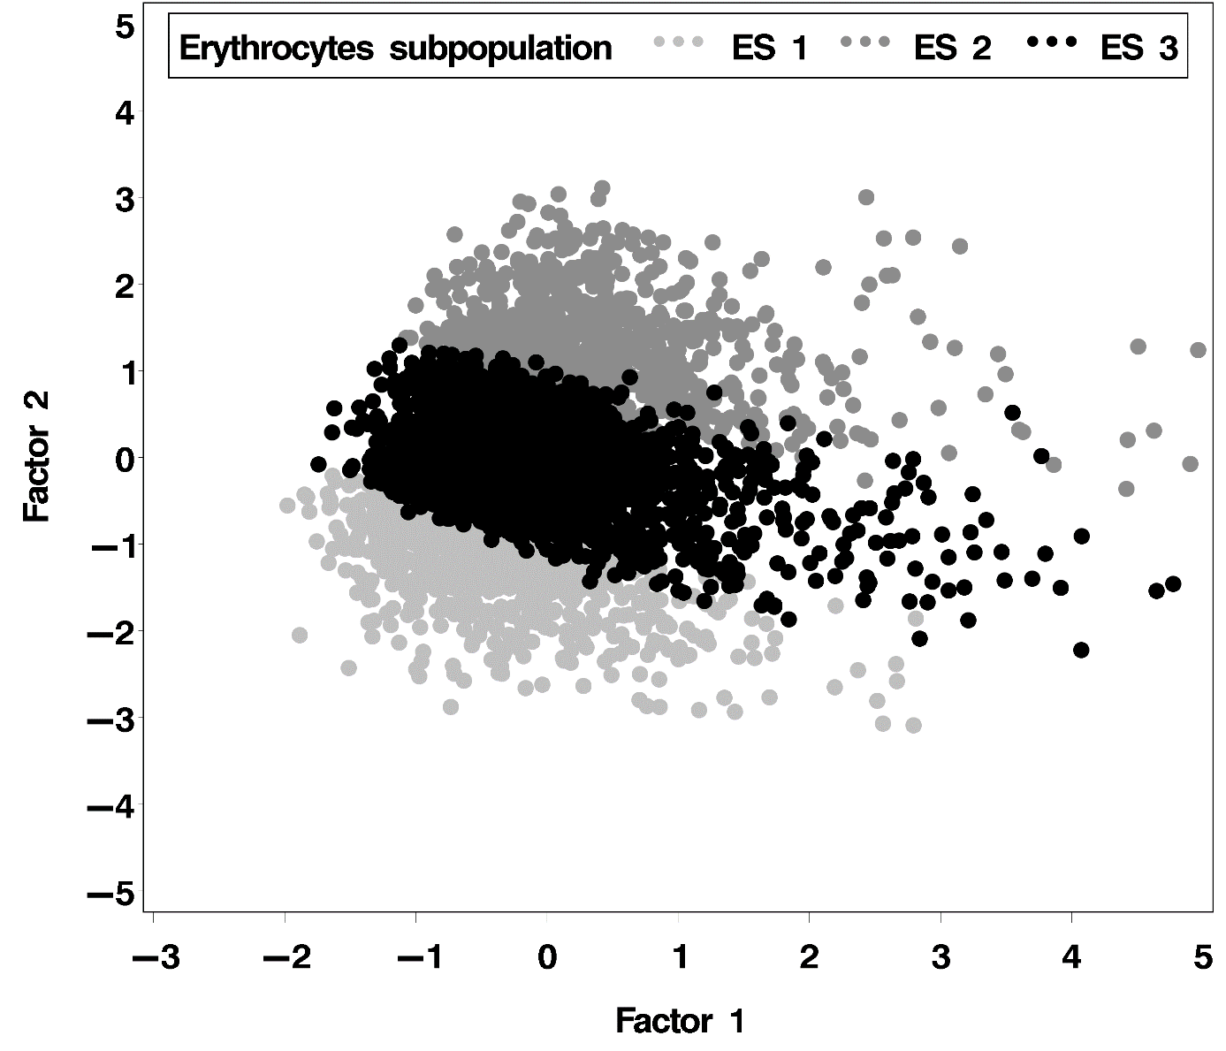

Fig. 7. Distribution of erythrocytes subpopulations (ES 1 - The smallest and most elongated erythrocytes; ES 2 - The biggest and most rounded erythrocytes; ES 3 - Average size and shape erythrocytes) according to erythrocytes size (factor 1 - outline) and shape (factor 2 - roundness) in Pramenka breed sheep – Lika strain.

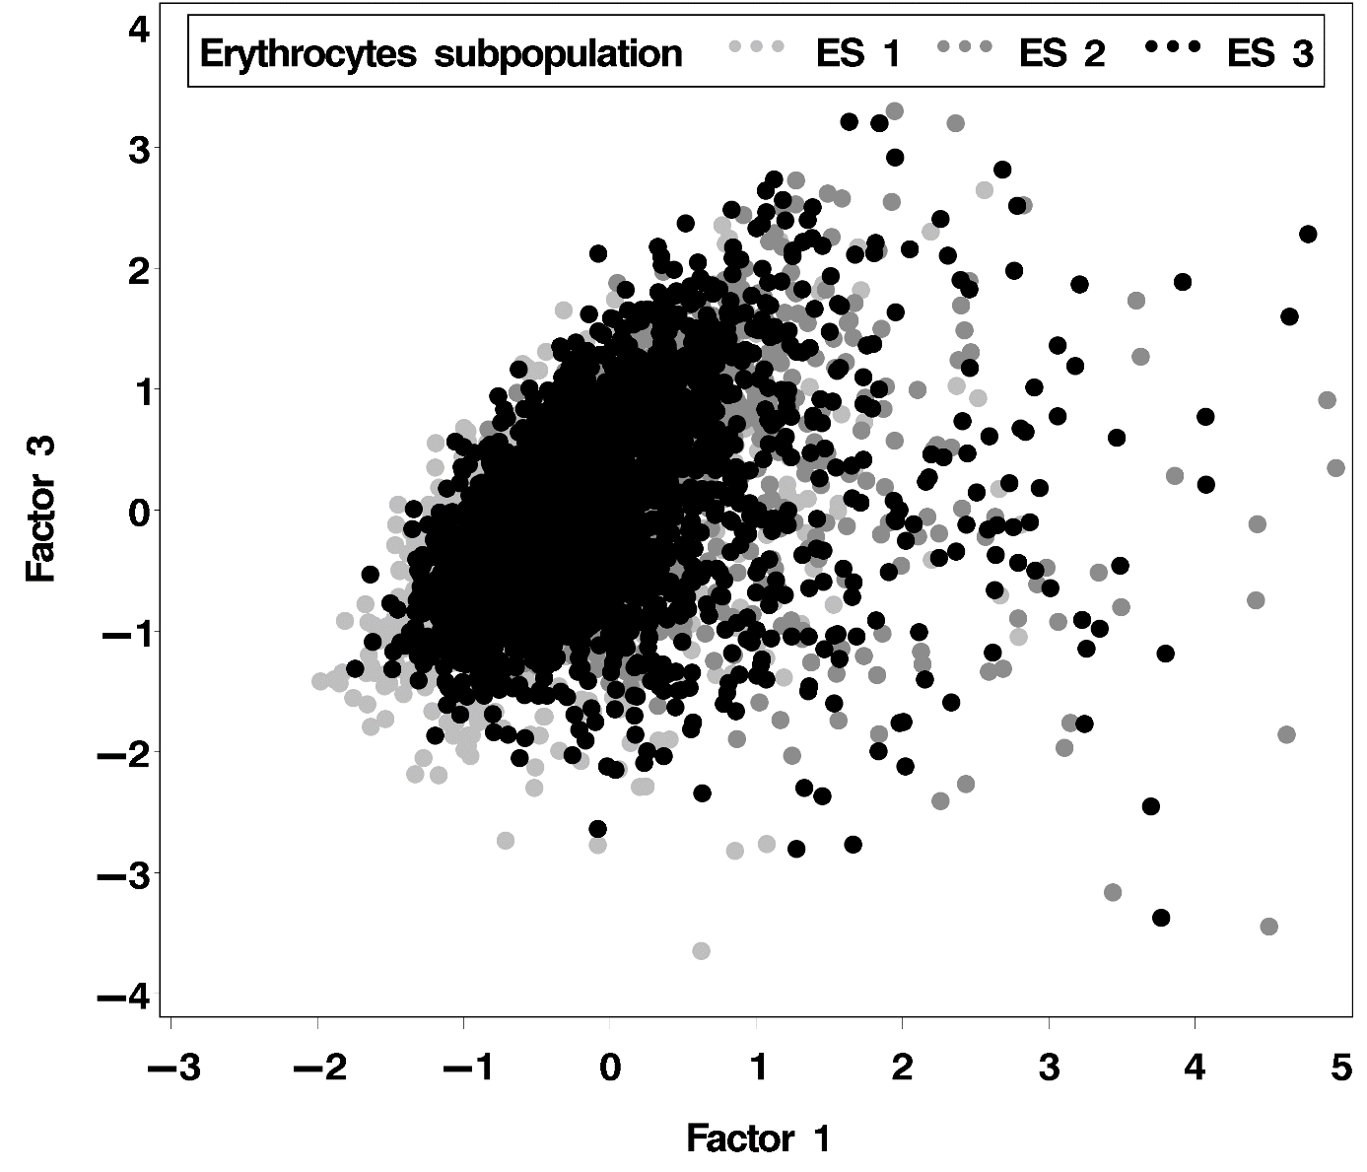

Fig. 8. Distribution of erythrocytes subpopulations (ES 1 - The smallest and most elongated erythrocytes; ES 2 - The biggest and most rounded erythrocytes; ES 3 - Average size and shape erythrocytes) according to erythrocytes size (factor 1 - outline) and shape (factor 3 elongation) in Pramenka breed sheep – Lika strain.

*4.4.* *The distribution of subpopulations* *of ovine erythrocytes in categorized groups by age and values of hematological parameters*

By testing the distribution of RBCs subpopulations according to the RBCs size and shape morphometric variables, there were a significant difference between the RBCs groups formed by categorizing of values of hemathological parameters (HGB, HCT, MCV, MCH, MCHC and RDW). Significantly higher proportion of ES 2 and ES 3 subpopulations as well as significantly lover proportion of ES 1 subpopulation were established in Hgb 2, HCT 2, MCV 2 and MCH 2 groups (groups of RBCs higher values of Hgb, HTC, MCV and MCH, respectively) than in Hgb 1, HTC 1, MCV 1 and MCH 1 groups, respectively (Fig. 9., Fig. 10., Fig. 11. and Fig. 12.). It was found that the proportion of ES 1 and ES 3 subpopulations were significantly lover while ES 2 proportion was significantly higher in the MCHC 2 than in MCHC 1 group (Fig. 13.). In addition, group of RDW 2 had significantly lover proportion of ES 2 and ES 3 subpopulations and significantly higher proportion of ES 1 subpopulation in comparison to RDW 1 (Fig. 14.). There were no significant differences in the distribution of RBCs subpopulations only between the AGE 1 and AGE 2 groups (Fig. 15.).

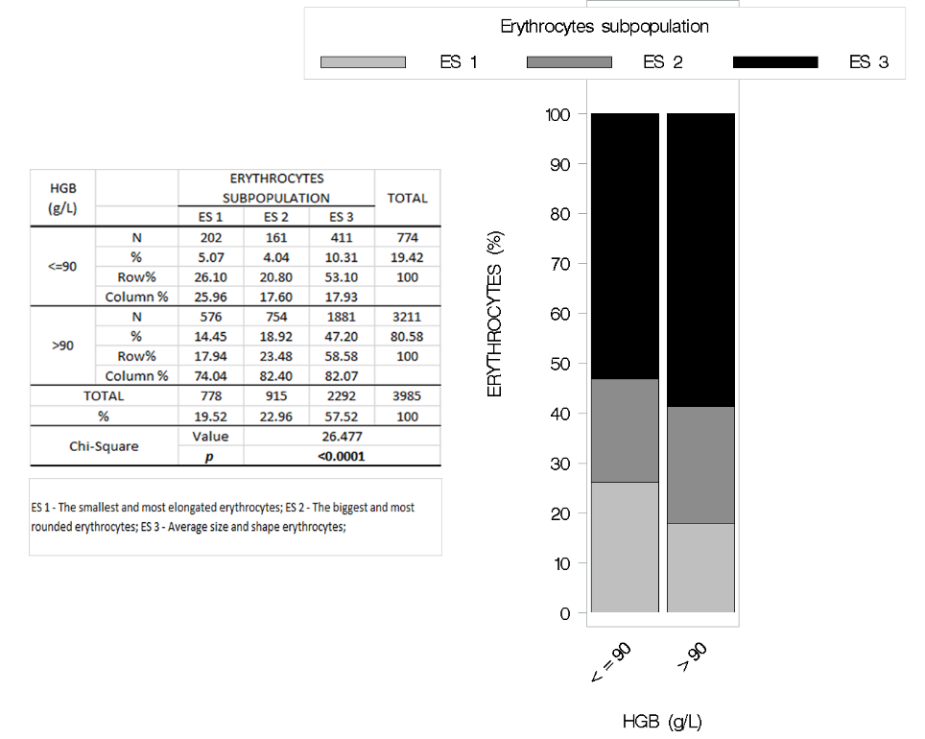

Fig. 9. Proportion of erythrocytes subpopulations (ES 1 - The smallest and most elongated erythrocytes; ES 2 - The biggest and most rounded erythrocytes; ES 3 - Average size and shape erythrocytes) in Pramenka breed sheep grouped by the concentration of hemoglobin (HGB).

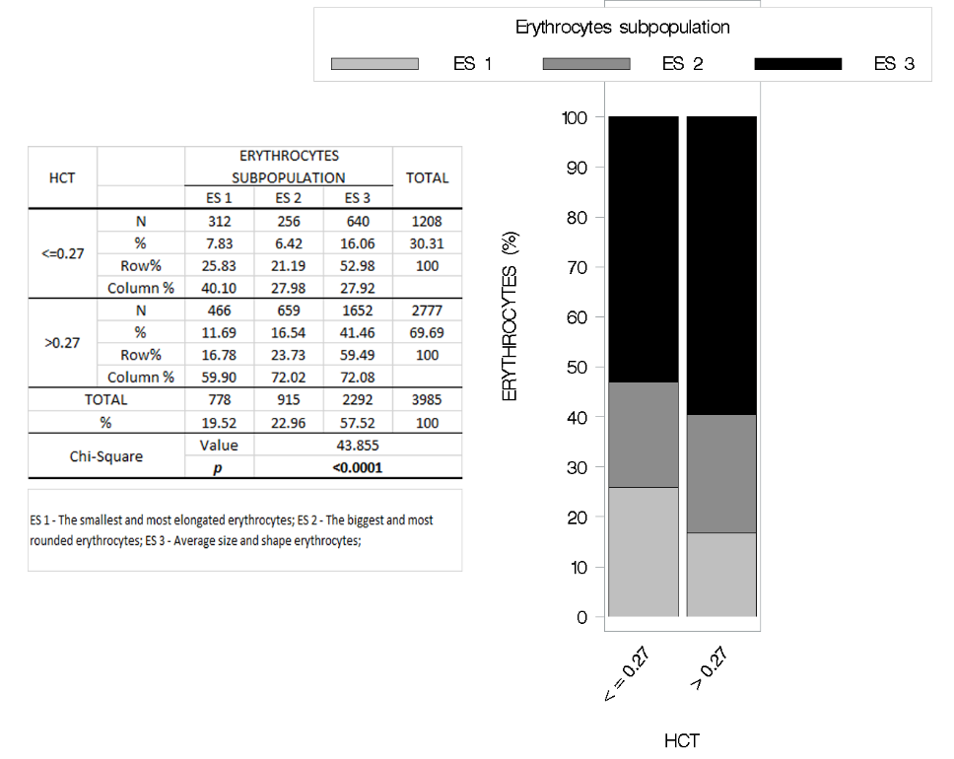

Fig. 10. Proportion of erythrocytes subpopulations (ES 1 - The smallest and most elongated erythrocytes; ES 2 - The biggest and most rounded erythrocytes; ES 3 - Average size and shape erythrocytes) in Pramenka breed sheep grouped by the hematocrit (HCT) values.

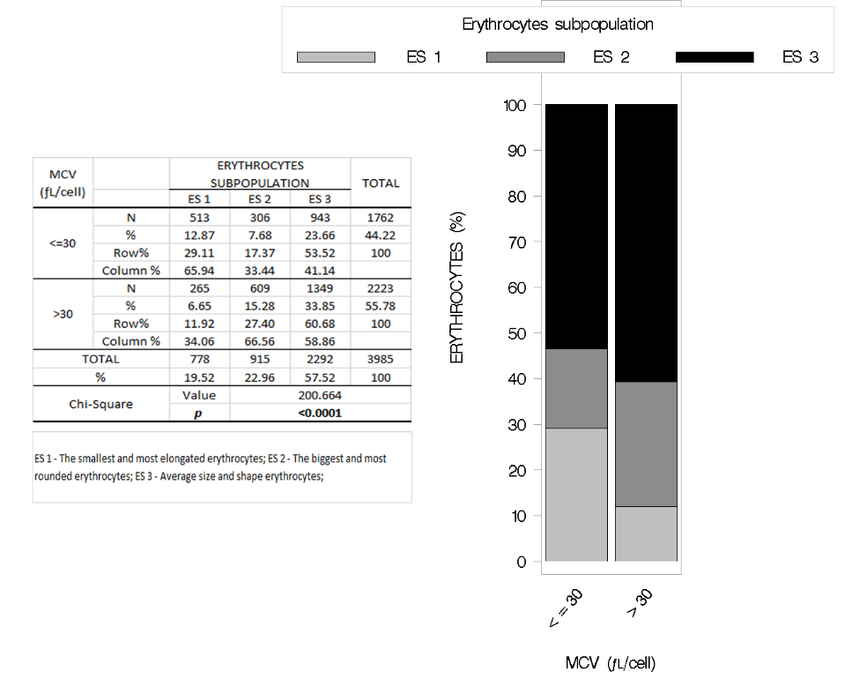

Fig. 11. Proportion of erythrocytes subpopulations (ES 1 - The smallest and most elongated erythrocytes; ES 2 - The biggest and most rounded erythrocytes; ES 3 - Average size and shape erythrocytes) in Pramenka breed sheep grouped by the mean corpuscular volume (MCV) values.

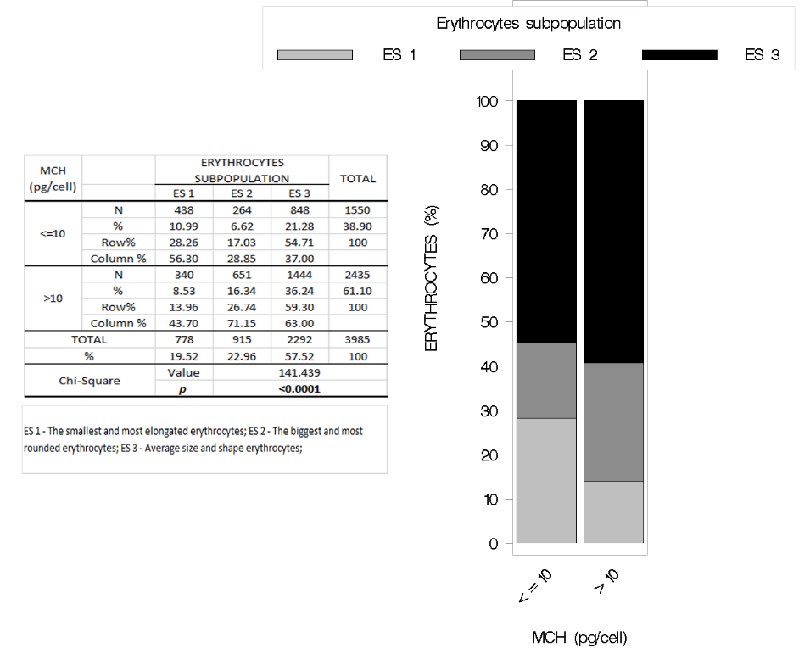

Fig. 12. Proportion of erythrocytes subpopulations (ES 1 - The smallest and most elongated erythrocytes; ES 2 - The biggest and most rounded erythrocytes; ES 3 - Average size and shape erythrocytes) in Pramenka breed sheep grouped by the mean corpuscular hemoglobin (MCH) values.

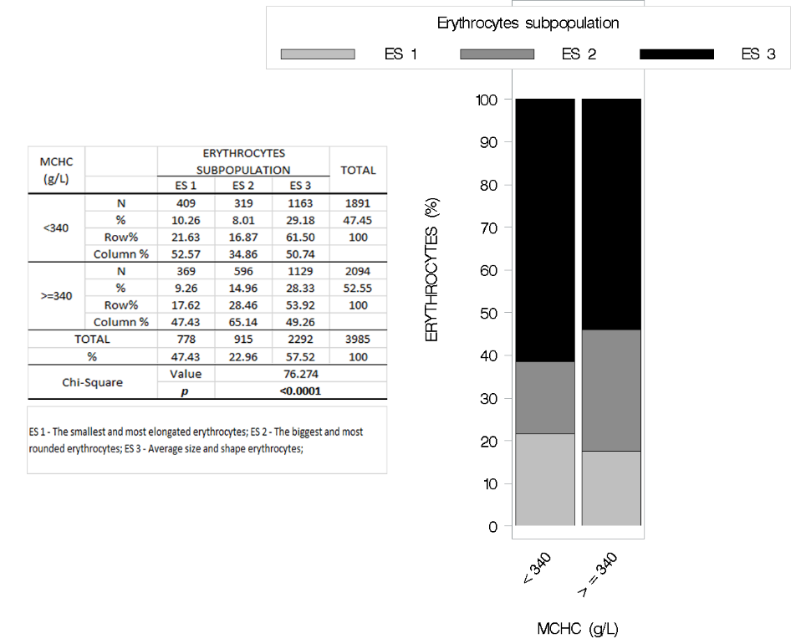

Fig. 13. Proportion of erythrocytes subpopulations (ES 1 - The smallest and most elongated erythrocytes; ES 2 - The biggest and most rounded erythrocytes; ES 3 - Average size and shape erythrocytes) in Pramenka breed sheep grouped by the mean corpuscular hemoglobin concentration (MCHC).

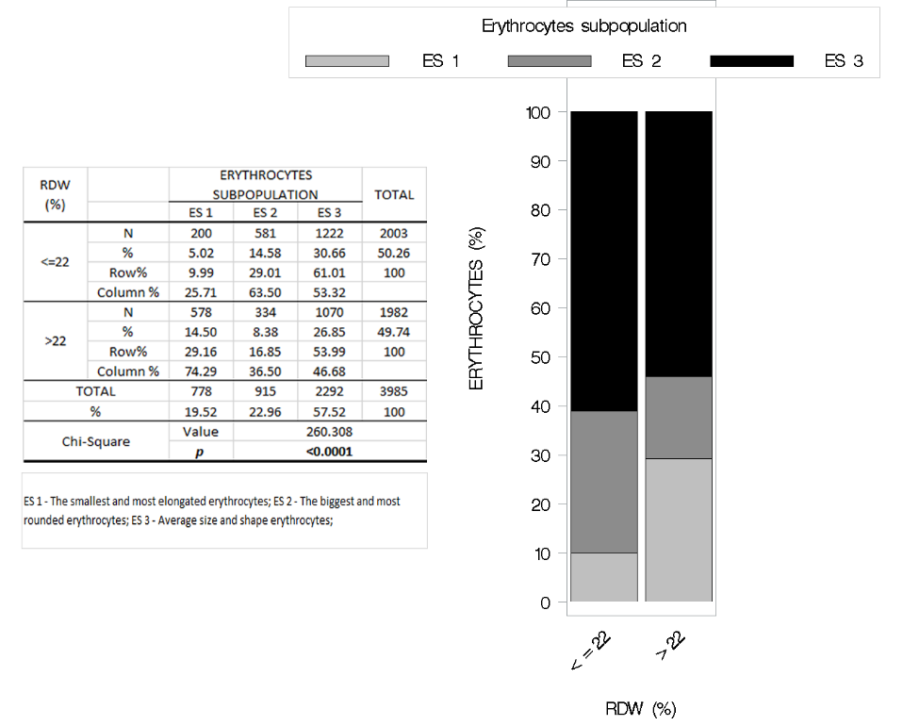

Fig. 14. Proportion of erythrocytes subpopulations (ES 1 - The smallest and most elongated erythrocytes; ES 2 - The biggest and most rounded erythrocytes; ES 3 - Average size and shape erythrocytes) in Pramenka breed sheep grouped by the percentage of red cell distribution width (RDW).

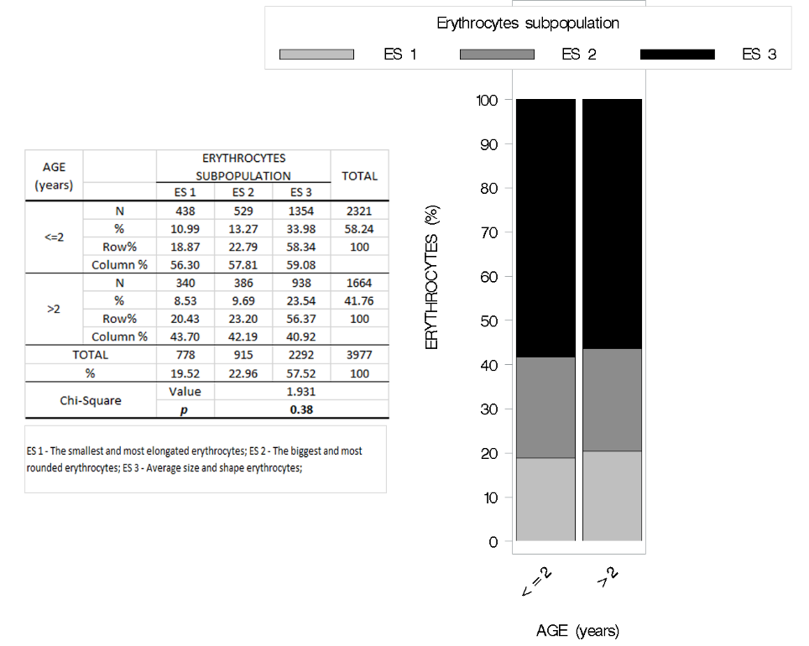

Fig. 15. Proportion of erythrocytes subpopulations (ES 1 - The smallest and most elongated erythrocytes; ES 2 - The biggest and most rounded erythrocytes; ES 3 - Average size and shape erythrocytes) in Pramenka breed sheep grouped by age.

**5. DISCUSSION**

Modification of erythrocyte morphology is clinically important in hematology and medicine. In addition, RBCs morphology is often an important aid in establishing a diagnosis regarding the cause of anemia, and it is sometimes helpful in establishing the diagnosis of other disorders as well. Its detection is routinely performed by subjective microscopic evaluation, which is difficult and strongly dependent on the operator’s expertise. Therefore, it is necessary to implement the automated methodology to analyze erythrocyte cell shape modification to support and improve the operator’s capability and expedite measurements (ALBERTINI et al., 2003; ADILI et al., 2016). The interpretation of RBCs morphology should be made in conjunction with other quantitative data from the complete blood count (THRALL, 2012).

Data from RBCs morphometric size and shape parameters in Pramenka sheep breed in general have not been investigated as well as only few RBCs morphometric size parameters (diameter, circumference, and the area) in sheep have been determined. Therefore, according to the above mentioned results of this study, most of the investigated morphometric parameters values cannot be compared. In addition, the most of the studied parameters in this study is not determined in domestic animals, and due to large differences in the morphology of RBCs between species, the obtained results can be compared with the data available for humans and other species. The morphometric study of red blood cell seems to show that the diameter, the circumference, and area of erythrocytes have a significant influence on the determination of the species of domestic animals. The RBCs size differs among animal species, so, the size of RBCs is greater in dogs followed by the horses, cattle, and sheep, respectively, whereas the goats have smaller RBCs (ADILI et al., 2016). It seems that this was an adaptive feature, because RBCs of the smallest size are greater in number. Because the sheep and goats were commonly found in regions of high altitudes with lower oxygen concentrations, the available hemoglobin was placed in a greater number of smaller packages so that a greater surface area would be available for diffusion (REECE, 2015). So, ovine RBCs are somewhat smaller than mammalian RBCs, have a diameter in 4.5 μm, width of 3.2-5μm and lifespan of 70-150 days, they do not aggregate or deform as readily as erythrocytes of other species (ADILI et al., 2016; ADILI et al., 2017). In this study, the mean and standard error values for RBCs length and breadth were 5.51 ± 0.47 μm, 4.9 ± 0.42 μm in Pramenka sheep breed, respectively. Namely, minor deviations in values of mentioned morphometric parameters in this study in comparison with ADILI et al. (2016; 2017) are likely to be related to the different ovine breed investigated in this and mentioned study. It is known that breed, age and sex are the features that affect values of morphometric parameters (ADILI et al., 2013; DAL'BÓ et al., 2015). Namely, the values of the RBCs length/diameter are almost equal to the values of THAMER et al. (2016) which obtained the values of RBCs diameter of 5.277±0.67 μm, although they had different sheep breeds included in the research from the breed included in this study. ADILI et al. (2013), also obtained similar values with regard to the ovine RBCs diameter but the values were similar to those in ewes (5.10 ± 0.22 μm), in one of the three investigated areas, while the values in the males were lower (4.58 ± 0.25 μm). In this study RBCs morphometric measurements were performed on ewes. According to the above mentioned, it could be concluded that sex, breed and altitude can have a significant effect on RBCs diameter value. The value of RBCs outline (circumference or perimeter) determined in this research (17.32 ± 1.45 μm) was quite the same to those determined by ADILI et al. (2016), but in ewes (17.08±0.81 μm) and it was lower in rams (16.70 ± 0.59 μm). Sex also seems to affect the value of RBCs outline in sheep. The value RBCs area obtained in this study (21.19 ± 3.45 μm2) does not match the values obtained by ADILI et al. (2016), namely the values of the RBCs circumference (16.89 ± 0.72 μm) and area (16.49 ± 0.97 μm2) that they had received in global (ewes and rams) were almost equal, which is surprising.

In this research, there were established differences in mean values of RBCs morphometric size and shape parameters between groups formed by categorization of age and values of hematological parameters (Hgb, HCT, MCV, MCH, MCHC and RDW) in Pramenka sheep breed. In addition, significantly higher values of RBCs area, outline, convex, minimal radius, maximal radius, length, breadth, were established in groups of higher values of Hgb, HCT, MCV, MCH, MCHC than in groups of lower values of Hgb, HCT, MCV, MCH, MCHC. The obtained results of the RBCs morphometric size parameters values determined in this study are consistent with the RAVI SARMA (1990), who stated that higher values of RBCs MCV, Hgb, HCT, MCH and MCHC are correlated with higher RBCs size. The results by ADILI et al. (2013) showed a significant influence of age on the morphometry of red blood cells, the young ovine’s RBCs being significantly larger than the adult’s RBCs. In this study, there were no significant differences for the values of RBCs area, outline, convex, minimal radius, maximal radius, length, breadth, ellipticity and elongation between the RBC groups of older and younger sheep. Namely, in the aforementioned study, only one morphometric parameter was measured, probably a RBCs diameter, besides that, no data regarding the age of younger and older animals was given. In this study, sheep were divided into two age groups, younger (1.82 ± 0.52) and older (3.08 ± 0.72), but the age difference between the groups was not so large as well as the sheep were sexually mature, and probably therefore, the difference in RBCs morphometric size value between the groups did not differ significantly. However, the RBCs morphometric shape value such as solidity, roundness and form factor were recorded significantly higher in group of RBCs of younger animals than in RBCs older group. The typical RBCs shape for multiple veterinary species is disc or biconcave disc (discoid) resulting in a high surface area to volume ration making the red blood cells deformable. The disc shape of the red blood cell facilitates gas exchange which is maybe because more hemoglobin molecules are closer to the plasma membrane than they would be in spherical cell (ADILI et al., 2017). Significantly higher values of the previously mentioned RBCs morphometric shape parameters determined in this study (RBC solidity, roundness and form factor), having values close to 1, are more like circle shape, which is according to the above, not preferred feature of the RBCs morphology. Namely, due to the significant difference in RBCs morphology in different species and scarcity of data in this area, additional studies are needed in this regard to properly interpret the determined RBCs morphometry parameters values in this study. On the other hand, the sheep in this study were clinically healthy as well as all hematologic parameters values were in the reference interval for sheep (JACKSON and COCKCROFT, 2002). Therefore, we believe that the results obtained in this research, represent a proper basis for the future evaluation of RBCs morphometric parameters in Pramenka sheep breed.

It has long been known that RBCs comprise various subpopulations, which can be, among other separated through Percoll density gradients (D'ALESSANDRO et al., 2013). However, to the best of our knowledge, there is no data in the recent literature on the analyses of RBC subpopulations in sheep regarding the morphometric size and shape parameters, both approaches using computer-assisted image analysis of RBC morphology and multivariate statistical methods, including principal component and cluster analyses. In this study, by cluster analysis, three RBCs subpopulations were obtained, based on the RBCs morphometric size and shape parameters, but with the highest proportion of average size and shape RBCs subpopulation (57.6%). In addition, the difference of the distribution of RBCs subpopulations between the RBCs groups formed by categorizing of hematological parameters values (HGB, HCT, MCV, MCH, MCHC and RDW) was established. The groups of higher values of Hgb, HTC, MCV and MCH comprised significantly higher proportion of RBCs of average size and shape, as well as the biggest and most rounded RBC subpopulations. BOSCH et al. (1992) and D'ALESSANDRO et al. (2013) observed that the humane RBC ageing has been reported to correlate with decreased cell volume, size and mean corpuscular volume, increased mean corpuscular hemoglobin concentration and cell deformability. According to the results of the aforementioned authors, it could be concluded that the groups of higher values of Hgb, HTC, MCV and MCH obtained in this study, with a significantly higher proportion of RBC average size and shape as well as the biggest and most rounded erythrocytes subpopulations, contained also a higher proportion of younger RBCs. In addition, group of higher RDW value had significantly lover proportion of the biggest and most rounded as well as average size and shape RBC subpopulations, and significantly higher proportion of the smallest and most elongated RBC subpopulation, in comparison to group with lover RDW value. It is well known that the increased value of RDW in blood sample indicate that the anisocytosis is present, furthermore, it is also known that sheep have physiological anisocytosis of erythrocyte (BYERS and KRAMER, 2010). The RDW values in blood samples of sheep in this study were within the physiological range referred by JACKSON and COCKCROFT (2002), and the obtained results give an insight into new findings related to the distribution of obtained RBC subpopulations depending on the greater or lesser RDW value. Distribution of the obtained RBC subpopulations in the formed RBCs groups is difficult to compare and explain because the data of this research, regarding to RBC morphometric parameters and RBC subpopulations were obtained and analyzed for the first time in this way, and gave a new insight into future research in this area.

**6. CONCLUSIONS**

The results clearly demonstrated that a set of selected morphometric size parameters values derived from optical microscope images, after calculations by specific formula and statistically analysed can effectively discriminate with a high degree of certainty among different shape modifications of RBCs in sheep. Also, this is the first analysis of the RBCs morphometric size and shape parameters values in Pramenka sheep breed.

This study allows us to propose a preliminary new reference values for the size and shape morphometric parameters of RBCs: area, outline, convex, minimal radius, maximal radius, length and breadth, ellipticity, elongation, solidity, roundness, form factor, contour index in Pramenka sheep breed. Both of these morphometric parameters appear most representative as to mark changes in the morphometry of RBCs.

The RBCs morphometry could serve to prevent any possible confusion in studying anemic syndromes *i.e.* could serve as a basis for the diagnostic interpretation of anemic syndromes in veterinary medicine especially concerning normocytic, macrocytic, and microcytic anemias in Pramenka sheep breed.

Based on the data obtained it can be concluded that the use of computer-assisted image analysis of the RBC morphometry and multivariate statistical methods, including principal component and cluster analysis, ovine RBCs subpopulations regarding the morphometric size and shape parameters can be obtained.

In addition, the distribution of RBCs subpopulations were significantly different between the RBCs groups formed by categorization of age and values of hematological parameters (Hgb, HCT, MCV, MCH, MCHC and RDW).

In conclusion, RBCs morphometry may have important applications and become part of the standard procedures in diagnostic interpretations and treatment of hematologic disorders in which the detection of ovine RBCs shape changes is crucial.

**7. ACKNOWLEDGMENTS**

This work has been fully supported by Croatian Science Foundation under the project “Innovative functional lamb meat products (“Inolamb”)” (HRZZ-IP-06-2016-3685).

I am very thankful to the farm managers and all the members of “Inolamb” research team for their support in sharing health records and help during the sampling process, data analysis and drafting of this manuscript.

I would also like to thank prof. Tanja Vrebalov Cindro, for proof-reading and editing of the text.

**8. REFERENCES**

1. ADILI, N., M. MELIZI (2013): The effect of age, sex and altitude on the morphometry of red blood cells in small ruminants. J. Anim. Sci. Adv. 3, 27-32.
2. ADILI, N., M. MELIZI, H. BELABBAS (2016): Morphometry and Comparison of blood samples in sheep and goat. Vet. World. 9, 960-963. doi: 10.14202/vetworld.2016.960-963.
3. ADILI, N., M. MELIZI, H. BELABBAS, A. BALA, S. MERAD, F. BOUALI, O. BENNOUNE (2017): Morphometric study of red blood cells in Sloughi and German shepherd dogs. Bulg. J. Vet. Med. 20, 125-130. doi: 10.15547/bjvm.993
4. ALBERTINI, M. C., L. TEODORI, E. PIATTI, M. P. PIACENTINI, A. ACCORSI, M. B. L. ROCCHI (2003): Automated analysis of morphometric parameters for accurate definition of erythrocyte cell shape. Cytometry A 52A,12-18. doi: 10.1002/cyto.a.10019
5. BARAĆ, Z., LJ. BEDRICA, M. ČAČIĆ, M. DRAŽIĆ, M. DADIĆ, M. ERNOIĆ, M. FURY, Š. HORVATH, A. IVANKOVIĆ, Z. JANJEČIĆ, J. JEREMIĆ, N. KEZIĆ, D. MARKOVIĆ, B. MIOČ, R. OZIMEC, D. PETANJEK, F. POLJAK, Z. PRPIĆ, M. SINDIČIĆ (2011): Green book of indigenous breeds of Croatia. Ministry of Environmental and Nature Protection, State Institute for Nature Protection; Croatian Agricultural Agency; Krka National Park; COAST / UNDP / GEF. Zagreb. Pp. 210-213.
6. BARGER, A. M. (2010): Erythrocyte morphology. In: Schalm’s veterinary hematology. 6th ed (Weiss, D. J., K. J. Wardrop, Eds.), Willey Blackwell, Ames, USA. Pp. 144-151.
7. BARTELS P. H., D. THOMPSON (1994): The Video Photometer. In: Image Analysis. A Primer for Pathologists. (Marchevsky, A. M., P. H. Bartels, Eds.). Raven Press, Ltd., New York. pp. 29-57.
8. BEREZINA, T. L., S. B. ZAETS, V. L. KOZHURA, I. S. NOVODERZHKINA, A. K. KIRSANOVA, E. A. DEITCH, G. W. MACHIEDO (2001): Morphologic changes of red blood cells during hemorrhagic shock replicate changes of aging. Shock 15, 467-470.
9. BOSCH, F. H., J. M. WERRE, B. ROERDINKHOLDER-STOELWINDER, T. H. HULS, F. L. WILLEKENS, M. R. (1992): Halie Characteristics of red blood cell populations fractionated with a combination of counterflow centrifugation and Percoll separation. Blood 79, 254-60.
10. BUSLOVSKAYA, L. K., E. Y. BELYAEVA, A. Y. KOVTUNENKO (2013): Adaptive dynamics of blood cell parameters in hens upon changes in the lighting conditions. Glob. Vet. 11, 441-445.
11. BYERS, S. R., J. W. KRAMER (2010): Normal hematology of sheep and goats. In: Schalm’s veterinary hematology. 6th ed (Weiss, D. J., K. J. Wardrop, Eds.), Willey Blackwell, Ames, USA. Pp. 836-842.
12. CONNOR, J., C. C. PAK, A. J. SCHROIT (1994): Exposure of phosphatidylserine in the outer leaflet of human red blood cells. Relationship to cell density, cell age, and clearance by mononuclear cells. J. Biol. Chem. 269, 2399-2404.
13. CONSTABLE, P. D., K. W. HINCHCLIFF, S. H. DONE, W. GRÜNBERG (2017): Veterinary medicine: A textbook of the diseases of cattle, horses, sheep, pigs and goats. 11th ed. Elsevier Ltd. Missouri, USA. Pp. 29-35.
14. DAL'BÓ, G. A., F. G. SAMPAIO, M. E. LOSEKANN, J. F. DE QUEIROZ, A. J. B. LUIZ, V. H. G. WOLF, V. T. GONÇALVES, M. L. CARRA (2015): Hematological and morphometric blood value of four cultured species of economically important tropical foodfish. Neotrop. Ichthyol. 13, 439-446.
15. D'ALESSANDRO, A., B. BLASI, G. M. D'AMICI, C. MARROCCO, L. ZOLLA (2013): Red blood cell subpopulations in freshly drawn blood: application of proteomics and metabolomics to a decades-long biological issue. Blood. Transfus. 11, 75-87. doi 10.2450/2012.0164-11
16. DERKS, M., H. HOGEVEEN, S. R. KOOISTRA, T. van WERVEN, L. W. TAUER (2014a): Efficiency of dairy farms participating and not participating in veterinary herd health management programs. Prev. Vet. Med. 117, 478-486.
17. DERKS, M., T. van WERVEN, H. HOGEVEEN, W. D. J. KREMER (2014b): Associations between farmer participation in veterinary herd health management programs and farm performance. J Dairy Sci. 97, 1336-1347.
18. GALLO, S. S. M., N. B. EDERLI, F. C. R. OLIVEIRA (2017): Hematological and morphometric differences of blood cells from rheas, *Rhea americana* (Struthioniformes: Rheidae) on two conservation farms. Braz. J. Biol. 77, 227-233.
19. GRGAS, A. (2014): Baštinjene pasmine ovaca i koza u RH. Savjetodavna služba, Zagreb. Pp. 1-7. (in Croatian).
20. HARVEY, J. W. (2009): The erythrocyte: Physiology, metabolism and biochemical disorders. In: Clinical Biochemistry of Domestic Animals. 6th ed. (Kaneko, J. J., J. W. Harvey, M. L. Bruss, Eds.) San Diego, Academic Press Inc. Pp. 173-240.
21. JACKSON, P. G. G., P. D. COCKCROFT (2002): Clinical Examination of farm animals. Blackwell science Ltd. P. 302
22. KISNER, H. J. (1988): Principles and clinical application of image analysis. Clin. Lab. Med. 8, 723-36.
23. KLEIN, B. G. (2013): Cunningham’s Textbook of veterinary physiology. 5th ed., Elsevier Saunders, St. Louis, USA, pp. 158-263.
24. MANJUNATHA, M., M. SINGH (2000): Digital analysis of induced erythrocyte shape changes in hypercholesterolemia under *in vitro* conditions. Curr. Sci. 79, 1588-1591.
25. NIKINMAA, M. (1997): Oxygen and carbondioxide transport in vertebrate erythrocytes: an evolutionary change in the role of membrane transport. J. Exp. Biol. 200, 369-380.
26. PARMAR, D., N. SAWKE, G. K. SAWKE (2015): Diagnostic application of computerised nuclear morphometric image analysis in fine needle aspirates of breast lesions. Saudi. J. Health Sci. 4, 51-55. doi:10.4103/2278-0521.151409
27. POLJIČAK-MILAS, N., I. KARDUM-SKELIN, M. VUĐAN, T. S. MARENJAK, A. BALLARIN-PERHARIĆ, Z. MILAS (2009): Blood cell count analyses and erythrocyte morphometry in New Zealand white rabbits. Vet. arhiv 79, 561-571.
28. OLVER, C. S., G. A. ANDREWS, J. E. SMITH, J. J. KANEKO (2010): Erythrocyte structure and function. In: Schalm’s veterinary hematology. 6th ed (Weiss, D. J., K. J. Wardrop, Eds.), Willey Blackwell, Ames, USA. Pp. 123-130.
29. RAVI SARMA, P. (1990): Red Cell Indices. In: Clinical Methods: The History, Physical, and Laboratory Examinations. 3rd ed. (Walker, H. K., Hall, W. D., Hurst J. W., Eds.). Boston, USA. Pp. 720-723.
30. REECE W. O. (2015): The composition and functions of blood. In: Dukes’ physiology of domestic animals.13th ed., (Reece, W. O., Ed.). Willey Blackwell, Ames, USA, pp. 114-136.
31. REVIN, V. V., A. A. USHAKOVA, N. V. GROMOVA, L. A. BALYKOVA, E. S. REVINA, V. V. STOLYAROVA, T. A. STOLBOVA, I. N. SOLOMADIN, A. YU. TYCHKOV, N. V. REVINA, O. G. IMAROVA (2017): Study of erythrocyte indices, erythrocyte morphometric indicators, and oxygen-binding properties of hemoglobin hematoporphyrin patients with cardiovascular diseases. Adv. Hematol. 2017, 1-9. doi.org/10.1155/2017/8964587
32. RUSSACK, V. (1994): Image cytometry: current applications and future trends. Crit. Rev. Clin. Lab. Sci. 31, 1-34.
33. SINKOVIĆ, T., M. ČAČIĆ (2018): Godišnje izvješće o uzgoju ovaca, koza i malih životinja za 2017. godinu, Republika Hrvatska, HPA, Križevci 2018. p. 20. (in Croatian)
34. SJAASTAD, V. Ø., O. SAND, K. HOVE (2010): Physiology of domestic animals. 2nd ed., Scandinavian Veterinary Press, Oslo, Norway, pp. 309-332.
35. ŠIMPRAGA, M., T. ŠMUC, K. MATANOVIĆA, L. RADIN, A. SHEK-VUGROVEČKI, I. LJUBIČIĆ, A. VOJTA (2013): Reference intervals for organically raised sheep: Effects of breed, location and season on hematological and biochemical parameters. Small Rumin. Res. 112, 1-6.
36. THAMER, I. K. H., O. A. JASSIUM, T. N. DAWOOD (2016): Morphometry and Comparison of blood samples in sheep and goat. Al-Anbar J. Vet. Sci., 9, 37-42.
37. THRALL, M. A. (2012): Hematology of Common Domestic Species. In: (2012): Veterinary hematology and clinical chemistry. 2nd ed., (Thrall, M. A., G. Weiser, R. Allison, T. Campbell, Eds.) Willey Blackwell, Ames, USA. Pp. 61-117.
38. TVEDTEN, H. (2010): Laboratory and clinical diagnosis of anemia. In: Schalm’s veterinary hematology. 6th ed (Weiss, D. J., K. J. Wardrop, Eds.), Willey Blackwell, Ames, USA. Pp. 152-161.
39. UREMOVIĆ, Z., M. UREMOVIĆ, V. PAVIĆ, B. MIOČ, S. MUŽIC, Z. JANJEČIĆ (2002): Stočarstvo, Agronomski fakultet. Zagreb. Pp. 359-401. (in Croatian)
40. VAN OSS, C. J. (1982): Shape of ageing erythrocytes. Biorheology 19, 725.
41. VINCE, S., M. PLATIŠA, J. GRIZELJ, B. ŠPOLJARIĆ, D. ĐURIČIĆ, F. SAMARTZI, H. VALPOTIĆ, V. BERTA, N. ROŠIĆ, B. STOJANOV, M. SAMARDŽIJA (2017): Determination of physiological particularities of the sexual cycle and breeding season of Pramenka breed. Vet stn. 48, 13-24. (in Croatian)
42. ZAETS, S. B., T. L. BEREZINA, C. MORGAN, M. KAMIYAMA, Z. SPOLARICS, D. Z. XU, E. A. DEITCH, G. W. MACHIEDO (2003): Effect of trauma-hemorrhagic shock on red blood cell deformability and shape. Shock. 19, 268-73.

**9. SAŽETAK NA HRVATSKOM**

Ingo Ralph Albin Lobpreis: Morfometrijske osobitosti eritrocita ovaca pasmine lička pramenka

Utvrđivanje vrijednosti hematoloških pokazatelja važan su odraz zdravstvenog stanja životinja. Morfometrijske analize eritrocita, utvrđene pomoću sofisticiranih i naprednih računalnih programa su točnije i preciznije od konvencionalnih, mikroskopskih analiza. Automatizirana metodologija morfometrijske analize oblika eritrocita omogućuje precizniju mogućnost mjerenja te ubrzava postupak mjerenja. Do sada još nisu istraživane morfometrijske osobitosti veličine i oblika eritrocita ovaca pasmine lička pramenka, dok je kod ovaca općenito određivano svega nekoliko morfometrijskih pokazatelja veličine eritrocita. Također, prema dostupnim podacima, ne postoje istraživanja koja su utvrdila subpopulacije eritrocita temeljem mofrometrijskih pokazatelja veličine i oblika, pomoću kompjuterski potpomognute morfometrijske analize eritrocita te multivarijantnih statističkih metoda, uključujući analize glavnih komponenti i klaster analize. Stoga su ciljevi ovog rada bili: (1) odrediti vrijednosti pojedinih hematoloških pokazatelja i morfometrijskih pokazatelja veličine i oblika eritrocita; (2) istražiti povezanost morfometrijskih pokazatelja eritrocita i hematoloških pokazatelja; (3) odrediti subpopulacije eritrocita pomoću analize glavnih komponenti i klaster analize; (4) utvrditi distribuciju subpopulacija eritrocita u grupama eritrocita kategoriziranima prema dobi i vrijednostima hematoloških pokazatelja u krvi ovaca pasmine lička pramenka. Punkcijom vratne vene izvađena je krv 36 nasumično odabranih, zdravih ovaca u dobi 2 do 5 godina. Na automatiziranom hematološkom analizatoru određeni su pokazatelji: hemoglobin (Hgb), hematokrit (HTC), prosječni volumen eritrocita (*mean corpuscular volume*, MCV), prosječna količina hemoglobina u eritrocitu (*mean corpuscular hemoglobin,* MCH), prosječna koncentracija hemoglobina u krvi (*mean corpuscular hemoglobin concentration*, MCHC) te širina distribucije eritrocita (*red blood cell distribution width*, RDW). Morfometrijskom analizom je izmjereno 3600 eritrocita pomoću SFORM računalnog programa na 36 krvnih razmaza. U svakom eritrociti određivani su sljedeći morfometrijski pokazatelji veličine eritrocita: površina, opseg, ispupčenost, najmanji i najveći promjer, duljina i širina, te su izračunati sljedeći morfometrijski pokazatelji oblika eritrocita: eliptičnost, izduljenost, indeks ispunjenosti, zaobljenost, faktor zaokruženosti oblika i indeks pravilnosti površine eritrocita.

Analizom glavnih komponenti utvrđene su tri glavne komponente morfometrijskih pokazatelja oblika i veličine eritrocita s najvažnijim pokazateljima za svaku komponentu: opseg eritrocita, zaobljenost i izduljenost. Na osnovi morfometrijskih pokazatelja veličine i oblika eritrocita klaster analizom su dobivene tri subpopulacije eritrocita (ES 1 – najmanji i najizduženiji eritrociti; ES 2 – najveći i najzaobljeniji eritrociti; ES 3 - eritrociti prosječnog oblika i veličine). Utvrđene su razlike u srednjim vrijednostima morfometrijskih pokazatelja veličine i oblika eritrocita između grupa kategoriziranih po dobi i vrijednostima hematoloških pokazatelja (više i niže vrijednosti Hgb, HCT, MCV, MCH, MCHC i RDW). Testiranjem distribucije subpopulacije eritrocita prema morfometrijskim pokazateljima veličine i oblika eritrocita, utvrđene su značajne razlike između grupa eritrocita kategorozoranih prema vrijednostima hematoloških pokazatelja: značajno je bio viši udio subpopulacija ES 2 i ES 3 , te niži ES 1 u grupama eritrocita s višim vrijednostima Hgb, HTC, MCV and MCH u odnosu na grupe s nižim vrijenostima istih pokazatelja. Na osnovi analiziranih podataka, može se zaključiti da je uz pomoć računalno potpomognute analize morfometrijskih pokazatelja eritrocita te multivarijantne statističke analize, uključujući analizu glavnih komponenti i klaster analizu, moguće odrediti subpopulacije ovčjih eritrocita na osnovi morfometrijskih pokazatelja veličina i oblika eritrocita. Distribucija subpopulacija se značajno razlikovala između kategoriziranih grupa eritrocita. U ovom istraživanju po prvi puta je provedena analiza morfometrijskih pokazatelja veličine i oblika eritrocita u ovaca pasmine lička pramenka. Dobiveni rezultati mogli bi doprinijeti preciznijoj dijagnostici anemija u veterinarskoj medicini, napose normocitnih, makrocitnih i mikrocitnih anemija u ovaca.

Zaključno, morfometrijske analize veličine i oblika eritrocita bi mogle imati važnu primjenu te postati dio standardnih protokola u dijagnostici i liječenju hematoloških poremećaja malih preživača.

**Ključne riječi**: lička pramenka, hematološki pokazatelji, morfometrijske analize, analiza glavnih komponenti i klister analiza, subpopulacije eritrocita

**10. SUMMARY**

Ingo Ralph Albin Lobpreis: Morphometric characteristics of erythrocytes in Lička pramenka sheep

Hematological tests are an important tool for the evaluation of farm animals’ health status. The morphometric studies of erythrocytes (RBCs) performed by sophisticated and advanced software are more appropriate and more precise than conventional measurements with the ocular micrometer. In addition, the automated methodology to analyze RBC cell shape support, improve the operator’s capability and expedite measurements. Data from RBCs morphometric size and shape parameters in Pramenka sheep breed have not been investigated in general, and few of the RBCs morphometric size parameters in sheep have been determined. Moreover, to the best of our knowledge, there is no data in the recent literature on the analyses of ovine’s RBCs subpopulations regarding the morphometric size and shape parameters, both approaches using computer-assisted image analysis of RBC morphometry and multivariate statistical methods, including principal component and cluster analysis. Therefore, the aims of this study were: (1) to determine the values of hematologic and RBCs morphometric size and shape parameters; (2) to investigate the relation between RBCs morphometric and hematologic parameters; (3) to determine the RBCs subpopulations by principal component and cluster analysis; (4) to investigate the distributions of RBCs subpopulations in categorized RBCs groups by age and values of hematological parameters in Pramenka sheep breed. The 36 blood samples were collected from jugular vein of randomly chosen healthy sheep, between the age of 2 and 5. Hematological parameters: haemoglobin (Hgb), haematocrit (HTC), mean corpuscular volume (MCV), mean corpuscular haemoglobin (MCH), mean corpuscular haemoglobin concentration (MCHC) and red blood cell distribution width (RDW) were analysed on hematology automized analyzer. Morphometric analyses were performed on 3600 RBCs in stained blood smears (n=36) by SFORM computer-assisted program. Following morphometric RBCs size parameters were determined: area, outline, convex, minimal radius, maximal radius, length and breadth as well as calculated morphometric RBCs shape parameters: ellipticity, elongation, solidity, roundness, form factor, contour index.

The principal component analysis revealed three components with the most important value for each: RBCs outline, roundness and elongation. Cluster analysis indicated there were three RBCs subpopulations based on the RBCs morphometric size and shape parameters (ES 1 - the smallest and most elongated RBCs; ES 2 - the biggest and most rounded RBCs; ES 3 - average size and shape RBCs). Differences in mean values of RBCs morphometric size and shape parameters between groups formed by categorization of age and values of hematological parameters (Hgb, HCT, MCV, MCH, MCHC and RDW) were established. By testing the distribution of RBCs subpopulations according to the RBCs size and shape morphometric parameters, a significant difference was established between the RBCs groups formed by categorizing values of hematological parameters: significantly higher proportion of ES 2 and ES 3 subpopulations as well as significantly lower proportion of ES 1 subpopulation was established in groups of RBCs with higher values compared to RBCs with the lower values of Hgb, HTC, MCV and MCH. Based on analyzed data, it can be concluded that the use of computer-assisted image analysis of the RBC morphometry and multivariate statistical methods, including principal component and cluster analysis, ovine’s RBCs subpopulations based on the morphometric size and shape parameters can be obtained. In addition, the distribution of RBCs subpopulations was significantly different between the categorized RBCs groups. Also, this is the first analysis of the RBCs morphometric size and shape parameters values in Pramenka sheep breed. Hence, these results could serve as a basis for the diagnostic interpretation of anemic syndromes in veterinary medicine especially concerning normocytic, macrocytic, and microcytic anemia in sheep. In conclusion, RBCs morphometry may have important applications and become part of standard procedures in diagnostic interpretations and treatment of hematologic disorders in small ruminants.

**Key words**: Pramenka sheep breed, hematological parameters, morphometric analysis, principal component and cluster analysis, erythrocytes subpopulations

**11. CV**

My name is Ingo Ralph Albin Lobpreis and I was born in Zagreb on the 08. of July 1998 and raised up in Illertissen, a small town in Germany. My school education started 2005 in the elimentary school called Grundschule am Sonnenhang 3 in Jedesheim. Due to a home relocation I finished elementary school in the year 2009 in the Bischof Ulrich Grundschule in Illertissen. My further education continued 2009 in the Gymnasium Kolleg der Schulbrüder in Illertissen, where I finally have graduated in the year 2017.

I have two native languages, Croation and German. During my high school education I also learned English and a little bit of French. My interests are playing the piano and drums and spending time in the nature.

Both, my mother Mr. Sc. Dr. Inge Lobpreis and father Dr. Ralph Otmar Jahann Lobpreis are veterinarians, who own their own practice. My insight of the work of a veterinarian was really good because of that. Also one and the other of my parents studied veterinary medicine in Zagreb, so I wanted to get on with the tradition and study veterinary medicine in Zagreb. I was accepted in the new english program at the Faculty of Veterinary medicine University of Zagreb in 2017, and now I am in the forth semester as a regular student.

I also have a younger but taller brother Jan Ivan Lobpreis.