Final Design Package

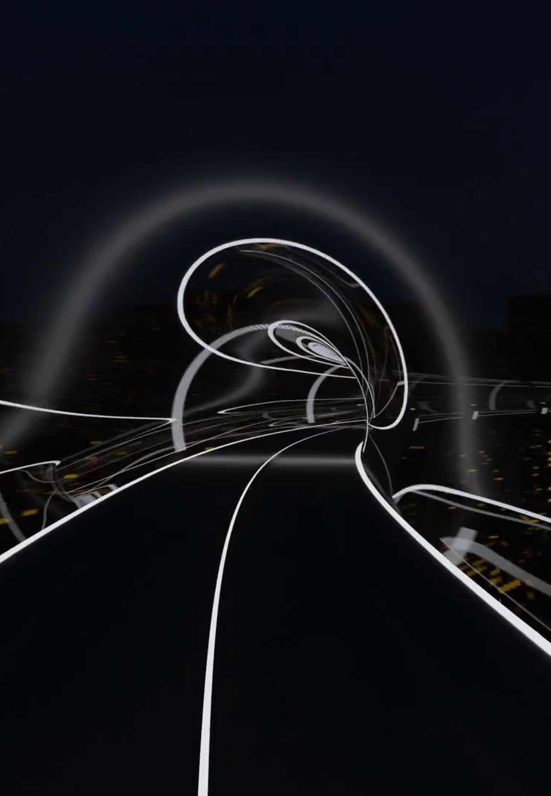

FERERI @ SpaceX



Contents

1. Description of the team 5

2. Pod top-level design summary & dimensions 6

3. Pod materials 6

4. Pod payload capability 7

5. Pod power source and consumption 7

5.1. Power requirements 7

5.2. Supercapacitors 7

5.3. Lithium-ion batteries 8

5.4. Cells' safety 8

5.5. Battery pack design 8

5.6. Housing and packaging 9

6. Safety features and electronics 10

6.1. Testing 13

7. Pod Navigation System 13

7.1. Main Computer 15

7.2. Battery temperature ECU: 15

7.3. Braking ECU 16

7.4. Redundant braking ECU: 16

7.5. Cooling ECU: 17

7.6. Speed detecting ECU: 17

7.7. Front analog ECU: 18

7.8 Rear analog ECU 18

7.9. Power system monitoring 19

7.10. Communication between the Flight Computer and the ECUs 19

7.11. Communication between the pod and the team laptop 20

8. Sensor Selection 22

8.1. Sensors for telemetry 22

8.2. Sensors for active control 23

8.3. Sensor Tests 26

9. Levitation 27

9.1. Introduction 27

9.2. Placement (Mechanical design) 30

9.3. Magnetic field plot 32

9.4. Magnetic levitation test description 33

10. Propulsion 35

10.1. Introduction 35

10.2. Choosing electromotor 35

10.3. Advantages of LIM 35

10.4. LIM limitations 36

10.5. Working principles and availability of LIM 36

10.6. Construction options 37

11. Braking 38

11.1. Working principle 38

11.2. Wear test 41

11.3. Final testing 43

11.4. Heat dissipation 43

11.5. Additional induction braking 44

12. Stability 44

13. Aerodynamics 47

13.1. Introduction 47

13.2. Flow regime 48

13.3. Numerical modelling 49

14. Cooling 53

14.1. Introduction 53

14.2. Description 53

14.3. Brakes 53

14.4. Frequency Inverter 54

14.5. Motor 54

14.6. Batteries 54

14.7. Cooling 55

15. Pod trajectory 56

16. Pod Dynamic Environments 56

17. Structural design 59

17.1. Intro 59

17.2. Static Loads 60

17.3. Dynamic Loads 60

17.4. Lifting of a pod 62

18. Subsystem and full pod functional test program 63

19. Pod production schedule 66

20. Cost breakdown 67

21. Funding plan 69

22. Comments on scalability to an operational hyperloop 71

23. Loading and unloading plan 74

24. List and description of stored energy on the pod 74

24.1. Pressure Vessels 74

24.2. Battery 74

25. Description of safety systems 75

26. Vacuum compatibility analysis 76

26.1. Battery 76

26.2. Electronics 76

26.3. Cooling system 77

26.4. Breaking system 77

# Description of the team

The team consists of 20 students from four faculties in Zagreb. It is divided into departments, each of which has a department leader. The following is a table explaining each member's role.

|  |  |  |
| --- | --- | --- |
| Team leader | Department | Members |
| Ante Renić | FERERI | Everyone |
| Šimun Kordiš | Aerodynamics | Toma Budanko |
| Cooling | Luka Milat |
| Levitation | Fran Ilčić |
| Stability | N/A |
| Structure | Domagoj Zagorac, Domagoj Ćorić |
| Šime Grbić | Navigation | Matej Rafaj, Davor Ostrihon, Jakov Kovačić |
| Martin Jurman | Braking | Igor Ciganović, Martin Gracin |
| Borna Pliskovac | Propulsion | Dino Cindrić, Robert Nemanić, Domagoj Adamović |
| Chris Lušetić | Power | N/A |
| Eduardo Marić | Finance and Operations | N/A |

***Table 1.*** *Team Structure*

Team advisors: Dominik Galić, Saša Ilijić, Ana Babić, Danijel Sestan, Marko Jokić, Krešimir Grilec, Vera Rede, Miho Klaić, Antun Galović, Tomislav Stipančić, Miho Klaić, Danijel Pavković.

# Pod top-level design summary & dimensions

We were going for a pod that works for the competition, but also made sure it resembled one that would be used in a real hyperloop system. The most notable example of this is the usage of a linear induction motor, instead of a rotational one. A standard rotational motor would be easier to size, to acquire, to power and to implement. It would also enable us to reach speeds in excess of 400 km/h with current specs. Unfortunately, it would also render the pod exceptionally boring. We sought a challenge and we wanted to genuinely contribute to the technology, so we opted for a linear induction motor. We made sure to have a strong construction, a light aeroshell, enough batteries, safe braking and the navigation equipment to satisfy all the requirements. This made the pod somewhat large at 2318×560×386 [mm] and heavy at 210 kg.

# Pod materials

|  |  |  |
| --- | --- | --- |
| Part | Material | Characteristics |
| Linear induction motor | Laminated steel | Eliminates eddy currents, low magnetic resistance |
| Copper windings | Low electric resistance, low cost |
| Back iron | Low magnetic resistance, low cost |
| Battery pack | Fiberglass | Good insulation per kg |
| Cooling system | Low carbon steel | Excellent weldability, hard case |
| Plastic impellers | Good mechanical properties |
| Chassis floor | Aluminium | High strength to weigth ratio |
| Carbon fiber |
| Halbach magnets, housing and back iron | NdFeB | High strength per kg |
| Cobalt-Chromium | Non-magnetic, good mech. properties |
| Iron | Ferromagnetic |
| Wheels | Brass | Soft, easily machinable |

***Table 2.*** *Pod Materials*

# Pod payload capability

The pod is not designed to carry any payload, though due to all the safety factors we used, we could probably fit some extra mass inside and not lose a lot of performance as a result. The extra volume in the pod amounts to around 50 litres, making a dummy payload possible.

# Pod power source and consumption

## Power requirements

The power system supplies devices with electrical power via batteries, whose total power output equals 195 kW. The main power consumer is the propulsion system (>99%) so the battery pack will be designed according to its requirements. As for the rest of the systems that have a smaller voltage, step-down converters will be used. The following are **maximum** power requirements per system:

|  |  |  |  |
| --- | --- | --- | --- |
|  | Voltage [V] | Current [A] | Power [kW] |
| LIM and inverter | 650 | 280 | 182 |
| Navigation | 5 / 3.3 | 5 | 0.025 |
| Cooling pumps | 24 | 20 | 0.48 |
| Braking | 5 | 5 | 0.025 |
|  |  |  |  |
| Batteries | 650 | 300 | 195 |

***Table 3.*** *Power Requirements*

For the power source, we needed high energy and specific density. The battery sources that were considered were li-ion cells and supercapacitors.

## Supercapacitors

As per the competition’s nature the accelerating phase is <20 seconds so batteries with high discharge capabilities were needed. For most of the battery configurations that we analysed, calculations showed that more than half of battery energy was left in the cells after the run, and that is before regenerative braking. Due to this fact supercapacitors were considered as they can output much higher power but can't store as much energy. As it turns out, the energy they can store is insufficient for our needs. They would require li-ion batteries to partially charge them while they are being used. This option called for a more complex power distribution unit, and a battery management system that would have to be developed by the team. Due to time and budget restrictions, and the uncertainty of whether it would even work, we decided to leave this idea for future potential improvements.

## Lithium-ion batteries

Lithium-ion battery is a type of a rechargeable battery that is used in most consumer electronics and in the last few years it has become the standard power source for electric vehicles. Because of the enormous growth of EVs in the past couple of years, lithium-ion battery technology is being advanced daily, as it is a bottleneck of EVs. As battery technology advances, our power system will hopefully be able to scale in power and size with practically no increase in battery size in the future. Lithium-ion cells are available in three different types - cylindrical, pouch and prismatic. To be able to withstand harsh environments of vacuum and possible vibrations while being relatively safe, cylindrical cells are used.

## Cells' safety

Cylindrical cells are packed into metal enclosures that offer good mechanical stability, so they can withstand high internal pressures without deforming. The cells also include a Positive Thermal Coefficient (PTC) switch to resist the flow of overcurrent. This is a resettable fuse as the resistance drops back down after the high current stops flowing. The cell also uses a pressure relief mechanism due to overcharge called the Charge Interrupt Device (CID). This fuse activates an irreversible safety feature and the battery cell is rendered useless afterwards.

## Battery pack design

The whole power system consists of one type of a high-power battery with step-down converters to power navigation electronics, pumps, solenoids, sensors, etc. Per power requirements, the battery voltage for the motor will be 650V with a discharge capability of 300A resulting in total power of nearly 200 kW. The battery chosen is LiFePo4 A123 ANR26650 M1B with the following specifications.

|  |  |
| --- | --- |
| Battery | |
| Name | A123 |
| Max. voltage [V] | 4.1 |
| Nominal voltage [V] | 3.6 |
| Max. constant current [A] | 70 |
| Max. current peak - 10 s [A] | 120 |
| Capacity [Ah] | 2.3 |
| Power capacity [Wh] | 8.28 |
| Weight [g] | 70 |
| Price [USD] | 8 |
| Internal resistance [mΩ] | 10 |
|  |  |

***Table 4.*** *Battery specs*

To satisfy power requirements, an 160S3P pack will be constructed, resulting in the following battery specifications.

|  |  |
| --- | --- |
| Pack | |
| Max. voltage [V] | 656 |
| Nominal voltage [V] | 576 |
| Max. constant current [A] | 210 |
| Max. current peak - 10 s [A] | 360 |
| Capacity [Ah] | 6.9 |
| Power capacity [Wh] | 3.97 |
| Weight [g] | 33.6 |
| Price [USD] | 3850 |

***Table 5.*** *Battery pack specs*

The battery pack has a continuous current of 210 A and a peak current of 360 A for 10 seconds which will cover our power needs during the acceleration phase. Additional tests will be performed on cells and the pack to determine the maximum continuous discharge rate for the duration of 20 seconds.

## Housing and packaging

The battery pack consists of 8 separate battery modules, each containing 60 cells, resulting in 480 cells. The cells will be placed in a former to hold the cells in place and to prevent thermal runaway propagation in case of battery cell malfunction. Ideally, the former will be of thermally and electrically non-conductive and light material. Cells will be connected using copper busbars. Since the A123 cells housing is aluminum, busbars will be laser welded to the cells. Battery terminals will be placed on the same side of the module with distance twice the arcing distance of module.

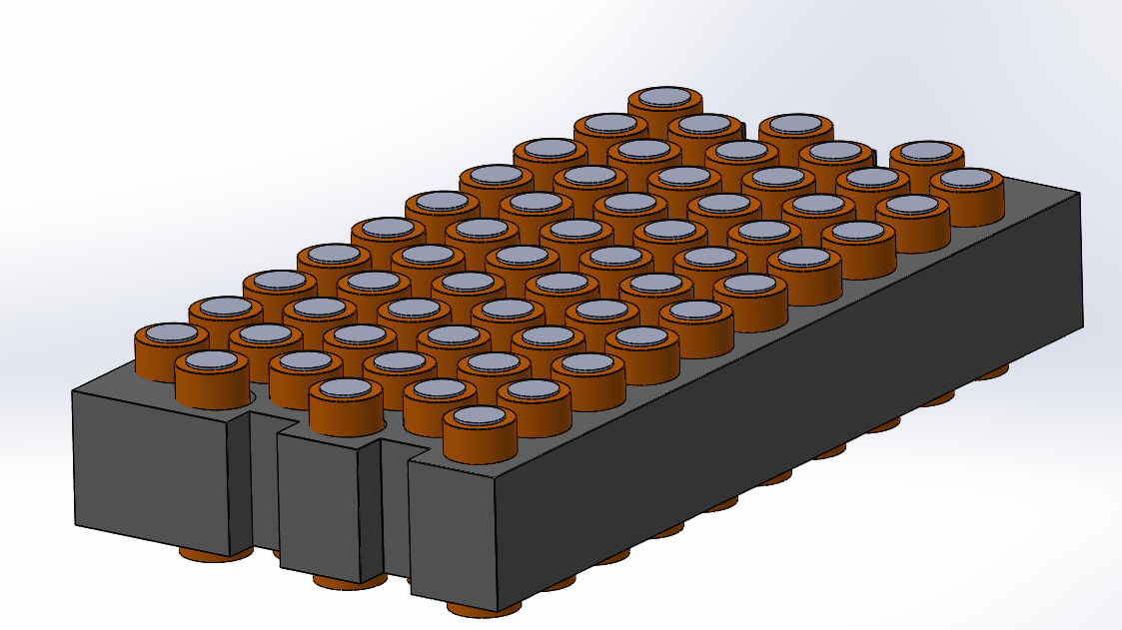

***Figure 1.*** *Pack rendering*

The module will be placed in a fiberglass enclosure and sealed with a sealant to prevent

coolant leaking. Batteries will be in direct contact with non-conductive coolant to ensure better heat transfer. For coolant, Galden HT 170 is used.

# Safety features and electronics

To ensure nominal operation of batteries and to prevent overcharge and over discharge of individualcells, off the shelf battery management system (BMS) will be used. Bestech HCX-D170V1 BMS is capable of carrying 500A constant current and up to 1800A peak current. The BMS will communicate with main ECU over I2C protocol. The BMS also regulates maximum current drawn from battery and outputted to the inverter, as well as monitoring high and low cutoff voltages of the cells.

An additional safety ECU will be used to monitor the temperature of every fourth cell. For the temperature sensors the NTC thermistor will be used, and feed back to the ECU over multiplexor. In the event of the soft temperature limit reached, the main ECU will lower the power output to the inverter, and in the event of the high limit reached, power to the inverter will be cut completely.

A power control panel will be mounted close to the battery and will contain LED indicators and switches. LED indicators will show the current state of the battery, and switches will be used to turn on or off different parts of the power system.

When connecting the battery to the inverter, there is a high current drawn due to the inverters' capacitors being charged up. To prevent this current inrush, a precharge circuit will be designed using contactors. First the contactor K1 will close and the current will flow through a resistor to limit the current drawn. After 2-3 seconds, the capacitors will be charged to around 50 percent and the K2 contactor will close, and K1 will open allowing current to flow directly to the inverter.

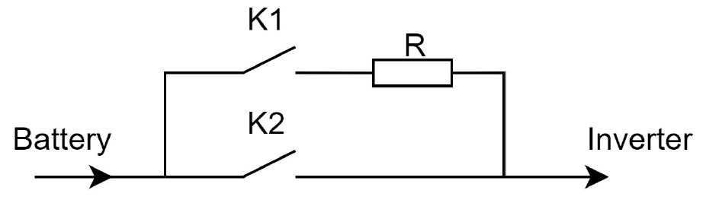

***Figure 2.*** *Pre-charge circuit*

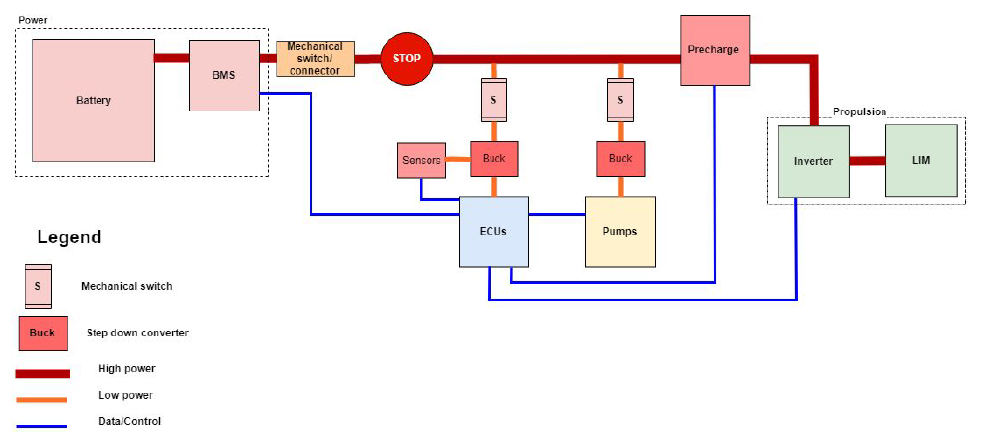

***Figure 3.*** *Power system schematic*

The power system has a disconnect-switch for service purposes. It disconnects all electrical power on pod. We plan to use Gigavac HBD41A that operates on 100 VDC, 400 A and it can stand 2000 A for one minute.

A Fuse is used to protect the cable from overcurrent. The nominal current and voltage of the fuse are 600 A and 1000 VDC, respectively. In a case of a short circuit, the current will be much higher than 600 A and the fuse will disconnect the power supply. It's placed in the fuse holder, so it can be easily changed. The fuse is shown below. Other two fuses are placed before dc/dc converters, those are smaller, and they protect low voltage circuits.

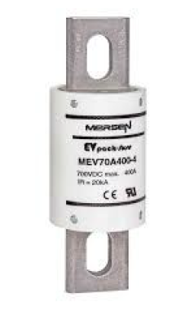

***Figure 4.*** *Overcurrent fuse*

As power is running through the cable, we chosen cable that can conduct 300 A. To conduct 300 A, cable’s diameter needs to be 95 mm2. We chose orange cable isolated with silicone rubber because of its good performances in vacuum and at extremely high-temperatures. High voltage cables are marked with black striping to differ from low voltage cable that are marked with white striping.

To unplug cable safely in case of moving parts, we chose connector MSD-M-350-2-C-F, Amphenol PCD Shenzhen.

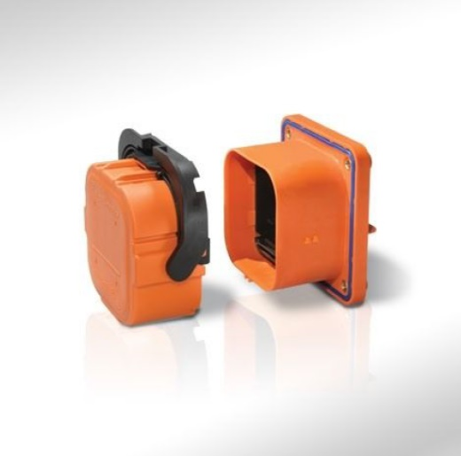

***Figure 5.*** *Cable connectors*

## Testing

Cells will be tested to determine upper limit of current drawn without overheating the cell.

Test will be performed in the following way:

Nominal constant current of 50A will be drawn from the cell, while logging voltage, current, temperature and time. Test shall be done with and without cooling and stop conditions shall be set by over temperature limit of 90°C. Every following test will gradually increase current drawn from cell by 5A, until stop conditions are met. The goal of this test is to determine current limits of a cell for the duration of 20 seconds and determine cooling efficiency. Test results will be scaled up for module testing, then for the pack testing.

# Pod Navigation System

|  |  |  |  |
| --- | --- | --- | --- |
| ECU | Purpose | Sensors and actuators | Location |
| Main computer | General control of the pod and communication between ECUs and the team | LIM, BMS | Center of the pod |
| Front analog ECU | Collection of data from sensors located at the front of the pod | Height sensor, IMU, LVIT, Optical laser sensor | Front of the pod |
| Rear analog ECU | Collection of data from sensors located at the rear of the pod | Height sensor, IMU, LVIT, 1D accelerometer | Rear of the pod |
| Speed detecting ECU | Detection of the stripes and speed estimation | Optical laser sensor | Front of the pod |
| Battery temperature ECU | Reading all the temperatures from the battery sensors | Multiplexer + 121 temperature sensors | Center of the pod |
| Redundant braking ECU | A failsafe ECU for braking | 1x brake solenoid, 1x pressure sensor | Center of the pod |
| Braking ECU | Main Braking ECU | 1x brake solenoid, 1x pressure sensor, 2x brakes temperature sensor | Center of the pod |
| Cooling ECU | Reading temperature of the LIM, batteries and inverter and control of the cooling subsystem | 6x Batteries, LIM, Inverter, (2 of each) temperature sensors, coolant pump, 2x coolant pressure sensor | Center of the pod |

***Table 6.*** *Pod ECUs*

Pod navigation system is responsible for proper functioning and safety of the pod. Navigation consists of one main ECU and 7 secondary ECUs. For the secondary ECUs Arduino Due is used, because of its simplicity and price. Slave ECU’s are positioned accordingly with other subsystems: propulsion, levitation etc. Since there are no complex processing and time critical operations happening on secondary ECUs Arduino Due with its 32-bit processor and 84 Mhz clock is viable option. All Arduino communicate with main control board that is Asus Tinker Board over CAN communication protocol. CAN is widely used in automotive industry and is fairly simple and fault proof. Since none of the ECUs has dedicated on board CAN hardware, Arduino CAN shields will be used.

While deciding which ECU controls which part of the system wire management and reliability was primary concern. Due to high currents and electromagnetic interference most sensors and corresponding ECU’s are placed in front and rear of the pod to distance them from these interferences. Sensor wires to ECUs will be kept short, and CAN cables connecting slave ECU’ to master ECU shall be shielded. PCBs for each ECU and sensors will be designed and produced. Also additional hardware needed for smooth operation of the navigation subsystem such as transistors, for the amplification of the control signals being sent actuators, and pull-up resistors to protect the ECUs will be placed on the PCBs their values and position will be determined through tests.

The power for the ECUs and the sensors will be provided from the main battery pack using converters. A backup power supply for the navigation will be developed if we determine that it is needed. The list of all ECUs with corresponding sensors and actuators can be seen in the above table (Table 6.)

## Main Computer

Communication with every ECU over CAN bus and PC over ethernet port with minimal data processing. Furthermore Asus is used to send control signals to inverter for controlling linear asynchronous motor, for communication with BMS and for the State machine.

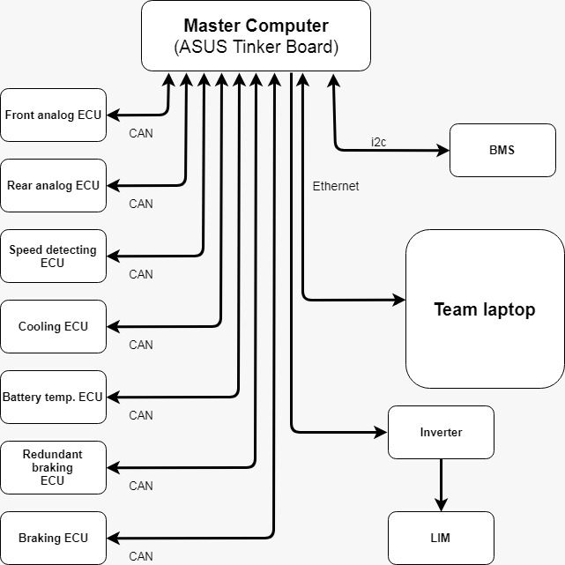

***Figure 6.*** *ECU schematic*

## Battery temperature ECU:

One temperature sensor is placed per 4 battery cells, inside the battery pack. To read and process all these sensors Arduino in combination with MUX is used. All analog inputs are read then temperature is calculated using look-up tables.

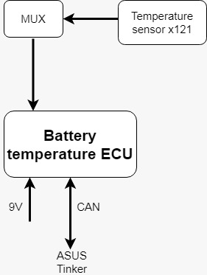

***Figure 7.*** *Temperature ECU*

## Braking ECU

Braking ECU is monitoring the pressure in the pressure tank and keeps the normally opened solenoid valves closed so that the brakes are opened during the run. This ensures that if there is an power outage or if solenoids lose communication with the ECU the brakes will close, if this happens the Braking ECU will send a request to the Main computer to shut down the engine. An amplifier will be used to amplify the signal from the ECU to the solenoid.

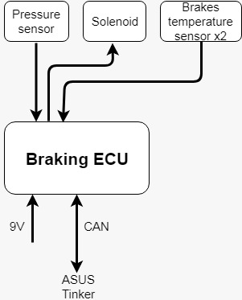

***Figure 8.*** *Braking ECU*

## Redundant braking ECU:

This microcontroller is only a failsafe if the main Braking ECU fails, it is using the redundant solenoids and a redundant pressure sensor. A logic pneumatic OR gate will be used to ensure that if any of the solenoids are open that the brakes will close

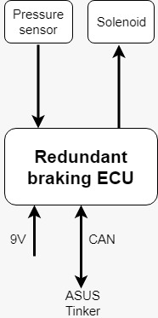

***Figure 9.*** *Redundant braking ECU*

## Cooling ECU:

The function of this ECU is to read the temperatures from the sensors located on the LIM, inverter, brakes and battery pack. According to this information it controls the cooling subsystem. It also monitors the cooling subsystem by watching the pressure in the subsystem.

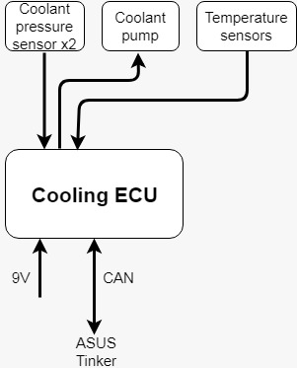

***Figure 10.*** *Cooling ECU*

## Speed detecting ECU:

The sole purpose of this ECU is to detect the stripes located in the tube and based on them and acceleration to give a speed and position estimate. A microcontroller dedicated only to speed detection is probably an overkill but since speed and position are two of the most important things we have to monitor we wanted to make sure to do it correctly.

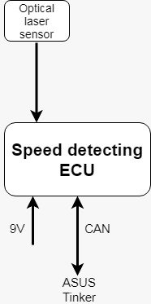

***Figure 11.*** *Speed detecting ECU*

## Front analog ECU:

Front analog ECU collects data from the analog sensors located at the front of the pod, namely IMU, LVIT, optical sensor and height sensor. This data is then filtered, processed and sent to the main computer by the Front analog ECU.

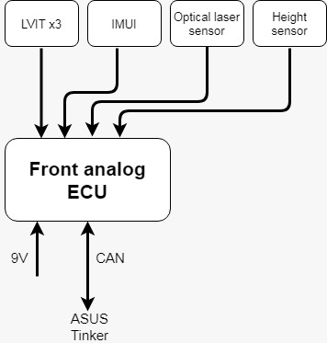

***Figure 12.*** *Front analog ECU*

## 7.8 Rear analog ECU

The purpose of the of the Rear analog ECU is the same as the that of the Front analog ECU, and that is to collect and process the data from the analog sensors located at the back of the pod in the case of the Rear analog ECU. This sensors are IMU, LVIT, 1D accelerometer and height sensor.

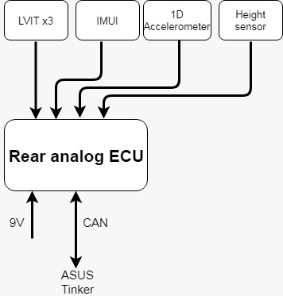

***Figure 13.*** *Rear analog ECU*

## Power system monitoring

For power system controlling and monitoring dedicated BMS in combination with Arduino Due is used. There is 121 temperature sensors inside the battery pack to ensure that battery is operating in nominal temperature range. Arduino with its corresponding MUX is used for reading those sensors. More information of power system monitoring can be found at the chapter“ Power system“.

## Communication between the Flight Computer and the ECUs

The Flight Computer and all ECUs will communicate between each other through a CAN bus. The flight computer will use the SocketCAN Linux drivers and the ECUs will use an Arduino CAN shields to connect to the bus. Low speed CAN will be used for the physical layer for increased reliability.

The following information will be sent through the CAN bus:

* From Flight Computer to ECUs:
  + Commands (Size: 1 byte, 44 bit frame; Frequency: 1 Hz; Bandwidth: 52bps per ECU, 364bps total)
* From Battery Temperature ECU to Flight Computer:
  + Maximum, minimum and average battery temperature as signed 16-bit integers(Size: 6 bytes, 44 bit frame; Frequency: 25 Hz; Bandwidth: 2300bps)
* From Speed Sensing ECU to Flight Computer:
  + Stripe Count as unsigned 16-bit integer and speed as unsigned 32-bit integer(Size: 6 bytes, 44 bit frame; Frequency: 25 Hz; Bandwidth: 2300bps)
* From Front Analog ECU to Flight Computer:
  + Height as unsigned 16-bit integers, acceleration in 3-dimensional space as 3 signed 16-bit integers, magnetic field in 3-dimensional space as 3 signed 16-bit integers, wheel and brake offset as 3 unsigned 16-bit integers(Size: 20 bytes, 44 bit frame; Frequency: 25 Hz; Bandwidth: 5100bps)
* From Rear Analog ECU to Flight Computer:
  + Height as unsigned 16-bit integers, acceleration in 3-dimensional space as 3 signed 16-bit integers, magnetic field in 3-dimensional space as 3 signed 16-bit integers, wheel and brake offset as 3 unsigned 16-bit integers, forward acceleration as singed 32-bit integers(Size: 24 bytes, 44 bit frame; Frequency: 25 Hz; Bandwidth: 5900bps)
* From Braking ECU to Flight Computer:
  + Brake pressure unsigned 32-bit integers and brake temperature as signed 16-bit integers(Size: 6 bytes, 44 bit frame; Frequency: 25 Hz; Bandwidth: 2300bps)
* From Cooling ECU to Flight Computer:
  + Pod temperature as 2 signed 16-bit integers and coolant pump pressure as 2 unsigned 32-bit integers(Size: 12 bytes, 44 bit frame; Frequency: 25 Hz; Bandwidth: 3500bps)

Total CAN bus bandwidth: 21764bps, or ~21.25kbps.

## Communication between the pod and the team laptop

The Flight Computer, Emergency Braking ECU and Speed Sensing ECU will all be connected to the SpaceX network through the Ubiquiti Rocket M900 radio. The team laptop will be connected to the same network through the provided Ethernet cable. The network protocols used will be UDP for the purpose of sending telemetry from the pod to the laptop and TCP for the purpose of sending commands from the laptop to the pod.

The following information will be communicated through the network:

* From Flight Computer to team laptop:
  + The telemetry frame described in the Pod Communications section of the Pod and Track Specifications, which the laptop will send to the appropriate SpaceX connection(192.1680.1 port 3000) as they are received.
  + Further telemetry, including the internal pod state(as described in the State Diagram), brake and cooling pressure, more detailed pod and battery temperature, more detailed battery voltage and current, pod height, pod brakes offset acceleration in 3-dimensional space, wheel and
* From team laptop to Flight Computer:
  + Commands
* From team laptop to Emergency Braking ECU:
  + The “Stop” command

|  |  |  |  |
| --- | --- | --- | --- |
| Pod State | Telemetry State Mapping | State Description | Expected ways to enter state |
| Idle | Safe to Approach | The pod is idle and safe to approach. | Enter when the pod is turned on, or from the Normal Brake state if the pod is stationary for X. Can also be entered from the Preparing and Ready states if the Return command is given. |
| Preparing | Fault | The pod prepares all required systems for launch, transitions into Ready state if preparations are successfully completed. | Enter from Idle when the Prepare for Launch command is given. |
| Ready | Ready to Launch | The pod is ready for launch, but no actions are being taken by any of the pod actuators. | Enter from Preparing when the launch preparations are completed. |
| Launch | Launching | The pod’s Linear Induction Motor (LIM) is powered on and gradually ramped up to maximum power. | Enter from Ready when the Launch command is given. |
| Accelerating | Launching | The pod’s LIM is active and accelerating the pod. | Enter from the Launch state once the initial launch sequence is finished. |
| Normal Brake | Braking | The motor reverses it’s direction to decelerate the pod and the brakes are closed to bring the pod to a stop. | Enter from Launch or Accelerating when the Brake command is given or the pod calculates it needs to start braking from the current position and velocity. |
| E Braking | Fault | The motor is turned off if it was on upon entering the state. The brakes are closed. | Enter from any state if there is a fault in the system or the Stop command is given but the position, velocity and acceleration sensors are still working properly. |
| E Stationary | Fault | The brakes are opened. | Enter from E Braking if the pod is stationary for X. |
| E Unknown | Fault | Same as E Braking. | Enter from any state if there is a fault in the system or the Stop command is given and the position, velocity and acceleration sensors are not working properly, or not working at all. |

***Table 7.*** *Pod State Diagram*

# Sensor Selection

To control and gather information about the pod an array of sensors is necessary. Sensors are used for both telemetric sensing and active control of the pod. In access of 20 sensors are used to collect information about pod position, velocity, acceleration, roll, pitch, yaw, pressure, temperature, power and ride height. Sensors are interfaced with 4 PCB-s that collect data from the digital and analog sensors, process the data and send it to the master computer for health monitoring and piloting purposes.

During the selection process we tried to find analog sensors that use the 4-20mA standard. There are two types of 4-20MA standard, 2-wire and 3-wire. 2-wire has 2 pins: Power and Analog Output. 3-wire has an additional pin, which is a ground connection. The advantages of this type of sensors are:

* Robust to resistance of wire (i.e. length of wire),
* Robust to supply voltage change,
* Much simpler than digital protocols like I2C, SPI, UART,
* Fault detection. If 0 A are showing, something is wrong, either the loop is broken, sensor is connected incorrectly, et cetera,

While the disadvantages are:

* Cannot be read directly by ADC – sense resistor is required,
* Maximum of 1 sensing variable per loop,
* Need to be careful to avoid ground loops when using more than one of these sensors.

All of the disadvantages are easily avoided and therefore most of our sensors use the 4-20mA standard.

## 8.1. Sensors for telemetry

* **1D Accelerometer** – Dytran 7506A1:

Since our pod is one solid unit only one 1D Accelerometer is needed to get the information about the acceleration of the pod. The Dytran 7506A1 has 100 uA/g sensitivity and ±50g range which is plenty for our needs.

* **Temperature sensor –** Omega SA1-RTD-B:

This is na RTD type temperature sensor with temperature Range of -73C to 260°C continuous which is the temperature we shouldn't reach anywhere on the pod. These sensors are placed on the motor, inverter, batteries and brakes. Its accuracy is ±0.12% (DIN Class B)

* **Pressure sensor:**

Ambient pressure will be monitored using IMU which will be listed under control sensors

* **Linear Variable Inductive Transducer** – Omega LDI-619-015-A010S:

A number of this sensors will be placed on the stability wheels to get an information about their shift if they come into contact with the rail and also on the brakes to detect if they have closed. The LDI-119-150-A020A takes in 18-30 VDC, outputs 4 - 20 mA, and has 0.025% of full scale resolution. Its update rate is 300 Hz, and its stroke length is 15 mm.

* **Height sensor** – Baumer OADM 13I6575/S35A:

These sensors are used to ensure that our pod hasn't started levitating. Baumer OADM 13I6575/S35A has a sensing range of 50...350 mm and resolution of 0,01mm is enough for our needs.

* **Current senso**r - LEM LF 510-S:

Current sensor is used to measure current from battery pack as a redundancy to BMSs current measuring. Current to inverter and each of the three phases of LIM are monitored by inverter and reported to Asus Tinker over CAN bus. Maximum current that can be detected with this sensor is 500A.

## 8.2. Sensors for active control

* **Inertial Measurement Unit** – VectorNav VN-100 Rugged:

Two of these units are used, one at the front of the pod and one the back. They provide us with live feedback on the accelerations in all axis, yaw, pitch and roll of the front end and of the back end of the pod. The three axis magnotometer with in this IMU will come in handy when dealing with electromagnetic interference since using its data we will know how strong is the magnetic field along any of the axis. Additionally it has a built in Kalman filter.

* **Optical Fiducial** - FALN-BP-0A:

For backup speed measurement we will use FALN-BP-0A sensor. This is a polarized reflectoactive laser sensor which will be aimed at the reflective stripes along the tube and detect when we pass a stripe. It will be paired with an Schmitt trigger to ensure we don’t get false reading from for example tube walls. We decided to use Schmitt trigger instead of a software solution to this problem because a software solution would prevent us from programming the Fiducial microcontroller to use interrupts when a stripe is detected and without interrupts there is a possibility that we could pass a stripe without microcontroller counting it.

* **Light sensor** - Keyence LR-W500:

For the speed measurement we will use Keyence LR-W500 sensor. This light sensor which will be aimed at the reflective stripes along the tube will detect when we pass a stripe. The sensor operates with a response time of 200μs (frequency = 5kHz). The operating frequency is high enough for our application. If the maximum speed of the pod is assumed to be 70m/s, then the time the pod takes to pass a stripe at that speed is t = 1.428 ms. Hence, it obeys the Nyquist theorem and the sampling rate is at least twice faster than the frequency of the stripes to occur. NPN output mode is selected so that an output signal is generated each time a stripe is identified.

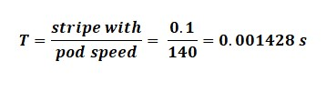

* **Brakes pressure senso**r – PX119-300AI:

This sensor is used to monitor the pressure in our air brake system. It is rated for 21 bar and has a 0.5% FS accuracy.

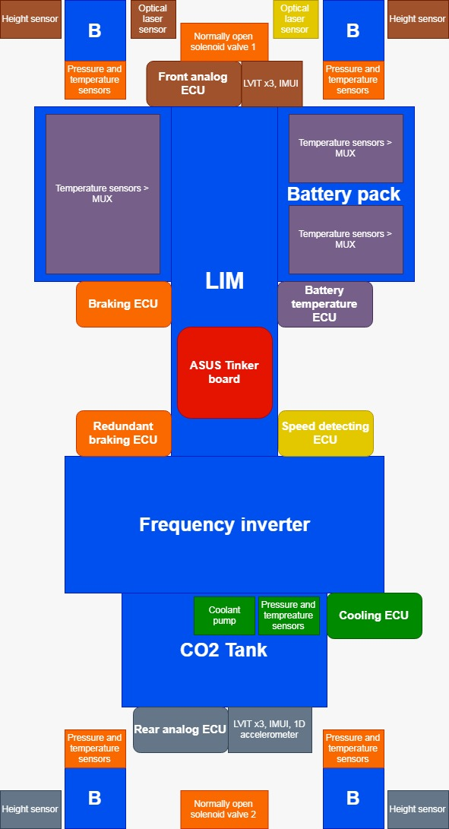

***Figure 14.*** *Pod component placements*

## 8.3. Sensor Tests

* Light sensors:

We will test the light sensors by setting up an electric motor with a spinning disc. Reflective stripes will be attached to the disc with some intervals in order to imitate the frequency of stripes occurring in the tunnel.

* IMUs:

IMUs will be tested on a device simulating pod’s movement through the tube

* All sensors (except for the ones tested on vibration by manufacturer):

Vibration environment tests using Electrodynamic Shakers.

* All sensors:

Vacuum Chamber tests.

* Temperature sensors:

Temperature sensors will be heated to the maximum values provided in the datasheets.

* Batteries:

Using Arbin Cell Cycler, batteries will be charged and discharged. Voltage and Current characteristics will be monitored and recorded.

# Levitation

## 9.1. Introduction

The purpose of levitation is the reduction of forces acting on the pod in the direction opposite of movement. The problematic force in question is friction, which rises with the square of the pod’s speed. Since the speed of the pod is one of the key considerations for this competition, friction ought to be reduced as much as possible.

To reduce friction, few configurations were discussed, such as air bearings with compressor, magnetic levitation and wheels in combination with magnetic levitation. Air bearings were quickly dismissed due to the lower velocities of the pod (less than supersonic), for in accordance with the Kantrowitz limit, reached velocity wouldn’t choke the flow, hence its exclusion at early stages, resulting in a more aerodynamic pod structure in exchange.

By utilising magnetic levitation and wheels having no contact with the rail, friction is non-existent, however to retain the LIM (linear induction motor) efficiency, a suspension is needed to keep the LIM at a constant distance above the rail. This suspension would add weight and unnecessary complexity to the pod’s structure. This could be avoided by using wheels for the LIM while having all the other subsystems levitating, but this solution demands suspension and complex construction for the other subsystems.

Using wheels in combination with magnetic levitation would be a much simpler solution as there wouldn't be the need to worry about the gap between the rail and the pod and therefore a much simpler design for the LIM suspension can be acquired. Moreover, the LIM should be as close as possible to the rail as the air gap exponentially reduces its effectiveness, resulting in even greater requirement for a stabilised system which can be easily achieved by fine tuning the wheels. It was decided to use magnetic repulsion to reduce most of the normal strain on the wheels. This will achieve both low friction and high efficiency of the LIM. Description of the wheels used is provided in the stability section.

To achieve magnetic levitation, EDS (specifically Inductrack I) and EMS systems were discussed.

The main difference between EMS and ESS is that the EMS utilizes the magnetic attraction to a ferromagnetic surface, while the EDS utilizes the repulsive magnetic force produced by relative motion to a conducting surface. Also, the EMS uses electromagnets while the EDS can use both super-cooled, superconducting electromagnets and permanent magnets. The EMS system is not suitable with the track and has need for expensive complex sensing systems to maintain stability. EDS (ElectroDynamic Suspension) has incredible stability at high speeds but it needs to be built up to sufficient speed (about 35kmph/22mph) in order for pod to levitate, also it enables the use of permanent magnets.

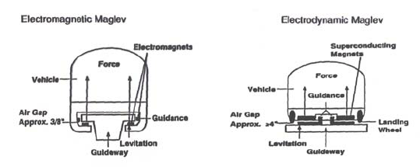

***Figure 15.*** *Comparison between EMS and EDS*

Inductrack I is a new type of EDS that uses permanent magnets to produce the magnetic field and in case of power failure can slow down gradually. An Inductrack pod will levitate nearly an inch (2.54 centimetres) above the track. Moving the Halbach array (special arrangement of permanent magnets) at high speeds, enough opposing magnetic field and force to lift the pod will be induced by currents in the conductive aluminium rail. With the Halbach array, we are able to augment the magnetic field on one side of the array while cancelling the field to a near zero on the other side, enabling us to use fewer permanent magnets for levitation. Two Halbach arrays will be sufficient for lifting most of the mass off the wheels.

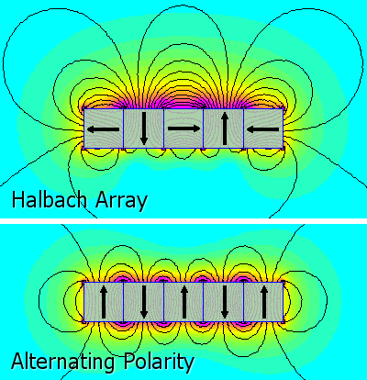

***Figure 16.*** *The difference between Halbach array and Alternating Polarity*

A problem with the Halbach array is its complex and dangerous assembly. For its assembly, 5 NdFeB magnets will be used. These magnets feature very high strength and relatively low cost. A drawback is that its properties deteriorate rapidly at 80°C (176°F), but by cooling main heat producers, these temperatures won’t be reached. The magnet material is N35--the "N" denoting a Neodymium-Iron-Boron ([NdFeB](http://www.femm.info/wiki/NdFeB)) material and the "35" denoting a nominal energy product of 35 MGOe. Grade N35 was chosen because of the durability/ force/ price trade-off.

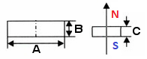

|  |  |  |  |  |  |
| --- | --- | --- | --- | --- | --- |
| Grade | A | B | C | B [T] | Price [$] |
| [mm] | | |
| N35 | 40 | 10 | 10 | 0,40 | 5,05 |
| N35 | 50 | 10 | 10 | 0,43 | 6,21 |
| N35 | 60 | 10 | 10 | 0,42 | 7,40 |
| N52 | 50 | 15 | 15 | 0,50 | 15,44 |

***Figure 17.*** *Grade/ force/price trade-off comparison (based on manufacturers catalogue)*

|  |  |
| --- | --- |
| Design Parameter | Value |
| Magnet length | 50 mm |
| Magnet thickness | 10 mm |
| Magnet width | 10 mm |
| Magnet material | NdFeB, Grade N35 |
| Back iron thickness | 10 mm |
| Nominal gap height | 10 mm |

***Table 8.*** *Design Parameters and Values of Magnets*

## 9.2. Placement (Mechanical design)

The NdFeB magnets will stick together by their own forces. The Halbach array itself will be glued onto the backing iron which is glued into a housing made of cobalt and chromium alloy which is non-magnetic. On the back of the array, a 10 mm backing iron plate is placed to block magnetic field from interfering with the LIMs magnetic field and any pod’s navigation equipment. To prevent the assembly from being displaced, the housing will be confined with magnetically permeable epoxy resin. Halbach array housings will be placed above rail, centred on the x-axis.

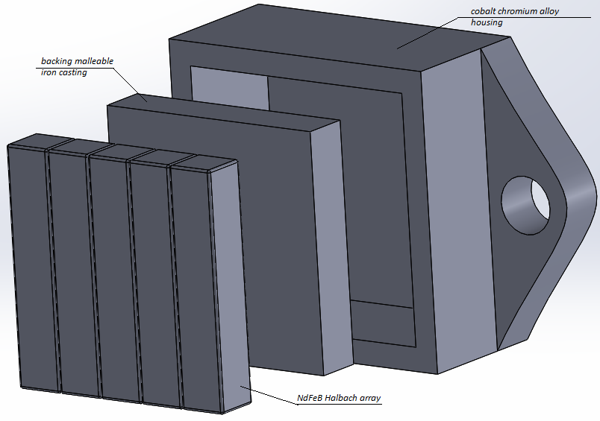

***Figure 18.*** *Halbach array assembly*

The housings will be mounted onto the pods supporting structure by bolted joint.

Backing iron

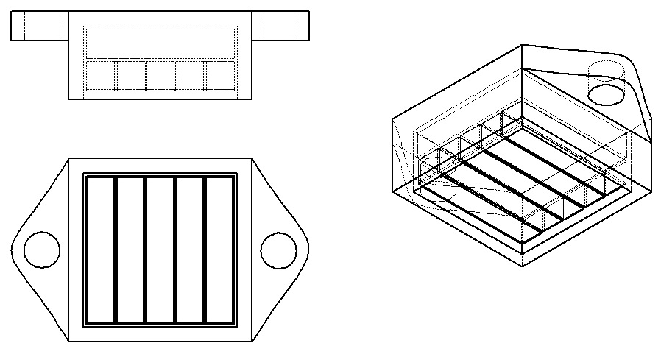

Halbach array

***Figure 19.*** *Representation of the mounting housing*

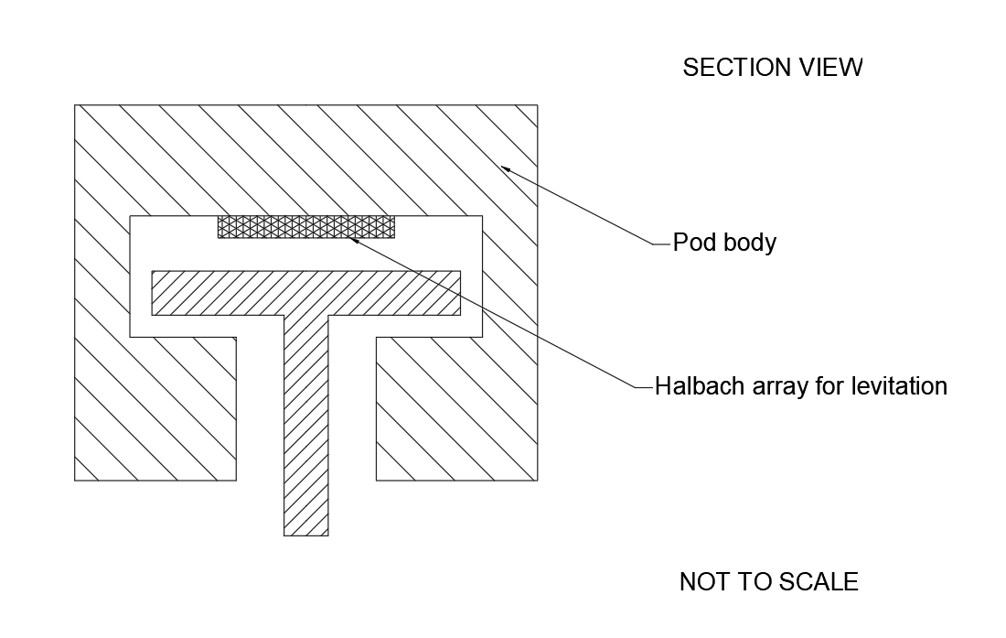

***Figure 20.*** *Halbach array placement*

## 9.3. Magnetic field plot

Finite Element Method Magnetics (FEMM) was used for plotting the magnetic fields.

When back iron material is non-magnetic aluminium 6061-T6, magnetic field can be seen reaching above the Halbach array housing which is undesirable. Magnetic field can be seen being blocked by back iron when its material is malleable iron casting. This can be seen on figures below. Malleable iron casting was chosen as it has good shock resistance which is highly desirable as Halbach array housing bears most of vibrations caused by rail irregularities, is ductile and is very machinable.

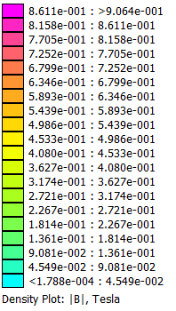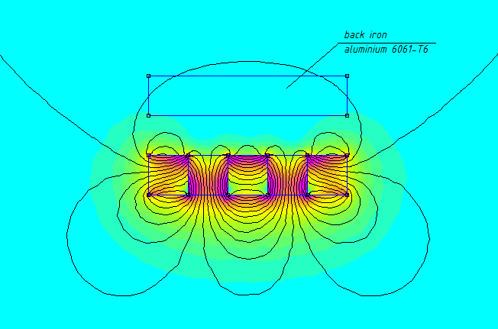

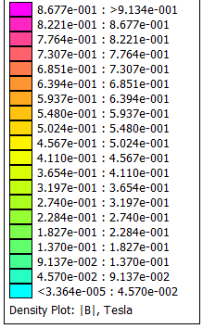***Figure 21.*** *Plot of magnetic fields (back iron material is non-magnetic aluminium 6061-T6)*

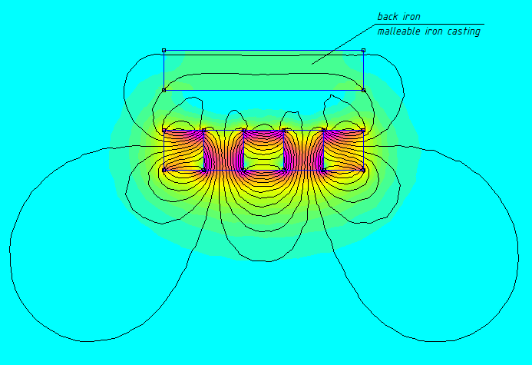

***Figure 22.*** *Plot of magnetic fields (back iron material malleable iron casting)*

At high velocities, the lift force asymptotically approaches a constant, while the drag force is inversely proportional to the velocity. This means that the propulsive power to overcome the electrodynamic drag becomes independent of the velocity. Since the drag force is highest when the acceleration is the highest – at the start of the run, it will be adequately negated, but will not equal zero. This behaviour can be seen in *Fig.10*.

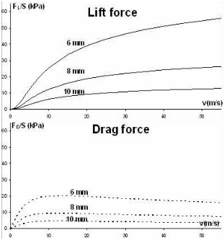

***Figure 23.*** *Lift and drag force behaviour at high velocities*

## 9.4. Magnetic levitation test description

A scale model of magnets and the aluminium rail (considering magnetic field and resistance) will be constructed. A rotating aluminium ring simulates relative movement between the pod and the rail. The disk will be placed horizontally which enables the use of a disk of a smaller diameter, which removes the need for a large enough disk so that it appears straight from the Halbach array’s perspective. Force and offset are measured at various speeds, providing insight into actual pod requirements. For the test, an asynchronous motor will be used, as well as the same NdFeB magnets which will be used on the pod, assembled in a Halbach array. Testing couldn’t be completed due to insufficient funds at this point.

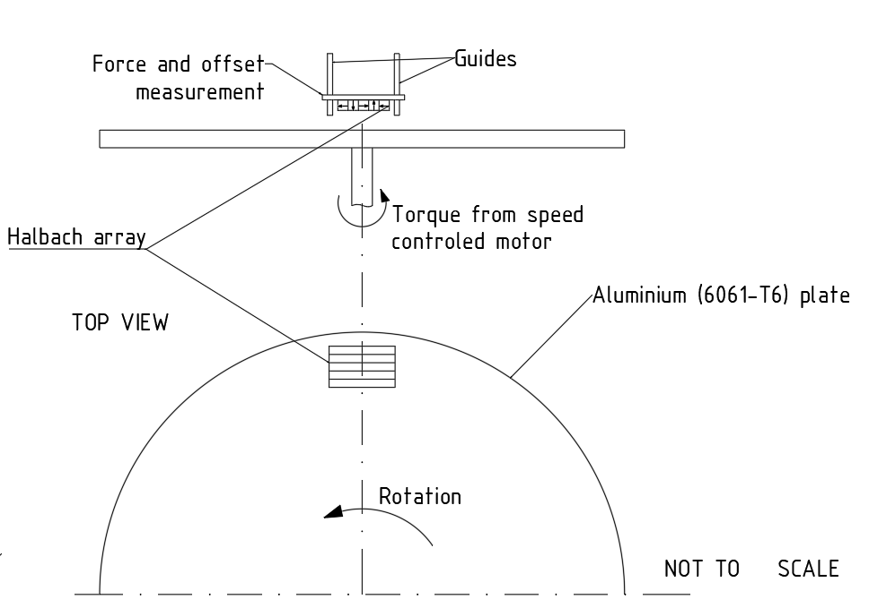

***Figure 24.*** *Testing structure*

# Propulsion

## 10.1. Introduction

The propulsion system is unarguably the most important part of the pod. As such, everything else is designed around this system. In reality, heavy back and forth communication is required to make an optimal choice of a propulsion method as the motor choice also depends on other subsystems, such as power and braking systems. The approach taken by us, concerning this challenge, ultimately did not pan out due to sheer unexpected complexity. Nevertheless, we came up with a solution for everything.

## 10.2. Choosing electromotor

For propulsion of our pod, we have decided to use linear induction motor, as it showed up as the most efficient solution for our purposes. Other possible solutions for propulsion were rotary induction motor, synchronous motor and DC motor, but they were quickly disregarded because their electrical, mechanical and thermal characteristics are not compatible with our design considerations (acceleration, achievable speed, regenerative braking etc.).

Some of the reasons why LIM is preferred over other types of machines:

* conventional rotary motor (either induction, synchronous or DC) requires additional mechanical parts
* reaction rail for linear synchronous motor is very complicated compared to one that is needed for LIM (there must be continuous installation of stator coils in the guideway and wayside converters to energize each block section of track)
* DC motors have permanent magnets which are highly susceptible to temperature increase, thus not stable on higher working temperatures compared to LIM
* permanent magnet motor has lower rotor flux density, thus can provide less torque than induction motor

## 10.3. Advantages of LIM

First obvious benefit of LIM is longitudinal (linear) force (which is produced by LIM) which is used to directly drive a vehicle, in our case, the pod. That is the reason why LIM doesn’t need mechanical parts like rotary machines (i.e. driveshaft, gearbox or axle) which results with lower total mass of propulsion system and almost completely eliminated mechanical losses (estimated power savings of around 5%).

Specifically, for our system, loss of energy to a vibration or friction will be reduced by utilizing Halbach arrays, which is thoroughly discussed in *“Levitation”* section.

LIM itself can be used to decelerate and stop the pod via regenerative braking. When we need to decelerate, the pod will be placed in regenerative braking working condition in which LIM operates as generator - kinetic energy of the pod is changed into electric energy which is then fed back to pod power system, therefore increasing overall efficiency of the pod.

Even though there is a substantial construction difference between LIM and conventional rotary induction motor, existing drive technologies (i.e. variable frequency drives) for rotary IM can be easily applied to LIM without making any radical changes to the system, which gives us flexibility in terms of designing control system for LIM.

## 10.4. LIM limitations

The main disadvantage of LIM is lower electrical efficiency compared with rotary AC motors (typically around 10-20%, sometimes even 40%) which is due to end effects where magnetic flux produced by the primary tends to leak out at the exit end without doing any useful work. However, overall benefits described earlier in this text shown that LIM is the optimal choice for Hyperloop pod propulsion system.

The main flaw of LIM is its low efficiency which is mainly caused by air-gap, end effects, normal force and skin effects. We are aware of these problems and we are doing everything to minimize their effects on our LIM's efficiency and performance. To be specific, minimum air-gap will be ensured by non-levitating pod (more about that in “*Levitation*” section).  
  
Furthermore, end effects, which affects the propulsive force of LIM, can be formed in two ways: transversal and longitudinal. Transversal end effects are going to be minimized by forming the primary above the complete surface of the track and longitudinal end effects are going to be minimized by using a longer motor that will cause the better use of magnetic field. Normal force, which results with lifting the pod from the track, will be partially nullified by putting iron plate on the opposite side. This kind of design is still expected to produce the small lifting force that will help our levitating system. Losses caused by skin effects are relatively small and there are some potential solutions like using braided wires or special materials to overcome these effects. Optimal solution will be chosen after testing the LIM.

## 10.5. Working principles and availability of LIM

Linear induction motors (LIMs) consists of two main parts: the primary and the secondary. Considering overall efficiency, the single-sided configuration was chosen for a primary. The secondary is predefined with aluminium I-beam profile in a Hyperloop tube. The primary consists of three-phase winding on top of I-beam profile main plate and of two iron plates under the main plate from every side of vertical part of I-beam profile for closing magnetic field lines. Windings are installed in the uniform slots of the laminated high-quality steel core to provide better efficiency due to lower eddy currents and hysteresis. The coil windings and lamination stack are encapsulated in a thermally conductive epoxy. Approximate dimensions of LIM are 1000x150x125 [mm].

The LIM operates as its rotary counterpart does, with thrust instead of torque and linear speed instead of angular speed, based on the principle of travelling field in the airgap. When three-phase AC power is applied to the primary, a travelling electromagnetic field wave is induced and moves relative to the primary. The wave induces an electric current in the conductive aluminium I-beam profile. The induced electric current interacts with the magnetic field and according to the Lorenz law (F=qE+ q(vxB)) produces a linear force.

A three-phase winding produces a travelling field in the airgap at the speed of V = 2τf where τ is pole pitch and f is primary current frequency. The speed of the motor can be varied by changing the input frequency using a frequency inverter. To achieve desired speed around 100 m/s with pole pitch around 30 cm frequency of a three-phase current needs to be around 170 Hz (considering the slip).

When designing a LIM, dynamic and static longitudinal end effects need to be taken into account. Due to the open character of the magnetic circuit along the travelling field direction, additional currents are induced at entry and exit ends. They die out along the active part of the LIM, producing additional secondary losses, and thrust, power factor and efficiency deterioration. Transverse edge effect also needs to be taken into a count. Induced currents have part of their closed paths contained in the active primary core. They have additional longitudinal components which produce additional losses in the secondary and a distortion in the airgap flux density along the transverse direction.

The longitudinal end effect is proven to depend only on goodness factor Ge (Ge = Xm/R2’ where Xm is magnetization reactance and R2’ is secondary equivalent resistance), the number of poles and the value of slip S. Airgap leakage, skin effect, and transverse edge effects are accounted for in Ge.

Based on a physical kinematics laws and financial opportunities, decision was made to go with a motor with an output power of 150 kW and a target speed of 100 m/s. None of the single-sided commercially available LIMs are suitable for such a high speed and power. Most of LIMs produced for the industry are smaller motors for driving industrial tools and motors with higher output power don't match our specific dimensions required for best performance. All of this led to the decision to design our own linear induction motor.

## 10.6. Construction options

LIMs come in several shapes. The first choice concerns the number of separate stators. While a double-sided LIM has higher efficiency than a single-sided one, the rail's shape makes it difficult to implement. Additionally, using a back iron vastly increases the LIM's efficiency without the need for another stator by lowering the total magnetic resistance for the magnetic field lines - hence our choice of a single-sided LIM with a back iron. More specifically, the back iron will be done in two parts - as previously explained.

Another important choice is that of the windings. Generally, the lesser the pole number, the greater the speed and the lesser the maximum force. Simulations show that the forces achievable with this are sufficient, therefore our choice of a single pair of poles. As mentioned earlier, the end effects are reduced by having a long motor - combined with a long pole count makes for a high value for pole pitch.

Winding options are, at the moment, above our knowledge. Additional simulations ought to be made, and discussions are underway to physically build a small-scale model of the pod and the track in a faculty lab which will enable us to thoroughly test all the different configurations of windings. Later, this small-scale model will be used in laboratory exercises in the Physics I course for freshmen.

Material choices are straightforward, i.e. copper wires, electrical steel for the magnetic core and silicon-based standard laminations.

# Braking

The main goal when designing the braking system was to stop the pod before the end of the track without damaging the rail. Dynamics of the pod should not be influenced during the period when braking system is engaged. The brakes should turn on automatically in case of a power failure and have minimal effect on the lateral and vertical degrees of the freedom of the pod to prevent dynamic impacts.

After taking all pros and cons into consideration and determining other pod subsystems, friction was chosen as the main braking system. Major reason for using friction brakes over regenerative braking is simplification of LIM control system and removing additional load on already highly loaded batteries. Eddy current brakes were also taken into consideration, but the calculations have shown that friction brakes offer acceptable performance to weight ratio. Additionally, eddy current brakes’ main disadvantage is inability to completely stop the pod and therefore additional brake system is required which increases pod’s mass and complexity.

## 11.1. Working principle

The braking system is a key component of the pod’s safety system as it provides necessary stop in case of any unplanned events. Therefore, it is responsible for preventing the pod from damaging the track. Briefly, pod braking is based on pneumatic system with 4 brake calipers positioned symmetrically on the horizontal surface of the rail; 2 in front of the LIM, 2 in the back. Each caliper has 2 pneumatic cylinders approx. 35mm in diameter. Compressed gas is stored in a high-pressure tank, connected to the calipers with tubing. Brakes are engaged by opening a solenoid valve.

The system uses 3 valves. The first one will be manually operated to facilitate braking system’s handling. It will remain open during the run and it will only be used for safer and easier transportation as it closes the gas tank before the pod is fully set up and the power is on. The other two valves will be solenoid which are electrically actuated and will be controlled by the pod’s computer. As it is common in other safety systems, the braking system will use a normally open solenoid for the main valve. In the case of power failure, normally open solenoid valve will automatically open and activate the brakes, so the pod can stop safely. To prevent possible mechanical valve failure, two parallel valves can be used. In addition, the system has one additional depressurization solenoid valve, which’s function is discussed in the text bellow. The following table describes all possible combinations of valve states (not in order off occurence).

|  |  |  |  |
| --- | --- | --- | --- |
| 1 (Manually  operated) | 2  (Normally open) | 3  (Normally closed) | Description |
| O | O | O | Tank discharging (in exceptional situations) |
| O | O | C | During the run in **braking stage** |
| O | C | O | Depressurisation before the run during tube vacuuming  Depressurisation after the run for removing the pod from the rail |
| O | C | C | Immediately before start, during the run in acceleration stage |
| C | O | O | Never occurs |
| C | O | C | When the power is off, during transportation and storage |
| C | C | O | Never occurs |
| C | C | C | Never occurs |

***Table 9.*** *Valve states*

|  |  |  |  |  |
| --- | --- | --- | --- | --- |
|  | Valve is under voltage |  | O | Valve is opened |
|  | Valve is NOT under voltage |  | C | Valve is closed |

***Table 10.*** *Description of table 9 symbols*

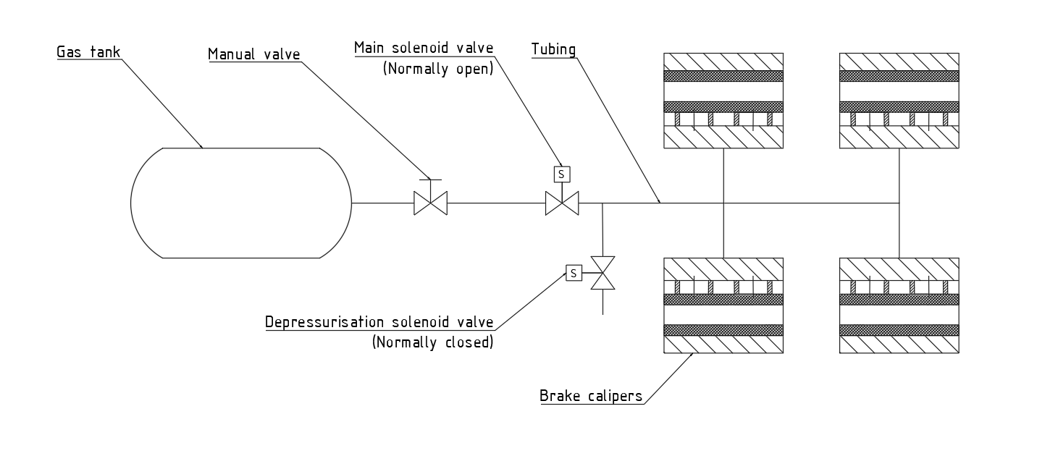

**Figure 25.** Braking system diagram

Pneumatic system is chosen over hydraulic for few reasons, such as weight reduction, elimination of hydraulic pump and oil reservoir, easier engagement, elimination of the additional complexity of the system, as well as safety features in case of power loss. The pod has to brake only once in a run, so the energy for braking can be stored one-time in the form of pressurized gas. After each engagement, gas tank has to be refilled. Pneumatic brakes are already widely used in numerous applications, but this principle with small gas tank is not scalable to commercial vehicles because of need to refill the gas tank after every brake application. Within the specific requirements in Hyperloop pod competition, this principle is acceptable.

As a working media, carbon dioxide is chosen due to lower adiabatic index in regard to air and other conventional gases, non-toxicity and accessibility. Lower adiabatic index affects gas tank pressure, lowering the required pressure. For the same braking system parameters (expansion chamber volume, starting volume, final pressure), gas with lower adiabatic index will have lower starting pressure. Brief calculation shows that gas tank volume should be around 2 dm3 and the working pressure is estimated to be around 25 bar. Furthermore, gas expansion will lower the temperature in the tubing and gas tank, but that will not affect brake system components and braking process. Temperature drop is calculated to be less than 10°C. Detailed calculations of gas expansion in the braking system and experimental testing will be done additionally.

The atmospheric pressure, which is trapped in the braking system, could be a possible problem during vacuuming the tube. If the brake system pressure is higher than the pressure of the tube, the force on the brake pistons may be generated and brake pads will get in unwanted contact with the rail before the run. It can cause poor acceleration during the run, or it can affect brake pad wear and additional heat will be produced due to unwanted friction. This problem will be solved by using additional depressurization solenoid valve. The additional valve will be used to equalize tubal pressure and the braking system’s pressure. During tube vacuuming, this valve will be opened until the tube reaches final pressure. As a safety feature, normally open solenoid valve will be used so in case of power failure, braking system will work normally. Same valve will be used to depressurize the system after the run, so the pod can be easily removed from the rail.

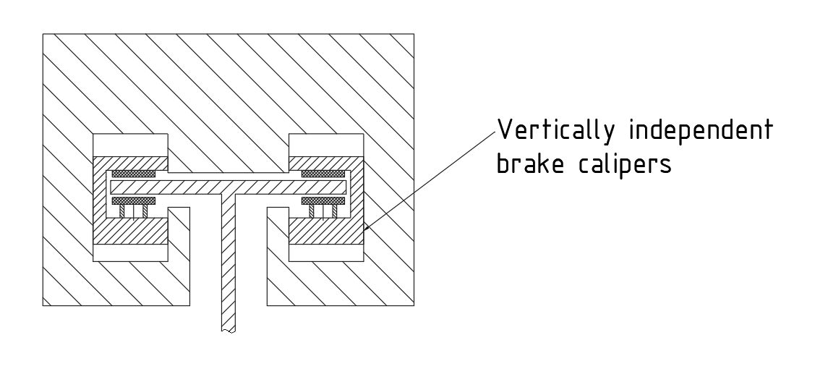

**Figure 26.** Position of the brake callipers

Brake calipers will be custom made according to the rail dimensions. Aluminum will be used due to its high specific heat capacity and good machining properties. Brake pistons will be bought separately, from automotive brakes and fitted onto custom made calipers. Vertical movement of the brake calipers mustn't be restricted and friction between brake calipers and pod body must be minimized to ensure a uniform force on both brake pads.

Live control and telemetry to the outside computer will be enabled. Temperature and pressure will be measured and controlled the whole time. If necessary, the braking can be activated from the outside of the tube in any time during the pod’s run. The engagement time of the brakes has been estimated at maximum of 0.2 seconds. More accurate number will be known after testing is done.

## 11.2. Wear test

Aluminium rail mustn't be damaged during the run, so tribological properties of brake pad material and rail material will be tested. Brake pads and aluminium are in sliding contact, so wear types, sorted by danger in sliding wear are:

* Adhesion (very high)
* Surface fatigue (medium)
* Abrasion (low)
* Tribocorrosion (very low)

Adhesion is reduced by choosing materials with good tribological compatibility i.e. those which don't make micro-welds in mutual contact. Probability of surface fatigue grows proportionally to the number of repetitions of sliding contacts. As we have only one passing, the risk of significant surface fatigue is low. Abrasion can be reduced by choosing homogeneous material without hard particles. Danger of tribocorrosion is very low, because there is no atmosphere in hyperloop tube. Organic brake pads, which are made from a mixture of fibres, held together with a resin, with addition of kevlar, carbon, and rubber among other things depending on the application, are chosen because they show good properties for all wear types. The negative side of this brake pad compound is lower coefficient of friction. It’s shown in some researches that it goes around µ=0,2 - 0,25 in Al - Organic brake pad contact. This will have to be compensated by using higher pressures to ensure enough braking force. The fact that rail doesn't get very hot during braking must be taken into consideration because tribological properties highly depend on temperature.

Method used for laboratory testing of tribological properties is ''block on ring''. Force is applied on block which is pressed against rotating ring. Force acting on block and ring speed can be regulated to simulate real-life conditions. Additionally, the force and the coefficient of the friction will be measured with built-in dynamometer. After the testing is done, tested samples will be analysed with SEM to get insight into the state of aluminium surface.

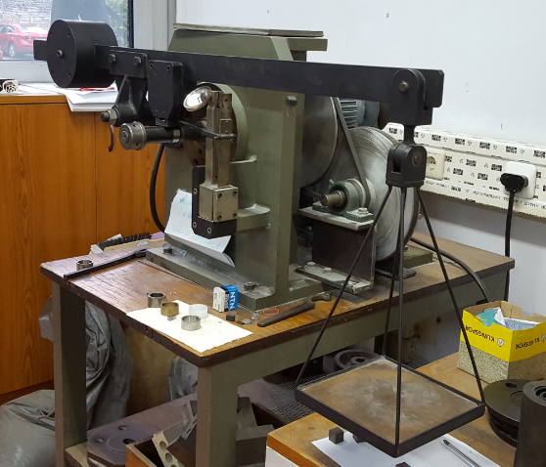

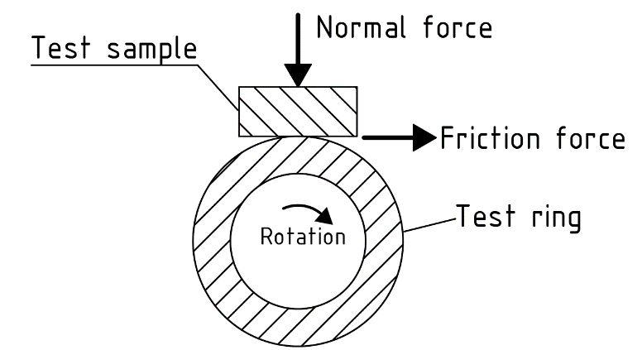

**Figure 27.** Test principle

**Figure 28.** Test rig

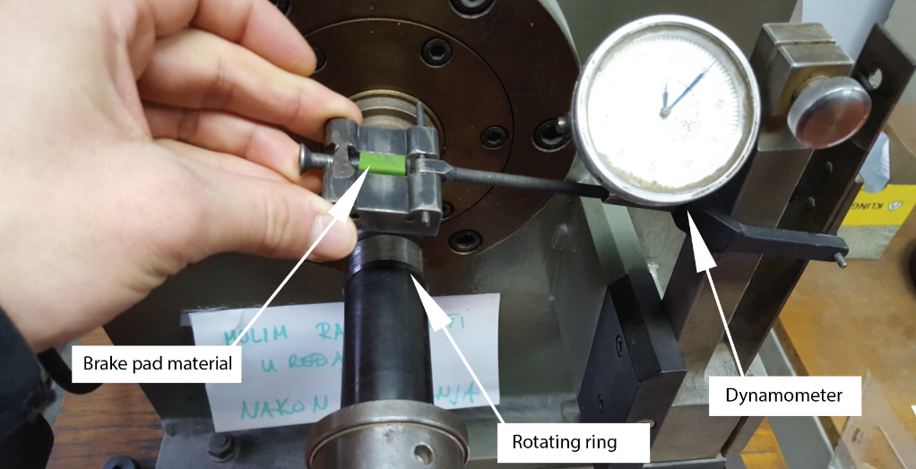

***Figure 29.*** *Main parts (close view)*

## 11.3. Final testing

Before we start final testing, leak test will be performed with CO2 leak tester at all critical spots such as joints, fittings, valves and brake pistons, so we can be sure there is no unwanted pressure loss. Besides that, control system will be tested too.

For final testing purposes, rotating motion will be used instead of linear. Rotating motion of the disc will simulate the pod's movement down the track. Test will consist of electric motor, flywheel, dyno and test disc rotating on the same shaft. Shaft will be supported by three bearings. Breaking will be done by using brake caliper like the ones on the pod. Torque for the system will be provided by asynchronous electric motor. Flywheel will be designed so that it has the same moment of inertia as the real pod. After the shaft reaches full speed, the motor will be shut off and the brake will be activated. The measured parameters will be braking torque, pressure, time and number of revolutions per second. From those parameters, coefficient of friction will be calculated and later used for more accurate braking calculations. Braking time will provide us information of brakes efficiency.

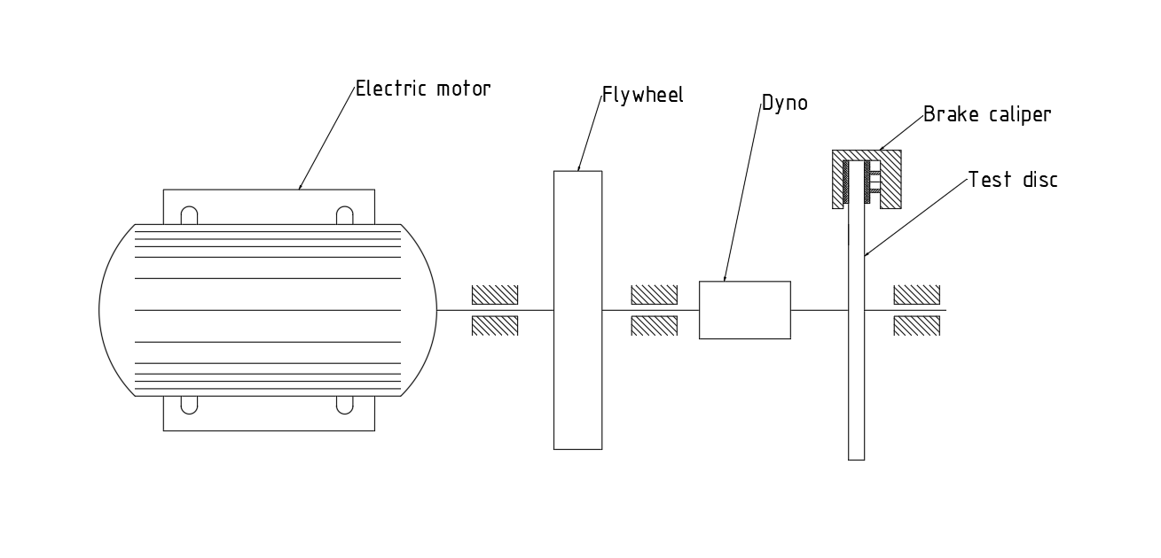

**Figure 30.** Brake testing equipment drawing

## 11.4. Heat dissipation

During the braking phase, the kinetic energy of the system will be converted into heat. In conventional disc brakes, heat is distributed partially on the rotor and partially on the brake pads and caliper. In Hyperloop, the rail acts as a rotor, so significant amount of heat will be dissipated on the rail. The rail will not be damaged by braking heat because it will be distributed along the track, so individual parts of the rail will not get warmed up considerably. It has been calculated that the rail will not warm up more than 5°C locally. Brake pad material has much lower thermal effusivity than aluminum rail and it acts as an insulator, so the brake pads and calipers will only take minor part of the produced heat. Brake calipers will be designed accordingly, so that they can take significant amount of heat from brake pads in order to ensure there won't be unwanted brake fade. Calculations show that brake calipers will take around 10X less heat than the aluminum rail.

## 11.5. Additional induction braking

Due to possibly overheated batteries after acceleration phase, regenerative braking isn’t feasible and safe at motors full power. It’s estimated that it will be possible to use one third of motor power. Friction brakes will be designed to completely stop the pod, and induction braking will be used to modulate the resultant braking force and achieving desired deceleration. Modulation will be achieved by lowering the frequency with frequency converter bellow synchronous speed.

# Stability

For both vertical and lateral stability, wheels suspended by a linkage system with a rubber spring will be used. It was chosen over magnets as it shows good properties, is much cheaper and easier to mount onto the pod. Magnets will still be used vertically to lift 95 percent of the weight of the pod off the wheels thereby almost completely eliminating the rolling resistance. The wheels will however stay in contact with the rail at all times, ensuring the proper positioning of the pod structure.

For wheels, softer brass shell will be pulled over steel bearing so that the trail cannot be damaged by a harder surface.

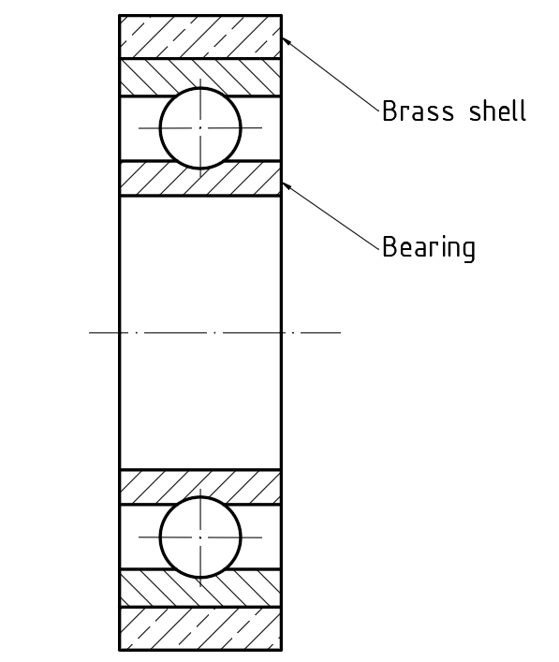

**Figure 31.** Bearing and brass shell representation

Rubber springs are used for damping vibrations and shock load caused by rail irregularities so that it doesn’t come to undamped oscillations and ultimately to resonance. Damped vibrations from the friction are converted into heat. Absorption of energy by material known as hysteresis, happens during the deformation of viscoelastic material, more precisely when rubber suspensions are compressed (stressed). This can be demonstrated on the below stress/strain graph.

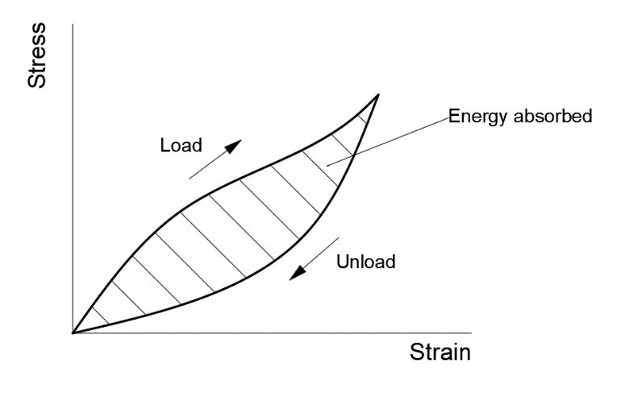

**Figure 12.** Rubber hysteresis graph

As can be seen on the rubber hysteresis graph, the “Load” cycle follows a different “Unload” cycle. This difference, which is hysteresis, is due to the energy being absorbed during Load cycle and is equal to the shaded area of the graph. The area below Unload cycle shows the energy returned. The total area of both hysteresis and the energy returned equals the sum of energy used to deform the spring. Damping factor is the ratio between the total sum of the energy used and the hysteresis.

Rubber shock absorber has low hysteresis and high resilience (the opposite of hysteresis), meaning that the pod would be rebounded off the shock absorber rather than being absorbed. Hysteresis results in an increase of roll resistance of rubber wheels, which is an undesired effect, hence the brass shell.

Rubber cannot be compressed, it can change its shape, but not the volume. If it were closed from all sides, it would lose its elastic properties. Because of the notch effect, sharp edges and corners should be avoided.

For suspension bushings, rubber and polyurethane materials were considered. The most significant difference is that rubber tends to deteriorate easier than polyurethane, but polyurethane is usable up to 50°C which is undesirable. The softer the bushing, the quieter and smoother the ride will be. Therefore, rubber bushings will be used for the competition as they provide less vibrations and a quieter ride.

These rubber springs will be placed on top of the rail and on its sides in pairs for both vertical and lateral stability. This placement can be seen in *Fig.3*.

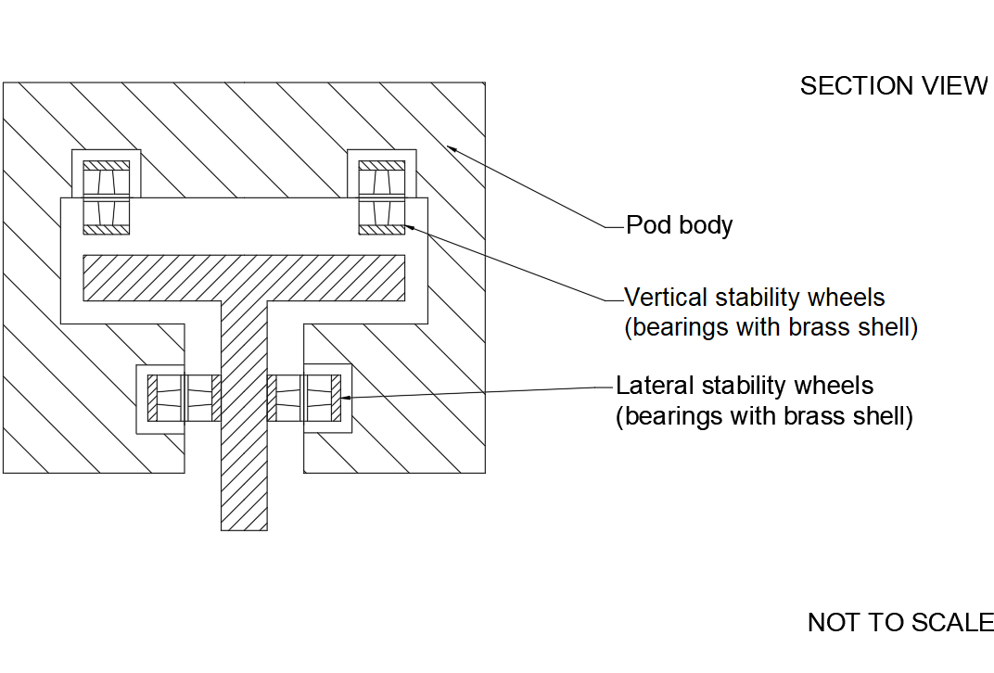

**Figure 33.** Rubber spring and wheels placement

Linkage system will be used for easier spring positioning inside the pod, to transfer force from the rail and the wheels onto the rubber spring and to precisely control and fine tune travel and rigidity of the aforementioned rubber springs by changing the ratio of the levers.

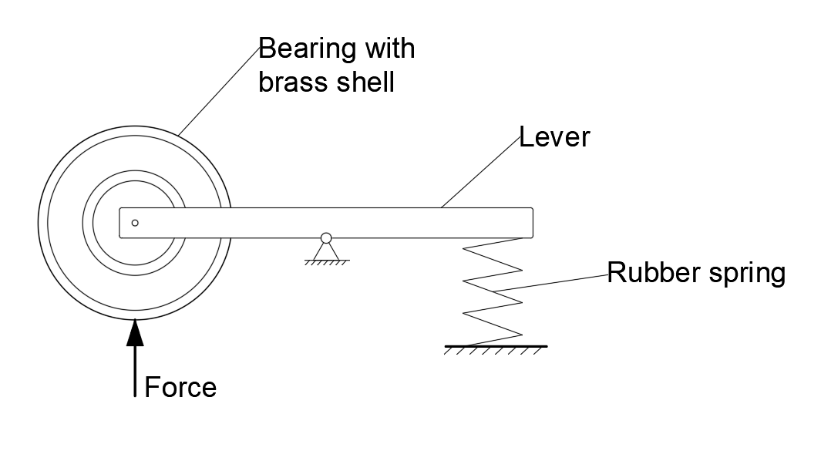

**Figure 34.** Linkage system representation

# Aerodynamics

## 13.1. Introduction

One of the fundamental concepts of the Hyperloop is that by travelling through a near vacuum environment the aerodynamic drag is significantly reduced, allowing for much higher travel speeds and lowering power losses. The performance of the pod can be further improved by enveloping the vehicle structure in an aerodynamically efficient fairing. The gains in performance thus obtained, although not expected to be large at the speeds aimed for, are worth the design and fabrication effort since the fairing can be made light using carbon fiber reinforced resin.

The total aerodynamic force acting on the vehicle can be split into two components, the lift force and the drag force. Due to structure and track limitations the fairing will produce a certain amount of net lift force, normal to the horizontal plane which isn’t wanted but is unavoidable. This effect is studied in order to inform the design of the levitation and suspension sub-systems which have to take this force into account. Meanwhile, the main goal of the fairing is to reduce the drag force which acts parallel to the flow.

The drag force consists of the viscous drag and the form drag. The viscous drag is caused by friction between fluid particles in the thin boundary layer on the fluid surface. It will be reduced by working the surface of the fairing to a very fine finish and low surface roughness. The form drag occurs because the fluid flowing over the surface of the vehicle loses energy due to viscosity and thus does not experience full pressure recovery. This means the front of the vehicle experiences higher pressure than the rear amounting to a net force counter to the direction of travel.

To accelerate the design process with drag reduction in mind the fairing was designed as a lofted feature of NACA airfoils. It consists of 3 parts, two bottom cowls and a cover. The fairing is not a structural component of the vehicle and is only aerodynamically loaded. The bottom parts are bolted to the structure and the cover is attached to the bottom parts using pins akin to the ones used to secure hoods on racing cars. The pins have a negligible aerodynamic effect on the pod and they make the internals of the pod easily accessible. The pod masses in at 8 kg.

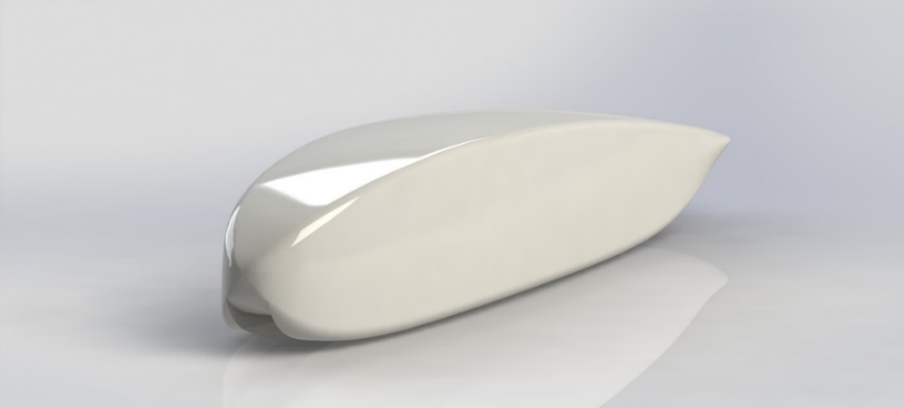

**Figure 35.** Aerodynamic fairing

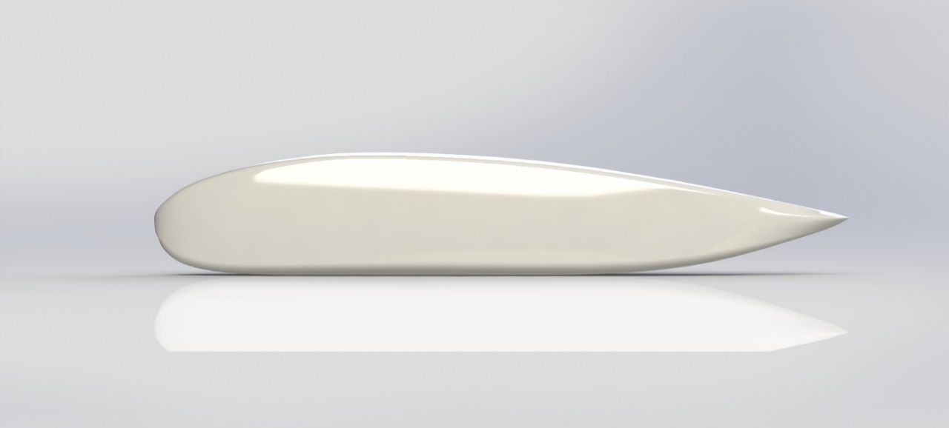

**Figure 36.** Aerodynamic Fairing Side View

## 13.2. Flow regime

The Reynolds number of the flow is around 100 000. The flow is internal in nature, so it is expected to transition into turbulent flow somewhere along the surface of the fairing. Flow separation significantly increases form drag and this proves to be problematic in this flow regime because in conditions of low Reynolds numbers, the flow easily separates even at small positive pressure gradients. Turbulent flow is less prone to separation so to reduce the chance of flow separation the flow can be made to transition into turbulent sooner by use of vortex generators.

As the maximum speed is projected to be 100 m/s, the Mach number is around 0.3, with the speed of sound in air depending only on temperature. We thus neglect the effects of compressibility to simplify the model without making large mistakes.

Furthermore, the near vacuum of the tube presents other questions. The continuum hypothesis posits that the properties of matter are uniformly distributed through space and is very important in mechanics. Among other things, it allows the use of calculus. Since the air surrounding the pod in this case is extremely rarified at a pressure of only 860 Pa with a density of 0.01 kg/m3, the validity of the continuum hypothesis has to be checked. This can be done via the Knudsen number which represents the ratio of the mean free path of a fluid molecule and a representative length scale of the structure. As a rule of thumb, if it is smaller than 0.1, the continuum hypothesis stands. It can be expressed as

$$Kn=\frac{μ}{ρL}∙\sqrt{\frac{πm}{2k_{B}T}}$$

And in this case, it turns out to be around 4 x 10-6, meaning the continuum hypothesis stands. Thus, a standard CFD solver, like Fluent can be used without having to deal with rarified gas dynamics.

## 13.3. Numerical modelling

Taking into account the flow regime, the governing equations of the model are taken to be the Reynolds Averaged Navier-Stokes (RANS) equations. The shear stress transport (SST) k-ω turbulence model is used with corrections for low Reynolds numbers.

The outer bound of the flow domain is the tube specified by SpaceX and the inner is the surface of the pod. The vehicle skin is modeled as a stationary wall with the no-slip condition and the standard wall function applied. The roughness is set to 0 m, due to the fine surface finish that the fairing will have. The walls of the tunnel are modeled as translational walls, also with the no-slip condition and the standard wall function applied. The inlet of the flow domain is a velocity inlet with a velocity magnitude of 100 m/s and a uniform velocity distribution. The turbulent intensity and turbulent integral length scale are set to 0.01% and 0.1 m respectively at the inlet which corresponds to calm static air, a fair estimate for the inside of the tube prior to the start of the run. The field is initialized from the inlet. The outlet is a pressure outlet with a gauge pressure of 0 Pa.

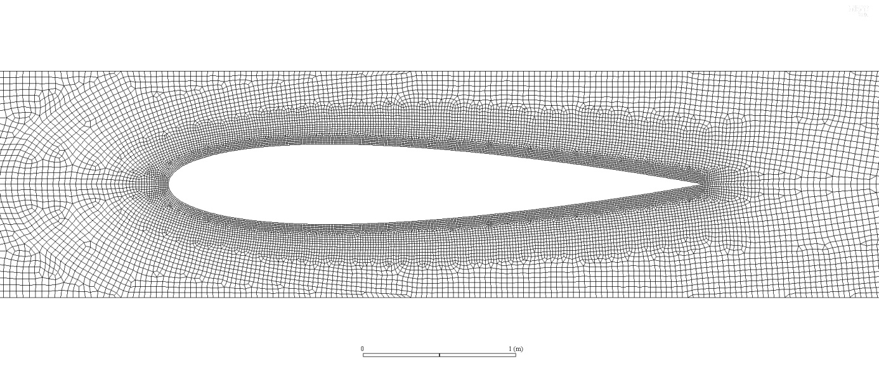The discretization of the flow domain was carried out in ANSYS Meshing using unstructured tetrahedral elements. The size of the control volumes directly on the surface of the vehicle is determined so that the dimensionless distance y+ of the first computational node next to the surface has a value of 30. This has been recommended by some authors for reliable results to avoid the inner boundary layer. The mesh is finer closer to the vehicle surface and in the wake of the vehicle. Additionally, the mesh is made finer still in the gaps between the vehicle and the rail. It is important to note, that openings for the elements protruding from the fairing such as the friction brakes and the wheels are not modeled. It is assumed that their impact on the overall aerodynamic performance of the pod can be neglected without large negative effects.

**Figure 37.** NACA 0015 2D mesh

Initially, planar 2D flow around key sections of the aerodynamic fairing was simulated. Even though this isn’t an approximation that can yield even remotely correct results it does give quick and useful insight into the flow phenomena during the run. A symmetrical NACA 0015 airfoil is used as the horizontal section of the vehicle.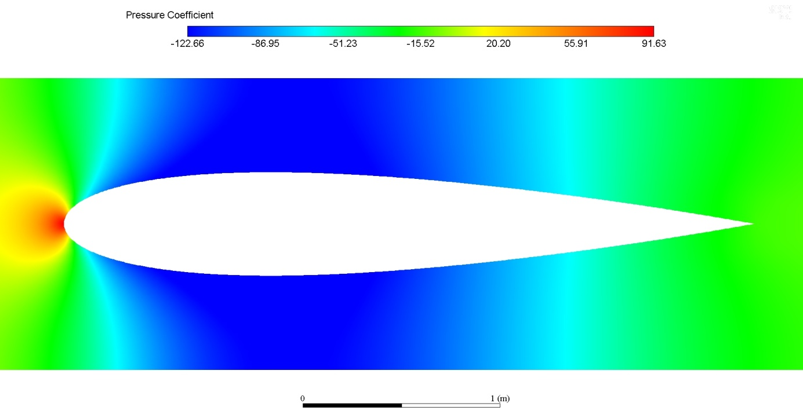

**Figure 38.** NACA 0015 Pressure Coefficient

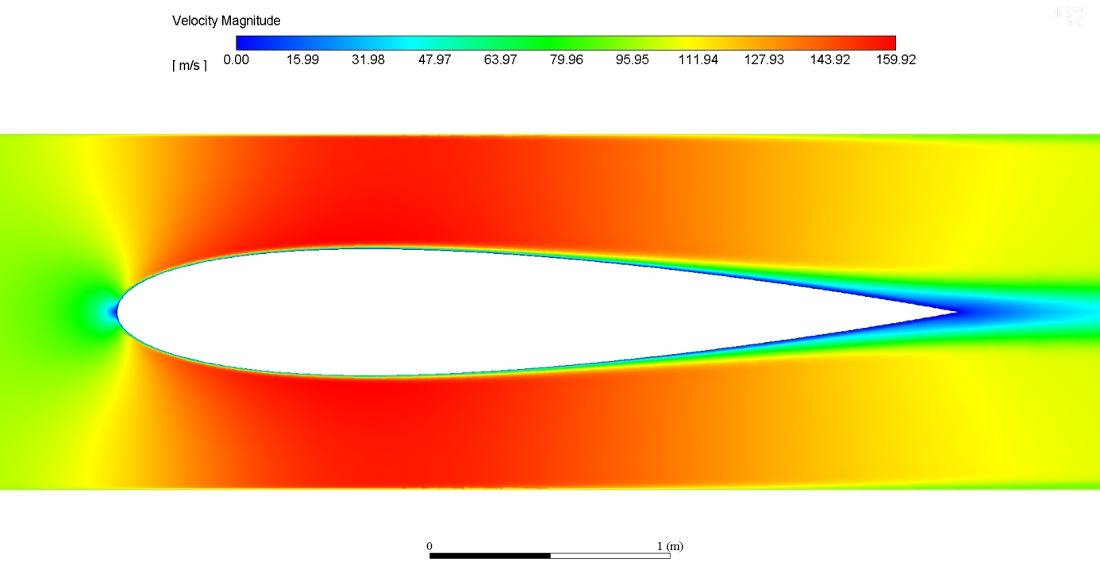

**Figure 39.** NACA 0015 Velocity field

For the vertical section directly above the rail, the NACA Clark Y flat bottomed air foil was simulated. To avoid flow separation it was slightly changed yielding a better result. 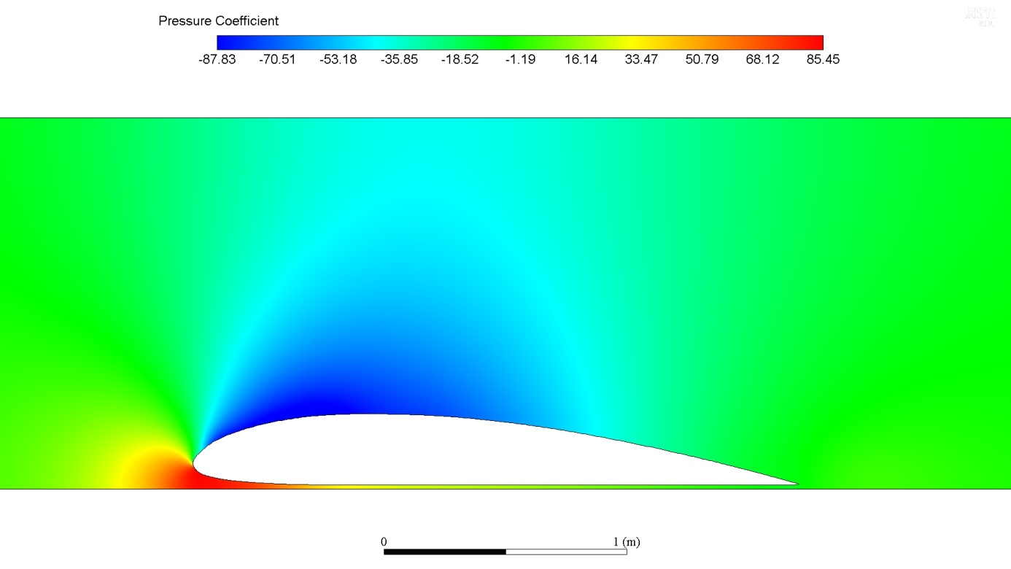

**Figure 2.** NACA Clark Y Pressure Coefficient

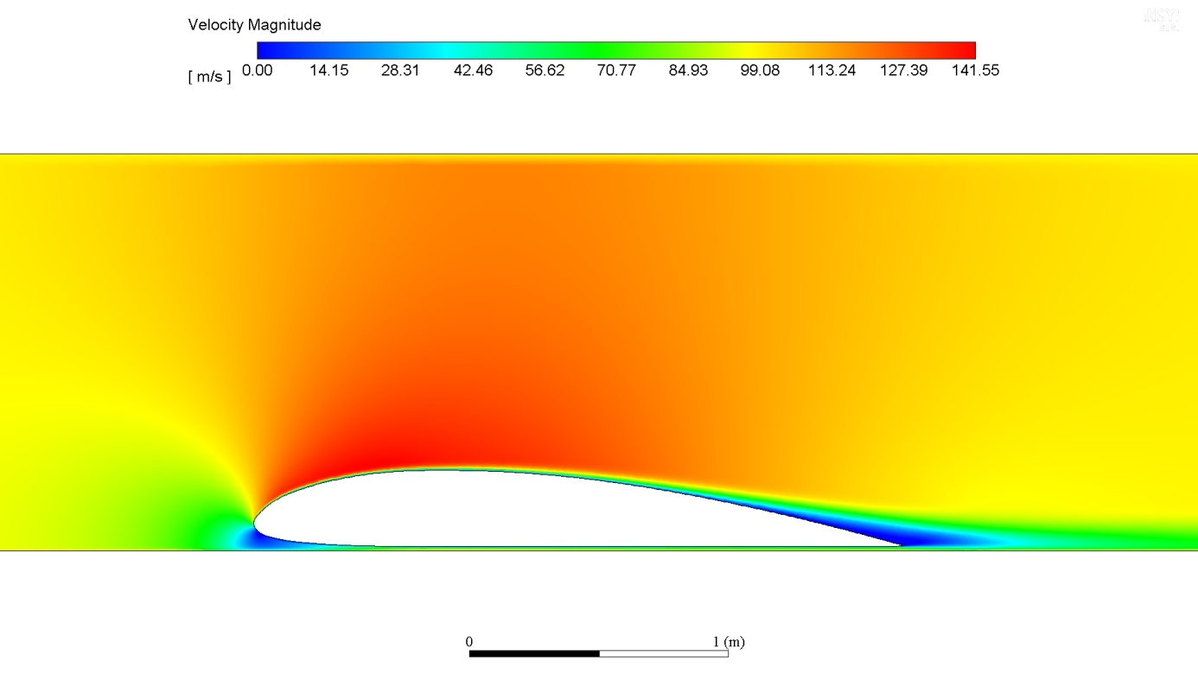

**Figure 3.** NACA Clark Y Velocity field

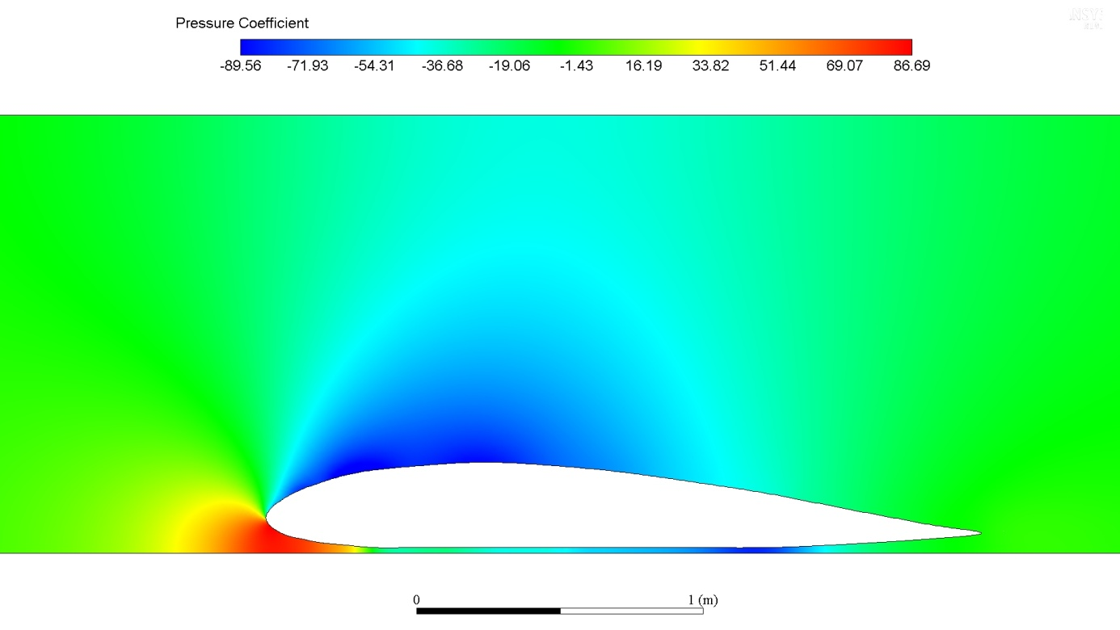

**Figure 42.** Modified NACA Clark Y Pressure Coefficient

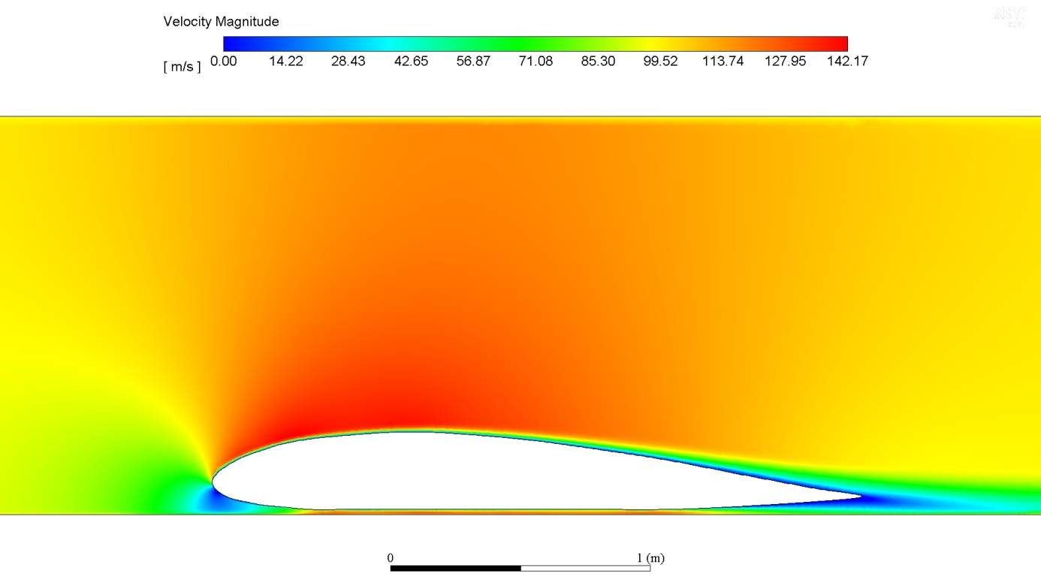

**Figure 4.** Modified NACA Clark Y Velocity field

Finally, to determine the aerodynamic coefficients of the pod, visualize the flow field and validate the design a 3D simulation was performed. The computational setup, model and boundary conditions remained the same as in the 2D simulations. The results yielded a coefficient of drag CD = 0.22 resulting in 3.2 N of drag force at 100 m/s in the tube conditions. The coefficient of lift is CL = 0.49 resulting in 7.9 N of lift, acting in the positive direction of the z-axis.

# Cooling

## 14.1. Introduction

By travelling through near vacuum, we neglect the convection and due to the short travel time, radiation is ignored because there is not enough time to affect the temperature inside the pod. Therefore, we are focusing on a conduction while assuming with big certainty that heat dissipation is reduced to minimum and can be ignored. Huge power elements will be overheated which is why a proper cooling system needs to be found.

## 14.2. Description

Inside our pod, there are 4 main parts which produce heat that can affect the vehicle. These are:

* Friction Brakes
* Frequency inverter
* Motor
* Batteries

The heat produced from computers, sensors and other navigation equipment is incomparable to the parts mentioned above.

## 14.3. Brakes

When the pod reaches the expected maximum speed of 70 m/s at the position of 1000 meters from the track start, regenerative braking will start, and friction brakes will engage at the same time. An estimation of the heating produced by friction brakes was carried out which concluded that they would produce maximum of 7500 kJ of heat. That will not be enough to affect the strength of aluminum calipers if the heat is dissipated correctly. Brake pad material has much lower thermal effusivity than aluminium rail and acts as an insulator, meaning brake pads and calipers will take only minor part of the produced heat.

Brake calipers will be designed so they can take significant amount of heat from brake pads to ensure there won't be unwanted brake fade. Calculations show that heat will be distributed mainly on the rail, order of magnitude 10 times more than on the brakes. Based on the previous claims, there is no need to cool the brakes.

## 14.4. Frequency Inverter

Frequency inverter is the element which must not be heated to more than 70°C in order for system to work properly. Primarily, IGBTs are being heated, followed by the heating of the cables. If we assume there is not convection, the aluminum cooler is not functionable and conduction cooling must be applied. Galden will be used to reduce the possible overheating which will be sufficient to keep the temperature under 65°C with its flow. Secondly, IGBTs at FI, which are standardly powered (up to 132 kW), are completely submerged in galden, keeping it under 65°C. The 3-phase frequency inverter with an output power of 150 kW will generate approximately 10 kWh of heat loss during the test run. In addition, frequency converter enables 4-quadrant operation of the drive so regenerative braking can be used as assistance to friction brakes. Heat losses during regenerative breaking, due to the lower currents of charging than discharging, will be the same or lower during acceleration.

## 14.5. Motor

As the motor has no moving parts, the only heat it produces comes from the conduction of windings. In theory, three notions ought to be considered; melting, resistance and expansion.

Safely assuming that 10 kW of power during the run is converted into windings' heat, the temperature increasement will be on the order of tens of Kelvins.

Copper's melting point is 1358 K, while electrical resistance rises by 0.393% for each additional Kelvin and its linear thermal expansion coefficient is 17×10-6. With this in mind, the three potential issues mentioned above are easily shown to be of no concern.

The other part of the motor is the iron core, which gets all of its heat from contact with the windings. As the core is laminated, no eddy currents will be induced, therefore no heating will come from the core, and all of its heat will be generated from contact with the soils. Its heating is therefore lesser, while its mass is higher, and the other relevant properties are comparable. This too can be ignored in regard to overheating, and thus there is no need for cooling.

## 14.6. Batteries

To ensure lowest possible internal resistance and greatest capacity, cells should be maintained in nominal temperature range, that is at 50°C +- 5°C, and no more than 85°C. If cooling is not sufficient and temperature soft limit is reached, battery power is lowered, and if hard limits is reached, battery power is shut completely. Our cooling system is designed to keep batteries under 80°C for the duration of acceleration and deceleration in which regenerative braking is charging batteries. The flow of the current causes heating of the battery cells and their interconnection systems which is proportional to the square of the current flow, multiplied by the internal resistance of the cells and the interconnect systems. The performance of batteries is greatly impacted by their temperature as they do not perform well in extreme environments, which leads to damage of the cells and shorter lifespan of a battery. While heating batteries isn't the problem (assuming the tunnel is underground), cooling them is.

## 14.7. Cooling

While discussing possibilities, the conclusion was made that air cooling isn't suitable for batteries. Air-cooling system requires many parts such as condenser, compressor, evaporator and other regulative segments which would bring us additional unwanted weight. Moreover, air cooling requires big spaces between cells to allow sufficient fresh air to circulate between them, which would result with bigger and heavier pod. As mentioned above, convection is reduced to minimum which is why a pressurized housing will be built.

Housing will be built around the batteries which will be connected to the reservoir with silicon-automotive pipes. For refrigerant, we have decided to use galden. Galden is a high-performance, perfluorinated, dielectric inert polyether fluid making it ideal refrigerant for our purposes. It also doesn't corrode or react with construction materials and has excellent thermal and chemical stability. Here are different variations of galden polymer.

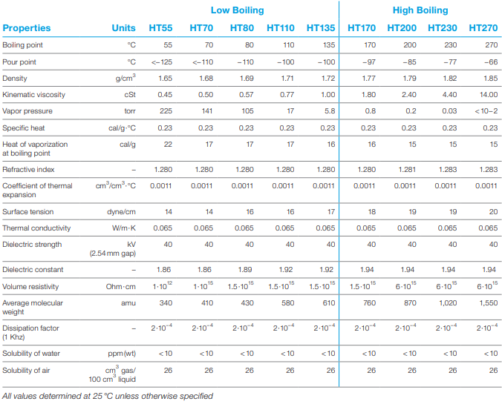

**Table 11.** Galden properties

The problem with galden is its high density which directly affects the pump size. We have assumed the pump size would be approximately 250 Watt, while further possibilities will be discussed. As for the galden, pump will be used to circulate the coolant, a thermostat to control the temperature and a reservoir to keep it flowing around and between batteries to keep the system at working temperatures. Another disadvantage of galden its low thermal conductivity, but circulating it, effective heating surface will be increased, creating equivalent wind-chill effect.

# Pod trajectory

This is a result of our simulation, but with no losses. To account for all losses, we estimate the final speed to be around 70 m/s.

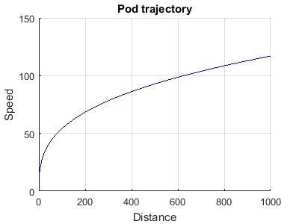

**Figure 44.** Pod trajectory

# Pod Dynamic Environments

Dynamic environments consist of all excitations (internally or externally induced) that produce dynamic loads upon a pod and its components. Excitation signals are classified as being periodic, transient or random in character. In the following section, specific dynamic environments will be analysed and summarized.

* Transportation:

Transportation of a pod from its manufacturing point to the other points of storage, assembly and testing will be achieved by a truck. Furthermore, transportation to the launch site will most likely be by an aircraft or a watercraft. In any case, during the transportational activity, dynamic loads will be produced which may cause damage to the pod and its components.

* Possible seismic activities during launch:

Competition facility is located at Hawthorne, California, where seismic activity is relatively common. Even though the chances of an occurence of an earthquake strong enough to damage the pod's components during competition are extremely low, this should not be neglected.

* Track deformation:

Due to possible deformations and curvature caused by welding track and subtrack parts, minor transient excitations may be generated.

**Transient signal generated by transition between track p**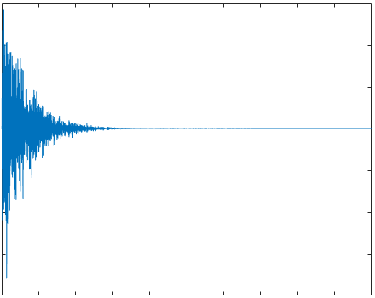

**Figure 45.** Track vibration signal

* Aerodynamic loads during motion inside of tube:

Although the pod will move through mostly vacuum, some fluctuating pressures between the external surface and extremely thin atmosphere inside of a tube will be generated.

* LIM generated vibration loads:

During the LIM operating, relatively small structureborne vibrations will be produced that may be transmitted through mounts to the pod structure and components.

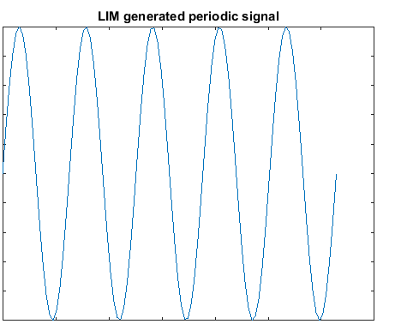

***Figure 46.*** *LIM generated signal*

* Vibrations caused by wheel to track contact:

As the motor, brakes and lateral stabilizers are constantly maintaining contact with track by using wheels, relatively heavy vibrations will be generated because of uneaven surfaces of the track, subtrack and wheels. In order to minimize these vibrations and its effects, rubber springs will be attached.

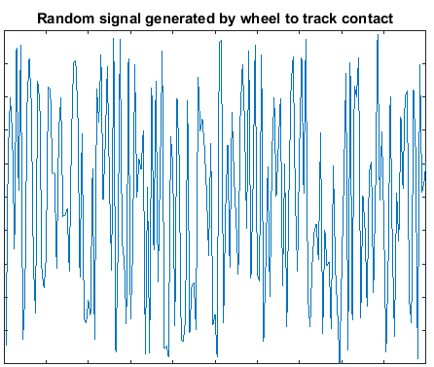

**Figure 5.** Random wheel-track vibrations

* Magnetic and electromagnetic noise:

Magnetic and electromagnetic forces caused by levitation, as well as LIM, will directly produce minor vibrations of the pod's conductive parts, coils and magnets themselves.

* Frictional Braking:

During the braking phase, small vibrations will be generated. This is caused by sudden contact and friction between pads and wheels.

* Pod Equipment Operations:

Some electronical and mechanical components on the pod may produce vibration during pod's operational phase. Example of these vibration inducing sources are on-board movements of actuators and pumps while operating with fluid.

A summary of dynamic environments with information about character of excitations, as well as magnitude of each type of load is given in the following table.

|  |  |  |  |
| --- | --- | --- | --- |
| **No.** | **Dynamic environment** | **Random (R), Periodic (P), or Transient (T)** | **Magnitude** |
| **1** | Transportation | R, T, P | Low to High |
| **2** | Seismic Activity* | R, T | Low to High |
| **3** | Track Deformation | T | Very Low |
| **4** | Aerodynamic Loads | R | Very Low |
| **5** | LIM Loads | P, R | Low |
| **6** | Wheel-Track Contact | R | High |
| **7** | Magnetic and Electromagnetic Noise | R | Medium |
| **8** | Frictional Braking Loads | R | Medium |
| **9** | Pod Equipment Operations | R,P,T | Low |

**Table 12.** Dynamic environments

*If the seismic activity occurs

In order to maintain stability and proper function of a pod and its electronical and mechanical components during handling, transportation and run, all the systems will be vibration tested. These tests will consist of inducing shock signals (transients), periodic vibrations and random vibrations in x,y and z directions. After tests being conducted, all components will be inspected for possible damage.

# Structural design

## 17.1. Intro

The main purpose of a pod’s structure is to resist all applied loads without a failure during its lifetime. This is crucial in order to perform spotlessly while being able to adjust to different situations upon which pod may be subjected to. Furthermore, in the future, strong and stable structure will provide safety and comfort to passengers. Although the implementation of a strong and complex chassis, as well as suspension system, will increase mass and cost, it is absolutely necessary for highly dynamic systems such as this one.

There are three basic load cases; bending, torsion and buckling. All of the mentioned will occur at some point of pod’s life as a product of static or dynamic loads. Crucial situations where these loads will have the greatest effect on the structure will be analysed in the sections below.

## 17.2. Static Loads

All forces and loads, in term of compression or tension, which are constant during long periods of time are described as static. First and foremost, the complete mass of pods components will produce never-ending load onto a structure while at rest. The heaviest loads will be generated by LIM, frequency converter, batteries and compressor, as they possess the highest mass. However, the weight will be significantly reduced while the pod is increasing its speed due to levitation magnets. Other examples of static loads may occur during transportation while other sources of mass are subjected onto pod. Static loads will generate forces that may cause bending and buckling of the structure.

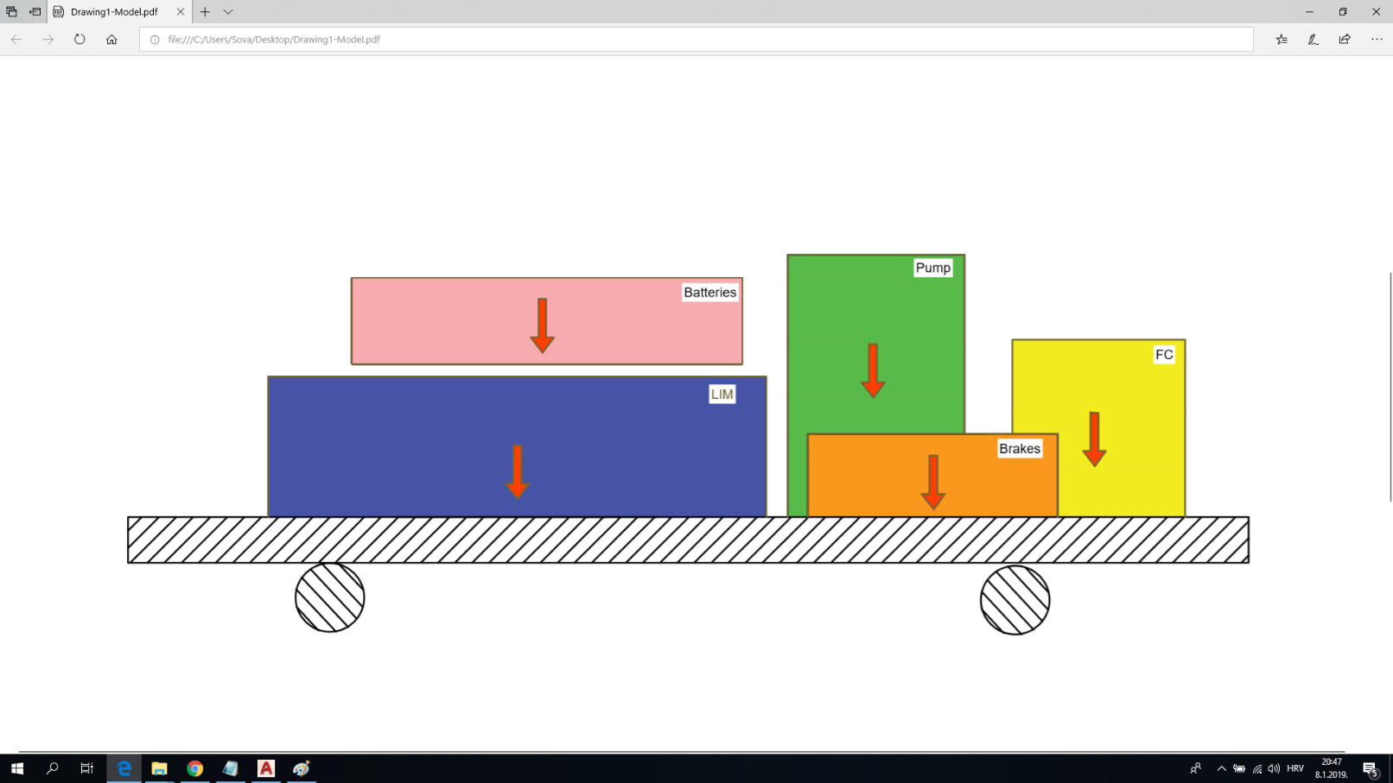

**Figure 48.** Weight of different subsystems

## 17.3. Dynamic Loads

Dynamic loads present the biggest problems for the structure of a pod. While accelerating or decelerating, inertia forces are generated causing the weight to transfer from front to the back and vice versa. When accelerating towards maximum velocity, the pod will tend to pitch backwards and generate larger force on back wheels while relieving load on front wheels. Larger forces will be generated at the initial acceleration, just after pod starts moving on the track.

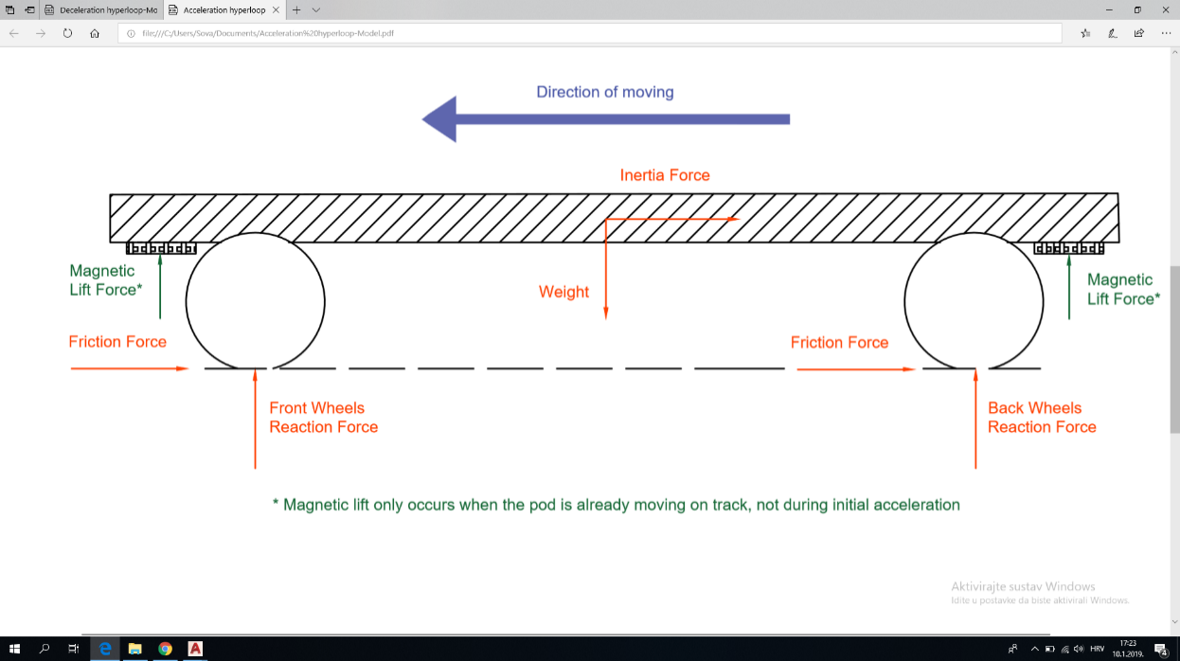

**Figure 49.** Acceleration

The same principle works for deceleration and braking, although when braking, additional forces will be generated as a result of friction between wheels and pads. The pod will tend to pitch frontwards meaning resulting force on front wheels is increased, thus decreasing resulting force on back wheels.

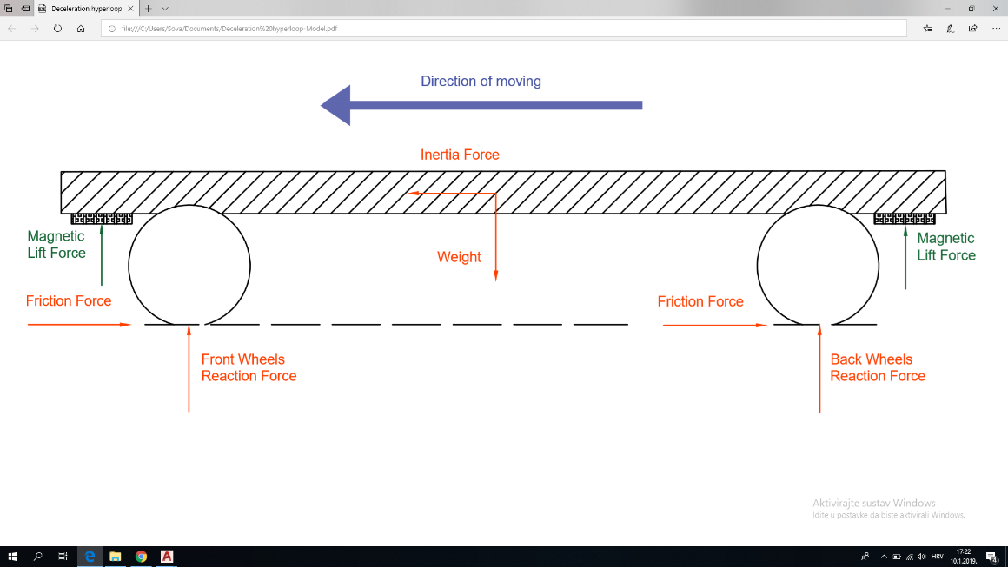

**Figure 50.** Deceleration

Both acceleration and deceleration will generate additional bending of the structure. Those effects will be minimized by using strong framework, proper assembly and precise mass distribution. In order to avoid crash of the pod while pitching, suspension system will be implemented.

Furthermore, possible deformations and curvature of the track caused by welding and assembling track and subtrack parts could produce lateral loads onto the pods structure. These shock forces will be generated at the point of contact between main wheels and track, as well as lateral wheels and track. Secondly, there is a small chance that one wheel hits a small bump or is slightly above the other wheel. Both of the examples will generate transient forces which will result in a tilting of a pod and bending of the structure. Once again, framework with another suspension and reinforcements system will provide enough stiffness to the structure, making sure the pod does not tip over.

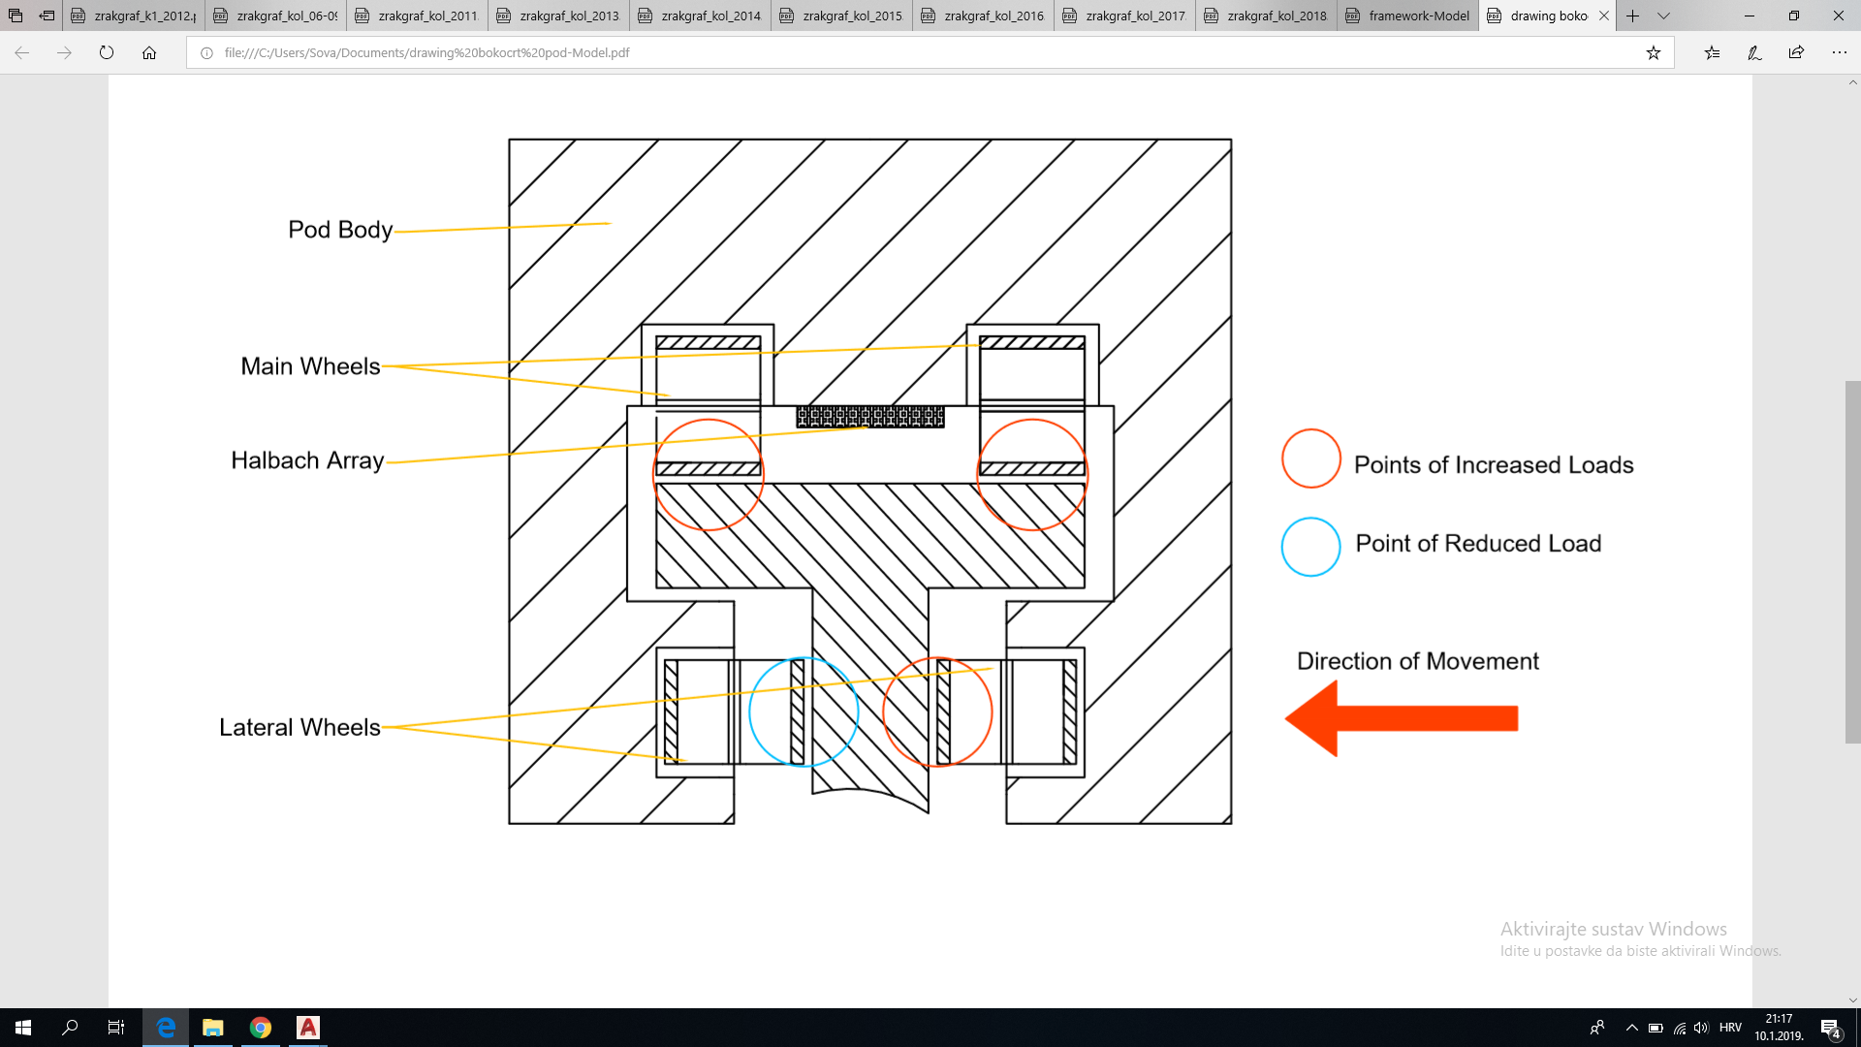

**Figure 51.** Section view

## 17.4. Lifting of a pod

Finally, at the competition, and possibly during moving and transportation, the whole structure will have to be lifted and placed at the beginning of the track with a warehouse forklift. This will be executed with a set of straps which are going to be linked to the hooks at the corners of the chassis an then connected to the forklift’s hook. The weight of the pod will produce loads onto straps and hooks, as well as external conditions like wind, or vibrations generated by the forklift. In order to prevent the straps and hooks from breaking, and pod from dropping mid-air and damaging, safety factor of at least 2.0 will be used. Connecting straps to the four opposite points of the framework enables for an even distribution of the loads that act upon them, thus significantly increasing stability and decreasing chances of unpredicted occurrences.

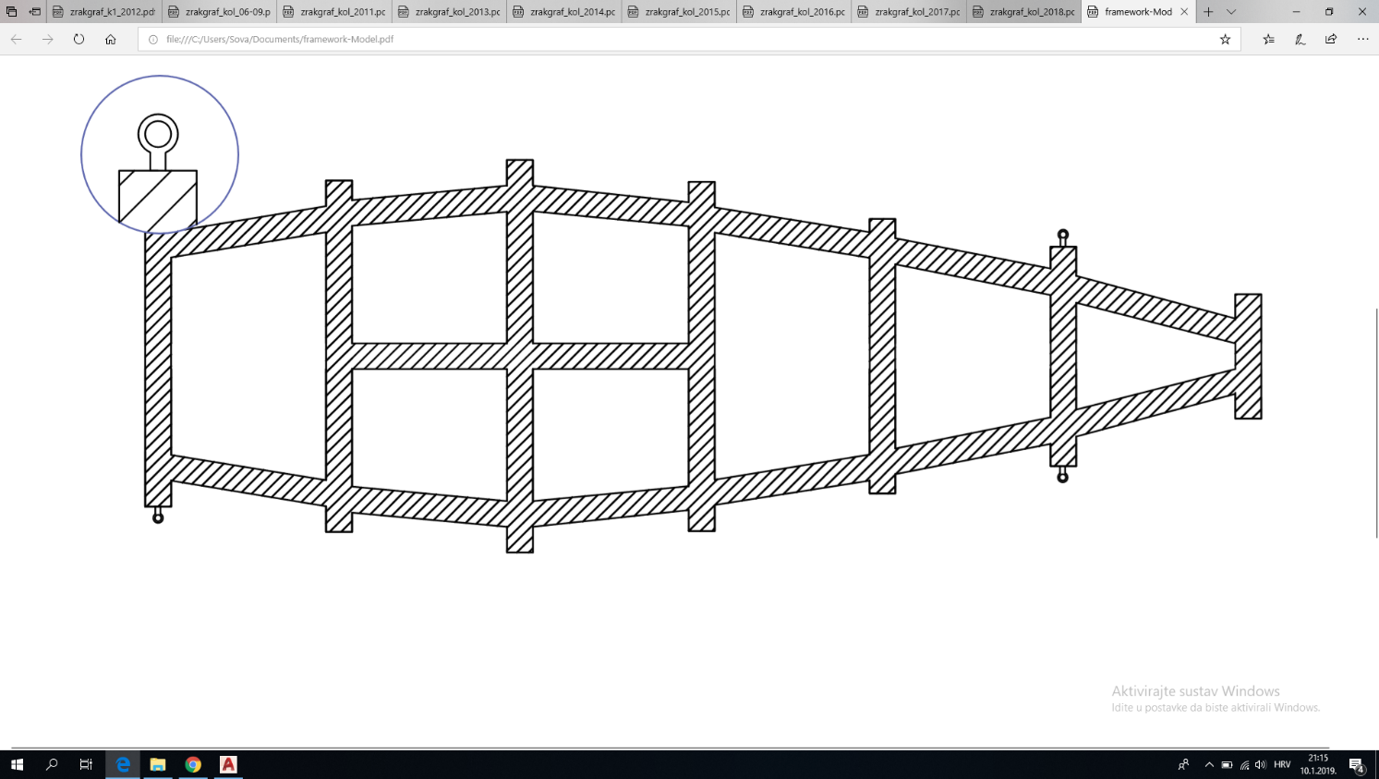

**Figure 6.** The layout of the framework with hooks mounted at 4 points

|  |  |  |
| --- | --- | --- |
| Situation | Type of Load | Effect on the Structure |
| Rest | Static | Bending, Buckling |
| Transportation | Static, Dynamic | Bending, Buckling |
| Acceleration | Dynamic | Bending |
| Deceleration | Dynamic | Bending |
| Braking | Dynamic | Bending |
| Lateral Shift | Dynamic | Bending |
| Tilting | Dynamic | Bending, Torsion |
| Lifting | Static,Dynamic | Bending, Torsion |

**Table 7.** Loads

# Subsystem and full pod functional test program

Pod functions are divided in 6 main subsystems: power, propulsion, navigation, levitation, stability and braking. All of them are closely related and mutually dependent, so testing of their interactions is crucially. Firstly, all subsystems will be tested on its own, and after those testing’s are completed, subsystem interactions will be tested.

Test program by subsystems:

* **Power:**
* Testing of upper limit of current drawn without overheating the cell
  + Nominal constant current of 50A will be drawn from the cell, while logging voltage, current, temperature and time.
  + Test shall be done with and without colling and stop conditions shall be set by over temperature limit of 90°C.
  + Every following test will gradually increase current drawn from cell by 5A, until stop conditions are met.
  + The goal of this test is to determine current limits of a cell for the duration of 20 seconds, and determine cooling efficiency.
  + Test results will be scaled up for module testing, then for the pack testing
* Final testing in completed assembly with other subsystems
* **Propulsion:**
* Short-circuit and idle test for checking LIM characteristics
  + This test will be used for determining basic parameters and losses
  + All testings will be done with frequency converter connected
  + Frequency converter characteristics and losses will be measured simultaneously in all tests
* Final tests will be done on short test track or disc which will represent aluminium rail
* **Navigation, controllers and sensors:**
* Unit testing of individual components.
* Controler testing by simulated inputs..
* Testing of all subsystem parts wich are interacting with other subsystems by simulated inputs.
* Testing of whole subsystem with simulated inputs.
* Testing of whole subsystem inside final pod assembly .
* Sensor tests
  + Light sensors: we will test the light sensors by setting up an electric motor with a spinning disc. Reflective stripes will be attached to the disc with some intervals in order to imitate the frequency of stripes occurring in the tunnel.
  + IMUs: IMUs will be tested on a device simulating pod’s movement through the tube
  + Temperature sensors: Temperature sensors will be heated to the maximum values provided in the datasheets.
  + Batteries: Using Arbin Cell Cycler, batteries will be charged and discharged. Voltage and Current characteristics will be monitored and recorded.
  + All sensors:
    - Vibration environment tests using Electrodynamic Shakers (except for the ones tested on vibration by manufacturer).
    - Vacuum Chamber tests.
* **Levitation:**
* Testing of magnetic lift on speciffically constructed testing device (more info is provided under levitation subsystem description)
* Additional testing is not necessary because of expected high accuracy of results in this test.
* **Stability:**
* Suspension tests will be done on speciffically constructed device, by representing unevenness of the track with uneven rotating disc.
* Additionally, computer model and simulation of stability system will be done
* **Braking:**
* Tribological properties and wear characteristics of aluminium and brake pad material will be tested in laboratory conditions with ''block on ring'' method.
  + Results of the test will be analyzed with SEM.
  + Simultaneously, coefficient of friction will be determined.
* Brake system assembly tests
  + Critical spots such as joints, fittings, valves and brake pistons will be tested with CO2 leak detector at MAWP.
  + Brake system control and power failure tests will be performed at working pressure.
* Final braking system performance and parameters (such as friction force, coefficient of friction, response time and working pressure) will be tested on a speciffically built system (more details is provided in braking subsystem description)
* Pod assembly testing

Considering that building an actual rail of significant length is way too expensive, not to mention this vacuum chamber, testing will be confined to subsystem testing in lab conditions. Also, computer simulations of subsystems and their interactions will be done. For educational purposes and popularisation of science, fully-functional small-scale model will be made due to big interest of certain professors who were contacted in search of additional info during the project. Later, model will be used in physics lessons at FER Zagreb

# Pod production schedule

|  |  |  |  |  |  |  |
| --- | --- | --- | --- | --- | --- | --- |
|  | Propulsion | Power | Braking | Navigation | Construction and levitation | Cooling |
| January 2019 | Optimisation of the LIM and LIM speed controller simulations  Design choices between easier production and efficiency | Design of the battery holders, simulations of the battery pack and tests on single batteries | Selection and ordering of the pneumatic equipment, Design of the brakes | Design of the PCBs and enclosures for the ECUs  Ordering of the ECUs and sensors  Final design choices | Finalisation of the pod constuction and aero shell design  Structural simulations  Levitation simulations and design of Halbach arrays  Tests on a single Hallbach array | Final thermal simulations  Choises of the exact cooling equipment use on the pod |
| February 2019 | Design of the LIM  Design of the LIM speed controller | Production of the battery holders and connecting batteries | Further design of the brakes and manufacturing sheets  Start of the production | Production of the PCBs  Writing code for the ECUs  Connecting sensors with their ECUs and testing | Design of the manufacturing sheets  Start of manufacturing  Supervision of the manufacturing | Finalisation of the cooling subsystem design  Ordering and manufacturing of the parts needed |
| March 2019 | Further design of the LIM and its ecosystem  Beginning of production | Tests of the whole battery pack  Changes if necessery | End of production Assembly of the brakes Changes in the design if necessery  Start of testing | Testing of the each ECU and sensors under various conditions  Start of the UI design for the team laptop | Finalisation of the manufacturing  Structural, aerodinamical and thermodynamical tests of the  Levitation tests | Assembly of the cooling subsystem  Tests of under various conditions and optimisation |
| April 2019 | Finishing of the construction Testing of the LIM and speed controller on their own  Assembly with the rest of the pod | Finishing touches on the batteries Assembling batteries with the rest of the pod and connecting them to other devices | End of testing  Assembly with the rest of the pod. | Interfacing the navigation subsystem with other subsystems and tests of their compatibility | Optimisation of the construction  Assembly with the other parts of the pod | Integration of the cooling subsystem in the pod enviroment and ensuring its compatibility with other subsystems |
| May 2019 | Tweaking of subsystems that require it  Tests of the whole pod | | | | | |
| June 2019 | Further tests of the whole pod and its optimisation  Getting pod ready for the competition  Arranging shipping | | | | | |

**Table 8.** Production plan

|  |  |  |  |  |  |  |  |  |  |
| --- | --- | --- | --- | --- | --- | --- | --- | --- | --- |
|  | | |  | |  |  |  |  | |
|  | | |  | |  |  |  |  | |
| Cost breakdown | | | | | | | | |
|  | | |  | |  |  |  |  | |
| Subsystem/Part | | | Quantity | | Weight/item (kg) | Total Weight (kg) | Cost/item (USD) | Total Cost (USD) | |
| Power | | | | | 93.31 kg | | $8,632.00 | | |
| Contactors (pre-charge) | | | 1 | | 0.38 | 0.38 | $160.00 | $160.00 | |
| Fuse (700VDC/350A) | | | 1 | | 0.26 | 0.26 | $70.00 | $70.00 | |
| Fuse (1000VDC/6A) | | | 1 | | 0.2 | 0.2 | $70.00 | $70.00 | |
| Fuse (1000VDC/1A) | | | 1 | | 0.2 | 0.2 | $70.00 | $70.00 | |
| Connector | | | 1 | | 0.3 | 0.3 | $80.00 | $80.00 | |
| Disconnect - Switch | | | 1 | | 0.5 | 0.5 | $92.00 | $92.00 | |
| Cables | | | 1 | | 10 | 10 | $70.00 | $70.00 | |
| DC/DC Converters | | | 2 | | 1.055 | 2.11 | $275.00 | $550.00 | |
| Battery Cells | | | 480 | | 0.07 | 33.36 | $8.00 | $3,840.00 | |
| Busbars and Enclosure | | | 1 | | 40 | 40 | $3,445.00 | $3,445.00 | |
| NTC thermistor | | | 120 | | 0.05 | 6 | $185.00 (pack) | $185.00 | |
| Cooling | | | | | 48.45 kg | | $938.00 | | |
| Pump | | | 1 | | 20 | 20 | $35.00 | $35.00 | |
| Automotive Cooling Pipes | | | 1 | | 15 | 15 | $140.00 | $140.00 | |
| Connectors | | | 30 | | 0.2 | 6 | $35.00 (pack) | $35.00 | |
| Reservoar | | | 1 | | 2 | 2 | $35.00 | $35.00 | |
| Output Vent | | | 1 | | 0.2 | 0.2 | $58.00 | $58.00 | |
| Thermocouple | | | 10 | | 0.025 | 0.25 | $35.00 (pack) | $35.00 | |
| Galden | | | 1 | | 5 | 5 | $600.00 | $600.00 | |
| Aeroshell & Construction | | | | | ~ 10 kg | | $1,550.00 | | |
| Carbon | | | 1 | | ~ 10 kg | | $1,550.00 | $1,550.00 | |
| Levitation | | | | | ~ 0.5 kg | | 718 € | | |
| Magnets | | | 10 | | ~ 0.5 kg | | $80.00 | $800.00 | |
| Metal Dash | | | 2 | | $16.00 | $32.00 | |
| Magnet and Dash Case | | | 2 | | N/A | N/A | |
| Stabilisation | | | | | ~ 0.5 kg | | $1,550.00 | | |
| Wheels (rubber suspension) | | | 8 | | ~ 0.5 kg | | N/A | N/A | |
| Propulsion | | | | | 52 kg | | $1,709.00 | | |
|  | | | Weight (kg) | | Cost/Kilogram | | Total cost (USD) | | |
| Copper Wires | | | 16 kg | | $5.86 | | $94.00 | | |
| Steel Core | | | 22 kg | | $2.00 | | $44.00 | | |
| Back Iron | | | 8 kg | | $1.45 | | $12.00 | | |
| Lamination Silicon | | | 6 | | $67.00 | | $402.00 | | |
| Assembly | | |  | |  | | $1,200.00 | | |
| Navigation | | | | | 5.134 kg | | $8,419.00 | | |
| Arduino Due | | | 7 | | 0.036 | 1.764 | $40.00 | $280.00 | |
| Asus Tinker | | | 1 | | 0.045 | 0.045 | $92.00 | $92.00 | |
| CAN Shield | | | 7 | | 0.035 | 0.245 | $35.00 | $245.00 | |
| Tempareture Sensor (Omega SA1 - RTD) | | | 9 | | 0.03 | 0.27 | $38.00 | $342.00 | |
| LVIT sensor Omega LDI 619 015 A010S | | | 6 | | 0.08 | 0.48 | $390.00 | $2,340.00 | |
| Baumer OADM (Laser height sensor) | | | 2 | | 0.1 | 0.2 | $520.00 | $1,040.00 | |
| 1D accelometer Dytran 7506A1 | | | 1 | | 0.08 | 0.08 | $288.00 | $288.00 | |
| IMU sensor Vector Nav Vn100 | | | 2 | | 0.12 | 0.24 | $860.00 | $1,720.00 | |
| LEM LF510 electricity sensor | | | 3 | | 0.12 | 0.36 | $288.00 | $864.00 | |
| Laser height sensor | | | 1 | | 0.09 | 0.09 | $115.00 | $115.00 | |
| Reliable Speed Sensor | | | 1 | | 0.1 | 0.1 | $288.00 | $288.00 | |
| Pressure Sensor Omega PX 119 | | | 2 | | 0.13 | 0.26 | $115.00 | $230.00 | |
| Pull up sensors, Cables, PCBs etc. | | | / | | ~ 1 | ~ 1 | $575.00 | $575.00 | |
|  |  |  |  |  | Total Mass: | 210 kg | Total price: | $23,516.00 | |
| Counting in unexpected expenses (20% increase): | | | | | | | Total price: | $28,219.00 | |

**Table 9.** Budget & weight breakdown

# Funding plan

Using the information deduced by the budget breakdown mentioned earlier in this document, with the goal of aquiring neccessary financial and material gain for the needs of testing and building our pod, we have broken down our funding plan into two main rounds, being:

* Pre-advancement period
* After-advancement period

General sources of funding consist of corporate sponsorships, both in terms of financial donations and material ones, and available funding given out by relevant institutions, like our university's development and governmental funds. For the financial and material needs of building the pod by June, since bureaucracy works rather slow in Croatia, we expect the bulk sum of the funding to come from corporate and private donations. Although other needs, such as workspace and consultancy, are in motion to be recieved by either our University or the State. In the case neither can provide a suitable workspace, since its acquisition time is of high importance, it will hopefully be provided by some of the local companies or rented with the raised funds, worst case scenario being building the pod in one of the teammembers residences. Cost of which being non-existent, we are likely to get simbolic sponsorships by both the university and our faculties, and by other government institutions such as the Office of the President of Croatia whose activities in the last year include strong promotion of STEM projects. All of which are expected to boost our performance with acquiring corporate and state financial donations.

In the period from the preliminary design to the final design deadline we've come to realise that we're in a different situation, in terms of aquiring corporate funding, while we're unable to confirm our passage into the finals of the competition and once we can. By not having a promise of continuing on in the competition, taking eventual marketing gains as the main driver for acceptance, some companies might not be ready to sponsor just yet. To mitigate that, we are offering a special angel supporter status and ensuring promotion during this years finals, or in the case of not advancing, a special position in the competitions to come.

To be able to accept the funds, in early december we've set into motion the creation of a non-profit civil organisation whose goal is to design, test and build our version of the hyperloop pod for the needs of the SpaceX competition. With that in mind, we've already started approaching companies going by our list of strategic partners. Those that we are sure are able and willing to build and donate one of the parts are of higher importance than the ones only providing financial donations. In the same manner, companies that are known to support student projects and whose corporate activities align with our mission are of bigger interest to us and are expected to be more likely to get involved with such projects. We expect the non-profit to be fully realised by the time any corporate donation takes place, timeframe being end January.

In return for financial, material and simbolic sponsorships and donations we are offering marketing space for sponsors logos on our pod, whose size and poistion will depend on the scale of the donation. In addition to a strong social media presence, due to Croatia's population size, we predict an extensive PR and marketing campaign in the form of news coverages. In combination, for sponsorships, companies and entities are expected to receive promotion through all of our appearances and outlets.

We've layed out the general funding plan timeline (start of activity – worst case deadline) in the following figure:

2019

Dec

Jun

May

Apr

Mar

Feb

Jan

Post-advancement

Pre-advancement

Additional funding round (optional)

Initial Sponsor Contact Early Supporter

Workspace acquisiton Government funding

Transportation lock-in

Legal Entity

Raising full sum (build)

***Figure 53.*** *Funding timeline*

We've built our sponsorship packages having in mind the level of success similar projects have managed to achieve with their set of packages, local companies financial status in terms of ability to donate funds and the rate of acceptance that we project. With our set of packages, we expect to raise funds to meet expectations of building expenses by additional 50% by getting at least 20 companies on board with chosen package ratio being the most likely one (most lower end, average medium end and least number of highest end donations).

Once we proceed into the finals (end february), a full scale sponsorship acquisition will start taking place (both financial, material and simbolic), having first reapproached those who were waiting for advancement into the finals.

While raising funds, starting in mid January, in coordination with the production plan, the purchase of parts will start.

Special expenses such as eventual transport of teammembers and the pod to California are projected to be covered by strategic partners like Croatia Airlines, whose negotiations will start before advancement, in order to get feedback of their ability to meet our needs.

# Comments on scalability to an operational hyperloop

Our pod is designed primarily to fit within the competition parameters, but we have also embraced the spirit of hyperloop, i.e. a fast, efficient and cool transport system.

The following is a list of subsystems and the changes that ought to be implemented for a full-fledged hyperloop system. The track is considered to be a long intercity route, full vacuum.

* + Propulsion:

A LIM is a natural fit for hyperloop for reasons already stated in the *propulsion* section. While a high speed, high power LIM is hard to do, an actual hyperloop system will not need to accelerate as quickly as our small pod does to achieve enormous speeds. Additionally, a large payload-filled pod has enough length for this LIM to fit, all to achieve a comfortable acceleration of 2 m/s2, which requires an acceptable distance of 28 km to reach a speed of 1 mach. Furthermore, the end effects as the major causes of inefficiency in LIMs can be substantially mitigated with a long pod. An alternative is to have the LIM's primary be implemented as a part of the track and have the rotor on the pod. This certainly would make the pod's power management a lot simpler, but it would also require higher track installation costs, high energy transmission losses due to the track's length (or the need to depend on solar panels which are highly unreliable as a primary power source due to weather and time of day) and much more difficult maintenance as opposed to having a passive track. Either way, the choice of a LIM reduces the total mass as either the stator or the rotor is omitted.

* + Braking:

An additional advantage of a LIM is its ability to regeneratively brake, thusly returning energy to batteries. This also conserves material (both of any friction brakes and of the rail) and reduces heating. Regenerative braking's deceleration decreases asymptotically as the speed approaches zero, so stopping after crawling to the station is done normally with friction brakes. Damage to track caused by this is easily manageable as it happens right at the station, and not further out along the track.

* + Power:

In this highly efficient system, most of energy used for accelerating can be returned to the batteries - either by slowly recharging said batteries and/or the onboard power supply, or potentially by momentarily storing the energy in flywheels or supercapacitors in order to return it to the batteries later and at a rate the batteries can handle. In case this proves too difficult, an option is to hot-swap a used battery with a fresh one. Then, the spent one can recharge by the time another pod comes by.

* Cooling:

Since the energy efficiency is high, the cooling will also pose less of a problem. Furthermore, the pod will accelerate only for a short while as opposed to for the whole trip, so it is potentially possible to skip cooling altogether (a significant amount of time will be spent at a station inside an atmosphere, that's where the accumulated heat can dissipate).

* Levitation:

As with our competition pod, a full-sized hyperloop pod ought to use Halbach arrays. As opposed to our competition pod, it should actually levitate so as to reduce friction and, long-term-wise, conserve the low-speed wheels' and the rail's material. Efficiency of the LIM can still be achieved by having the whole primary suspended from the pod and having its own set of tiny Halbach arrays which will provide just enough force to levitate, but also keep the air gap and thus the losses at a minimum. A decent amount of the LIM's power is lost to vertical forces. Said forces can be used in tandem with magnets to aid with levitation. Air bearings seem a decent option as a full vacuum is hard to maintain, but it uses moving parts and thusly aids in pod complexity

* Stability:

Wheels wear and cause rail wear. They're easier and slightly cheaper to install short term, but magnets' lower maintenance costs and reduced friction makes lateral Halbach arrays worth it in the long term.

A relevant option to note is the usage of a much harder material at the end of the track, as opposed to aluminium, which is soft. At this short a distance from the station, the pod will crawl on wheels anyway, and does not need aluminium's properties to regeneratively brake. The benefit of this is to require less rail maintenance over time as this part of the track is often in contact with the pod's low-speed wheels.

A system described above is cost-efficient to manufacture, power and maintain. A worthy problem is maintaining the vacuum. This is helped with the usage of tight airlocks, which is where pods go just after leaving and before arriving to a station. Pod diameter should be comparable to that of a passenger train, and tube diameter slightly larger than that. In case of a track in an underground tunnel, the right (exit) side will have extra space for people on which to move in an emergency, with pressurized pockets of air that can quickly fill the tunnel with that sweet atmosphere. On the other hand, in case of a tube suspended on pylons, the extra needed space is inefficient to build, so the pod will have an emergency exit in the back, so passengers can leave and move toward the last passed pylon and use the hatch there to access the ladder within or beside the pylon to get to the ground. This sort of tube has no need for pockets of air and will use hull valves to increase the pressure inside.

A full pod includes tens of people and their luggage, large batteries, a large LIM, a lavatory and the associated plumbing, other electrical installations (a step-down converter, wiring, power outlets, sensors, an entertainment system...), oxygen masks, etc. The mass here is estimated to be several tens of tons, and the pod cost on the order of 1,000,000€.

# Loading and unloading plan

The pod can easily roll on its wheels with the brakes disengaged. This is how it will be moved across the SpaceX land area. It will be lifted with a crane onto the wooden deck with the piece of rail removed. It contains hooks used for lifting the pod, beneath the aeroshell, which can easily be removed and put back into place once the pod is on the deck. Then, it will be rolled into the tunnel and onto the rail.

“Ready to launch” checklist: all computers working and sending telemetry, all sensors’ data between minimum and maximum values, brakes disengaged, cooling pumps operational, battery management system operational.

“Ready to remove” checklist: pod stopped, sensors’ values nominal, then power off (with brakes engaged). Now the pod can be approached and its brakes can be disengaged manually while power is off (with a depressurisation solenoid valve).

With the power off and the brakes manually disengaged the pod can easily be pushed wherever it need s to go.

Lifting of the pod is described in the “Structural design” section.

# List and description of stored energy on the pod

Energy needed for the proper functioning of the pod is primarily being stored in the form of pressure vessels and batteries.

## 24.1. Pressure Vessels

Pressure vessels, in the form of a gas tank, are being used for the purposes of braking, and are filled with carbon dioxide. The volume of the tank is expected to be around 2 dm3 with the working pressure around 25 bar. Its sole output will be through a manual valve that is additionally connected to a solenoid one, since its usage is one time only. Once opened, due to the gas expansion, drop in temperature is expected not to exceed 10°C. Additional information of the tanks performance once in use will be determined in the testing phase.

## 24.2. Battery

The main source of power for the pod is made up of batteries, which provide the pod with 195 kW of power. The voltage that the battery operates on is set to be 650V, being able to provide 300A of current which results in 280A through work (electrical). Lithium-Ion batteries make up the pack due to their compatable energy storage capacities and a low self-discharge rate. Structure of the cells is cylindrical. Ultimately, the cells will be packed into metal enclosures.

The packaging will consist of 8 separate battery modules, each containing 60 cells, with a sum amount of 480 cells. The cells will be placed in a former to ensure their stability. The former itself will be a light, thermally and electrically non conductive material. The cells will be mutually connected by wielded busbars. The whole module is then enclosed in fiberglass and sealed with a sealant. Additional information in regards to the Housing design can also be found under „Housing and packaging“ in the „Power System“ section.

# Description of safety systems

1. Main computer on pod (ASUS Tinker board) has the task to prohibit any type of braking during the acceleration phase. We will implement simple IF statement inside our code to prevent any software from braking during acceleration phase unless, of course, something goes wrong and ASUS activates emergency braking and shutdown state. Pod doesn't have any hardware inhibits on braking just software which is described above.
2. With complete power loss pod will automatically start braking. This is possible because we will use normally open solenoid valves that will open air flow to cylinders.
3. If braking subsystem starts losing pressure system will immediately start braking both with LIM and emergency brakes so pod will have enough time to brake because pressure of CO2 tank is 30 bar and the brakes need 25 bar to brake effectively.
4. In case of rapid pressurization there should be no problem with the pod as all subsystems are resistant enough to handle that kind of problem. Aeroshell will protect the pod during the run so there is no need to be worried that something will be damaged.
5. For levitation subsystem there will be no safety feature as levitation is passive and is connected with the speed of the pod. We will run number of tests to be sure it doesn’t fail in the tube. If levitation fails after all, the pod will simply run on its wheels. For every other subsystem (except braking subsystem) pod computer will determine if the that subsystem is safe to continue if some sort of problem appears on that part of the pod but will shut down all other subsystems except ones that are used to safely stop. If problem appears on braking subsystem pod computer will immediately start with emergency braking state. We will make sure that every subsystem is ready to react fast if problem appears and has enough power or pressure to stop safely. For example, pressure in the CO2 tank will be 30 bar but brakes need only 25 to brake which is 16.6% more.
6. To prevent any subsystem from potential failure we will try to make every subsystem as simple as possible to make it less susceptible to potential problems. Less complicated types of systems are less likely to fail. Because we can't rely on just simplicity of our subsystems we implemented different types of safety features that will be controlled from the pod computer and team laptop. Every problem that occurs main pod computer will evaluate and react accordingly except for power loss. Power loss will be solved with normally open solenoid valves that will open air flow from tank to cylinders and the pod will brake.
7. Pod will only become immovable within tube if brakes lock in. That problem will be solved with the simple blow off valve that will release the air and depressure brake cylinders. If the pod stops during the run because of the problem our team members will enter the tube and push the pod to the nearest tube exit.
8. Pod-Stop command can be activated on team laptop or with pod computer that has some level of autonomy. There will be two kinds of stop commands, emergency and classic deceleration.

# Vacuum compatibility analysis

## 26.1. Battery

Past research done by NASA has proven Lithium-ion cells performance in a state of vacuum which enables us to use them for the needs of building the battery packs. Although actual cells differ in their specifications, the underlying technology behind them is the same. The mechanism itself is not based on atmospheric pressure which further enhances its performance in a state of vacuum.

## 26.2. Electronics

Small electronic parts are planned to be tested in a state of vacuum, both individually and as a part of the final structure.

## 26.3. Cooling system

Providing pod cooling in a state of vacuum makes for one of the biggest technical challenges that we’ve faced. Some of the equipment is normally cooled passively through air, but we’ve neglected the effect of convection, as was mentioned in the cooling chapter. Since we use conduction as a method for cooling the pod, vacuum compatibility analysis was crucial in the process of choosing the right cooling system. Our first approach was to use a heat-transferring fluid, such as water. But due to water evaporation while on low temperatures in vacuum, we’ve chosen galden as the more appropriate fluid. Galden is a dielectric fluid with a high boiling point, low viscosity, no flash or fire points and no explosion hazards.

## 26.4. Breaking system

One of the problems, while ensuring vacuum in the tube, is the potential trapped atmospheric pressure contained in the braking system. This problem will be solved by using an additional depressurization solenoid valve, as was described in the chapter “Breaking”.