University of Zagreb

School of Dental Medicine

Iva Biloš and Ivan Boras

Assessment of interocclusal sensitivity threshold: influence of parafunctional behaviours, age, dental status, and gender

Zagreb, 2024

The research was conducted at the Department of Removable Prosthodontics of the School of Dental Medicine, University of Zagreb, under the supervision of Professor Iva Alajbeg, as part of the Croatian Science Foundation scientific project (IP-2024-05-7019 “Functional association of gene activity and sensory perception with painful temporomandibular disorders” led by Professor Iva Alajbeg) and is submitted for the Rector's Award in the academic year 2023/2024.

(proofread by Ozana Valent)

**ABBREVIATIONS**

OPB – oral parafunctional behaviours

OBC – oral behaviours checklist

PMT – periodontal mechanosensitive threshold

LFP – low frequency parafunction group

HFP – high frequency parafunction group

YDG – young dentate group

ONTG – older natural teeth group

ODG – older dentures group

Table of Contents

**1.** **Introduction** 1

**1.1.** **Periodontal ligament** 1

**1.2.** **Methods used for the assessment of periodontal sensation** 1

**1.3.** **Oral parafunctional behaviors** 2

**1.4.** **Interocclusal sensitivity threshold in patients with natural teeth** 2

**1.5.** **Interocclusal sensitivity threshold in patients wearing complete dentures** 3

**1.6.** **Aim of the study** 3

**2.** **Objectives and hypothesis** 4

**3.** **Materials and methods** 5

**3.1.** **Participants** 5

**3.2.** **Oral behavior checklist** 7

**3.3.** **Materials used in research** 8

**3.3.1.** **Articulating foils** 8

**3.3.2.** **Google forms survey** 10

**3.3.3.** **Elimination of possible interferences during clinical practice** 13

**3.4.** **Simple size calculation** 15

**3.5.** **Statistical analysis** 15

**4.** **Results** 17

**4.2.** **Comparison of sensitivity threshold for interocclusal thickness between genders** 24

**4.3.** **Comparison of sensitivity threshold for interocclusal thickness among groups** 25

**4.4. Comparison of sensitivity threshold for interocclusal thickness between HFP and LFP group on total sample** 28

**4.5. Comparison of sensitivity threshold for interocclusal thickness between HFP and LFP group within each of three groups individually** 29

**5.** **Discussion** 32

**5.1.** **Sensitivity threshold with respect to different frequency of oral parafunction** 32

**5.2.** **Sensitivity threshold with respect to dentition status** 34

**5.3.** **Sensitivity threshold with respect to age** 34

**5.4.** **Sensitivity threshold with respect to gender** 35

**6.** **Conclusion** 36

7. **Acknowledgment** 37

**8.** **References** 38

**9.** **Summary** 42

**10.** **Sažetak** 44

1. **Introduction**

## **Periodontal ligament**

The high tactile sensitivity of periodontium, which is the specialized supporting tissue that surrounds and supports the teeth, is significant for the regulation and functioning of the masticatory system. It plays a primary role in oral motor behavior and refines the functions related to incising and masticating. One of the key elements of periodontium is the periodontal ligament. It is a soft, richly vascular, cellular specialized connective tissue that surrounds the roots of the teeth and joins the root cementum with the alveolar bone (1,2). Within the periodontal ligament, highly sensitive receptors, known as mechanoreceptors (3), can be found. By sensing the deformation of the periodontal fibers, they enable continuous transfer of information about the direction and force magnitude applied to each tooth. With that, they are able to minimize the effect of excessive forces during chewing in order to prevent harm to the teeth (4). At the same time, they are also able to notice small changes in the position that happen in the interocclusal space and enable a quick transfer of such information to the brain (5). Such sensation might be extremely important when adjusting and correcting occlusal contact for fixed prosthetic work because of different individual reactions to occlusal contact.

## **Methods used for the assessment of periodontal sensation**

In the literature, there are two known methods which can be used for the assessment of periodontal sensation. One method measures the detection of forces applied to the teeth using monofilaments and refers to the minimal force that can be detected. The second one, which is the one incorporated in this study, measures the sensitivity threshold for interocclusal thickness. In other words, it corresponds to the individuals’ ability to detect small objects, such as articulating foils, when placed between maxillary and mandibular teeth during the maximal intercuspation (6). Since periodontal mechanoreceptors are highly sensitive to small deformations of periodontal fibers, it is assumed that different thicknesses of the articulating foils will be perceived differently (7).

## **Oral parafunctional behaviors**

Oral parafunctional behaviors (OPB) are described as activities of the mouth beyond its original functions of masticating, swallowing and talking (8). They differ from the functional behaviors of the masticatory muscles by their involuntary, repetitive and non-goal-oriented actions. Research indicates that the number of people dealing with OPB is increasing (9).

Some authors distinguish between OPB that occur at night (“sleep bruxism”) and those that occur during the day (“awake bruxism”) (10). Grinding, extended tooth contact and tapping of the teeth can occur during sleep, whereas awake bruxism is most likely to consist of chewing food on one side only, holding the jaw in a rigid or tense position, and many more (11). Clinically, such involuntary and non-functional behaviors manifest as tooth-wear and fracture, masticatory muscle and TMJ tenderness, tongue or cheek ridging and other extra and intraoral changes. The etiology is less clear. Some findings have associated daytime OPB with stress, anxiety and deficits in proprioceptive awareness. Some OPB simply represent behaviors that were learned in childhood and have persisted in adulthood (12).

Due to the overuse of the masticatory muscles, aberrant occlusal forces are applied to the teeth, so the function of the periodontium can be modified by the greater activity of the periodontal receptors, thus altering occlusal sensitivity. However, studies on the occlusal sensitivity in individuals with different degrees of self-reported OPB are lacking (8).

## **Interocclusal sensitivity threshold in patients with natural teeth**

Occlusal sensitivity of the natural teeth mainly relies on the mechanoreceptors located in the periodontium. They are highly important for the regulation of occlusal forces and balancing biting forces. Further on, these receptors are highly sensitive to small deformations of periodontal fibers which may be responsible for determining the thickness of interocclusal objects (13). Studies have found that anesthesia to the occluding teeth results in a marked impairment of the occlusal sensitivity, demonstrating that periodontal mechanoreceptors are primarily responsible for it. Furthermore, it has been reported in previous studies that patients with painful TMD find it more difficult to adapt to experimentally inserted premature contacts than individuals free of TMD (14).

## **Interocclusal sensitivity threshold in patients wearing complete dentures**

Meanwhile, an increasing number of studies which analyze interocclusal tactile threshold in patients with complete dentures are being conducted. Along with the complete loss of their teeth, such patients have also lost periodontal receptors, and the important proprioceptive information associated with them (3). After the transition to complete dentures, sensory cues from food become impaired. They cause blunted sensations and decrease masticatory efficiency, causing the masticatory efficiency to be only one-fourth of normal. More research on that topic should be done, but previous studies suggest that receptors from adjacent tissues, such as muscles or TMJ, are stimulated during chewing and are responsible for that certain degree of proprioceptive information (15).

## **Aim of the study**

The aim of this study was to assess occlusal sensitivity across various participant groups to determine potential differences:

1. between individuals reporting a high frequency of oral parafunctional behaviors and those reporting a low frequency
2. between different age groups, and
3. between complete denture wearers and individuals with natural teeth

# **Objectives and hypothesis**

Based on the aforementioned, the objectives of this research are the following:

1. Evaluate the sensitivity threshold for interocclusal thickness between individuals self-reporting a high frequency of oral parafunctional behaviors and individuals reporting a low frequency
2. Inspect how the sensitivity threshold for interocclusal thickness differs among the age groups
3. Determine whether the sensitivity threshold for interocclusal thickness varies between subjects who wear complete dentures and those who have their natural teeth
4. Compare the sensitivity threshold for interocclusal thickness between males and females

Null hypothesis:

There will be no differences in occlusal sensitivity across participant groups categorized by:

1. frequency of oral parafunctional behaviors (high or low)
2. age
3. gender, and
4. dentition status (complete dentures wearers or individuals with natural teeth)

# **Materials and methods**

The research was conducted at the Department of Removable Prosthodontics at the University of Zagreb, School of Dental Medicine, in accordance with the fundamental principles and ethical standards of the Declaration of Helsinki. The study protocol was approved by the Ethics Committee of the School of Dental Medicine in Zagreb (05-PA-30-22-11/2023). All participants were informed beforehand in detail about the study design and protocols and have given a written consent.

## **Participants**

Our intention in this study was to follow three groups of participants, categorized according to certain universal criteria, and evaluate the previously mentioned objectives.

Patients were excluded from the study if they fulfilled any of the following criteria: patients with severe defects in the upper and lower jaw, presence of severe malocclusion, ongoing orthodontic treatment, presence of implants, presence of a fixed partial denture, patients with severely mobile teeth, patients with mental health conditions, and patients who refused to participate in the research.

The inclusion criteria were individually designated for each of the groups. All the participants were invited to report their age, gender and frequency of their oral parafunctional behavior (OPB) using an Oral Behavior Checklist (OBC, see section 3.2). After calculating the results of the OBC, participants were further divided into groups with self-reported high or groups with self-reported low frequency of parafunctional behavior.

The first group, a young dentate group (YDG), primarily consisted of students and friends. The following were the inclusion criteria: aged between 18 and 40, presence of first permanent molars, good general health and willingness to participate in the study. Forty-two questionnaires were distributed and the OBC score was calculated. Based on the results, within this first group, we chose to randomly divide 20 individuals into two subgroups based on the results of the OBC and gender as follows: a high frequency parafunction group (HFP group) with 10 individuals, 5 men and 5 women and a low-frequency parafunction group (LFP group), with 10 individuals, 5 men and 5 women.

The second group, an older group of patients with natural teeth (ONTG), consisted of older participants, aged between 40 and 80, who have their natural teeth. Identical criteria were applied as for the first group. Out of 28 voluntary participants, 20 were selected for the clinical part of the study. Based on the OBC results, two subgroups were formed again: an HFP group with 9 individuals, 3 men and 6 women, and an LFP group, with 11 individuals, 7 men and 4 women.

The last group consisted of prosthodontic individuals from the Department the of the Removable Prosthodontics of the School of Dental Medicine, University of Zagreb. They were invited by our mentor, Professor Iva Alajbeg. The inclusion criteria for this group were: aged between 40 and 80, wearing complete dentures and willing to participate. Out of 20 initial respondents, 10 were chosen to participate. They formed an older dentures group (ODG) that consisted of 10 subjects (4 males and 6 females). The lack of individuals who wanted to participate in the research prevented us from forming a larger group of participants.

*Table 1. Grouping of participants*

|  |  |
| --- | --- |
| Group 1 | a young dentate group, individuals aged 18-40 |
| Group 2 | an older natural teeth group, individuals aged 41-80 |
| Group 3 | an older dentures group, individuals aged 41-80 |

## **Oral behavior checklist**

Due to the fact that most of the awake oral parafunctional behaviour tends to occur outside usual conscious awareness and is therefore unobservable, the Research Diagnostic Criteria for Temporomandibular Disorders (RDC/TMD) Validation Project developed a standardized research questionnaire, known as the Oral Behaviour Checklist (16,17,18). It consists of a variety of non-observable behaviours and it is one of the most frequently used self-reporting instruments to assess awake oral behaviour.

Using this form, all of the participants were encouraged to report the frequency of oral parafunctions accurately and effectively. OBC-tot consists of 21 questions, with 19 of them relating to the level of awake oral parafunction and the remaining two to the frequency of nightly parafunction activities. Each question can receive a maximum of 4 marks, which adds up to a total of 84 marks (76 for OBC-day and 8 for OBC-night). By summing up the answers, the score is interpreted as low (1-24) or high (25-84) (19).

Within each of the three groups, the participants were divided into two subgroups: according to Ohrbach and Knibbe: Diagnostic Criteria for Temporomandibular Disorders (DC/TMD) Scoring Manual for Self-Report Instruments: a “high-frequency parafunction” (HFP) group with an OBC-tot sub score 25-84 and a “low-frequency parafunction” (LFP) group with an OBC-tot sum score 1-24.

A reduced 6-time version included 6 selected items from the original questionnaire (OBC-tot) which are: #3 (“grind teeth during waking hours”), #4 (“clench teeth during waking hours), #5 (“press, touch or hold teeth together not while eating – that is, creating contact between upper and lower teeth”), #10 (“bite, chew or play with your tongue”), #12 (“hold objects, such as hair, pipe, pencils, pens, fingers, between teeth”) and #13 (“use chewing gum”) (20).

For each participant, a total score (OBC-tot), OBC-day, OBC-night and a reduced score (OBC-6) were calculated.

## **Materials used in research**

### **Articulating foils**

Articulating foils were of different thicknesses, ranging from 8 μm to 56 μm with a constant increment of 8 μm, and 1 sham test without any foil, 8 tests in total (Figure 1). The aluminum foil with the articulating holder was inserted in the area of the first permanent molars (Figure 2) (for the patients wearing complete dentures, it was inserted in the area where their first molar is). Participants were asked to answer YES or NO as to their perception of the presence of the foil between their teeth. The testing thicknesses and the sham test were placed in six sets in random order (48 tests in total).

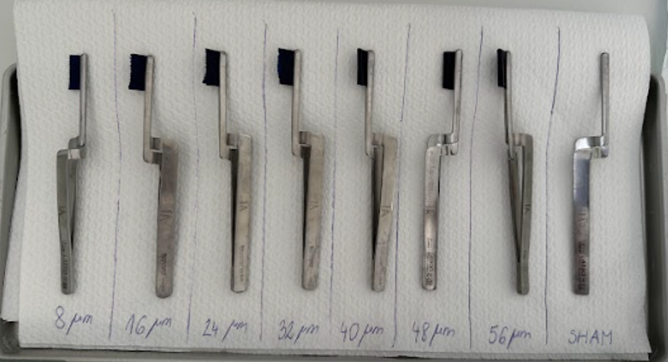

Figure 1. Distribution of articulating holders with foils by thickness, from the thinnest (8 μm) to the thickest (56 μm)

Figure 2. Placement of the articulation foil on the occlusal surface in the molar region

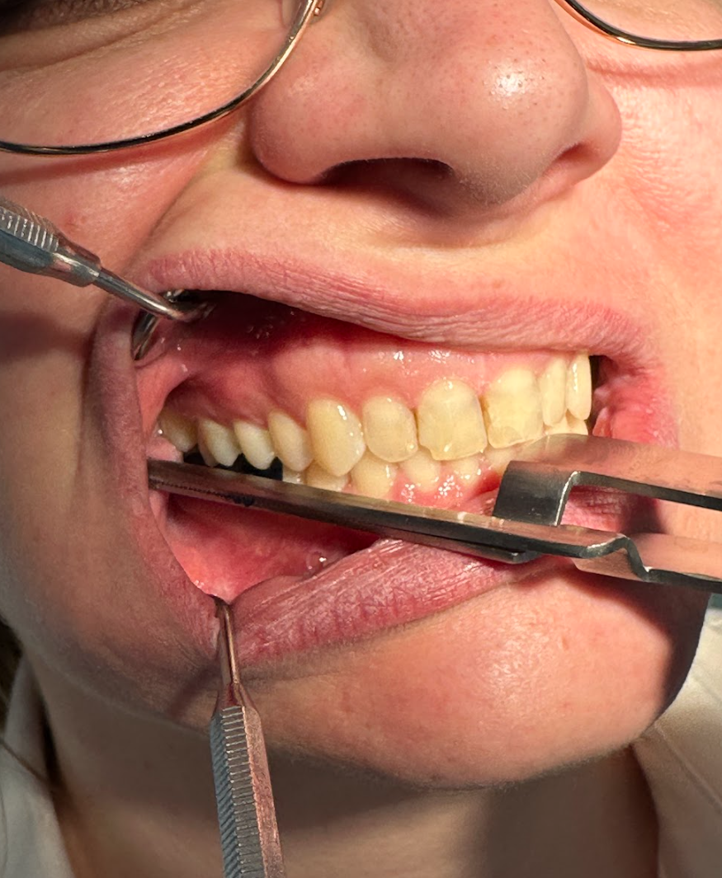

### **Google forms survey**

Since the test included randomly placing articulation foils, it was necessary to think of a much quicker method of recording the data. For the purpose of this scientific study, a survey was created in Google forms (Figure 3). Students approached the participants together; one of them retracted buccal mucosa with a dental mirror and inserted an articulating holder with a foil in a random sequence in the region of the molars. Before each set, the computer generated a random sequence of thicknesses (Figure 4) (21). The participants were asked to bite down once and respond to the following question with a brief YES or NO answer: “Do you feel the articulating foil between your teeth?”. After hearing the answer, another student marked a response in the form. After six sets, the form was submitted. Using this system, responses from all participants were collected and directly saved in an Excel table which was used to conduct statistical analysis.

In the case of articulating foil, the answer was considered correct when the participant recognized the presence of the foil and false when they did not. In the case of the sham test, when the participant recognized that there was no foil, the answer was considered correct.

Figure 3. An example of a sheet made in Google Forms that was filled out by the examiners for each of the participants, based on their response

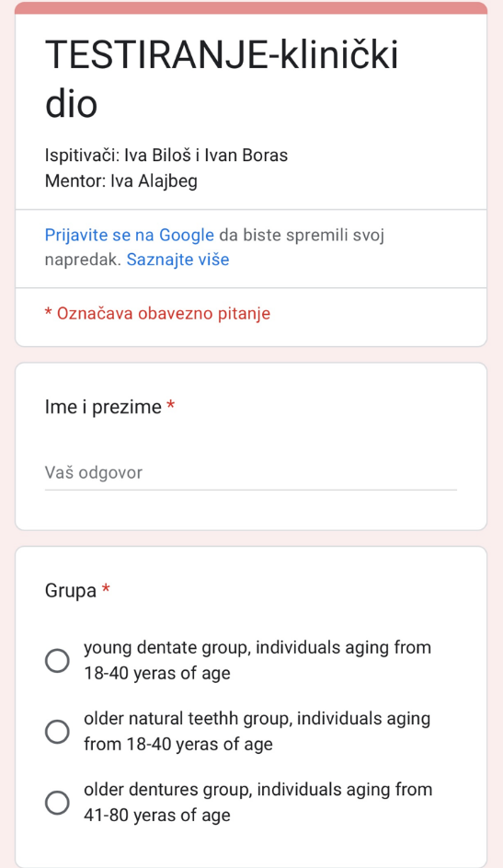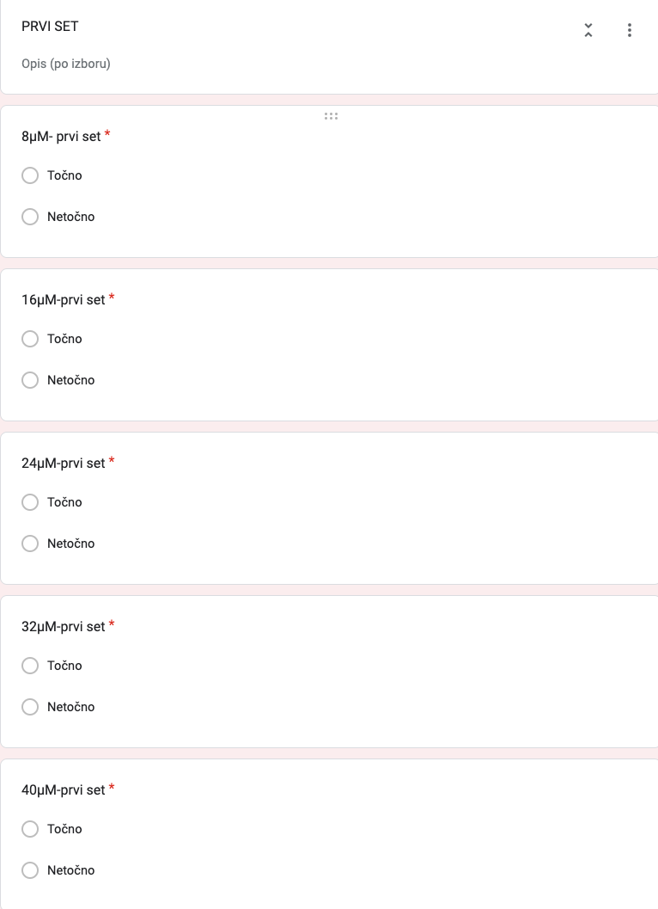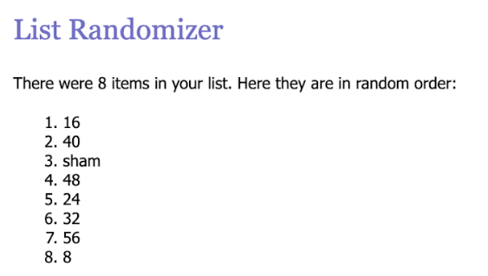

Figure 4. One example of the random articulating foil thickness sequence for each individual generated by the computer. After each set, a new random order was generated (21)

### **Elimination of possible interferences during clinical practice**

In order to ensure that the results of the clinical part of the research were as relevant as possible, we tried to exclude all external factors.

Each participant received earplugs and a face mask (Figure 5). Earplugs helped us eliminate external sounds, especially the sound of the articulation foil. In addition to serving as a cover for the eyes, the face mask ensured that the participants could not see the thickness of the articulation foil, or in the case of a sham test, that the articulation foil was missing.

In addition to the above, we took care of the size of the articulating foil that we put in the holder. If the foil covered a much larger surface than the occlusal one, it would represent a potential problem of perception itself, due to the proximity of the tongue. That would allow the participant to potentially shift the tactile sensation of the tongue impression, instead of focusing on the interocclusal sensation. To avoid this, we measured the width of each articulating foil and requested each patient to place their tongue on the palate during the evaluation. Additionally, some studies have shown that the periodontal mechanosensitive threshold (PMT) stimulated apically from the occlusal surface, was significantly greater than that from the buccal to lingual in all types of teeth. Therefore, by using the reference range of PMT stimulated from the occlusal direction, perceptive abnormalities of low values may be detected (22).

In the literature, some studies pay particular attention to the functional head position during the evaluation of occlusal parameters. It has been found that there is a change in the initial contact between supine, upright and active feeding head postures and that the greatest asymmetry of force was found in the supine position (23). Since our research was based on sensation itself, it was important to focus on it. That is the reason why we made sure that the participant was in the most upright position possible to obtain the most objective results.

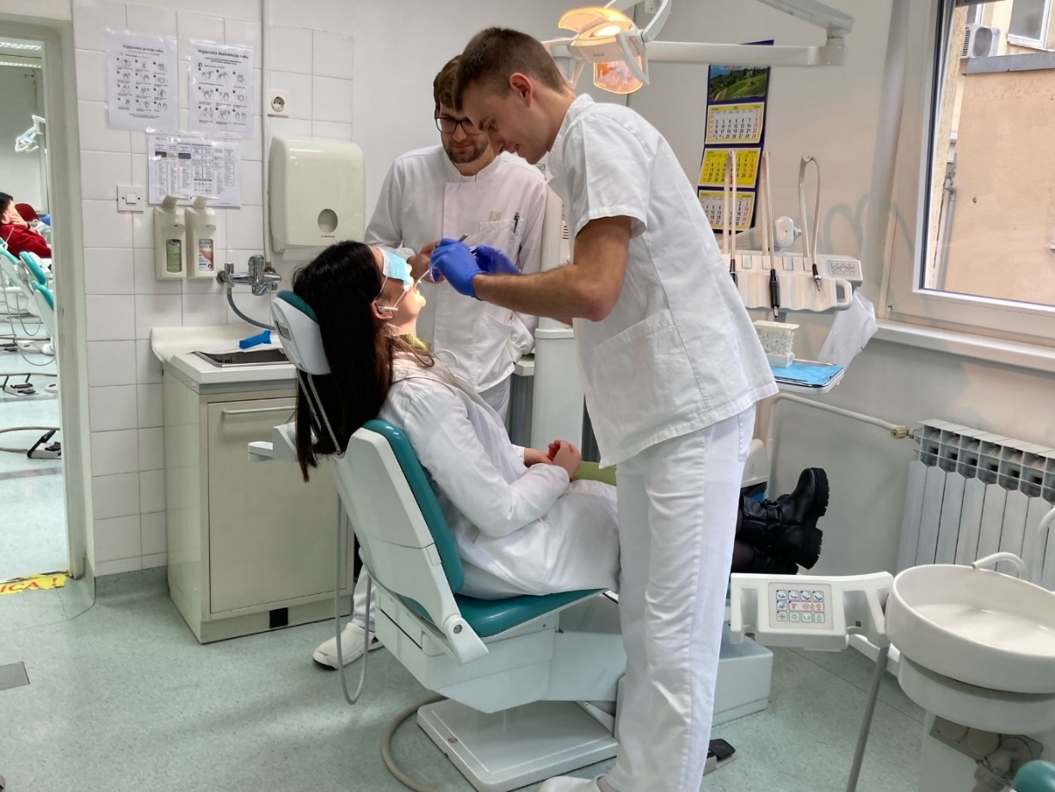

Figure 5. Students at the School of Dental Medicine (IB, IB) conduct the clinical part of the research on the Department of Removable Prosthodontics with Marko Zlendic, DMD

## **Simple size calculation**

To detect differences in occlusal sensitivity concerning the OPB frequency, based on the results of a previous study (8) which compared high frequency parafunction individuals with those with a low frequency of parafunction, it was determined that a sample of 18 participants (9 per group) was necessary to achieve a power of 80% with a significance level of 0.05. This calculation was made to detect a mean difference of 10.0% in the percentage of correct answers between the two groups, assuming an estimated standard deviation of 8.0% and using a two-sided unpaired t-test.

To detect differences in occlusal sensitivity concerning the dentition status (complete denture wearers, older individuals with natural teeth, and young individuals with natural teeth), it was calculated that a total sample of 30 participants (10 per group) is required to obtain a power of 0.80 at an alpha level of 0.05. The calculation was made to detect mean differences in the percentage of correct answers between the three groups, using analysis of variance (ANOVA), followed by post hoc tests under the same conditions.

If these calculations can be generalized and applied to our sample and design, the size of our sample (n = 50) can provide acceptable power to identify moderate treatment effect size differences.

## **Statistical analysis**

Statistical analysis was performed using IBM SPSS Statistics for Windows, Version 26.0 (Armonk, NY: IBM Corp). The distribution of data was checked using the Shapiro–Wilk test. Analyses consisted of descriptive statistics and appropriate tests. Between-group differences were assessed using Kruskal–Wallis Test and Mann–Whitney U tests (for continuous variables) and chi-squared tests (for categorical variables).

The Kruskal Wallis-ANOVA test was performed to determine whether there is a difference in age and oral parafunctions (OBC-tot, OBC-day, OBC-night, and OBC-6) between the groups in the aforementioned variables. Owing to the ease of interpreting and analysing the data, an ordinal number was allocated to each group: number one represents the YDG, number two represents the ONTG, and number three represents the ODG. The Kruskal Wallis test does not require data to be normally distributed because it is employed when we have independent measurements or ordinal variables with more than two expressions. A post-hoc test had to be created in order to verify the results of the Kruskal-Wallis ANOVA, which indicated that there is a difference for a variable between the groups, but not precisely between which groups. The Mann-Whitney U test was used to see exactly which groups have differences in the mentioned variables.

This was followed by examining how different foils with varying thicknesses were perceived. To make it easier to calculate the percentage of responses, answers marked with yes throughout the clinical portion of the study were substituted with 1, and answers marked with no were substituted with 0. The percentage of correct answers for each thickness was determined for each patient. These data were then calculated at the group level and displayed as the mean value (standard deviation, standard error, etc.) for the percentage of correct answers for each individual film thickness per group. The Mann-Whitney U test was then used to determine obvious differences between the groups. Using the complete sample, men and women underwent the same test.

A value of p < 0.05 was considered statistically significant.

# **Results**

In the clinical part of the research, 50 adult individuals (24 males and 26 females) participated. They were divided into three groups: the YDG (an average of 23.40 ± 3.98 years of age), the ONTG (an average of 52.95 ± 8.13 years of age) and the ODG (an average of 68.70 ± 6.33 years of age). For each group, the following variables were evaluated: OBC-tot, OBC-day, OBC-night and OBC-6.

Table 2. Descriptive statistics for the young dentate group

|  |  |  |  |  |  |
| --- | --- | --- | --- | --- | --- |
| Descriptive statistics (YDG) | Valid N | Mean | Standard error | Minimum | Maximum |
|  |  |  |  |  |  |
| Age | 20 | 23.40 | 0.89 | 20.00 | 38.00 |
| OBC-tot (1-84) | 20 | 26.35 | 2.48 | 5.00 | 41.00 |
| OBC- day (1-76) | 20 | 23.50 | 2.00 | 5.00 | 36.00 |
| OBC-night (1-8) | 20 | 2.85 | 0.60 | 0.00 | 8.00 |
| OBC-6 (1-24) | 20 | 7.95 | 0.84 | 0.00 | 17.00 |

young dentate group (YDG); Oral Behaviours Checklist (OBC)

Table 3. Descriptive statistics for the older natural teeth group

|  |  |  |  |  |  |
| --- | --- | --- | --- | --- | --- |
| Descriptive statistics (ONTG) | Valid N | Mean | Standard error | Minimum | Maximum |
|  |  |  |  |  |  |
| Age | 20 | 52.95 | 1.82 | 43.00 | 74.00 |
| OBC-tot (1-84) | 20 | 25.25 | 1.75 | 11.00 | 46.00 |
| OBC- day (1-76) | 20 | 20.95 | 1.48 | 11.00 | 38.00 |
| OBC-night (1-8) | 20 | 4.30 | 0.65 | 0.00 | 8.00 |
| OBC-6 (1-24) | 20 | 6.15 | 0.77 | 0.00 | 13.00 |

older natural teeth group (ONTG); Oral Behaviours Checklist (OBC)

Table 4. Descriptive statistics for the older dentures group

|  |  |  |  |  |  |
| --- | --- | --- | --- | --- | --- |
| Descriptive statistics (ODG) | Valid N | Mean | Standard error | Minimum | Maximum |
|  |  |  |  |  |  |
| Age | 10 | 68.70 | 2.00 | 59.00 | 80.00 |
| OBC-tot (1-84) | 10 | 15.90 | 2.59 | 5.00 | 33.00 |
| OBC- day (1-76) | 10 | 13.70 | 2.50 | 4.00 | 29.00 |
| OBC-night (1-8) | 10 | 2.20 | 0.61 | 0.00 | 4.00 |
| OBC-6 (1-24) | 10 | 1.90 | 0.62 | 0.00 | 5.00 |

*older dentures group (ODG); Oral Behaviours Checklist (OBC)*

In order to find out whether there were differences in the mentioned variables among the three test groups, the Kruskal Wallis – ANOVA test was done. Since Kruskal-Wallis ANOVA only showed that there are differences between groups, but did not specify between which groups exactly, an additional post-hoc test had to be done. Therefore, the Mann-Whitney U test was used.

Firstly, the Kruskal Wallis – ANOVA test determined that a difference in **age variable** exists between all three groups. To determine between which groups specific differences exist, the Mann-Whitney U test was done. As we expected, the test showed the difference in age variable between all three groups (the YDG and the ONTG, the YDG and the ODG, and the ONTG and the ODG). The YDG was the youngest group, while between other two groups (the ONTG and the ODG), the difference in average age was significantly different. That was expected, considering that the average age of a patient with dentures is significantly different from individuals who have their natural teeth. When comparing individuals by groups, a value p < 0.05 was considered significant, the proof of which we provide when comparing individuals by groups.

Table 5. The Mann-Whitney U test showing age difference between groups

|  |  |  |  |
| --- | --- | --- | --- |
| Mann-Whitney U test  Variable: AGE | Mean | Z adjusted | p-value |
|  |  |  |  |
| YDG vs. ONTG | 23.4 vs. 52.95 | -5.41 | <0.001 |
| YDG vs. ODG | 23.4 vs. 68.7 | -4.41 | <0.001 |
| ONTG vs. ODG | 52.95 vs. 68.7 | -3.70 | <0.001 |

*young dentate group (YDG); older natural teeth group (ONTG); older dentures group (ODG)*

As already, mentioned we decided to test if there are any significant differences in the OBC variables. We started with **OBC-tot**, where the Kruskal-Wallis ANOVA test showed that a difference exists (p = 0.014). The Mann Whitney U test was done, where it was shown that the relationship between the YDG and the ONTG was not statistically significant (table). But the test showed that there is a statistically significant difference when comparing the YDG and the ODG, and the ONTG and the ODG. The ODG had significantly lower values of OBC-tot than the other two groups (the YDG and the ONTG).

Table 6. The Mann-Whitney U test showing the OBC-tot difference between groups

|  |  |  |  |
| --- | --- | --- | --- |
| Mann-Whitney U test  Variable: OBC-tot | Mean | Z adjusted | p-value |
|  |  |  |  |
| YDG vs. ONTG | 26.35 vs. 25.25 | 0.43 | 0.66 |
| YDG vs. ODG | 26.35 vs. 15.90 | 2.56 | 0.01 |
| ONTG vs. ODG | 25.25 vs. 15.90 | 2.64 | 0.01 |

*young dentate group (YDG); older natural teeth group (ONTG); older dentures group (ODG); Oral Behaviors Checklist (OBC)*

The Kruskal-Wallis ANOVA test showed a difference in the **OBC-day** variable (p = 0.009). The Mann-Whitney test proved that a statistically significant difference exists between the YDG and the ODG, as well between the ONTG and the ODG.

Table 7. The Mann-Whitney U test showing OBC-day difference between groups

|  |  |  |  |
| --- | --- | --- | --- |
| Mann-Whitney U test  Variable: OBC-day | Mean | Z adjusted | p-value |
|  |  |  |  |
| YDG vs. ONTG | 23.50 vs. 20.95 | 1.34 | 0.17 |
| YDG vs. ODG | 23.50 vs. 13.70 | 2.60 | 0.01 |
| ONTG vs. ODG | 20.95 vs. 13.70 | 2.58 | 0.01 |

*young dentate group (YDG); older natural teeth group (ONTG); older dentures group (ODG); Oral Behaviours Checklist (OBC)*

For the **OBC-night** variable, the Kruskal-Wallis ANOVA test did not find a significant difference between the three groups (p= 0.082). The Mann-Whitney U test showed that the difference exists only between two groups (the ONTG and the ODG). Even though the difference is slightly below the p value, it still exists.

Table 8. The Mann-Whitney U test showing the OBC-night difference between groups

|  |  |  |  |
| --- | --- | --- | --- |
| Mann-Whitney U test  Variable: OBC-night | Mean | Z adjusted | p-value |
|  |  |  |  |
| YDG vs. ONTG | 2.85 vs. 4.30 | -1.69 | 0.09 |
| YDG vs. ODG | 2.85 vs. 2.20 | 0.41 | 0.68 |
| ONTG vs. ODG | 4.30 vs. 2.20 | 2.02 | 0.04 |

*young dentate group (YDG); older natural teeth group (ONTG); older dentures group (ODG); Oral Behaviours Checklist (OBC)*

The last variable that we tested was **OBC-6**. The Kruskal-Wallis ANOVA test showed significant difference among the groups (p<0.001). When the Mann-Whitney test was performed, the situation was nearly identical as in OBC-tot and OBC-day, where the only difference could be noticed between the YDG and the ODG, as well as between the ONTG and the ODG.

Table 9. The Mann-Whitney U test showing the OBC-6 difference between groups

|  |  |  |  |
| --- | --- | --- | --- |
| Mann-Whitney U test  Variable: OBC-6 | Mean | Z adjusted | p-value |
|  |  |  |  |
| YDG and ONTG | 7.95 vs. 6.15 | 1.56 | 0.12 |
| YDG and ODG | 7.95 vs. 1.90 | 3.81 | <0.001 |
| ONTG and ODG | 6.15 – 1.90 | 3.19 | <0.001 |

*young dentate group (YDG); older natural teeth group (ONTG); older dentures group (ODG); Oral Behaviours Checklist (OBC)*

## **Comparison of sensitivity threshold for interocclusal thickness between genders**

When we compared foil perception between males and females on the total sample (24 males and 26 females), no statistically significant differences could be seen (Figure 6). Female individuals (orange line) better perceive thinner foils (up to 24 microns), whereas male individuals (blue line) perceive thicker foils slightly better. There are no differences in the perception of the sham test.

Figure 6. Mean percentage of correct answers with standard error for each testing thickness among males (blue line) and females (orange line) (whole sample)

## **Comparison of sensitivity threshold for interocclusal thickness among groups**

Analysis of foil perception among all three groups (Figure 7) showed that individuals significantly differently perceive foil thickness starting from 24 microns and following thicker foils, because for the perception of the first two thicknesses, there were no statistically significant differences among the three groups.

Figure 7. Mean percentage of correct answers with standard error for each testing thickness among the YDG (blue line), the ONTG (orange line) and the ODG (grey line)

In order to find out between which groups the differences can be seen, the Mann-Whitney U test was done. The test showed that we cannot see the statistically significant difference between the YDG and the ONTG through any of the tests, starting from 8 microns up to 56 microns, including the sham test.

Next, the relationship between the YDG and the ODG was compared. In those two groups, four out of seven values (24, 40, 48 and 56 microns) showed statistically significant differences (Table 9). That is the reason why we can see a huge gap between the blue line (the YDG) and the grey line (the ODG) on the graph (Figure 7). Another relationship that was also proved while using this test was between the ONTG and the ODG. It shows that the difference exists in two different foil thicknesses, namely 48 and 56 microns (Table 10). Regarding the sham test, there were no statistically significant differences among any of the groups.

Table 10. The Mann-Whitney U test comparing sensitivity threshold for all thicknesses between the YDG and the ODG

|  |  |  |  |
| --- | --- | --- | --- |
| Mann-Whitney U test (YDG and ODG) | Rank Sum YDG | Rank Sum ODG | p-value |
|  |  |  |  |
| 8 µm | 327.00 | 138.00 | 0.37 |
| 16 µm | 334.00 | 131.00 | 0.28 |
| 24 µm | 359.00 | 106.00 | 0.03 |
| 32 µm | 346.50 | 118.50 | 0.11 |
| 40 µm | 358.00 | 106.50 | 0.01 |
| 48 µm | 367.50 | 97.50 | <0.001 |
| 56 µm | 361.00 | 104.00 | 0.01 |
| sham | 332.00 | 133.00 | 0.15 |

young dentate group (YDG); older dentures group (ODG)

Table 11. The Mann-Whitney U test comparing sensitivity threshold for all thicknesses between the ONTG and the ODG

|  |  |  |  |
| --- | --- | --- | --- |
| Mann-Whitney U test (ONTG and ODG) | Rank Sum ONTG | Rank Sum ODG | p-value |
|  |  |  |  |
| 8 µm | 309.50 | 155.50 | 1.00 |
| 16 µm | 339.50 | 125.50 | 0.18 |
| 24 µm | 348.50 | 116.50 | 0.09 |
| 32 µm | 340.50 | 124.50 | 0.18 |
| 40 µm | 345.00 | 120.00 | 0.10 |
| 48 µm | 367.50 | 97.50 | <0.001 |
| 56 µm | 364.00 | 101.00 | <0.001 |
| sham | 336.00 | 129.00 | 0.06 |

older natural teeth group (ONTG); older dentures group (ODG)

## **4.4. Comparison of sensitivity threshold for interocclusal thickness between the HFP and the LFP group on total sample**

When comparing the perception of foil thickness between the HFP individuals and the LFP individuals on the whole sample, no statistically significant differences were found. Generally, individuals within the LFP group perceive thinner foils better, while on the contrary, individuals in the HFP group perceive thicker foils better. The sham test was perceived a little better by individuals in the HFP group (Figure 8).

Figure 8. Comparison of mean percentage of correct answers with standard error for each testing thickness among the LFP group (blue line) and the HFP group (orange line) on the total sample

## **4.5. Comparison of sensitivity threshold for interocclusal thickness between the HFP and the LFP group within each of three groups individually**

Tests of differences in perception of various foils thicknesses between the HFP individuals and the LFP individuals analysed in each of the three tested groups individually is shown in the pictures: Figure 9 (the YDG), Figure 10 (the ONTG) and Figure 11 (the ODG).

The Mann-Whitney test showed that within the YDG there are statistically significant differences in the perception of thinner foils (8 and 24 microns) between the HFP and the LFP group. Additionally, the LFP group perceives thinner foils better. As the thickness of foils increases, those differences are less and less visible by the YDG.

Figure 9. Comparison of mean percentage of correct answers with standard error for each testing thickness among the LFP group (blue line) and the HFP group (orange line) within the YDG

In ONTG, no statistically significant differences were found in regard to the frequency of parafunctions.

Figure 10. Comparison of mean percentage of correct answers with standard error for each testing thickness among the LFP group (blue line) and the HFP group (orange line) within the ONTG

For the ODG, even though the graph seems to show that differences exist, there were only two individuals in the HFP group, so the testing procedure, due to a relatively small number of individuals, did not show statistically significant differences in perception.

Figure 11. Comparison of mean percentage of correct answers with standard error for each testing thickness among the LFP group (blue line) and the HFP group (orange line) within the ODG

# **Discussion**

The purpose of this study was to evaluate the sensitivity threshold for interocclusal thickness between individuals self-reporting a high or low frequency of oral parafunctional behaviour on the whole sample and within each of the specific groups individually. Furthermore, other aims of this study were to determine if the occlusal sensitivity varies between individuals having complete dentures and those with their natural teeth, between genders, and between different age groups. The significance of occlusal sensitivity is extremely important, which is proved by the fact that an increasing number of research are based on examining the factors which might cause it to change. However, up until now, no conducted study with similar group division has tested several variables in several distinct categories, trying to find the potential correlation.

## **Sensitivity threshold with respect to different frequency of oral parafunction**

Based on the research conducted in 2019 (8), it was determined that there is a difference in the perception of different foils thicknesses in the HFP and the LFP groups. Accordingly, it was determined that individuals in the HFP group perceive thicker foils (56 microns) better, while on the other hand, in the sham test and when testing thicknesses between 8 and 48 microns, there were no statistically significant differences between the two groups. In our study, when comparing the perception of foil thickness between the HFP and the LFP groups on the whole sample, there were no statistically significant differences between the two groups. The data also suggests that, generally, individuals in the LFP group perceive thinner foils better, while on the contrary, individuals in the HFP group perceive thicker foils better.

The fact that individuals with lower oral parafunctional behaviour frequency (LFP) have better occlusal perception than those with higher oral parafunctional behaviour frequency (HFP) can be explained by considering the following factors:

Neuromuscular Adaptation: Continuous parafunctional activities may lead to neuromuscular adaptations that desensitize the oral structures. It was found that increased frequency of oral parafunctional activities seems to cause harmful effects on muscles and joints and is presumed important in initiating and perpetuating factors in the TMDs and myofascial pain (24). In such a situation, the sensorial-motor mechanism responsible for thickness discrimination is severely altered (25,26,27). The repetitive forces exerted during these behaviours could alter the threshold levels for detecting occlusal changes, making individuals less sensitive to minor variations.

Sensory Fatigue: A high frequency of parafunctional activities might result in sensory fatigue of the periodontal mechanoreceptors, which are critical for detecting occlusal thickness. The excess of fatigue and subsequent pain resulting from the contraction of the muscles in the parafunctional activity decreases the threshold of excitability of the neurons of the reflex centre initiating the feedback mechanism (28). This fatigue reduces the receptors' responsiveness, leading to poorer occlusal perception in the HFP individuals.

Periodontal Ligament Health: The periodontal ligament contains mechanoreceptors that are essential for detecting occlusal forces and thickness which is in the accordance with previous studies, which reported that the threshold for interocclusal detection of small objects, such as foils, is dependent on the activity of the periodontal mechanoreceptors (29). In individuals with LFP, these structures are likely to remain healthier and more responsive compared to those in the HFP individuals, who may experience ligament degradation due to excessive mechanical stress. This is in agreement with findings obtained by Ortún-Terrazas et al (30), who found that no signs of periodontal ligament damage were observed in normal chewing conditions, but in traumatic occlusion conditions, damage of the fibrous networks was caused by the high occlusal load, resulting in rupture of collagen fibres and interstitial fluid overpressure in the apical region of the PDL.

Our findings agree with the study (5), which found that in patients with teeth, the percentage sensibility was directly proportional to the foil thickness. Therefore, the thinner the foil, the lesser the tactile sensitivity. When we examined each group separately, starting with YDG, we observed a variation in foil perception within that group. The difference was identified during the statistical analysis of the data, where it showed that the LFP group perceives thinner foils better than the HFP group, but as the thickness of foils increases, the differences are less and less visible. Likewise, it should be noted that one of the obstacles of the research was the relatively same age of the patients within this group, taking an example, that most people in this group were 20 years old, while the range of the group itself was from 18 to 40 years of age. Within the ONTG, there were no statistically significant differences. When speaking about the ODG, it can be noticed that these individuals, especially those belonging to the HFP group, do not perceive thinner foils at all (8, 16 and 24 microns). This is probably due to the fact that people who have lost their own teeth had significantly reduced levels of sensation, but not completely lost (31). Furthermore, it seems that huge differences between two groups exists, but are not of great significance, since the number of participants in that group was very small and testing did not show real significant differences in perception. One of the reasons for that is the fact that these are elderly people with whom the appointment was difficult to schedule, compared to the other two groups. Namely, a larger number of respondents would certainly provide us with a better insight into the relationship within this group.

## **Sensitivity threshold with respect to dentition status**

There are very few studies that compared tactile sensibility threshold between natural dentition and complete dentures, but those that were conducted, suggest that occlusal sensitivity in the case of complete dentures is smaller than in natural dentition (6). In our study, the analysis of foil perception depending on the dentition status showed that there is a significant difference in the perception of foil thicknesses among individuals. The Mann-Whitney U tests revealed the greatest differences between the YDG and the ODG for the thicknesses 24 (p=0.03), 40 (p=0.01), 48 (p=0.00) and 56 microns (p=0.01). When the same test was used to compare the sensitivity threshold between the ONTG and the ODG, comparable results were found. Differences were observed for 48 (p=0.00) and 56 microns (p=0.00). These results are not in accordance with our initial hypothesis, which is probably because edentulous patients have lost periodontal receptors and the important proprioceptive information associated with them, but when they are rehabilitated with complete dentures, receptors from other tissues, such as muscles or TMJ, might be stimulated during chewing (3). These findings might be useful for further research on this topic and may help understand whether the perception in edentulous individuals improves due to the adaptation of complete dentures.

## **Sensitivity threshold with respect to age**

Previous studies (7,32) reported no significant correlation between interocclusal tactile sensibility and age. When comparing occlusal sensitivity in different age groups in our study, namely the YDG and the ONTG, it can be clearly seen that individuals in the YDG with LFP perceive smaller thicknesses significantly better, 8 and 24 microns, than individuals with LFP in the ONTG.

## **Sensitivity threshold with respect to gender**

Researchers (5,32) have found that there were no differences in the minimum interdental threshold between men and women, while in other research (6), gender appeared to be a significant factor, resulting in differences for interocclusal thickness, where female individuals had lower values in the sensibility threshold for interocclusal thickness when compared to males. In our research, considering the data from all 50 participants, the results are in accordance with the research hypothesis, demonstrating no statistically significant difference in the perception of different foil thicknesses among genders. What our findings suggest is that women perceive thinner foils better, while on the other hand, men perceive thicker foils better.

# **Conclusion**

When analysing the sensitivity threshold for interocclusal thickness, no statistically significant differences were found between the HFP individuals and the LFP individuals in the total sample. Generally, the LFP individuals perceived thinner foils better, while the HFP individuals perceived thicker foils better. Within the YDG, the LFP perceived thinner foils (p<0.05) significantly better, with differences diminishing as foil thickness increased. In the ONTG, no significant differences were observed between the HFP and the LFP individuals. In the ODG, noticeable differences were present but not statistically significant due to the small number of the HFP individuals.

No significant differences were found between the YDG and the ONTG regarding age, but both groups perceived all foil thicknesses significantly better than the ODG, likely due to the loss of teeth are reduced periodontal ligament function. Gender did not affect sensitivity thresholds, although females perceived thinner foils slightly better, whereas males perceived thicker foils better, with no differences in the perception of the sham test.

Based on the dentition status, no statistically significant differences were observed between the YDG and the ONTG. However, when we compared the YDG and the ODG, in four out of seven values statistically significant differences were observed, and those are 24 μm (p=0.03), 40 μm (p=0.01), 48 μm (p<0.001) and 56 μm (p=0.01). Furthermore, between the ONTG and the ODG, there were significant differences in the perception of 48 μm (p<0.001) and 56 μm (p<0.001) thicknesses. Regarding the sham test, there were no statistically significant differences among any of the groups.

In conclusion, sensitivity thresholds for interocclusal thickness varied based on age and dentition status, with the YDG and the ONTG perceiving thicknesses better than the ODG. Significant differences in perception were observed primarily at thinner foil levels, particularly among the LFP individuals and specific comparisons involving the ODG, highlighting the impact of periodontal health on tactile sensitivity. Also, lower oral parafunctional behaviour frequency preserves the integrity and sensitivity of oral structures, leading to better occlusal perception compared to those with a higher frequency of such behaviours.

# **Acknowledgment**

We express our gratitude to our mentor, Professor Iva Alajbeg, for unselfish support during

the research. Thank You for all Your time, encouragement, and guidance with the thesis

writing.

We also acknowledge Marko Zlendić (DMD) for all his help with the clinical part of

the research and guidance.

We want to thank the nurses from the Department of Removable Prosthetics for preparing all

the materials for the clinical part of the research.

# **References**

|  |  |
| --- | --- |
| 1. | Hirashima S, Kanazawa T, Ohta K, Nakamura KI. Three-dimensional ultrastructural imaging and quantitative analysis of the periodontal ligament.. Anat Sci Int. 2020; 95(1): 1-11. |
| 2. | de Jong T, Bakker AD, Everts V, Smit TH. The intricate anatomy of the periodontal ligament and its development: Lessons for periodontal regeneration. J Periodontal Res. 2017; 52(6): 965-74. |
| 3. | González-Gil, D., Flores-Fraile, J., & López-Marcos, J. Tactile Sensibility Thresholds in Implant Prosthesis, Complete Dentures and Natural Dentition: Review about Their Value in Literature. Medicina (Kaunas, Lithuania). 2022; 58(4). |
| 4. | Trulsson M. Force encoding by human periodontal mechanoreceptors during mastication. Arch Oral Biol. 2007; 52(4): 357–60. |
| 5. | Calderon Pdos S, Kogawa EM, Corpas Ldos S, Lauris JR, Conti PC. The influence of gender and bruxism on human minimum interdental threshold ability. J Appl Oral Sci. 2009; 17(3): 224-28. |
| 6. | Shala KS, Dula LJ, Pustina-Krasniqi T, Bicaj T, Ahmedi EF, Lila-Krasniqi Z, Tmava-Dragusha A. Evaluation of Sensibility Threshold for Interocclusal Thickness of Patients Wearing Complete Dentures. Int J Dent. 2017; 2017:5138950. |
| 7. | Kogawa EM, Calderon PD, Lauris JR, Pegoraro LF, Conti PC. Evaluation of minimum interdental threshold ability in dentate female temporomandibular disorder patients. J Oral Rehabil. 2010; 37(5): 322-28. |
| 8. | Bucci R, Koutris M, Lobbezoo F, Michelotti A. Occlusal sensitivity in individuals with different frequencies of oral parafunction. J Prosthet Dent. 2019; 122(2): 119–22. |
| 9. | Perrotta S, Bucci R, Simeon V, Martina S, Michelotti A, Valletta R. Prevalence of malocclusion, oral parafunctions and temporomandibular disorder-pain in Italian schoolchildren: An epidemiological study. J Oral Rehabil. 2019; 46(7): 611-16. |
| 10. | Alajbeg IZ and Alajbeg I. Epidemiologija neodontogene orofacijalne boli. In Savic Pavicin SS,e. Javno zdravstvo i oralna epidemiologija. Zagreb: Naklada Slap; 2024¸ p. 125-32. |
| 11. | Lobbezoo F, Ahlberg J, Glaros AG, et al. Bruxism defined and graded: an international consensus. J Oral Rehabil. 2013; 40(1): 2-4. |
| 12. | Ferreira, Joao; Fricton, James; Rhodus, Nelson. Orofacial Disorders: Current Therapies in Orofacial Pain and Oral Medicine. 1st ed.: Springer International Publishing; 2017. |
| 13. | Bucci R, Koutris M, Palla S, Sepúlveda Rebaudo GF, Lobbezoo F, Michelotti A. Occlusal tactile acuity in temporomandibular disorder pain patients: A case-control study. J Oral Rehabil. 2020; 47(8): 923-29. |
| 14. | Cioffi I, Farella M, Festa P, Martina R, Palla S, Michelotti A. Short-Term Sensorimotor Effects of Experimental Occlusal Interferences on the Wake-Time Masseter Muscle Activity of Females with Masticatory Muscle Pain. J Oral Facial Pain Headache. 2015; 29(4): 331-39. |
| 15. | Jang KS, Kim YS. Comparison of oral sensory function in complete denture and implant-supported prosthesis wearers. J Oral Rehabil. 2001; 28(3): 220-5. |
| 16. | Kuwashima A, Nagata S, IgarashiK, Koide Y, Gunji A, Okubo M, Iijima M, Kawai Y. Do Oral Parafunctional Behaviors Relate to the Natural Course of Self-healing of Temporomandibular Disorder? An 8-month Prospective Study. International Journal of Oral-Medical Sciences, 2018;17(3): 93-9. |
| 17. | Bucci R, Manfredini D, Lenci F, Simeon V, Bracci A, Michelotti A. Comparison between Ecological Momentary Assessment and Questionnaire for Assessing the Frequency of Waking-Time Non-Functional Oral Behaviours. J Clin Med. 2022; 11(19): 58-80. |
| 18. | Kaplan, S. E., & Ohrbach, R. Self-Report of Waking-State Oral Parafunctional Behaviors in the Natural Environment. Journal of Oral & Facial Pain and Headache. 2016; 30(2): 107-19. |
| 19. | Schiffman, Eric et al. Diagnostic Criteria for Temporomandibular Disorders (DC/TMD) for Clinical and Research Applications: recommendations of the International RDC/TMD Consortium Network and Orofacial Pain Special Interest Group. J Oral Facial Pain Headache. 2014; 28(1): 6-27. |
| 20. | Valentino, R., Cioffi, I., Vollaro, S., Cimino, R., Baiano, R., & Michelotti, A. Jaw muscle activity patterns in women with chronic TMD myalgia during standardized clenching and chewing tasks. Cranio. 2021; 39(2): 157-63. |
| 21. | Random.org. [Online].; 2010 [cited 2023 October 10]. Available from: <https://www.random.org/lists/>. |
| 22. | Ryuhei Kanda , Norio Mukai, Junko Tanaka , Masahiro Tanaka. Reference range for periodontal mechanosensitive thresholds in molars stimulated from the buccal and occlusal directions in healthy subjects with natural dentition. Journal of Osaka Dental University. 2020; 54(1): 61-72. |
| 23. | Haralur S, Al-Gadhaan S, Al-Qahtani A, Mossa A, Al-Shehri W, Addas M. Influence of functional head postures on the dynamic functional occlusal parameters. Ann Med Health Sci Res. 2014; 4(4): 562-6. |
| 24. | Ohrbach R, Michelotti A. The Role of Stress in the Etiology of Oral Parafunction and Myofascial Pain. Oral Maxillofac Surg Clin North Am. 2018; 30(3): 369-79. |
| 25. | Huang GJ, LeResche L, Critchlow CW, Martin MD, Drangsholt MT. Risk factors for diagnostic subgroups of painful temporomandibular disorders (TMD). J Dent Res. 2002; 81(4): 284-8. |
| 26. | Koutris M, Lobbezoo F, Sümer NC, Atiş ES, Türker KS, Naeije M. Is myofascial pain in temporomandibular disorder patients a manifestation of delayed-onset muscle soreness? Clin J Pain. 2013; 29(8): 712-6. |
| 27. | Michelotti A, Cioffi I, Festa P, Scala G, Farella M. Oral parafunctions as risk factors for diagnostic TMD subgroups. J Oral Rehabil. 2010; 37(3): 157-62. |
| 28. | Menrique Corradi L, Eduardo Toledo Avelar L. Oral Parafunction - Aetiology, Implications and Relation to Orthodontic Treatment. In Ahmad Almasri M KRe. Maxillofacial Surgery and Craniofacial Deformity - Practices and Updates.: IntechOpen; 2020. |
| 29. | Piancino MG, Isola G, Cannavale R, Cutroneo G, Vermiglio G, Bracco P, Anastasi GP. From periodontal mechanoreceptors to chewing motor control: A systematic review. Arch Oral Biol. 2017; 78: 109-21. |
| 30. | Ortún-Terrazas J, Cegoñino J, Pérez Del Palomar A. In silico study of cuspid' periodontal ligament damage under parafunctional and traumatic conditions of whole-mouth occlusions. A patient-specific evaluation. Comput Methods Programs Biomed. 2020; 184: 105-7. |
| 31. | González-Gil D, Dib-Zaitum I, Flores-Fraile J, López-Marcos J. Importance of Osseoperception and Tactile Sensibility during Masticatory Function in Different Prosthetic Rehabilitations: A Review. Medicina. 2022; 58(1): 91-2. |
| 32. | Enkling N, Nicolay C, Bayer S, Mericske-Stern R, Utz KH. Investigating interocclusal perception in tactile teeth sensibility using symmetric and asymmetric analysis. Clin Oral Investig. 2010; 14(6): 683-90. |

# **Summary**

Iva Biloš, Ivan Boras

ASSESSMENT OF INTEROCCLUSAL SENSITIVITY THRESHOLD: INFLUENCE OF PARAFUNCTIONAL BEHAVIOURS, AGE, DENTAL STATUS AND GENDER

INTRODUCTION: Periodontium is the specialized tissue that surrounds and supports the teeth, with the periodontal ligament playing a key role through its mechanoreceptors, which detect the smallest changes in the interocclusal space and rapidly relay this information to the brain. This study used different thicknesses of articulating foils to represent these minor changes. Oral parafunctional behaviours (OPB) involve involuntary, repetitive activity of masticatory muscles, which may alter the activity of periodontal receptors. The presence or absence of the teeth can significantly impact the perception of foil thicknesses. The study aimed to assess occlusal sensitivity across various participant groups to determine potential differences based on the frequency of parafunctional activity, age gender and dentition status.

MATERIALS AND METHODS: Fifty healthy volunteers (24 males and 26 females) participated in the study, selected based on inclusion criteria and divided into three groups: young dentate group (average age 23.40 ± 3.98 years), older natural teeth group (average age 52.95 ± 8.13 years) and older dentures group (average 68.70 ± 6.33 years). Participants completed an Oral Behaviour Checklist (OBC) to classify them into high or low-frequency parafunctional behaviour group. Occlusal sensitivity was tested using 7 aluminium foils ranging from 8 μm to 56 μm in 8 μm increments, and 1 sham test without any foil. Each foil was presented 6 times in random order (48 tests in total).

RESULTS: In the total sample, no statistically significant differences were found between individuals with high and low frequency of parafunctional behaviours (p>0.05). However, within specific groups, differences emerged. In the YDG, individuals with LFP perceived thinner foils better (p<0.05), with diminishing differences as foil thickness increased. In the ONTG, no significant differences were found between the HFP and the LFP individuals (p>0.05). In the ODG, noticeable differences were present, but the small number of the HFP individuals rendered these differences statistically insignificant.

Comparing age groups, there were no significant differences between the YDG and the ONTG, but both groups perceived all foil thicknesses significantly better than the ODG, likely due to the loss of teeth and reduced periodontal ligament (PDL) function in the latter. Additionally, no gender differences in the sensitivity threshold for interocclusal thickness were found, although female participants perceived thinner foils slightly better, while male participants perceived thicker foils better. Regarding dentition status, no significant differences were observed between the YDG and the ONTG. However, significant differences were found when comparing the YDG and the ODG for 4 out of 7 values: 24 μm (p=0.03), 40 μm (p=0.01), 48 μm (p=0.00) and 56 μm (p=0.01). Between the ONTG and the ODG, significant differences were noted for the 48 μm (p=0.00) and 56 μm (p=0.00) thicknesses.

CONCLUSION: No statistically significant differences in occlusal sensitivity were found between individuals reporting high and those reporting low frequency of parafunctional behaviours, nor between genders, though females slightly better perceived thinner foils, and males’ thicker foils. A positive correlation in occlusal sensitivity was observed based on the dentition status, with significant differences between the YDG and the ODG, as well as between the ONTG and the ODG. These differences likely result from the loss of periodontal receptors and proprioceptive information associated in edentulous patients.

KEY WORDS: occlusal sensitivity, oral parafunctional behaviours, occlusal perception, periodontal ligament

# **Sažetak**

Iva Biloš, Ivan Boras

PROCJENA PRAGA INTEROKLUZALNE OSJETLJIVOSTI: UTJECAJ PARAFUNKCIONALNOG PONAŠANJA, DOBI, DENTALNOG STATUSA I SPOLA

UVOD: Parodont je specijalizirano tkivo koje okružuje i podupire zube, pri čemu parodontni ligament ima ključnu ulogu jer pomoću svojih mehanoreceptora otkriva i najmanje promjene u interokluzijskom prostoru i brzo prosljeđuje te informacije mozgu. U ovome istraživanju korištene su različite debljine zglobnih folija za prikaz manjih promjena. Oralna parafunkcionalna ponašanja (OPB) uključuju nenamjernu, ponavljajuću aktivnost žvačnih mišića, koja može promijeniti aktivnost parodontnih receptora. Prisutnost ili odsutnost zuba može značajno utjecati na percepciju debljine folije. Cilj istraživanja bio je procijeniti okluzalnu osjetljivost među različitim skupinama sudionika kako bi se utvrdile potencijalne razlike na temelju učestalosti parafunkcionalne aktivnosti, dobi, spola i statusa denticije.

MATERIJALI I METODE: U istraživanju je sudjelovalo 50 zdravih dobrovoljaca (24 muškarca i 26 žena), odabranih na temelju kriterija uključivanja i podijeljenih u tri skupine: mlađa skupina s protezom (prosječna dob 23,40 ± 3,98 godina), starija skupina s prirodnim zubima (prosječna dob 52,95). ± 8,13 godina) i starija skupina s protezom (prosjek 68,70 ± 6,33 godine). Sudionici su ispunili Kontrolni popis o oralnom zdravlju (OBC) kako bismo ih klasificirali u skupinu parafunkcionalnog ponašanja visoke ili niske frekvencije. Okluzalna osjetljivost testirana je korištenjem 7 aluminijskih folija u rasponu od 8 μm do 56 μm u razmacima od 8 μm i 1 lažnim testom bez ikakve folije. Svaka folija korištena je 6 puta slučajnim redoslijedom (ukupno 48 testova).

REZULTATI: U ukupnom uzorku nisu utvrđene statistički značajne razlike između osoba s visokom i niskom učestalošću parafunkcionalnih ponašanja (p>0,05). Međutim, unutar pojedinih skupina bile su vidljive razlike. U skupini mladih pojedinaca s protezom, pojedinci u skupini parafunkcionalnog ponašanja niske frekvencije bolje su percipirali tanje folije (p<0,05), uz smanjenje razlika kako se debljina folije povećavala. U skupini starijih pojedinaca s prirodnim zubima nisu pronađene značajne razlike između pojedinaca parafunkcionalnog ponašanja niske i visoke frekvencije (p>0,05). U skupini starijih pojedinaca s protezom primijetile su se razlike, ali mali broj osoba u skupini parafunkcionalnog ponašanja visoke frekvencije čini te razlike statistički beznačajnima.

Uspoređujući dobne skupine, nisu primijećene značajke razlike između skupine mladih pojedinaca s protezom i skupine starijih pojedinaca s prirodnim zubima, ali obje su skupine percipirale sve debljine folije značajno bolje od skupine starijih pojedinaca s protezom, vjerojatno zbog gubitka zuba i smanjene funkcije parodontnog ligamenta (PDL) u potonjoj. Osim toga, nisu pronađene spolne razlike u pragu osjetljivosti za interokluzalnu debljinu, iako su sudionice ženskog spola nešto bolje percipirale tanje folije, dok su muški sudionici bolje percipirali deblje folije. Što se tiče statusa denticije, nisu primijećene značajne razlike između skupine mladih pojedinaca s protezom i skupine starijih pojedinaca s prirodnim zubima. Međutim, utvrđene su značajne razlike pri usporedbi mladih pojedinaca s protezom i skupine starijih pojedinaca s protezom za 4 od 7 vrijednosti: 24 μm (p=0,03), 40 μm (p=0,01), 48 μm (p=0,00) i 56 μm (p=0,01). ). Između skupine starijih pojedinaca s prirodnim zubima i skupine starijih pojedinaca s protezom, zabilježene su značajne razlike za debljine od 48 μm (p=0,00) i 56 μm (p=0,00).

ZAKLJUČAK: Nisu pronađene statistički značajne razlike u okluzalnoj osjetljivosti između pojedinaca koji su prijavili visoku i onih koji su prijavili nisku učestalost parafunkcionalnog ponašanja, niti između spolova, iako su žene nešto bolje percipirale tanje folije, a muškarci deblje folije. Uočena je pozitivna korelacija u okluzalnoj osjetljivosti na temelju statusa denticije, sa značajnim razlikama između skupine mladih pojedinaca s protezom i skupine starijih pojedinaca s protezom, kao i između skupine starijih pojedinaca s prirodnim zubima i skupine starijih pojedinaca s protezom. Te su razlike vjerojatno rezultat gubitka parodontnih receptora i proprioceptivnih informacija povezanih s bezubim pacijentima.

KLJUČNE RIJEČI: okluzalna osjetljivost, oralna parafunkcionalna ponašanja, okluzalna percepcija, parodontni ligament